draft: work in progress
[Classes]
functional specification

Executive Summary

Background
Alliance Francaise de Shanghai provides general courses for French following 10 level curriculum based on the Common European Framework of Reference for Languages (CEFRL). Assessment is mandatory in General French curricula. It has 4 parts, which are: reading, listening, writing and speaking.
- Basic user: Breakthrough (A1.1 and A1.2), Elementary (A2.1 and A 2.2).
- Independent user: Intermediate (B1.1, B1.2, B1.3) and Upper intermediate (B2.1, B2.2, B2.3)
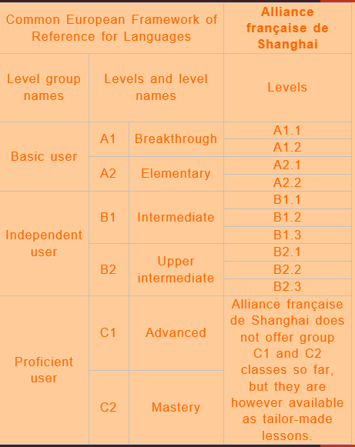
There are 5 sessions per year. Each session lasts either 2 months or 4 months.
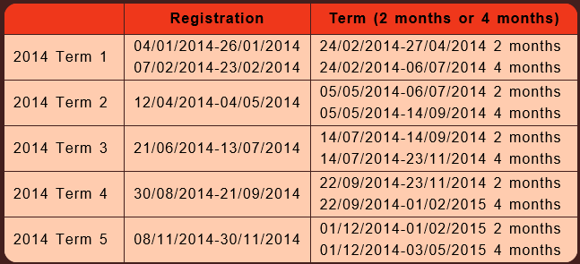

Proposal
We will re-design exercises sharing experience between teachers and students to:
- Facilitate students access to exercises materials: # download compared to Yunio, #students perform exercises
- Increase students confidence to pass exam: participate # =>
- Increase students exam notes: =>
We will support Android phones at the moment.
We will develop a learning assistant app for AF teachers by breaking down into 4 components. We might cover Messaging in another spec. We will have one version to cover Teachers persona, and the other version to cover Students persona.

This spec focuses on Contacts experiences. Students and teachers registration flow are as below:

High-level schedule
Each semester lasts for 19 weeks not including holiday. Our release will be based on AF semester schedule. M1 (milestone 1) refers to the semester September 20th 2014 – Feb. 1st 2015. M2 refers to the semester from Feb. – May 2015. M3 refers to the semester May – August 2015.
For M1 schedule
- Oct. 1st: self-host build ready for internal testing purpose.
- Oct. 1st – Oct. 15th: 1) self-hosting with internal participants. 2) Metric data auto-collection coding, 3) Feedback collection tool coding so that students/teachers can report issues directly from their phones.
- Oct. 31st : beta release with Feedback collection tool
- Nov. 1st – Feb. 1st: beta release for AF A1.1 students and teacher. (can we roll out App update whenever we wish to fix important bugs for example. )
- First week of January: survey with students and teacher.
How can we triage and track issues reported from students/teachers. Is there an existing 3rd party open source tool?

Scenario Goals & Non-Goals

Goals

Following are goals for teacher persona. Definition of priority are: Pri1 must have, priority2 nice to have, and Priority 3 ok to cut.
Goals for Teachers | Priority
Teacher can add a contact (student) to a class | 1
Teacher can edit his profile info registered at AF | 2
Teacher can create/rename/delete a group for exercises or historical exams.  - One group of exercise refers to a course level  - One group of historical exams refers to an official exam at AF given a year/date | 1
Teacher can bulk upload several exercises to a group from PC (or other approach?) | 2
Teacher can upload one exercise to a group from PC (or other approach?) | 1
Teacher can select exercises within a group to distribute to his students | 1
Teacher can select groups of exercises to distribute to his students | 2
Teacher can upload one historical exam | 1
Teacher can bulk upload historical exams | 2
Teacher can see statistic data about students participation | 1
Teacher can see statistic data about exercise scores | 1
Teacher can modify an exercise | 1
Teacher can delete exercises from a group | 2
Teacher can receive an offline message with a specific exercise attached from student | 2
Teacher can reply back to one student as private message | 2
Teacher can forward a message to another student | 2
Teacher can forward a message to all students | 2
Teacher can select if students can see correct answers after completing whole series or not | 2
Teacher can receive a general message without attachment from student | 3
Teacher can save his comment to a given exercise | 3
Teacher can randomly generate pseudo-exams 模拟考卷 from existing historical exams | 2
Teacher can recall back exercises distributed to students | 2
Teacher can use scanner or camera to upload exercises (to be covered in Auto-upload spec) | 2

Following are goals for student persona. Definition of priority are: Pri1 must have, priority2 nice to have, and Priority 3 ok to cut.
Goals for Students | Priority
Student can sign in with his email account or phone # registered at AF, and set a password | 1
Student can edit his profile info registered at AF | 2
Student can select an exercise group or a historical exam to do | 1
Student can see which exercises he has completed within a group (historical exercises) | 2
Student can see which exercises he has not yet completed within a group | 1
Student can see highlights on new exercises distributed from teacher | 1
Student can get push notification at his mobile with new exercises | 2
Student can answer exercises easily on the phone (with less gestures) | 1
Student can answer exercises easily on Tablet (or the app will zoom on tablet) | 2
Student can see his score after completing a group of exercises | 1
Student can re-play exercises from beginning??? | 2
Student can resume exercises | 1
Student exercise status can roam to another device | 3
Student can send questions related to an exercise to teacher thru message (to be covered in Messaging spec?) | 2
Student can send a message to teacher (to be covered in Messaging spec?) | 3
Student can export exercises (to PDF, Word, then to print these exercises out)  - Need to clarify in use of term that these exercises should not be used for business purpose | 3
Student can see how long time he takes to complete a series of exercise | 3
Student can save exercises to favorite | 3

Non-Goals

Non-Goals | Comment
Non-AF students scenarios | We do not target public students, only students registered at AF.
口语 exercise | We will look into this scenario later.
写作题 | We will look into this scenario later.
Diffuse course record thru Video format | To be considered later, in another spec.
Messaging | To be covered in another Spec?
Real time 1:1 course between teacher and student | To be considered later, in another spec
Non-Android platform | To be considered later based on market share

Functional Requirements (High-Level) for Pri1 scenarios

General requirements for App
App Setting
 | Font setting (font and font size) |  | 3 | Can be Pri2 for elder teachers.
 | UI language (Chinese/French/English)  - By default: be aligned with Phone languages |  | 1 | M1: provide default setting  M2: allow users to customize
 | Background picture |  | 3
 | Term of usage |  | 2
 | Help and Feedbacks collection |  | 1 | M1
Installation (on Android only)
 | Install on mobile phone at first time  - Default install on the phone.  - Data storage based on phone setting |  | 1 | M1: default setting  M2/M3: allow users to choose where to install: phone or SD card
 | Move the app to SD card |  | 2 | Probably fine not to cover in M1.
 | Uninstall with data removal |  | 1 | M1
 | Uninstall by keeping data |  | 2
 | Reinstall with data kept |  | 2

Teachers Pri1 Scenarios

# | Requirement | Metrics | Priority | Milestone
Sign-up/Sign-in/sign-out
 | Sign-in with Email registered at AF | # sign-in attempts  # success/failure | 1 | M1
 | Sign-in with mobile phone # registered at AF | # sign-in attempts  # success/failure | 1 | M2: probably sign-up with Email is OK for M1?
 | User sign-out. | # sign-out attempts  #success/failure | 1 | M1
 | User sign-up with Email and create a new password | # sign-up attempts  # success/failure | 1 | M1
 | User sign-up with mobile phone # and create a new password |  | 2 | M2?
 | User change password | # pwd changed  # success/failure | 1 | M1
Manage one exercise or one historical exam to a group
 | Upload/modify/delete a selective exercise (选择题) | # exercises  # success/failure | 1 | M1
 | Upload/modify/delete a Yes/No or Yes/No/I do not know exercise (对错题). There are 2 types of 对错题  - Yes or No  - Yes or No or I do not know (when it’s not mentioned in the text) | # exercises  #success/failure | 1 | M1
 | Upload/modify/delete a written exercise (写作题) | # exercises  #success/failure | 2 | M2
 | Upload/modify/delete a matching exercise (配对题) | # exercises  #success/failure | 1 | M1
 | Upload/delete/modify an exercise with an audio file 听力题 (mp3, wav)  (what are audio format and size limit to support?) | # exercises  # success/failure  audio file size uploaded  Audio file format uploaded | 1 | M1
 | Upload/delete/modify an exercise with several pictures (jpg, png, jpeg)  (what are image format and size limit to support?) | # exercices  # success/failure  # image files | 1 | M1
Manage Group
 | Create a group and auto-assign with a default name  - One group for exercises refers to a course level  - One historical exam group refers to a specific year/date for that exam | # groups created | 1 | M1
 | Validate group name if not exist |  | 1 | M1
 | Check group name with restriction upon creation? Do we need to apply some name convention here? |  | 2
 | Delete a group (exercises in the group will be deleted too)  (how about a group distributed? Or only allow to delete if not distribute? If yes, teacher needs to recall the group first) | # groups deleted | 2
 | Delete several groups (how about groups distributed?) |  | 2
 | Rename a group after its creation  (how about if a group is distributed to students already? Or this is only allowed when a group is not distributed?) | # groups renamed | 1 | M1
Distribute exercises to students
 | Tag a group for distributed or not distributed |  | 1 | M1
 | Select and Distribute an exercise from a group |  | 1 | M2:  Assume at the beginning teacher will rather bulk distribute exercises instead of distributing one single exercise
 | Select and Distribute several exercises from a group |  | 1 | M1
 | Select and Distribute one group |  | 1 | M1
 | Select and Distribute several groups |  | 2 | M2/M3?
Report – students/exercises/time
 | Print out report |  | 3
 | Teacher can see # of exercises completed by students given a time frame |  | 1 | M2
 | Show summary report (with Pie format) |  | 1 | M1
 | Select one section in Pie and break down into a detailed report |  | 1 | M1

Students Pri1 scenarios
# | Requirement | Metrics | Priority | Milestone
Sign-up/Sign-in/sign-out
 | Sign-in with Email registered at AF | # sign-in attempts  # success/failure | 1 | M1
 | Sign-in with mobile phone # registered at AF | # sign-in attempts  # success/failure | 1 | M2
 | User sign-out | # attempts  #success/failure | 1 | M1
 | User sign-up with email and create a new password | # attempts  # success/failure | 1 | M1
 | User sign-up with mobile phone # and create a new password |  | 1 | M2
 | User change password | # attempts  # success/failure | 1 | M1
Conduct exercises and historical exams
 | Answer a selective exercise (选择题) | # exercises  # success/failure | 1 | M1
 | Answer a Yes/No exercise (对错题) | # exercises  #success/failure | 1 | M1
 | Answer a written exercise (写作题) | # exercises  #success/failure | 2 | M3
 | Answer a matching exercise (配对题) | # exercises  #success/failure | 2 | M2
 | Answer an exercise with an audio file 听力题 (mp3, wav)  (what are audio format and size limit to support?) | # exercises  # success/failure  audio file size?  Audio file format? | 1 | M1
 | Answer an exercise with several pictures (jpg, png, jpeg)  (what are image format and size limit to support?) | # exercices  #success/failure  # image files | 1 | M1
Show exercise group and historical exams
 | List of exercise groups and historical exams (what is default view: by course level) |  | 1 | M1
 | View by sorting groups with date of publishing | # view selected | 2 | M3
 | View by sorting groups with completion status | # view selected | 2 | M2
 | View by sorting groups with course level followed with years of exams | # view selected | 1 | M1
 | From group list view, each group shows # completed / # total |  | 1 | M1
 | From one group view, show # completed, # correct, # wrong |  | 1 | M1
 | From one group view, show list of exercise groups so students can jump to quickly??? |  | 2 | M3
 | From one group view, show an arrow to enter into next exercise level |  | 1 | M1
 | From one group view, show an arrow to enter into previous exercise level |  | 2 | M2
 | From one group view, show an arrow to be back to group list overview. |  | 1 | M1
 | Hide/Unhide a group |  | 2 | M3
 | Delete a group (maybe needed due to storage size on local devices???) |  | 2 | M3
Notification experience
 | Show new exercises # distributed on App icon |  | 1 | M1
 | Show new exercises # distributed information at Notification center |  | 1 | M1
 | Click notification message will launch the app |  | 1 | M1
 | Turn on/turn off the notification  - Turn on by default |  | 2 | M1: turn on by default  M2: allow to turn off.

# | Requirement | Telemetry | Priority | Milestone
Sign-in Experience
 | Sign-in with Email | # sign-in attempts  # sign-in success  # sign-in failure and failure reason | 1 | M1
 | Share entry point on list views | No | 2 | M1
 | Share entry point on list views in selection mode  Supported in Blue in Phone | No | 1 | M1
 | Share entry point on context menu in list view  - When: Press and hold one item (Supported in Blue in Phone)  - When: Press and hold header | No | 3
 | Share entry point for sets and smart sets | No | 2
 | Share as link entry point within app  This might be replaced depending on Threshold plans by share picker team | No | 2 | M1
 | Share entry point on viewer in editing mode | No | 2 | M1
 | Hookup in-app share entry points to share flow | No | 1 | M1
 | Hookup in-app ‘share as link’ entry points to share flow
 | Hookup share charm entry points to share flow | No | 2 | M1
 | Hookup threshold replacement for share charm entry point to share flow | Yes | 2
Selection and commanding
 | Selecting multiple items in selection mode  Dependency on Internal team- Rich views | Yes | 1 | M1
 | Selecting events in selection mode  Dependency on Internal team- Rich views | Yes | 1 | M1
 | Share preview with ability to edit selection (select/unselect)  Dependency on Internal team- Rich views | Yes | 1
 | Share entry point on list views enables pre-selection of content (“share mode”)  Dependency on Internal Team-Rich views to enable selection mode w/ headers | Yes | 2 | M1
 | video trimming | No | 3
Share as File
(standard format=support exists for viewing on any platform;
Rich format/Rich Media Types (RMT)= support for viewing RTMs on windows platforms in Threshold. Currently viewing only supported through specific apps)
 | Share standard format local content as files | No | 1 | M1
 | Share standard format OneDrive content as files  Threshold dependency on gamma/OneDrive team to know if file is synced on OneDrive and locally, and download from OneDrive if needed | Yes | 2 | M1
 | Share standard format local and OneDrive content as files | Yes | 2 | M1
 | Share rich format local content as standard format files  Dependency on Nokia to provide conversion from rich format to standard formats | Yes | 2 | M1
 | Share rich format OneDrive content as standard format files | No | 2 | M1
 | Share rich format local and OneDrive content as standard format files | No | 2 | M1
 | Share a combination of photos and videos as files  Not supported on Phone blue. Need to determine dependency on which team | Yes | 1 | M1
 | Mechanism to package local content as file attachment | No | 1 | M1
 | Mechanism to package OneDrive content as file attachment  Threshold dependency on gamma/OneDrive team to Specify set of files to download from OneDrive because available resolution is not acceptable | Yes | 2 | M1
 | Mechanism to package local +OneDrive content as file attachment  Threshold dependency on gamma/OneDrive team to Specify set of files to download from OneDrive because available resolution is not acceptable | Yes | 2 | M1
 | Detect sync status and resolution  - Detect when a file is sync'd on OneDrive  - Detect when a file is sync'd on OneDrive, but not sync'd locally  - Detect when a file is sync'd on OneDrive, and sync'd locally, but at a reduced resolution  Dependency on OneDrive/Gamma Team | Yes | 1 | M1
 | Download content from OneDrive to local device to share as file  - Used: when a file is sync'd on OneDrive, but not sync'd locally  - Used: when a file is sync'd on OneDrive, and sync'd locally, but at a reduced resolution (not “good enough” resolution) | Yes | 2 | M1
 | Provide original file size of contents to share targets  Support in blue for phone | No | 1 | M1
 | Set maximum download size for content downloaded from OneDrive to local device.  If original file size>maximum file size, provide maximum file of contents to share targets. | ? | 2 | M1
 | Configure resolution/size provided to share targets based on criteria:  - If user on Wifi, send ?  - If user on metered data connection, send ?  - Let share targets determine resolution they want  Dependency on team ‘x’ to get additional contextual information | Yes | 3
 | Create single data package containing multiple storage files.  Note: Data package supports sending both photos and videos together. | No | 1 | M1
 | Support locally backed storage files | No | 1 | M1
 | Support URI backed storage files  Dependency on Share contract team to support on Phone. Supported in Blue for PC.  This is useful for OneDrive content- we don’t need to download content from OneDrive to device and then upload from device to share target using data connection/wifi) | Yes | 2
 | Support Stream backed storage files  Dependency on Share contract team to support on Phone. | Yes | 2
 | Data package provided to share target contains rich metadata in addition to content, enabling target apps to create rich previews. | No | 2 | M1
Below portions of section 5 not covered during 5/16 review
Share as Link
 | Entry point available within app for sharing as OneDrive link | Dependency on Internal Team - Viewer | 1 | M1
 | Selection model and commanding | Dependency on Internal Team – Rich Views | 1 | M1
 | Share one photo or video (standard format) as links | No | 1 | M1
 | Share multiple photos and/or videos (standard format) as links  Share photos and videos as files | No | 1 | M1
 | Easily share “grouped” content available on any rich view as links  Example: Easily share all photos and videos from an event on the timeline view | No | 2 | M1
 | UX- Upload local content to OneDrive to package content as OneDrive link | No | 1 | M1
 | Image metadata to know whether the content lives on OneDrive | Internal Team- Gamma | 1 | M1
 | Mechanism to package local content as OneDrive link | No | 1 | M1
 | Mechanism to package local +OneDrive content as OneDrive link | No | 1 | M1
 | Mechanism to upload local content to OneDrive as part of share flow  When all content selected lives on OneDrive | No | 1 | M1
 | Bundle all selected content to generate a single OneDrive link (as opposed to individual links to each content) | No | 1 | M1
 | Generated link is a deep link to:  - Raconteur app  - If raconteur app does not exist, OneDrive app  - Else, OneDrive web | No | 2 | M1
 | Copy link to clipboard | No | 2 | M1
 | OneDrive creates a virtual folder with view only permissions, allowing viewing from anyone with the link (up to OneDrive’s max # viewers), no login required | No | 1 | M1
 | Link takes user to user friendly named virtual folder (ideally derived from metadata) | No | 3 | M1
 | Assume view only permissions for consumers. Neither initiator nor consumer can edit (add/delete) content to the virtual folder once the link is created | No | 1 | M1
 | Send as shortened link | No | 3 | M1
 | Shared link persists for the life of the user (or as long as the sender has an active OneDrive account) | No | 1 | M1
 | Share flow hooked up to share contract | No | 1 | M1
 | Content shared as OneDrive link has rich thumbnail previews and link to online content. Previews are consistent (thumbnails, metadata, link) on all top-tier share targets.  (May not require dev work here, but may require some PM work) | No | 2 | M1
 | Create data package containing multiple formats  Example: when sharing rich media, share the files in both standard formats and rich formats. Target app makes the choice. | No | 3 | M1?
 | Content shared as file attachment has rich and consistent previews (thumbnails, metadata) on all top-tier share targets.  Dependency on share targets to update previews  (May not require dev work here, but may require some PM work) | Yes | 2
Share Targets
 | Phone and PC on par with share target support.  i.e. Any target app that has implemented the share extensions and is registered with the share contract to receive photos and videos, and is downloaded on the user’s device should be surfaced as share target options during share flow. | No | 1 | M1
 | All target apps (downloaded to device) that support sharing of photos and videos as file attachments should be suggested share targets | External Team – Share Contract | 1 | M1
 | Suggest share targets that may have not been downloaded by user. During share flow, enable users to procure desired apps. | External Team – Share Contract/Share Picker | 2 | M1
 | Ensure that top tier share target apps for photos and videos are aware and capable of receiving links instead of (or in addition to) physical files  (May not require dev work here, but may require some PM work) | No | 1 | M1
Target Apps
 | Ensure best in class sharing experiences for top 2-4 target apps (for photo and video content) in the following categories: | No | 1 | M1
 | Social – Facebook, Twitter | No | 1 | M1
 | Messaging – Whatsapp, Snapchat, Text/SMS | No | 1 | M1
 | Email – Outlook, Hotmail, Gmail | No | 1 | M1
 | (For video) Youtube | No | 1 | M1
 | Mechanism to package relevant metadata alongside image files to be exposed on target apps as they see fit | maybe | 3 | M1
 | Date (or date range) | maybe | 3 | M1
 | Location Metadata | maybe | 3 | M1
 | Calendar Metadata | maybe | 3 | M1
 | Metadata to suggest and ideally, auto-populate fields in target apps | maybe | 3 | M1
 | Educate target apps to surface available metadata that is relevant to their app  (May not require dev work here, but may require some PM work) | No | 3 | M1
 | If sharing link, have a plug for OneDrive, such as a signature like ‘OneDrive Link provided by MS Photos app’ | No | 3 | M1
 | Sharing is a lightweight activity. Once content is curated and available on target app, user can hit send/complete and be done with share flow. If processes need to continue, they should run in the backend and not require user’s attention or interaction to complete. | No | 1 | M1
Share Rich Formats in full glory
 | Share rich file formats as OneDrive link | No | 2 | M1
 | Mechanism to upload rich format (image + rich data) to OneDrive within the share flow | No | 2 | M1
 | Mechanism to obtain link to content uploaded on OneDrive | No | 2 | M1
 | Consumption side: Rich playback in all its glory from within the MS photos app on any device | No | 2 | M1
 | Render content within app? Stream from OneDrive. | Maybe | 3 | M1

Success Measurements & Instrumentation

General Success Metrics
NOTE: Most of these metrics should be seen Threshold goals while during M1 we potentially have two Apps in parallel which might skew some of the success metrics.

Scenario: General sharing metrics
Question | Usage Plan | Pri | Metric (s) | Success metric (s)
Measuring Discoverability  Do first time users discover the share entry point?  How many people don’t know that they can share from the photos app? | If we do not meet the discoverability metrics we need to improve the way we expose sharing to the users to make it easier to find. | 1 | - How many times was the app opened before someone shared using the photos app  - From the first time the app was opened, how long did it take for users to share using the photos app  - The first time from when they share using a non-photos app to the first time they share from photos app | Quantitative Success metric:  - Phone/tablet:  - during first week, 50% users share at least once  - during first month, 80% users share at least once  - PC:  - during first week, 20% users share at least once  - during first month, % users share at least once  - Average time from the first time from when they share using a non-photos app to the first time they share from photos, is less than a week  Qualitative Success metric:  - 70% of users noticed/discovered the share entry point
Measuring Adoption  Are users utilizing our first party experience to share their moments? | We expect users to leverage our first party experience if we invest heavily into it. If we do not see the usage pattern to be leaning towards 1st party experience we'll either reroute our investment or rethink the experience. | 2 | - #/% of uploads happening via our 1st party experience  - #/% of uploads per version?  - Unique vs. repeat  - Number of videos shared  - # of single asset uploads  - # of multi asset uploads | Quantitative Success metric:  - For 3rd party online albums (Facebook), which we have access to, TBD% of uploads happen with first party  - Overall share volume increases vs. Blue: Share volume is the # of assets being uploaded over time. I.e.:  - 50 Single asset upload vs.  - 1 Multi-upload of 50 assets vs.  - 50 single asset uploads over multiple days or to multiple recipients
Measuring Reliability  Do our users successfully share? | If we enable our users to do sharing through first party experiences they have to be able to expect outstanding success percentages and feel empowered to see sharing through to the end without cancelling it. If user cancel more often than not we need to revisit why that is. If people do not successfully share we need to revisit robustness. | 1 | - % of Successful shares by returning S_OK  - At share contract level  - At share target level | Quantitative Success metric:  - 99.9% success rate when sharing through first party experience (Photos App) to tier 1 apps (Email, SMS, Face book, Sina Weibo, WhatsApp …)  - 90% success rate when sharing through non tier-1 apps (other apps exposing share contract)
Measuring Performance  Do users feel sharing Assets from the Photos app is fast? | We expect users to leverage our first party experience if we invest heavily into it. If we do not see the usage pattern to be leaning towards 1st party experience we'll either reroute our investment or rethink the experience. | 1 | - Average time taken to share a photo  - Average time taken to share a video | Qualitative Success metric:  - For the share feature, we get +4 (out of 5) on the perceived perf rate assessed via user feedback  Quantitative Success metric:  - Avg. time taken to share a photo is < than X seconds (Need to look at current data and competition to come up with a number here)  - Avg. time taken to share a video is < than X seconds (Need to look at current data and competition to come up with a number here)  - Time taken to share an asset is equal to or lesser than competition

Scenario based Success Metrics

Scenario: Share Single Asset using the Photos app

Question | Usage Plan | Pri | Metric (s) | Success metric (s)
Measuring Discoverability  Is it easy to discover ‘Share a single asset’ feature? | Change the icon or placement of the share button and get more data from flighting and A/B testing to update design and improve results | 1 | # of times the app was opened before someone shared a single photo using the photos app  % of users who have shared a single photo in their first month of using our app. | Qualitative Success metric:  - More than 90% of the users in usability studies noticed/discovered how to share a single asset.  Quantitative Success metric:  - X% of our active users on mobile devices have shared at least a single asset from the photos app in the first month of using our app.  - X% of our active users on PC have shared at least a single asset from the photos app in the first month of use of our app.
Measuring Usability  Do users like the experience of sharing a single asset using our app? | Tweak the design for the share workflow and get more user feedback from flighting and A/B testing. Iterate this process till we achieve our success metrics | 1 | # of clicks needed to share a single asset  # of shares cancelled by a user | Qualitative Success metric:  For the share feature, we get +4 (out of 5) positive appeal rate assessed via user feedback  Quantitative Success metric:  - Number of clicks/steps needed to share an asset is equal to or lesser than competition  - <2% shares are cancelled by the user.
Measuring Adoption  Are users increasingly using the Photos app to share their Photos/videos? | No one line answer here. We will analyze the data from various sources to understand the real problem why users aren’t adopting our sharing experience and update our app to address the top user concerns. | 1 | # of assets shared per month  # of unique users sharing assets using the Photos app  % of active users sharing from the Photos app | Qualitative Success metric:  Perform usability studies, undertake surveys, analyze reviews and user sentiments from social sites to measure the following:  - More than 70% users surveyed favor using our app for single asset sharing as compared to other competitor apps on the Windows system.  - More than 50% users surveyed choose our app for single asset sharing as compared to competitor apps on all the systems.  Quantitative Success metric:  - Number of single assets shared per month by active users increases every month  - Number of users sharing single assets increases per month  - At least X% of active users share single assets using our app per month  - Number of single assets shared per active user increase every month

Scenario: Share multiple Assets using the Photos app
Question | Usage Plan | Pri | Metric (s) | Success metric (s)
Measuring Discoverability  Is it easy to discover ‘Share multiple assets’ feature? | Change the icon or placement of the share button and get more data from flighting and A/B testing to update design and improve results | 1 | # of times the app was opened before someone shared bulk assets using the photos app  % of users who have shared bulk assets in their first month of using our app. | Qualitative Success metric:  - More than 90% of the users in usability studies noticed/discovered how to share a single asset.  Quantitative Success metric:  - X% of our active users on mobile devices have shared bulk assets from the photos app in the first month of using our app.  - X% of our active users on PC have shared bulk assets from the photos app in the first month of use of our app.
Measuring Discoverability  Does the user understand how easy it is to multi select assets and share? | Update the multi select and share design and get more user feedback from flighting and A/B testing. Iterate this process till we achieve our success metrics |  | # of users who share single different photos many times to the same target from the same view within an X minute window | Qualitative Success metric:  - More than 90% of the users in usability studies noticed/discovered how to multi-select photos and share.  Quantitative Success metric:  - No of users who share single different photos many times to the same target from the same view within an X minute window should be less than X%. This number may indicate that the user isn’t able to multi select assets.
Measuring Usability  Do users like the experience of sharing multiple assets using our app? | Tweak the design for the share workflow and get more user feedback from flighting and A/B testing. Iterate this process till we achieve our success metrics | 1 | # of clicks needed to share multiple assets  # of shares cancelled by a user | Qualitative Success metric:  For the share feature, we get +4 (out of 5) positive appeal rate assessed via user feedback  Quantitative Success metric:  - Number of clicks/steps needed to share multiple assets is equal to or lesser than competition  - <2% shares are cancelled by the user.
Measuring Adoption  Are users increasingly using the Photos app to share their Photos/videos in bulk? | If we do not get the bulk share numbers we are looking for we need to investigate whether we have the right usage pattern expectations of our users and what is holding them back from doing bulk sharing or whether the target set is simply too high. | 1 | # of assets shared per month  # of unique users sharing assets using the Photos app  % of active users sharing from the Photos app | Qualitative Success metric:  Perform usability studies, undertake surveys, analyze reviews and user sentiments from social sites to measure the following:  - More than 70% users surveyed favor our app for bulk sharing as compared to other competitor apps on the Windows system.  - More than 50% users surveyed favor our app for bulk sharing as compared to competitor apps on all the systems.  Quantitative Success metric:  - Number of bulk assets shared per month by active users increases every month  - Number of users sharing bulk assets increases per month  - At least X% of active users share assets using our app per month  - Number of bulk assets shared per active user goes up every month

Scenario: Share photos and videos as files
Question | Usage Plan | Pri | Metric (s) | Success metric (s)
Measuring Adoption  Do our users share assets as files? | Overall we should expect an uptick in sharing over previous releases and if not we need to investigate why our changes have not had the desired impact. |  | - What % of assets are shared as files?  - What are the targets for such shares? | Quantitative Success metric:  - Increase in the number of users sharing as files as compared to Blue.  - Majority of Shares as File are social networks or non-Microsoft image/video hosting sites (vs. Shares through SMS/Email)
Scenario: Share photos and videos as cloud-hosted links
Question | Usage Plan | Pri | Metric (s) | Success metric (s)
Measuring Adoption  Are users sharing more assets using Cloud hosted links? | We should determine whether users embrace sharing assets as cloud links and if not why that is the case. We need to identify what to hurdle is for our users may it be discoverability, a sense of privacy or whatever else it is to enable us to push better for cloud hosted links. |  | - What % of users who use email as primary mode of sharing photos use cloud hosted links to send assets?  - What % of assets uploaded from our app go to the Cloud-hosted album?  - What is the target app for cloud hosted links shares?  - What is the source location of the assets shared as cloud-hosted links i.e. are these files available locally or are they on the cloud? What is the % of the files present locally vs the cloud? | Quantitative Success metric:  - More than 75% users sharing assets using email use cloud hosted links regularly.  - Overall, we want at least 50% of all our active sharing users to use cloud hosted links regularly.  - % of files shared as cloud links increase with every version\release  - We get >25% of shares to external social networks to use Cloud hosted links.  Qualitative Success metric:  - Do users understand Cloud Hosted Link based sharing?
Measuring Adoption  Are users viewing the cloud hosted albums? | We need users not just to share but also consume cloud-hosted links and take actions accordingly if that is not the case like investigate the possible disconnect between sharer and consumer or whether our end-to-end story lacks at the consumption end-point due to various reasons like presentation or unnecessary delays which we may or may not be able to influence on our end. |  | - How many different users view the cloud hosted albums?  - What are the devices used to view these albums?  - Do they see any errors while viewing the assets?  - Do people comment or like the assets on the cloud? | - More than 95% of the cloud shared albums are viewed by people  - Success rate while viewing these albums is 99.9% on all devices

Feature Description
Guidelines

M1 Detailed Feature Requirements
Guidelines
For M1, we will enable users to perform all classic sharing tasks (sharing one or multiple photos and videos as file) as they are used to with windows/phone 8/8.1 releases.
We will focus on enabling sharing content as OneDrive links to improve (and in some cases like video, unblock) sharing of large size or large quantity of files and to preserve richness of special file types (panoramas, cinemagraphs etc.). We will make these experiences fast, responsive, rich ultimately to delight users into using the MS photos app for sharing content and using OneDrive as their cloud solution to photo management.

Note: wireframes available throughout the spec show more that what’s been scoped for M1. These frames are also not finalized, and subject to change.
Note: I have detailed E2E share flows, even though pieces of that flow are not detailed in (and not within the scope of) this spec.

Share Entry Point
In Blue on PC, many users did not discover the global share charm as an entry point to share content in the photos app. In order to fix that, we will have an in app share entry points where it makes sense.

Viewer
On the viewer we will have an explicit in-app share entry point to kick start the share flow of the file in view.
PC/tablet:
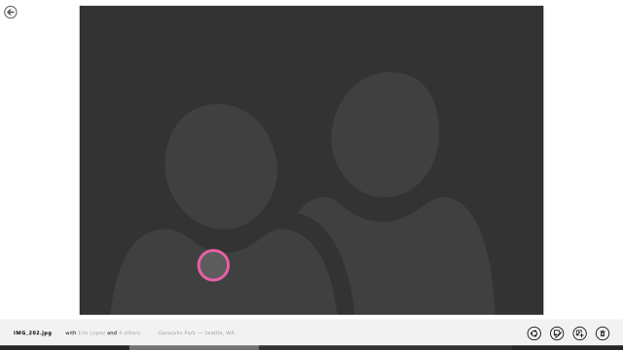
Phone:
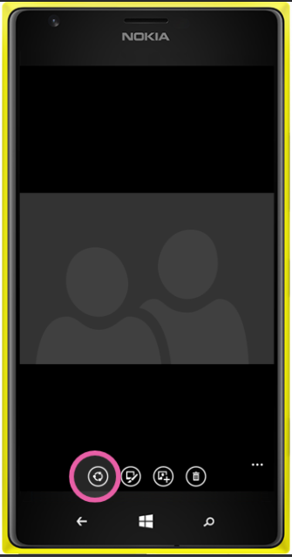
UI feature | Description | PC Shortcut | PM string | Proposed string | Final string
Button | Button available on the viewer app bar that when clicked initiates the share flow.  For M1 on viewer,  Phone-left most button on app bar.  PC- left of edit button on app bar. | needed | Share

List Views
Selection mode
When user presses select button, they get into selection mode. One of the actions users can take in selection mode is sharing the selected set of content.
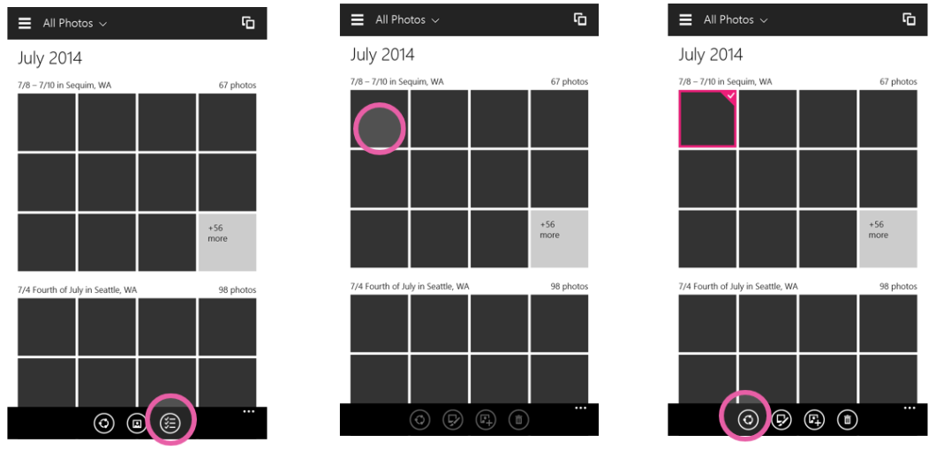
On any list view
<need design>
Flow tbd
UI feature | Description | PC Shortcut | PM string | Proposed string | Final string
Button | Share button available on any list view in selection mode that when clicked initiates the share flow.  For M1,  Phone- share button is left most on app bar  PC- Share button is left of edit button on app bar | needed | Share
Button | Button available on any list view that when clicked initiates the share flow.  For M1.1.1,  Phone&PC- share button on app bar is right of select button and left of delete button | needed | Share

Press and hold
Press and hold content
When user presses over a photo/video and holds, a context menu drops down with share as a menu item. User can quickly share the content using the share menu item.
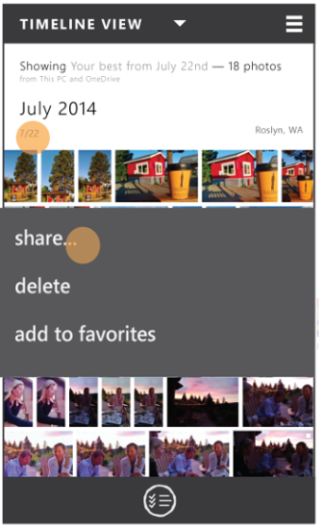
Press and hold headers
When user presses over a heading (like a date or month) and holds, a context menu drops down with share as a menu item. All the content under the heading is selected and can be shared by using the share menu item.
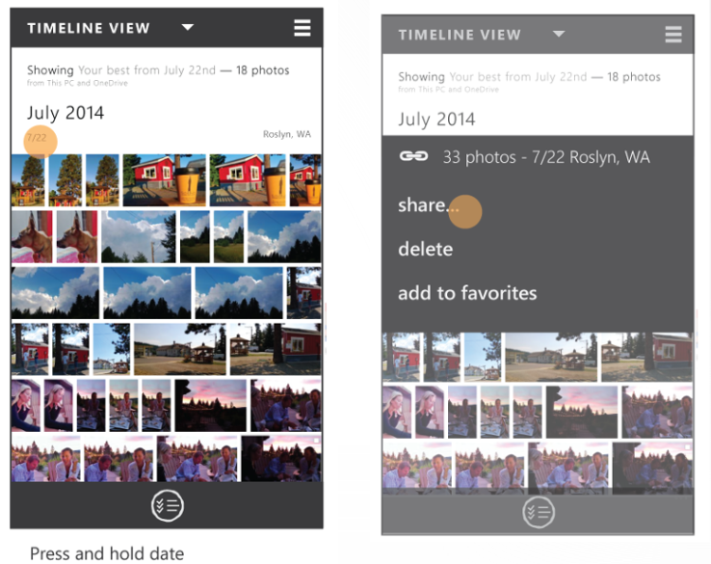

UI feature | Description | PC Shortcut | PM string | Proposed string | Final string
Context menu item | Share action is available as a context menu item  For M1,  Phone and pc- share is top most item on list | Not needed | Share…

Share as link
User’s explicit choice to share using a link
For users that start seeing the benefit of sharing content as link (in scenarios where it is promoted) and for users who are regular OneDrive users or understand the benefits of cloud hosted content, we need to provide an explicit entry point for sharing as link.

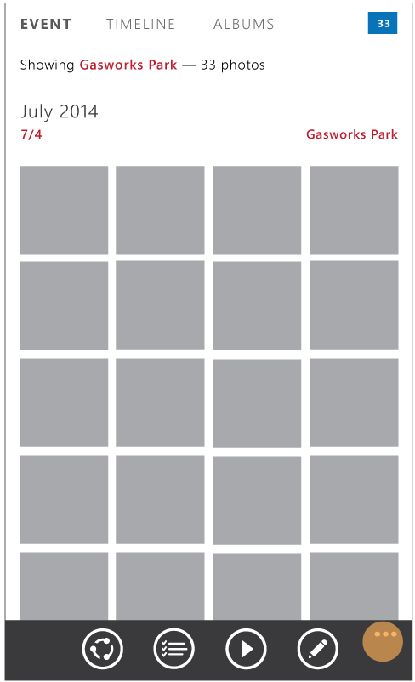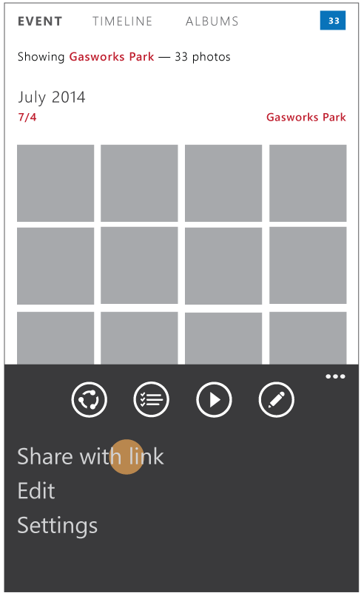

Will be covered in spec review #2
Share as link offered to user by app based on meeting criteria
When certain criteria is met (like one or more files selected is of rich format) then the user is offered the option of link explaining the benefits in their particular scenario.

<insert screen>
UI feature | Description | PC Shortcut | PM string | Proposed string | Final string
Menu item | Menu item in list view page.  Gives user the option of sharing content as link |  | Create a link
Menu item | Menu item in viewer  Gives user the option of sharing content as link |  | Create a link

UX Flows

Share standard content (one photos/video) from viewer
Enables user to share content in view.
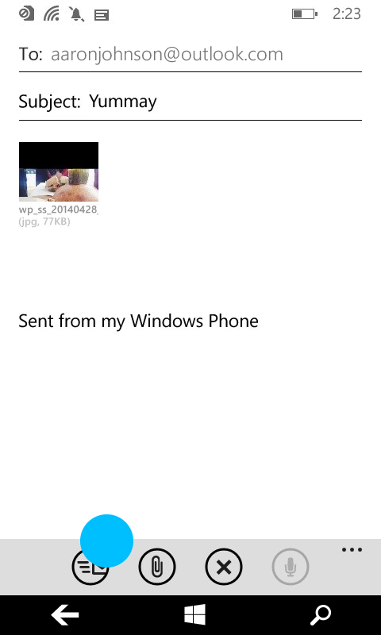
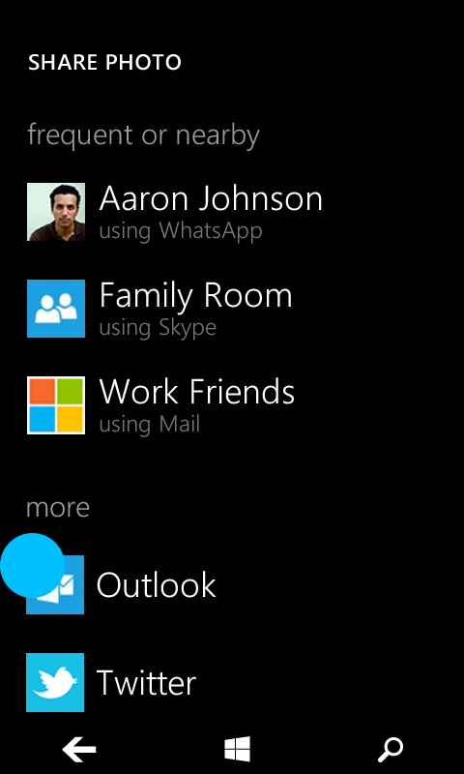
We will also support the (global) share charm entry point (and it’s replacement in threshold) to kick start the share flow.
Compressing video
Compression functionality is handled by the target app and is subject to their logic and data limits. Compression UI (progress) is handled between the share contract and target app. No work needs to be done from the Photos team.
Download content/Preparing content Progress UX
Progress shown to user as content is:
- Getting downloaded from OneDrive
- Creating data package
Standardize phone blue reqs and use for phone and pc in threshold.
<design needed>

Share Rich Media Types from viewer
Sharing Bursts/Stacks
<design needed>
Sharing Nokia Rich Media Types (like cinemagraph, living images etc.)
<design needed>

Share multiple/Event photos and/or videos from any list view
We will enable customers to share content from list views in the following ways:
- Press and hold content
- Press and hold headers
- (selection mode) Select multiple content->(optional)edit selection->->Share
- (selection mode) Select headers->(optional)edit selection->Share
- (share mode) Share->Edit selection -> confirm selection
We will enable users to individually select multiple content (as is supported in blue on phone and pc) and in addition, enable users to select events (and thereby all the content under that event). For example: ‘share all highlights from Tara’s birthday party’ or ‘Share the best of my photos from July’. This does not include sharing albums.

#1: Press and hold content
<need clearer design>
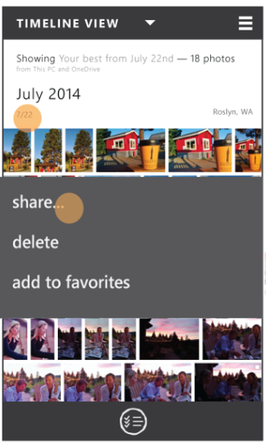

#2: Press and hold header
Users can press and hold any heading available on the list views. This automatically opens a context menu with the option to share all the contents contained under the header.

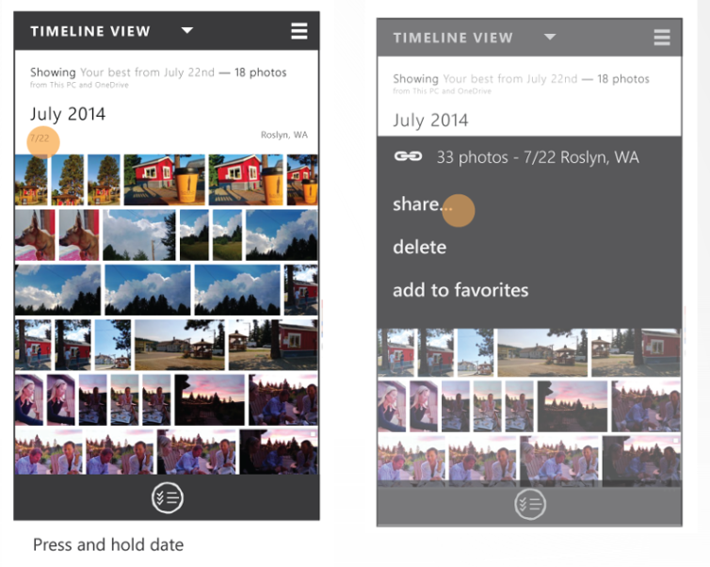

#3: (selection mode) Select multiple content->(optional)edit selection->->Share
From any list view available on the Raconteur app, we will enable customer to enter a selection mode where they can select multiple photos and videos through the selection picker. PC should have parity w/ functionality available from selection picker available in phone blue.
‘Selection picker’ button should be available to users from any list view.
One user starts selecting content, ‘share’ button should be clearly visible to users. Once share button is pressed, there will not be any verification of content selected.
The selection commanding should include the ability to select a combination of photos and videos to share. This has been a limitation in the past.
Phone:
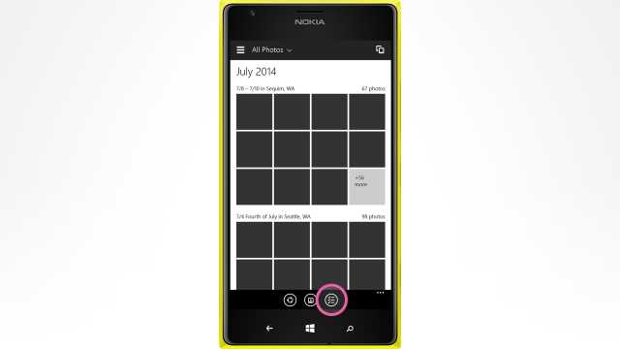
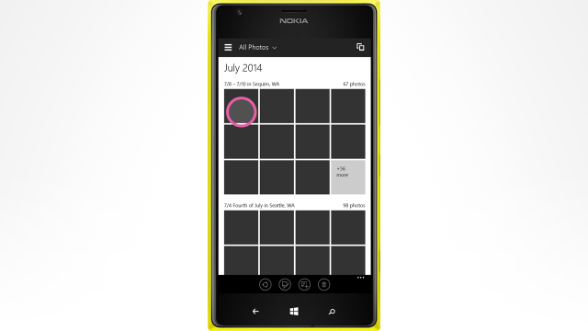
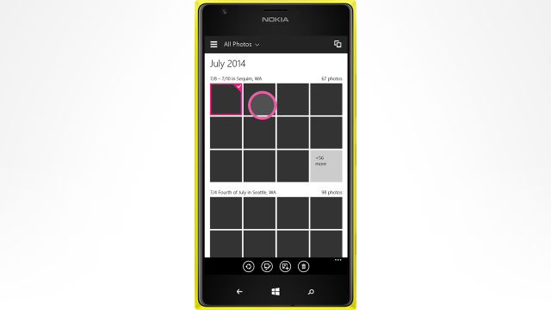
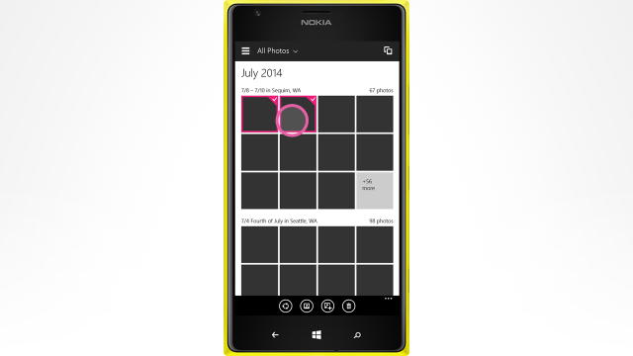
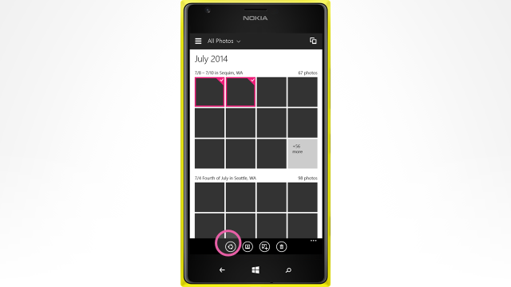

#4: (selection mode) Select headers->(optional)edit selection->Share
From any list view available on the Raconteur app:
- Selection button should be available to users from any list view.
- We will enable customer to enter a selection mode where they can select multiple photos and videos and any header through the selection picker. User can select multiple headings. For example from timeline view, user can select ‘July 2014’ heading or ‘7/22’ heading.
- All headers have an affordance for selecting. Users can visually understand that they can select headers.
- Once user starts selecting content, ‘share’ button should be clearly visible to users.
- Once share button is pressed, there will not be any verification of content selected.
<Insert screenshot>
The below is a rough idea.
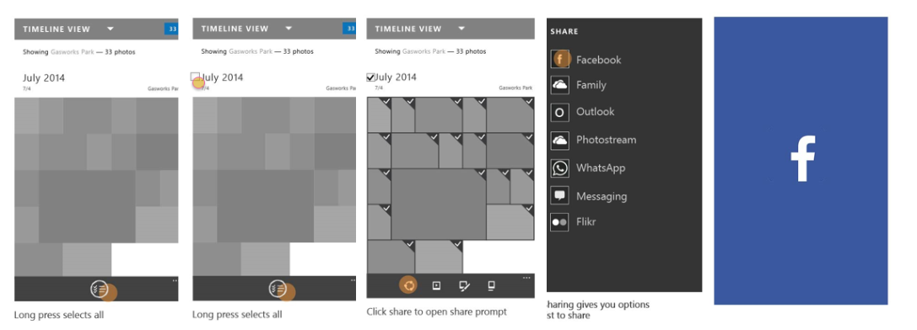
#5: (share mode) Share->Edit selection -> confirm selection
From any list view available on the photos app, share entry point should be clearly visible and available on canvas for user selection. Since both the selection mode entry point and the share entry point are going to be visible on the screen, we need to provide some differentiator between the two, so as to provide value add to customer.
PC/tablet:
User is viewing content in list. Share entry point is clearly visible and user clicks it.
<insert screenshot>
All content under headers fully visible on screen is pre-selected and it becomes clear to users what is already pre-selected and that they can edit the selection. User can then view the selection and makes edits as needed.
<Insert screenshot>
User can edit the selection including unselecting headers that were auto-selected. User confirms the selection and is then entered into the share flow.
<Insert screenshot>]

UI feature | Description | PC Shortcut | PM string | Proposed string | Final string
Button | Button available on any list view that when clicked initiates the share flow.  For M1.1.1,  Phone&PC- share button on app bar is right of select button and left of delete button | needed | Share
Button | Enables selection mode from any list view where user can select multiple items (photos and videos)  *Note: Not in scope for this spec. Detailed in Rich Views spec. | needed | Select

Need screens for this.
What is going to be pre-selected by default?
App bar changes, next step (clear selection, continue to next step, cancel?)

Share Flow Overview
In M1, we will enable users to share any content in two ways:
- Share as file- the physical files to be uploaded onto target app. We assume most users want to upload files to target apps and we do not want to disrupt this flow.
- Share as OneDrive link – Share a link to a location on OneDrive where all the content is available. We want to promote sharing as link to users where there is a payoff from doing so (Example: sharing special file types as OneDrive link that can be rendered with richness on any device).

User expectations/guidelines for share flow
- Promote share as link where it makes sense and adds value to user.
- Seamless experience – users don’t need to worry whether the content lives in the cloud or locally or 3rd party service. We need to handle mixed source content gracefully.
- Don’t made it harder to share as file – While we want to provide users the added benefits that come with sharing as link, we don’t want to make it harder to share as file to the apps and people they are used to. Only alter flow when there is clear value prop to user.
- Fast and responsive - Avoid having users experience large wait times while system is processing actions. This might include setting size restrictions during upload or download processes
- Users have control over what they share and how they do so

Share flow – All up

Share as File

Sharing standard format local content as files
Size
Share actual size of content. Target app can perform size alteration and compression as needed.
Packaging Mechanism for Local files
On par with what we have for phone and pc today, that is, creating a data package of locally backed storage file(/s).

Sharing standard format OneDrive content as files
Download
In the case where content lives in the cloud and needs to be shared via the photos app on any device as files, the content needs to be downloaded from cloud to local device in order to share those contents as files to target apps. We will download the full size content from OneDrive.
Size
Share actual size of image.
Packaging Mechanism for OneDrive files
Share target to receive full size content from photos app as storage files.
UX- downloading content
Since OneDrive content displayed on apps needs to be downloaded to share contents as file, we need to show the progress of the download to users.
<Design needed- for viewer and list view>
UI feature | Description | PC Shortcut | PM string | Proposed string | Final string
Indeterminate progress bar | Shows progress of downloading content from cloud when sharing files from viewer. Overlay over viewer page where you can still see content in viewer in the background. |  | Loading content
Indeterminate progress bar | Shows progress of downloading content from cloud when sharing files from any list view. Overlay over list view page where you can still see listed and selected content in background. |  | Loading content

Sharing rich format local content as files
When users capture rich media types (RMTs) on their windows devices, we want to enable sharing those content. One way to preserve the “richness” of those formats is to share the content as a OneDrive link (where OneDrive will support rendering this rich types with full control and interaction experience comparable to what is available via photos app viewer). Sharing links may work for some users, but we also need to provide support for those who want to send files instead.
Sending rich file formats in their original form limits viewing these types on other platforms. For example- Microsoft’s .pano file type cannot be rendered on iOS and android platforms. Since senders shouldn’t need to worry about the recipient’s device platform, we need to compress these rich types in standard formats (jpegs/mp4s) that can be handled on any platform.
All supported rich formats listed here: Sharing and Storing Rich Media Spec.
John McElmurray is the PM for rich media and has more rich media types details in the above listed spec.
Format conversion
The rich media team will provide an API query to return the standard format files of appropriate size (for sharing) for one or more selected RMTs
The table below lists the final file type that is shared to the share target, when sharing as file.
Rich Type being shared | What is finally shared | File type | Notes
Analyzed Rich Types
Stack/Soft Duplicates | Hero photo | jpeg
Bursts, photo loops
Microsoft Types
Explicit Bursts | Hero photo | jpeg
Cubemap pano | Flatted pano | jpeg
Nokia Types
Bursts/smart sequences | Final product of chosen smart sequence type | jpeg
2d pano from nokia app
Refocus | Final focus choice | jpeg
Reframe | Final frame choice | jpeg
Living moments | Image  (Potentially video?) | jpeg | The image is highest priority (since it was taken in Photo mode) but I can see scenarios for wanting to share the video frames as well
Cinemapgraph | Looping video | GIF or MP4 | GIF, MP4, or JPG are all valid representations (in order of most accurate representation)
parallax | snapshot of the current viewing angle | jpeg | There are several valid representations – GIF or video showing the parallaxing effect, a JPG of the shot taken, or a snapshot of the current viewing angle
selfie | Finally touched up image | jpeg
Nokia rich capture/dynamic mode | HDR or Flash/noflash image | jpeg

Size
Share actual size of standard format file.

Sharing rich format OneDrive content as files
Download
In the case where RMT lives in the cloud and needs to be shared via the photos app on any device as files, the standard format file needs to be downloaded from cloud to local device in order to share those contents as files to target apps.
Format conversion
The rich media+OneDrive team will provide an API query to return the standard format files of appropriate size (for sharing) for one or more selected RMTs in the Cloud
Dependency on which team?
Size
Share actual size of standard format file.
Packaging Mechanism for OneDrive files
Share target to receive full size content from photos app as storage files.
UX- downloading content
Same as in section 9.4.2

Data Package for ‘share as file’
Support in Blue
- PC: Data package work was performed by OneDrive team in Blue.
  - For details: See section 9.1 on Photo and Video Viewer – Functional spec for 8.1 and SkyDrive app sharing spec for 8.1
- Phone: In Blue nothing other than the photo binary was sent
Support in Threshold
List of all possible data package properties: http://msdn.microsoft.com/en-us/library/windows/apps/windows.applicationmodel.datatransfer.datapackagepropertyset.aspx
System provided properties listed here: http://portals/wpblue/blue/specstore/Blue%20Specs/Share%20Contract%20Phone%20Roadshow.pptx
Data package properties to be sent through the share contract:
Data package property | Description | Required? | Support
ApplicationListingUri | Gets or sets the Uniform Resource Identifier (URI) of the app's location in the Windows Store |  | Provided by system
ApplicationName | Gets or sets the name of the app that created the DataPackage object | Yes | Provided by system
ContentSourceApplicationLink | Gets or sets the application link to the content from the source app. It is a companion property that you use to attribute shared content. |  | Provided by raconteur app
Description (Body) | Gets or sets text that describes the contents of the DataPackage  String, e.g. “File from the Mail app” |  | Provided by raconteur app.  Text in tables below.
FileTypes | Specifies a vector object that contains the types of files stored in the DataPackage object. | Yes | Raconteur app provides file extensions of file(/s) being shared
Square30x30Logo | Gets or sets the source app's logo |  | Provided by raconteur app
Thumbnail | Gets or sets a thumbnail image for the DataPackage. | Yes | Raconteur app provides:  - A thumbnail of the item in the Viewer  - Thumbnails of items in list view
Title (Subject) | Gets or sets the text that displays as a title for the contents of the DataPackage object.  String, e.g. “1 photo” | Yes | Provided by raconteur app.  Text in tables below.
Specific Requirements:
Data package property | PM text |  | UA approved text | Comments | Final
Sharing 1 photo from viewer
Content | n/a | n/a |  | Single photo as storage file | n/a
Title | Photo from <location> taken on <date/date range> |  |  | Metadata about location/date in photo
Description | Shared from <host app name> app  Link to download app from store for device |  |  | String to indicate the file and host app that is sharing it  Link to download app from store for device
Sharing 1 photo from viewer
Content | n/a | n/a |  | Single video as storage file | n/a
Title | Video from <location> taken on <date/date range> |  |  | Add location/date metadata
Description | Shared from <host app name> app  Link to download app from store for device |  |  | String to indicate the file and host app that is sharing it
1 Rich Media Type from viewer
Content | n/a | n/a |  | Single photo/video as a storage file.  *conversion from RMT to standard type detailed in sections 9.4.2 and 9.4.3 | n/a
Title | <Rich media type name> from <location> taken on <date/date range> |  |  | Add location/date metadata
Description | Shared from <host app name> app  Link to download app from store for device |  |  | String to indicate the file and host app that is sharing it
Multiple photos and videos from list view
Content | n/a | n/a |  | Each item as storage file | n/a
Title | Photos from <location> taken on <date/date range>  OR  Videos from <location> taken on <date/date range>  OR  Photos and videos from <location> taken on <date/date range> |  |  | Add location/date metadata
Description | Shared from <host app name> app  Link to download app from store for device |  |  | String to indicate the file and host app that is sharing it

Error Handling
UX

<Design needed- for viewer and list view>
UI feature | Description | PC Shortcut | PM string | Proposed string | Final string
Toast | Display toast on viewer screen. |  | <based on which error occurs. Strings detailed below.>
Toast | Display toast on list view screen with selected content persisted. |  | <based on which error occurs. Strings detailed below.>
Error List
Continue what was supported in blue on pc: section 9.1.2 on spec
The Share platform allows source apps to provide a custom string to the Share flyout. The error cases and the corresponding custom strings are detailed below.

In these error cases, the Viewer/list view should opt-out of Share and provide the appropriate message as part of the data package.
New list:
Scenario | PM text | UA approved text | Comments | Final
File not present | This photo or video has been moved or deleted. |  | Error message shown when a file has been moved or deleted and the user tries to share it
Share invoked from share charm entry point | This action has been disabled. Please use the share button in the app instead. |  | Since the share charm is going away in Threshold, we are not going to do any work to plumb it. Therefore we will throw an error asking users to use the in-app share entry point
Cannot share due to no internet connection |  |  | If there is no internet, we cannot complete the share action.  Phone blue: Allows users to complete share flow, but share task is queued and will be sent when user connects to internet.
Cannot download OneDrive content to share due to lack of internet connection | Cannot get <content type> from Cloud. Please check your internet connection and try again. |  | Cannot download OneDrive content to share due to lack of internet connection  - Connection lost  - Airplane mode
Unable to download content from OneDrive due to invalid/incorrect/out-of-date credentials | Incorreect credentials. Please |  | Thumbnail exists in app but the password has expired or the account has been deleted/suspended making the contents in the cloud no longer accessible.
OneDrive is down |  |  | Cannot connect to OneDrive since OneDrive is down.
 |  |  | User is on battery saver mode
Error in generating standard format from rich format |  |  | File conversion from rich format to standard format failed.

Old list:
Scenario | PM text | UA approved text | Comments | Final
File not present | This photo or video has been moved or deleted. Select something else and try again. | This photo or video has been moved or deleted. | Error message shown when a file has been moved or deleted and the user tries to share it | Yes  Updated 12.6.12
User is in live camera feed mode |  | Take a photo or video, and then share it. | Error message shown when the user is looking at the live camera feed in the Camera app and invokes Share | Yes
User is looking at an unstitched panorama or is in the process of stitching the panorama |  | Your panorama isn’t quite ready yet. Stitch this panorama, and then share it. | Error message shown when the user tries to share an unstitched panorama | Yes
General error case |  | Restart the app, and then try to share. | Error message shown in general cases where we’re not sure what happened | Yes
User is in Edit mode  Note: this is for M1 only. This error message will be removed in MP when Tweak enables Share while editing. |  | Your file has unsaved changes. Save your changes, and then share it. | Error message shown when user is in Edit mode and invokes Share. This string will be removed in MP. | Yes
Error in generating standard format from rich format

Share as OneDrive Link
Given that all content will be backed in the cloud, we should enable users to take advantage of this and share content as links where it makes sense to users and has a clear value prop to them.

Criteria for offering OneDrive links
We will only offer OneDrive link as an option to users where there is a clear value prop for them. Users will have the ability to take our offer, or to decline it (share as file attachments) based on their needs. We will not always offer them that choice since that adds additional steps to all existing workflows, and doesn’t offer clear value in most cases.
In M1, if the following criteria are met, user will be offered a choice of link or attach:
# | Criteria | Requirement
1 | User has an MSA Account | Has to always be met. We will only offer links to user who already have an MSA account that the photos app is aware of.
2 | If any of the selected content is of RMT (cinemagraph etc.). List of all possible RMTs listed here Sharing and Storing Rich Media Spec. | In addition to criteria #1.

UX- Offering links for RMT
Think about explaining permissioning to users when links are offered
When criteria is met, the user is offered the option of sharing the selected content as OneDrive links or as files, explaining the benefit of sharing as OneDrive link in that scenario. The user is then forced to make an explicit choice to move to the next step in the share flow.
[Viewer] Imagine the below is a cinemagraph:
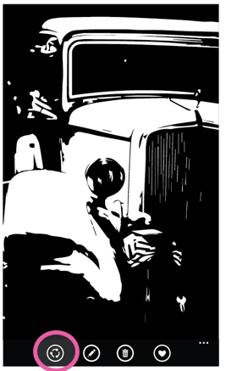 when user clicks share button -> 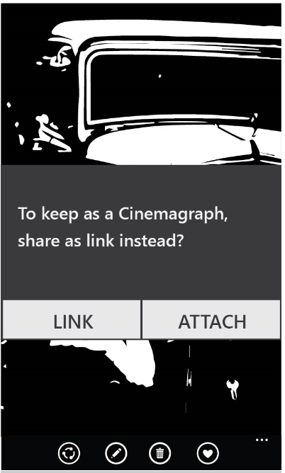
UI feature | Description | PC Shortcut | PM string | Proposed string | Final string
Modal Dialog | Explain to the user the benefit of sharing as link. User has to make an explicit choice. |  | To keep as a <rich type>, share as link instead?
Button on Modal Dialog | Share as OneDrive link.  This is the default button. Where possible highlight this option with different coloring as seen here: http://msdn.microsoft.com/en-us/library/windows/apps/xaml/hh738363.aspx |  | Link
Button on modal dialog | Share as file attachment |  | Attach

[List View]
User may have selected one or more rich types, in addition to one or more standard types from list view to share. Selecting one or more rich types meets the criteria to offer links.
<Design needed>
UI feature | Description | PC Shortcut | PM string | Proposed string | Final string
Modal Dialog | Explain to the user the benefit of sharing as link. User has to make an explicit choice. |  | To keep as a <rich type>, share everything as a link instead?
Button on Modal Dialog | Share as OneDrive link |  | Link
Button on modal dialog | Share as file attachment |  | Attach

Explicit Share as link entry point
Once users start getting used to being offered links (when selected content meets criteria) or users familiar with cloud sharing, we need to enable users who choose to share content as links instead of as files.
<need design for list view and viewer>
UI feature | Description | PC Shortcut | PM string | Proposed string | Final string
Menu item | Gives user the option of sharing content as link |  | Share link to content

Share link to content already in OneDrive
User selects content that lives in the cloud already, and chooses to share that content as an OneDrive link.
Getting a link
When the user selects one or more files from list view or viewer and chooses to share link to content, the system gets back a single link from OneDrive that contains a pointer to all the selected content, and hands that link to the share contract. This can be achieved through OneDrive by creating bundles and getting links to bundles that will the surfaced to recipients as virtual folders.
Use OneDrive SetPermissions API to generate links using the following properties:
- Type=link
- Link type=View Only
Maximum number of items
OneDrive APIs currently do not support bundling of more than 100 items in a single link. To respect this limit, we must handle the error gracefully.
UX- getting link progress
It might take some time to get a OneDrive link to all content selected, and therefore we need to show some progress UX.
<design needed for list view and viewer>
UI feature | Description | PC Shortcut | PM string | Proposed string | Final string
Indeterminate progress bar | Shows progress of getting a link from OneDrive. Overlay over viewer page where you can still see content in viewer in the background. | n/a | Getting link
Indeterminate progress bar | Shows progress of getting a link from OneDrive. Overlay over list view page where you can still see selected content in list view in the background. |  | Getting link

Viewing the shared link
The recipient(/s) on clicking the link would be taken to a list view that displays all the shared content.
Senders can later on view content they have shared through OneDrive web share page or through Raconteur app’s shared content page. In order to have parity with current experience, bundles are created for each share event.
In this scenario folders should be named by default:
Scenario | PM text |  | UA approved text | Comments | Final
Sharing 1 photo/video/RMT from viewer | Shared <file type> on <date>
Sharing 1 or multiple photo/video/RMT from list view  Only one type shared | Shared <file type>s on <date>
Sharing 1 or multiple photo/video/RMT from list view  Multiple types shared | Shared items on <date>

Link configurations and permissioning
- View only, can’t edit
- Doesn’t need to have OneDrive account to view (no sign in or sign up needed)
- Link can be further shared to any number of people, who can access it without restrictions
- Content only hosted on sender’s OneDrive. Not hosted on recipient’s OneDrive.
- Max number of distinct viewers?
- If sender deletes OneDrive content, recipients can no longer view the content
- If sender deletes their OneDrive account, recipients can no longer view the content

Share link to Local and/or OneDrive standard format content
User selects content, some of which live in cloud already and some of which live on local device (yet to get to cloud), and want to share their entire selection as OneDrive link.
On demand Uploading of local content to OneDrive
When users selects content that lives locally on device but is to be shared as an OneDrive link to the target apps, we need to upload the local content onto OneDrive.
If only local content was selected, then upload all local content to OneDrive and get a single OneDrive link that points to the entire set.
If mixed source content was selected (some local, some cloud), the upload the local content onto OneDrive and get a link to entire set link that represents both the content that already existed in OneDrive and the newly uploaded content
Upload location is the same as the location as where the content would be later backed up.
Upload size
Upload as much as needed to render a “good enough” view. 1600px?
If users selects multiple photos or videos that live on local device to upload to OneDrive, uploading the full resolution version of these files could take a really long time and forces the users to wait while this process occurs in order to move on to the next step of the share flow. In order to mitigate this, we should upload a max of 1600 pixels (display is good enough on most devices) during the on-demand upload process.
This on-demand upload needs to be compliant with the sync solution. It should not create two copies of the content in the cloud.
If we upload low res during on-demand upload and hi-res during sync process (mostly likely when user is connected to wifi) then we should ensure that the content referenced in the link is automatically and appropriately updated to point to the hi-res version without creating any duplication of content.
Open for investigation: on-demand upload compliant with sync solution

UX- Uploading content
Since OneDrive upload could take a significant amount of time, we need to show users upload progress.
<Insert screenshot>
Viewer:
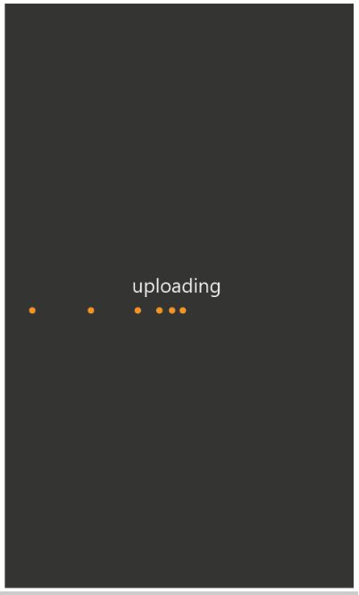
List View:
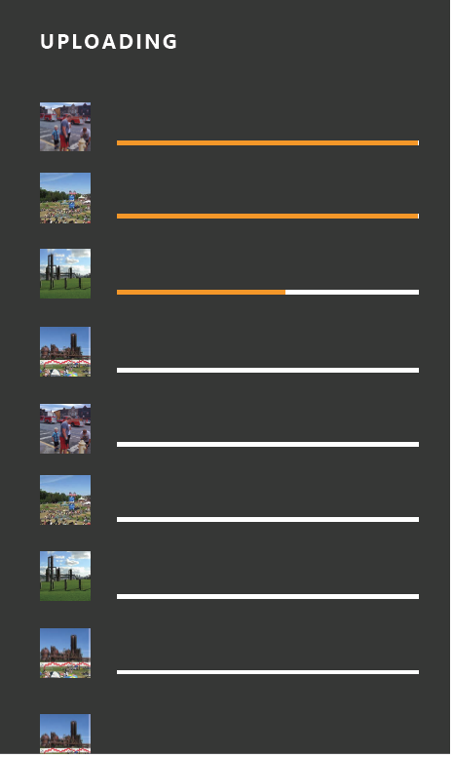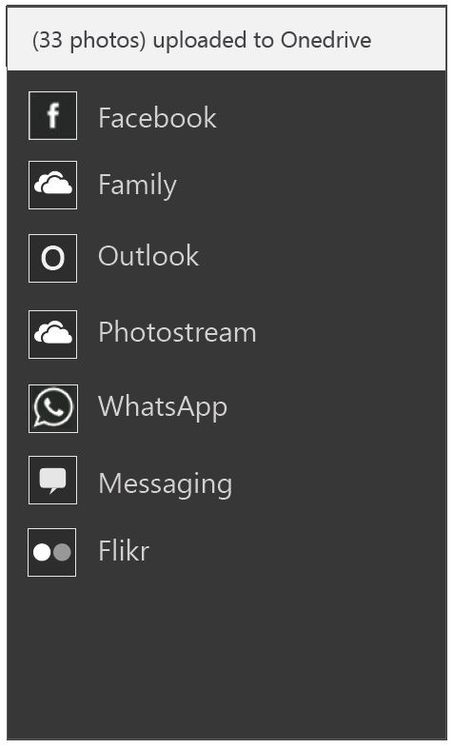
UI feature | Description | PC Shortcut | PM string | Proposed string | Final string
Page | Shows progress of uploads. Shows visual representation of each item being uploaded, progress of the uploads and enables user interaction (like cancel) |  | Upload progress page
Indeterminate progress bar | Shows progress of getting a uploading content to OneDrive. Overlay over viewer page where you can still see content in viewer in the background. |  | Uploading…
toast | Shows when the uploaded content is complete. For example ’33 photos uploaded to OneDrive’

Getting a link
The OneDrive link needs to reflect the entire set of selected content, irrespective of its source.
UX- getting link progress
It might take some time to get a OneDrive link to all content selected, and therefore we need to show some progress UX.
<design needed for list view and viewer>
UI feature | Description | PC Shortcut | PM string | Proposed string | Final string
Indeterminate progress bar | Shows progress of getting a link from OneDrive. Overlay over viewer page where you can still see content in viewer in the background. | n/a | Getting link
Indeterminate progress bar | Shows progress of getting a link from OneDrive. Overlay over upload progress page where you can still see selected content in list view in the background. | n/a | Getting link

Viewing shared link
A consumer clicking this link, would be able to seamlessly view all the selected content.

Share link to local and/Or OneDrive RMT content
Same as above

Deep App links
full section is TBD.
Generated link is a deep link to:
- Raconteur app
- If raconteur app does not exist, OneDrive app
- Else, OneDrive web
On pc, OneDrive web experience is probably better than or equal to app experience
Let OneDrive decide between showing OneDrive app or OneDrive web

On the receiving side, if the user has the racounteur app, the link should open in Racounteur.
If user has not downloaded racounter,
- Prompt user to download the app
- If racounter app does not exist on the platform, then open content in OneDrive app.
If user has not downloaded OneDrive app,
- Prompt user to download the app
- If racounter app does not exist on the platform, then open content in OneDrive web.

The link has the following link configurations:
- Providing links is a stripped down version of “shared albums” or “shared folders”
- Assume view only permissions for recipients with link.
- Neither sender nor recipient can edit (add/delete) content to the virtual folder once the link is created
  - More advanced sharing with ability to manage albums will come in the future
- Link will not be surfaced and available to sender once the share flow is complete
  - Sender will not be able to find all the links they have shared (unless they have manually saved the link after each share)
- Recipient with link can always access the contents. Shared link persists for the life of the send (or as long as the sender has an active OneDrive account)
- If user renames or deletes pictures that are referenced via a link (to a OneDrive virtual folder), we will follow OneDrive policies on this. That is,
  - Renamed pictures will still be accessible
  - Deleted pictures will no longer be accessible.
Open issue: need to verify the OneDrive policies on renaming/deleting content referenced in virtual folders

Data Package for ‘share as link’
Data package properties to be sent through the share contract:
Data package property | Description | Required? | Support
ApplicationListingUri | Gets or sets the Uniform Resource Identifier (URI) of the app's location in the Windows Store |  | Provided by system
ApplicationName | Gets or sets the name of the app that created the DataPackage object | Yes | Provided by system
ContentSourceApplicationLink | Gets or sets the application link to the content from the source app. It is a companion property that you use to attribute shared content. |  | Provided by raconteur app
Description (Body) | Gets or sets text that describes the contents of the DataPackage  String, e.g. “File from the Mail app” |  | Provided by raconteur app.  Text in tables below.
FileTypes | Specifies a vector object that contains the types of files stored in the DataPackage object. | Yes | Raconteur app provides file extensions of file(/s) being shared
Square30x30Logo | Gets or sets the source app's logo |  | Provided by raconteur app
Thumbnail | Gets or sets a thumbnail image for the DataPackage. | Yes | Raconteur app provides:  - A thumbnail of the item in the Viewer  - Thumbnails of items in list view
Title (Subject) | Gets or sets the text that displays as a title for the contents of the DataPackage object.  String, e.g. “1 photo” | Yes | Provided by raconteur app.  Text in tables below.

Specific Requirements:
Data package property | PM text |  | UA approved text | Comments | Final
Sharing 1 photo/video/RMT from viewer
Content | n/a | n/a |  | Single URI to file | n/a
Title | Photo from <location> taken on <date/date range> |  |  | Metadata about location/date in photo
Description | Shared from <host app name> app  Link to download app from store for device |  |  | String to indicate the file and host app that is sharing it  Link to download app from store for device
Sharing 1 photo from viewer
Content | n/a | n/a |  | Single URI to file | n/a
Title | Video from <location> taken on <date/date range> |  |  | Add location/date metadata
Description | Shared from <host app name> app  Link to download app from store for device |  |  | String to indicate the file and host app that is sharing it
1 Rich Media Type from viewer
Content | n/a | n/a |  | Single URI to file | n/a
Title | <Rich media type name> from <location> taken on <date/date range> |  |  | Add location/date metadata
Description | Shared from <host app name> app  Link to download app from store for device |  |  | String to indicate the file and host app that is sharing it
Multiple photos/videos/RMTs from list view
Content | n/a | n/a |  | Single URI to bundle | n/a
Title | Photos from <location> taken on <date/date range>  OR  Videos from <location> taken on <date/date range>  OR  Photos and videos from <location> taken on <date/date range> |  |  | Add location/date metadata
Description | Shared from <host app name> app  Link to download app from store for device |  |  | String to indicate the file and host app that is sharing it

Error Handling
UX
Same as section 9.4.6
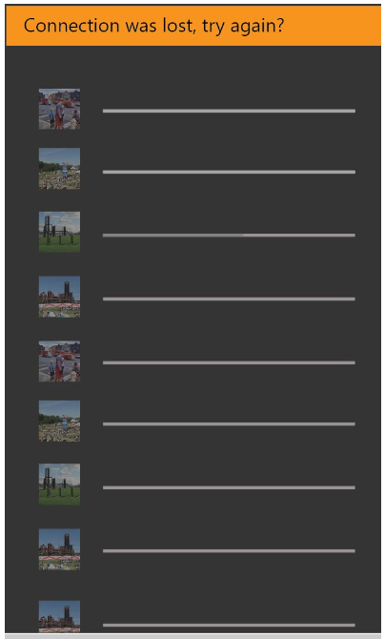
<Design needed- for viewer and list view>
UI feature | Description | PC Shortcut | PM string | Proposed string | Final string
Toast | Display toast on viewer screen. |  | <based on which error occurs. Strings detailed below>
Toast | Display toast on list view screen with selected content persisted. |  | <based on which error occurs. Strings detailed below.>
Toast | Display toast on upload progress page. |  | <based on which error occurs. Strings detailed below.>

List of errors
Scenario | PM text | UA approved text | Comments | Final
Can’t connect to cloud | Can’t connect to cloud at this time. Please try sharing again at a later time. |  | Cannot establish connect with cloud at all.
Connection lost while uploading content to OneDrive | Connection was lost. Check your internet connection and try again. |  | Connection lost while uploading content to OneDrive
Upload failed | Uploading to cloud failed. Check your internet connection and try again. |  | Upload failed for some reason.
User selected more than 100 files to share as link |  |  | OneDrive APIs currently do not support bundling of more than 100 items in a single link.

Share rich file formats

Rich Media Types (current and as prototypes)
Complete list:
- Microsoft
  - Cubemap panoramas (Photosynth on windows 8.1)
  - Bursts (windows phone 8.1)
  - Photo loops (windows 8.1)
- Nokia
  - .NAR burts/smart sequences
  - 2D panorama
  - Refocus
  - Reframe (digital negative)
  - Living moments/images
  - Cinemagraph
  - Parallax
  - selfie
Supported in M1:
- Explicit Bursts/smart sequences
- Soft duplicates (implicit bursts)
- Panoramas (Nokia)
- Panorama (Microsoft)
During M1, we want to enable sharing of rich formats unique to platforms we own, to be able to be seamlessly shared and consumed on non-windows devices.
Post M1, we will target support for more rich formats listed above.

Share as File (Standard format)
Share flow
When we detect that the user is sharing a special file type(s), we offer them the option of sharing as link to preserve richness of the file type and support rich rendering of the file. If the user chooses to forgoe share as link, then we share the content as files of standard formats (jpegs, mp4s).
Packaging content
Priority | Rich file format | Shared format
1 | Explicit burst | Share cover photo, jpeg
1 | Implicit burst (soft duplicates) | Share cover photo, jpeg
2 | panorama | jpeg
3 | cinemagraph | Video, mp4

Shaun: Sharing a pano should result in a nice experience for all recipients, regardless of their target OS, with a possibly upgraded experience for Windows users.
I don’t know how to have an upgraded experience here – we will need to think about that.

could share pano as pano, jpeg and let the target apps choose which format. Assume most wont support pano anyway.

Sharing rich file format in all their glory

Share Flow
This happens when user chooses to ‘share as link’ or “quick share”. By promoting “share as link” in general, we also dually achieve the purpose of promoting users to share their rich formats as links to recipients.
Packaging Content
- Upload image+backing data to OneDrive (if local content)
- Generating link to uploaded content
- Share OneDrive link to recipient(/s) per customer request
- Recipient can view linked content in full richness

Share Targets
Scope under review for M1

Phone and PC on par with share target support.

i.e. Any target app that has implemented the share extensions and is registered with the share contract to receive photos and/or videos, and is downloaded on the user’s device should be surfaced as share target options during classic share flow.
Pm work: need to get top tier share targets to register to receive links from OneDrive on both PC and phone.
Support sharing to top 2-4 target apps (for photo and video content) in the following categories:
- Social: Facebook, Instagram, Twitter
- Messaging: Whatsapp, Snapchat, Text/SMS
- Email: Outlook, Hotmail, Gmail
- For video: Youtube
Do we want to support Bluetooth for M1?
Need to add market based top tier share targets.
Share Target Issues
*Assume app is already installed on user’s device.
Share Target/Scenario support in Blue | Share 1 photo (as file) |  | Share 1 video (as file) |  | Share multiple photos and videos (includes bulk selection) (as file) |  | Share as Link
 | PC | Phone | PC | Phone | PC | Phone | PC | Phone
Facebook
Instagram
Twitter
Whatsapp
Snapchat
Text/SMS
Outlook
Hotmail
Gmail
Youtube

Error conditions
We will make the flow easier in case of failures. If failure (such as: video too large to compress) occurs in the target app, user would be brought back (or be easily able to navigate back) to content that was selected in the view that is was selected in. Content that was selected in the view that is was selected in persists till successful share flow is complete.

Share Previews/Consumption
Scope under review for M1
Still gathering requirements from top tier share targets to determine data package to create to enable targets to create rich views.
Rich preview when shared as OneDrive link
Recipient on any target app, gets a rich preview of content shared with them. This preview was automatically generated and requires no effort on the sender’s side. Generally the contents should contain:
- Good preview of content shared (all or a subset is shown directly as thumbnails)
- Link to view all (or view in full resolution)
- OneDrive or photos app branding
User’s that receive a OneDrive link should be able to:
- Access content (view only) without logging in or signing up for OneDrive
- Access content while logged in
- Access content from multiple accounts
- share that link with more friends and family, who will also be able to access the content per above requirements
OneDrive will enable rich viewing experiences for special file formats.
Content supporting rich previews
In order to enable rich previews when content is sent from the racounter app, we need to send the following pieces of information:
Priority | Data | Reason | Example
3 | - app icon  - app name | The platform ask would be to pass the app icon and the app name so that the string on Facebook that's called out in the attached images would read "Movie Moments for Windows Phone" | 

M2 Detailed Feature Requirements
<Placeholder for M2 feature requirements>
Things to address:
Download size restrictions
Share actual size of standard format file.
If users selects multiple photos or videos that live on OneDrive, downloading the full resolution version of these files could take a really long time and forces the users to wait while this process occurs in order to move on to the next step of the share flow. In order to mitigate this, we should download a max of 1600 pixels (display is good enough on most devices).

Video trimming
If user selects large # files, then have logic to reduce size
Albums
- 2 entry points: search and select photos and create album, create album and add photos
Shared albums
As detailed previously, the share entry points from the various views available on the photos app, kick start the share flow. Since we are offering users the
Option | Description | Pro | Con
 | Both entry points are provided on the app bar  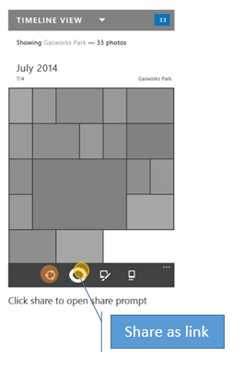 | - ‘share as link’ is highly discoverable | - Users can get confused between the regular share icon and ‘share as link’ icon if they are similar  - Already too many icons on app bar
 | Shows the ‘share as link’ as a menu item  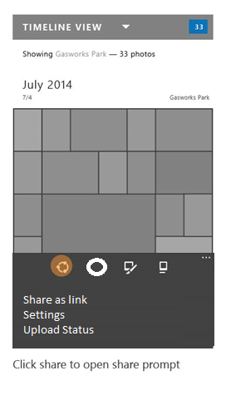 | - Doesn’t distract from regular share flows | - Harder to discover (If flighting suggests that several users use it, then we can consider it a first class citizen)  - What’s the point of enabling it, and then hiding as menu item?
 | Provides some customization on top of the Share picker UI enabling users to toggle between sharing as file or sharing as a link. Always default to ‘attachment’ and enable users to switch to ‘link’.  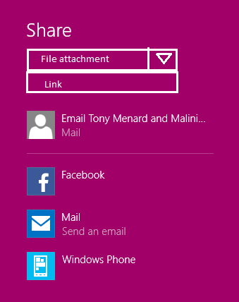 | - Natural part of current share flow  - Doesn’t disrupt regular share as file flows | - Limit discovery of ‘share as link’ option  - What is the phone solution?  - will we need to send content to share contract that enables both options, to make this happen?  - Unclear on how we will enable uploading local content using this entry point  - Dependency on threshold  - extra step
 | Provides some customization on top of the Share picker UI enabling users to toggle between sharing as file or sharing as a link.  Choose the selected option based on content selected. Like if they have selected 50 photos + videos, then suggest sharing as link, where the user has option of toggling to regular file share. | - Promoting share as link wherever we think best  - Prevents potential failures in target apps  - Natural extension of current share flow | - Confusing to users as to why we sometimes recommend file share and sometimes recommend share as link  - Reason for providing recommendation is not explicitly stated to user  - Users may make mistakes if they don’t notice the option we pre-selected for them  - Dependency on threshold
 | Provides some customization on top of the Share picker UI enabling users to toggle between sharing as file or sharing as a link.  Always default to ‘link and enable users to switch to ‘attachment. | - Highly promotes share as link option  - Natural extension of current share flow | - No clear (or communicated) value prop when sharing small amount of content  - Limits target app options potentially  - How does this look like on phone?  - Dependency on threshold
 | Always ask users to make a choice after they choose share entry point  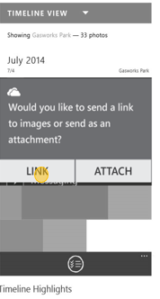  (add copy link to clipboard functionality) | - Promotes share as link  - Opportunity to communicate to user why they should share as link | - Always adding one extra step to share flow.  - Not intuitive to users who don’t know enough or want to make an explicit choice  - Becomes repetitive, perceived as annoying  - Alarming (at least the first few times) to have a dialog like this
 | Only provide form to user if they meet some criteria  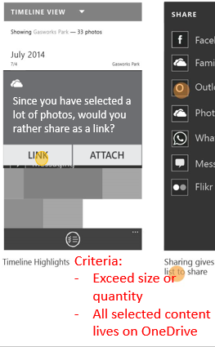  (add copy link to clipboard functionality) | - Promotes sharing as link especially for the scenarios we think that has the most value for  - Clearly explains value prop based on current selection for sharing as link (Example: Looks like you have selected a large amount of photos. Would you rather share as a link?) | - Hard to determine criteria since data limits vary extensively by app  - Seems magical when the option is provided, don’t know how to find the entry point when user selection doesn’t meet our set criteria
 | Regular share entry point that gives used a custom page enabling them to make choices on whether they want to share as file or as link. Page may look something like this:  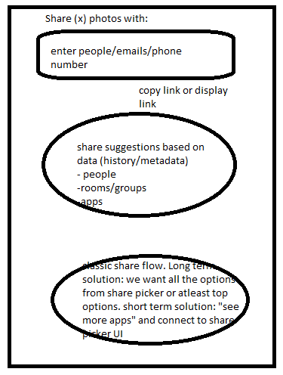 | - Promotes share as link without confusing users  - Provides user ability to share as file to the apps they use  - Flexible for future items like auto-suggestions (people, rooms/groups) and shared albums  - No dependency on Threshold  - Could take a dependency on integrating share targets into this UI | - Doesn’t enable users to share links to apps they are used to. Only file share is enabled for share targets.  - Page could get quite heavy  - For M1, share charm exists and experiences would differ  - In M1, have to go through share charm.
 | Let the target app choose. Photos app to provide both physical files and URL to content and the target app will choose which one they prefer to use. | - Target apps customize for sharing option that best meets their needs  - No extra UI, no user decision to be made | - User may get confused as to why certain apps display links while other have physical files  - User not in control of the choice, dependent on target app to make the right choice (apps have to be updated to add in this logic)  - Many target apps would choose to get physical content (as opposed to file) so chances of sharing as link become slim

These options are still under evaluation and a final decision has not been made. Due to it’s flexibility, chose option #8 for further exploration in section 9.2.2

Custom Share flow
Note: not in scope for M1
The solution detailed below combines the benefits of promoting sharing via OneDrive links as well as giving users the option of the classic share (as file to apps they want).
<insert screenshot>
Top box:
- “quick share” or “Share as OneDrive link”
- Enables user to enter recipients
- User can quickly complete the share flow if all content selected lives on OneDrive
  - Open issue: do we want them to wait around if we need to upload local content to OneDrive
  - Feedback loop and user interaction if upload fails
- This would immediately send the content to recipient(/s)
  - Open issue: is sender the customer or the racounteur service?
  - Ideally: customer’e email
  - How do we balance user completing share flow quickly and all the processing/uploading that needs to happen esp around large sets
- Supports sharing via email as P1
  - Supports texting as P2

[Post M1] Middle circle:
- Top share recommendations based on user’s history, image metadata etc.
- Includes suggestions for people, rooms and groups, target apps
- More details in future specs
Bottom circle:
- “classic share” or “Share as file”
- This portion is to enable users to share via target apps they are used to
- This performs share as file (classic share)
If we cannot incorporate share picker target apps into the custom share page, then we enable users to get to share picker UI from this screen.

Quick Share OR Share as OneDrive Link
New custom way to share content.
Packaging content
The table below details how we will package all the selected content to provide the Share contract an OneDrive link.
Content selected for sharing as OneDrive link | OneDrive link to content exists? | Package content
All OneDrive | Yes | Generate one link to all selected content (that is, one link to all bundled content)
All local | No. Needs to be uploaded. | Need to upload content to OneDrive. Generate one link to all uploaded content
Mixed source – some local, some Onedrive | Some have links, some need to be uploaded | Need to upload local content to OneDrive. Generate one link to all selected (available and uploaded to OneDrive) content

When does the upload happen? Do users need to wait while upload occurs? Feedback loop and user interaction when upload failures occur.
Event to trigger OneDrive backup option to users
- The first time user selects ‘share as link’ we will provide a trigger event to ask the user to backup using OneDrive in case they don’t already.
- If the user continues to not backup using OneDrive, then we can provide the trigger event on some regular cadence to drive users toward OneDrive backup for their photo and video content.

Generated Link

- Do we know which content is on OneDrive?
- For mixed source:
Get bundle ID (for existing OneDrive content)
Upload API (for local content) – maybe at the same time as above(get resource ID)
Add to bundle API (give resource ID)
- No current support for knowing whether the content lives on Onedrive
- Need API support to getting links and upload in the background [CJ]

Classic Share OR Share as File
Regular share flow using share contract and Share picker
Packaging content
When customer choses to share content as physical files (as opposed to link), then we need to provide the right mechanisms for gathering that content based on where the selected content lives:
Content selected for sharing as file | OneDrive link available? | Packaging solution
All OneDrive  *May have thumbnail versions on the local device, but full res lives in OneDrive only. | Yes | Option 1:  Get URI backed storage file for all selected content. Group all storage files and send as one single data package to Share contract.  Option 2:  Download all content to local device  Open issue: device storage implications for low cost devices
All local | No. | Get locally backed storage file for all selected content. Group all storage files and send as one single data package to Share contract.
Mixed source – some local, some OneDrive | Some have links, some don’t. | Option 1:  Get URI backed storage file for all selected content. Get locally backed storage file for all selected content. Group all storage files and send as one single data package to Share contract.  Option 2:  Download all OneDrive content to local device. Get locally backed storage file for all selected content. Group all storage files and send as one single data package to Share contract.  Open issue: device storage implications for low cost devices

Open question: Is URI backed storage file faster and/or cheaper than downloading OneDrive content to local device and then treat it as a local file.
Note: URI backed storage files shipping for Phone in Threshold M1.
How does this affect the apps requirements to have data access? I.e. apps define their capabilities and typically if they do image picker they would not necessarily need network access, but with this they would, correct?

The table below is tbd as we figure out flow.
UI feature | Description | PC Shortcut | PM string | Proposed string | Final string
App icon | Share as link |  | Share as link
Menu item | Share as link |  | Share as link
Page | Page showing the progress of uploading local content to OneDrive. Explains to user that the content doesn’t live on OneDrive already and so we need to Upload before we can share this content as a link. All content selected is shown as thumbnails with progress bars as upload occurs. Allow user to cancel and exit this form at any time. |  | Upload page
toast | Shows when the uploaded content is complete. For example ’33 photos uploaded to OneDrive’ |  | Upload complete toast

Health requirements

Data Consumption

Storage Consumption

Battery

Telemetry & Test in Production
Guidelines

Telemetry

Test in Production

Risks & Open Issues
Guidelines

Risks

Open Issues

Tenet Fundamentals
Guidelines - Click the links under Applicability and Assessment to understand requirements and get help.
 | Tenet Quality Area | Compliance/Quality value explained | Applicability and Assessment
Compliance – all teams | Accessibility | Features and scenarios just work for users with impairments and that leverage assistive technologies | Get Started
Compliance – all teams | Geopolitical | Features and content pose minimal or no legal or business risk in any market | Get Started
Compliance – all teams | Privacy and Safety | Protecting customer data from misuse, and ensuring services and features are safe and secure | Get Started
Compliance – all teams | Protocols | Networking protocols are documented according to Microsoft and regulatory requirements | Get Started
Compliance – all teams | Security and Anti-Fraud | Making Windows experiences the most secure and privacy-protecting OS on the market | Get Started
Tenets - all teams | Compatibility | Apps, devices and sites just work | Get Started
Tenets - all teams | Performance | Responsiveness, storage space, data usage and power satisfy competitive needs | Get Started
Tenets - all teams | Reliability | Devices and scenarios are measurably reliable per competitive needs | Get Started
Tenets - all teams | World-Readiness | Features and scenarios work for and excite customers worldwide per competitive needs | Get Started
Tenets - some teams | Developer Experience | Developers have the APIs, samples, and documentation needed to build great apps | Get Started
Tenets - some teams | Manageability | Cloud OS is enabled via automation and remote management of all applications, features, roles, and services | Get Started
Tenets - some teams | User Experience | UI meets UX guidelines around design and usability | Get Started

DOCUMENT UPDATE HISTORY

Date | Author | Changes
3/18/2014 | MaliniJa | First Draft of one pager
4/25/2014 | MaliniJa | Initial Review of scenarios, goals and non-goals complete
5/16/2014 | MaliniJa | File Share (Standard Format, local content) detailed spec review complete  Sections 5, 9.1, 9.2, 9.4.1 reviewed.
 | MaliniJa | File Share (Standard Format, local content) spec Signoff.  Sections 5, 9.1, 9.2, 9.4.1 locked.
 | MaliniJa | OneDrive Share detailed spec review complete
 | MaliniJa | OneDrive Share spec signoff
 | MaliniJa | RMT detailed spec review complete
 | MaliniJa | RMT spec signoff
appendix

Definitions & Acronyms

References

Feature Q&A / Decisions

Appendix (Deleted content that may be of use later)
Share one video questions
Open issue: can we improve the flow other than expecting the user to restart flow
Does the default experience on PC vary from phone?
Are there any differences in sharing videos between phone and pc?
Yes – they use the same share contract, but the user experience is different depending on what apps are available on the platform. Apps only show up if the register for the video file extension and they are installed on the device. E.g., facebook must support “.mp4” and must be installed on the phone before it will show in the list (discoverability issue?).
Do the share targets (let’s say gmail for example) compress the videos to the same extent?
On PC: no
On phone: if you use the in-box SMS texting or mail app, it will attempt to do compression automatically. If it can’t compress it enough, it will fail.
What are the other differences that you know of, and which device does it better?
Phone is better since you don’t have to find the share charm. A button on canvas invokes the share picker.
Difference in share targets:
Is there a difference in what target apps are available based on pc or phone? Are there some target apps that are supported for sharing video on one but not the other?
Facebook on PC doesn’t support video but facebook on phone does. I’m sure there are other instances of support on PC but not on phone or vice versa for cross platform apps.
PC seems to have fewer apps for social video sharing in general.
Why is for example 6snap or youtube not showing up as share targets (on phone) when I select a video?
First of all, there is not an official YouTube app on PC or on the phone, but that’s a problem that probably won’t get solved. (google embargo on Microsoft)
It wasn’t possible for apps without special provisioning from Microsoft (ie, only nokia or whatsapp who worked with us directly) to share a video before Blue (Arun, is this true? I think in 8.0 video could only be shared to special apps and inbox apps like mail and messaging)

As for 6snap, I assume (like snapchat on other platforms) you are expected to capture within the app to insure there is less spam and that the content is “in the moment.” However, if the developer (Rudy Hyun) wanted to, he could register for the video share contract in WP 8.1

