financial analysis

Mingwei Wu

# Data Description

## first_coloumn: Company represents sample companies

## second_column: Time shows different time periods that data belongs to. Time series length varies between 1 to 14 for each company

## third_column: Financial Distress is the target variable. if it is greater than 0.5 the company should be considered as healthy(0). otherwise, it would be regareded as financially distressed (1)

## rest_column: the features denoted by x1 to x83. are some financial and non-financial characteristics of the sampled companies.

# Goal

## checking the dataframe which features are most indicative of financial distress?

## what type of machine learning models perform best of this dataset.

library(DataExplorer)  
library(caret)

## Loading required package: lattice

## Loading required package: ggplot2

library(knitr)  
library(tidyverse)

## -- Attaching packages --------------------------------------- tidyverse 1.3.0 --

## v tibble 3.0.4 v dplyr 1.0.2  
## v tidyr 1.1.2 v stringr 1.4.0  
## v readr 1.4.0 v forcats 0.5.0  
## v purrr 0.3.4

## -- Conflicts ------------------------------------------ tidyverse_conflicts() --  
## x dplyr::filter() masks stats::filter()  
## x dplyr::lag() masks stats::lag()  
## x purrr::lift() masks caret::lift()

library(dplyr)  
library(ggcorrplot)  
library(gmodels)  
library(ROSE)

## Loaded ROSE 0.0-3

library(pROC)

## Type 'citation("pROC")' for a citation.

##   
## Attaching package: 'pROC'

## The following object is masked from 'package:gmodels':  
##   
## ci

## The following objects are masked from 'package:stats':  
##   
## cov, smooth, var

library(plyr)

## ------------------------------------------------------------------------------

## You have loaded plyr after dplyr - this is likely to cause problems.  
## If you need functions from both plyr and dplyr, please load plyr first, then dplyr:  
## library(plyr); library(dplyr)

## ------------------------------------------------------------------------------

##   
## Attaching package: 'plyr'

## The following objects are masked from 'package:dplyr':  
##   
## arrange, count, desc, failwith, id, mutate, rename, summarise,  
## summarize

## The following object is masked from 'package:purrr':  
##   
## compact

library(randomForest)

## randomForest 4.6-14

## Type rfNews() to see new features/changes/bug fixes.

##   
## Attaching package: 'randomForest'

## The following object is masked from 'package:dplyr':  
##   
## combine

## The following object is masked from 'package:ggplot2':  
##   
## margin

library(caTools)  
library(ggplot2) ## load the package in R

data<-read.csv("Financial Distress.csv",header = TRUE)  
head(data)

## Company Time Financial.Distress x1 x2 x3 x4 x5  
## 1 1 1 0.0106360 1.2810 0.0229340 0.87454 1.21640 0.060940  
## 2 1 2 -0.4559700 1.2700 0.0064542 0.82067 1.00490 -0.014080  
## 3 1 3 -0.3253900 1.0529 -0.0593790 0.92242 0.72926 0.020476  
## 4 1 4 -0.5665700 1.1131 -0.0152290 0.85888 0.80974 0.076037  
## 5 2 1 1.3573000 1.0623 0.1070200 0.81460 0.83593 0.199960  
## 6 2 2 0.0071875 1.0558 0.0819160 0.87949 0.68673 0.142630  
## x6 x7 x8 x9 x10 x11 x12 x13  
## 1 0.188270 0.52510 0.018854 0.182790 0.0064489 0.85822 2.00580 0.125460  
## 2 0.181040 0.62288 0.006423 0.035991 0.0017951 0.85152 -0.48644 0.179330  
## 3 0.044865 0.43292 -0.081423 -0.765400 -0.0543240 0.89314 0.41220 0.077578  
## 4 0.091033 0.67546 -0.018807 -0.107910 -0.0653160 0.89581 0.99490 0.141120  
## 5 0.047800 0.74200 0.128030 0.577250 0.0940750 0.81549 3.01470 0.185400  
## 6 0.043102 0.77198 0.119280 0.679730 0.0636050 0.81574 2.36460 0.120510  
## x14 x15 x16 x17 x18 x19 x20 x21 x22  
## 1 6.9706 4.6512 0.050100 2.1984 0.0182650 0.024978 0.0272640 1.41730 9.5554  
## 2 4.5764 3.7521 -0.014011 2.4575 0.0275580 0.028804 0.0411020 1.18010 7.2952  
## 3 11.8900 2.4884 0.028077 1.3957 0.0125950 0.068116 0.0148470 0.81652 7.1204  
## 4 6.0862 1.6382 0.093904 2.0588 0.0116010 0.094385 0.0144150 0.90391 7.9828  
## 5 4.3938 1.6169 0.239210 3.0311 0.0068143 0.079346 0.0088763 1.02510 4.7463  
## 6 7.2978 1.2609 0.207690 2.9089 0.0123070 0.087834 0.0159290 0.84185 3.8821  
## x23 x24 x25 x26 x27 x28 x29 x30 x31  
## 1 0.148720 0.66995 214.760 12.641 6.4607 0.043835 0.204590 0.35179 8.3161  
## 2 0.056026 0.67048 38.242 12.877 5.5506 0.265480 0.150190 0.41763 9.5276  
## 3 0.065220 0.84827 -498.390 13.225 16.2540 0.416570 0.074149 0.36723 9.3513  
## 4 0.125160 0.80478 -75.867 13.305 8.8950 0.083774 0.054098 0.54360 7.0909  
## 5 0.266020 0.76770 1423.100 11.575 17.4880 0.620770 0.046907 0.56963 9.4861  
## 6 0.239880 0.77264 1748.000 12.048 15.9330 0.604710 0.106850 0.59646 5.5914  
## x32 x33 x34 x35 x36 x37 x38 x39 x40  
## 1 0.28922 0.76606 2.5825 77.400 0.0267220 1.63070 0.0150160 0.0054783 0.12730  
## 2 0.41561 0.81699 2.6033 95.947 0.0075797 0.83754 0.0274250 0.0454340 0.13774  
## 3 0.50356 0.91962 1.4931 144.670 -0.0664830 0.95579 0.0172700 0.0280590 0.10242  
## 4 0.67133 0.93701 2.3533 219.750 -0.0170000 0.38335 0.0143270 0.2033700 0.10143  
## 5 0.68143 0.94242 4.1296 222.650 0.1312300 0.25301 0.0081518 0.3530100 0.17612  
## 6 0.86856 0.87851 3.8269 285.500 0.1004200 0.88660 0.0179220 0.3182900 0.17690  
## x41 x42 x43 x44 x45 x46 x47 x48 x49  
## 1 9.6951 -0.73622 0.98559 0.180160 1.50060 0.0262240 7.0513 1174.90 5.3399  
## 2 5.6035 -0.64385 1.30190 0.046857 1.00950 0.0078645 4.6022 1062.50 3.7389  
## 3 9.4003 -14.03200 0.75746 -0.579760 0.57832 -0.0643730 11.9880 651.15 10.9340  
## 4 5.7379 0.72205 1.39120 -0.150130 0.64508 -0.0177310 6.1114 703.04 5.7028  
## 5 4.5088 -0.11339 1.05270 0.607660 0.25782 0.1313800 4.4151 2465.40 4.1408  
## 6 5.6983 0.22828 0.68127 0.463080 0.35765 0.0931410 7.3356 2571.60 6.4112  
## x50 x51 x52 x53 x54 x55 x56 x57  
## 1 0.85128 12.837 0.06173700 0.180900 209.87 -0.582550 0.47101 0.109900  
## 2 0.94397 12.881 -0.00056494 0.056298 250.14 -0.474770 0.38599 0.369330  
## 3 0.93478 12.909 0.04162500 0.047562 280.55 -1.000000 0.48844 0.053299  
## 4 0.87484 13.094 0.10840000 0.101350 413.74 0.565000 0.34408 0.073356  
## 5 0.73398 11.396 0.25031000 0.222370 315.34 -0.060101 0.20242 1.229100  
## 6 0.76012 11.672 0.22394000 0.164730 412.79 0.102450 0.17945 0.611770  
## x58 x59 x60 x61 x62 x63 x64 x65 x66  
## 1 0.0000000 0.0000000 0.22009 7.1241 15.3810 3.2702 17.8720 34.6920 30.087  
## 2 0.0000000 0.0000000 0.00000 7.4166 7.1050 14.3210 18.7700 124.7600 26.124  
## 3 0.0037854 0.0051907 0.00000 3.6373 7.0213 1.1538 9.8951 6.4467 30.245  
## 4 0.0000366 0.0000453 0.00000 5.1442 9.9099 2.0408 -1.4903 -21.9070 34.285  
## 5 -0.0024910 -0.0029800 0.22688 7.1241 15.3810 3.2702 17.8720 34.6920 30.087  
## 6 -0.0112410 -0.0163690 0.22445 7.4166 7.1050 14.3210 18.7700 124.7600 26.124  
## x67 x68 x69 x70 x71 x72 x73 x74 x75 x76 x77 x78 x79  
## 1 12.8 7991.4 364.9500 15.8 61.476 4 36 85.437 27.07 26.102 16.000 16 0.2  
## 2 11.8 8322.8 0.1896 15.6 24.579 0 36 107.090 31.31 30.194 17.000 16 0.4  
## 3 10.3 8747.0 11.9460 15.2 20.700 0 35 120.870 36.07 35.273 17.000 15 -0.2  
## 4 11.5 9042.5 -18.7480 10.4 47.429 4 33 54.806 39.80 38.377 17.167 16 5.6  
## 5 12.8 7991.4 364.9500 15.8 61.476 4 36 85.437 27.07 26.102 16.000 16 0.2  
## 6 11.8 8322.8 0.1896 15.6 24.579 0 36 107.090 31.31 30.194 17.000 16 0.4  
## x80 x81 x82 x83  
## 1 22 0.060390 30 49  
## 2 22 0.010636 31 50  
## 3 22 -0.455970 32 51  
## 4 22 -0.325390 33 52  
## 5 29 1.251000 7 27  
## 6 29 1.357300 8 28

names(data)

## [1] "Company" "Time" "Financial.Distress"  
## [4] "x1" "x2" "x3"   
## [7] "x4" "x5" "x6"   
## [10] "x7" "x8" "x9"   
## [13] "x10" "x11" "x12"   
## [16] "x13" "x14" "x15"   
## [19] "x16" "x17" "x18"   
## [22] "x19" "x20" "x21"   
## [25] "x22" "x23" "x24"   
## [28] "x25" "x26" "x27"   
## [31] "x28" "x29" "x30"   
## [34] "x31" "x32" "x33"   
## [37] "x34" "x35" "x36"   
## [40] "x37" "x38" "x39"   
## [43] "x40" "x41" "x42"   
## [46] "x43" "x44" "x45"   
## [49] "x46" "x47" "x48"   
## [52] "x49" "x50" "x51"   
## [55] "x52" "x53" "x54"   
## [58] "x55" "x56" "x57"   
## [61] "x58" "x59" "x60"   
## [64] "x61" "x62" "x63"   
## [67] "x64" "x65" "x66"   
## [70] "x67" "x68" "x69"   
## [73] "x70" "x71" "x72"   
## [76] "x73" "x74" "x75"   
## [79] "x76" "x77" "x78"   
## [82] "x79" "x80" "x81"   
## [85] "x82" "x83"

names(data)[3] <- "financial_distress"

head(data)

## Company Time financial_distress x1 x2 x3 x4 x5  
## 1 1 1 0.0106360 1.2810 0.0229340 0.87454 1.21640 0.060940  
## 2 1 2 -0.4559700 1.2700 0.0064542 0.82067 1.00490 -0.014080  
## 3 1 3 -0.3253900 1.0529 -0.0593790 0.92242 0.72926 0.020476  
## 4 1 4 -0.5665700 1.1131 -0.0152290 0.85888 0.80974 0.076037  
## 5 2 1 1.3573000 1.0623 0.1070200 0.81460 0.83593 0.199960  
## 6 2 2 0.0071875 1.0558 0.0819160 0.87949 0.68673 0.142630  
## x6 x7 x8 x9 x10 x11 x12 x13  
## 1 0.188270 0.52510 0.018854 0.182790 0.0064489 0.85822 2.00580 0.125460  
## 2 0.181040 0.62288 0.006423 0.035991 0.0017951 0.85152 -0.48644 0.179330  
## 3 0.044865 0.43292 -0.081423 -0.765400 -0.0543240 0.89314 0.41220 0.077578  
## 4 0.091033 0.67546 -0.018807 -0.107910 -0.0653160 0.89581 0.99490 0.141120  
## 5 0.047800 0.74200 0.128030 0.577250 0.0940750 0.81549 3.01470 0.185400  
## 6 0.043102 0.77198 0.119280 0.679730 0.0636050 0.81574 2.36460 0.120510  
## x14 x15 x16 x17 x18 x19 x20 x21 x22  
## 1 6.9706 4.6512 0.050100 2.1984 0.0182650 0.024978 0.0272640 1.41730 9.5554  
## 2 4.5764 3.7521 -0.014011 2.4575 0.0275580 0.028804 0.0411020 1.18010 7.2952  
## 3 11.8900 2.4884 0.028077 1.3957 0.0125950 0.068116 0.0148470 0.81652 7.1204  
## 4 6.0862 1.6382 0.093904 2.0588 0.0116010 0.094385 0.0144150 0.90391 7.9828  
## 5 4.3938 1.6169 0.239210 3.0311 0.0068143 0.079346 0.0088763 1.02510 4.7463  
## 6 7.2978 1.2609 0.207690 2.9089 0.0123070 0.087834 0.0159290 0.84185 3.8821  
## x23 x24 x25 x26 x27 x28 x29 x30 x31  
## 1 0.148720 0.66995 214.760 12.641 6.4607 0.043835 0.204590 0.35179 8.3161  
## 2 0.056026 0.67048 38.242 12.877 5.5506 0.265480 0.150190 0.41763 9.5276  
## 3 0.065220 0.84827 -498.390 13.225 16.2540 0.416570 0.074149 0.36723 9.3513  
## 4 0.125160 0.80478 -75.867 13.305 8.8950 0.083774 0.054098 0.54360 7.0909  
## 5 0.266020 0.76770 1423.100 11.575 17.4880 0.620770 0.046907 0.56963 9.4861  
## 6 0.239880 0.77264 1748.000 12.048 15.9330 0.604710 0.106850 0.59646 5.5914  
## x32 x33 x34 x35 x36 x37 x38 x39 x40  
## 1 0.28922 0.76606 2.5825 77.400 0.0267220 1.63070 0.0150160 0.0054783 0.12730  
## 2 0.41561 0.81699 2.6033 95.947 0.0075797 0.83754 0.0274250 0.0454340 0.13774  
## 3 0.50356 0.91962 1.4931 144.670 -0.0664830 0.95579 0.0172700 0.0280590 0.10242  
## 4 0.67133 0.93701 2.3533 219.750 -0.0170000 0.38335 0.0143270 0.2033700 0.10143  
## 5 0.68143 0.94242 4.1296 222.650 0.1312300 0.25301 0.0081518 0.3530100 0.17612  
## 6 0.86856 0.87851 3.8269 285.500 0.1004200 0.88660 0.0179220 0.3182900 0.17690  
## x41 x42 x43 x44 x45 x46 x47 x48 x49  
## 1 9.6951 -0.73622 0.98559 0.180160 1.50060 0.0262240 7.0513 1174.90 5.3399  
## 2 5.6035 -0.64385 1.30190 0.046857 1.00950 0.0078645 4.6022 1062.50 3.7389  
## 3 9.4003 -14.03200 0.75746 -0.579760 0.57832 -0.0643730 11.9880 651.15 10.9340  
## 4 5.7379 0.72205 1.39120 -0.150130 0.64508 -0.0177310 6.1114 703.04 5.7028  
## 5 4.5088 -0.11339 1.05270 0.607660 0.25782 0.1313800 4.4151 2465.40 4.1408  
## 6 5.6983 0.22828 0.68127 0.463080 0.35765 0.0931410 7.3356 2571.60 6.4112  
## x50 x51 x52 x53 x54 x55 x56 x57  
## 1 0.85128 12.837 0.06173700 0.180900 209.87 -0.582550 0.47101 0.109900  
## 2 0.94397 12.881 -0.00056494 0.056298 250.14 -0.474770 0.38599 0.369330  
## 3 0.93478 12.909 0.04162500 0.047562 280.55 -1.000000 0.48844 0.053299  
## 4 0.87484 13.094 0.10840000 0.101350 413.74 0.565000 0.34408 0.073356  
## 5 0.73398 11.396 0.25031000 0.222370 315.34 -0.060101 0.20242 1.229100  
## 6 0.76012 11.672 0.22394000 0.164730 412.79 0.102450 0.17945 0.611770  
## x58 x59 x60 x61 x62 x63 x64 x65 x66  
## 1 0.0000000 0.0000000 0.22009 7.1241 15.3810 3.2702 17.8720 34.6920 30.087  
## 2 0.0000000 0.0000000 0.00000 7.4166 7.1050 14.3210 18.7700 124.7600 26.124  
## 3 0.0037854 0.0051907 0.00000 3.6373 7.0213 1.1538 9.8951 6.4467 30.245  
## 4 0.0000366 0.0000453 0.00000 5.1442 9.9099 2.0408 -1.4903 -21.9070 34.285  
## 5 -0.0024910 -0.0029800 0.22688 7.1241 15.3810 3.2702 17.8720 34.6920 30.087  
## 6 -0.0112410 -0.0163690 0.22445 7.4166 7.1050 14.3210 18.7700 124.7600 26.124  
## x67 x68 x69 x70 x71 x72 x73 x74 x75 x76 x77 x78 x79  
## 1 12.8 7991.4 364.9500 15.8 61.476 4 36 85.437 27.07 26.102 16.000 16 0.2  
## 2 11.8 8322.8 0.1896 15.6 24.579 0 36 107.090 31.31 30.194 17.000 16 0.4  
## 3 10.3 8747.0 11.9460 15.2 20.700 0 35 120.870 36.07 35.273 17.000 15 -0.2  
## 4 11.5 9042.5 -18.7480 10.4 47.429 4 33 54.806 39.80 38.377 17.167 16 5.6  
## 5 12.8 7991.4 364.9500 15.8 61.476 4 36 85.437 27.07 26.102 16.000 16 0.2  
## 6 11.8 8322.8 0.1896 15.6 24.579 0 36 107.090 31.31 30.194 17.000 16 0.4  
## x80 x81 x82 x83  
## 1 22 0.060390 30 49  
## 2 22 0.010636 31 50  
## 3 22 -0.455970 32 51  
## 4 22 -0.325390 33 52  
## 5 29 1.251000 7 27  
## 6 29 1.357300 8 28

data1<-data[complete.cases(data),]  
dim(data1)

## [1] 3672 86

##plot the relationship betweeen time and financial_distress

data1%>%  
 ggplot(aes(Time,financial_distress))+geom_point(color="blue")

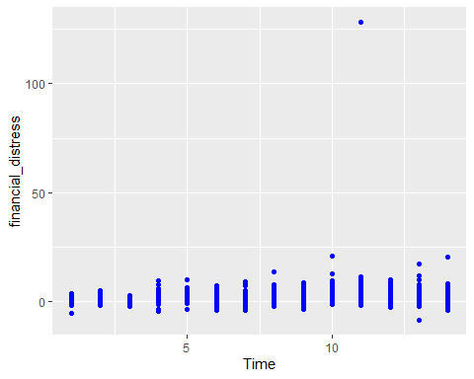

ggcorrplot(cor(data1))

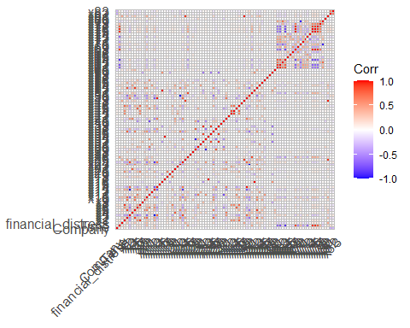

plot_histogram(data1)

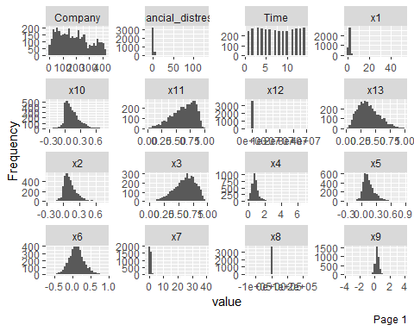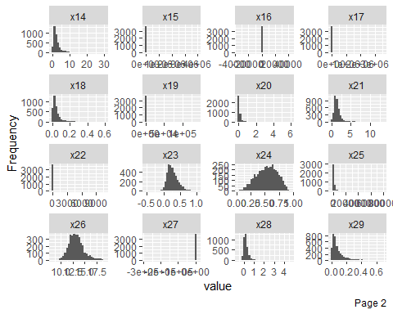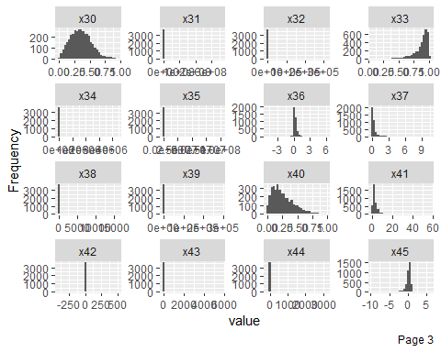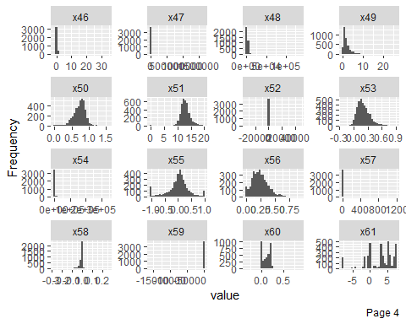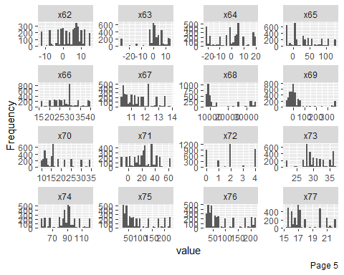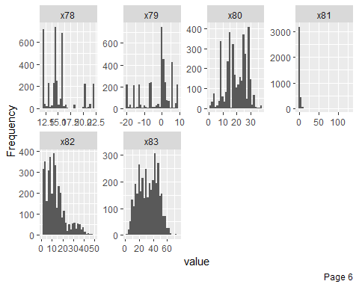

summary(data1[1:3])

## Company Time financial_distress  
## Min. : 1.0 Min. : 1.000 Min. : -8.6317   
## 1st Qu.: 80.0 1st Qu.: 4.000 1st Qu.: 0.1723   
## Median :168.0 Median : 7.000 Median : 0.5838   
## Mean :182.1 Mean : 7.528 Mean : 1.0403   
## 3rd Qu.:264.2 3rd Qu.:11.000 3rd Qu.: 1.3518   
## Max. :422.0 Max. :14.000 Max. :128.4000

summary(data1[4:86])

## x1 x2 x3 x4   
## Min. : 0.07517 Min. :-0.2581 Min. :0.01614 Min. :0.000001   
## 1st Qu.: 0.95214 1st Qu.: 0.0487 1st Qu.:0.50189 1st Qu.:0.552558   
## Median : 1.18360 Median : 0.1075 Median :0.63869 Median :0.775245   
## Mean : 1.38782 Mean : 0.1297 Mean :0.61577 Mean :0.868160   
## 3rd Qu.: 1.50648 3rd Qu.: 0.1887 3rd Qu.:0.74943 3rd Qu.:1.039000   
## Max. :51.95400 Max. : 0.7494 Max. :0.96790 Max. :6.835600   
## x5 x6 x7 x8   
## Min. :-0.2698 Min. :-0.62775 Min. : 0.03516 Min. :-145000.00   
## 1st Qu.: 0.0700 1st Qu.:-0.02775 1st Qu.: 0.43600 1st Qu.: 0.06   
## Median : 0.1318 Median : 0.10433 Median : 0.64187 Median : 0.14   
## Mean : 0.1549 Mean : 0.10672 Mean : 0.78403 Mean : 39.27   
## 3rd Qu.: 0.2196 3rd Qu.: 0.23123 3rd Qu.: 0.89677 3rd Qu.: 0.27   
## Max. : 0.8585 Max. : 0.92955 Max. :38.83600 Max. : 209000.00   
## x9 x10 x11 x12   
## Min. :-3.6112 Min. :-0.31866 Min. :0.02149 Min. :-2620000   
## 1st Qu.: 0.1577 1st Qu.: 0.03382 1st Qu.:0.50313 1st Qu.: 2   
## Median : 0.3026 Median : 0.10727 Median :0.67085 Median : 5   
## Mean : 0.3326 Mean : 0.13626 Mean :0.63883 Mean : 125273   
## 3rd Qu.: 0.4840 3rd Qu.: 0.21002 3rd Qu.:0.80492 3rd Qu.: 15   
## Max. : 3.8102 Max. : 0.76962 Max. :0.99827 Max. :38300000   
## x13 x14 x15 x16   
## Min. :0.0321 Min. : 0.0164 Min. : 0 Min. :-35758.00   
## 1st Qu.:0.2506 1st Qu.: 1.0075 1st Qu.: 2 1st Qu.: 0.09   
## Median :0.3613 Median : 1.7677 Median : 4 Median : 0.18   
## Mean :0.3842 Mean : 2.4383 Mean : 8186 Mean : -25.04   
## 3rd Qu.:0.4981 3rd Qu.: 2.9908 3rd Qu.: 8 3rd Qu.: 0.30   
## Max. :0.9839 Max. :30.1520 Max. :3960000 Max. : 42180.00   
## x17 x18 x19 x20   
## Min. : 0 Min. :0.0001016 Min. : 0.00 Min. :0.000127   
## 1st Qu.: 2 1st Qu.:0.0132660 1st Qu.: 0.01 1st Qu.:0.024805   
## Median : 2 Median :0.0283745 Median : 0.03 Median :0.053568   
## Mean : 2059 Mean :0.0413796 Mean : 77.55 Mean :0.103999   
## 3rd Qu.: 4 3rd Qu.:0.0522655 3rd Qu.: 0.07 3rd Qu.:0.108332   
## Max. :3540000 Max. :0.5965500 Max. :140000.00 Max. :5.964600   
## x21 x22 x23 x24   
## Min. : 0.000003 Min. : 0.000 Min. :-0.5538 Min. :0.01614   
## 1st Qu.: 0.904230 1st Qu.: 1.926 1st Qu.: 0.1565 1st Qu.:0.40091   
## Median : 1.262900 Median : 3.966 Median : 0.2476 Median :0.54250   
## Mean : 1.449663 Mean : 14.195 Mean : 0.2732 Mean :0.53212   
## 3rd Qu.: 1.741775 3rd Qu.: 7.780 3rd Qu.: 0.3687 3rd Qu.:0.67189   
## Max. :13.398000 Max. :10721.000 Max. : 1.0000 Max. :0.93563   
## x25 x26 x27 x28   
## Min. :-3374.6 Min. : 8.195 Min. :-288000.00 Min. :-0.49944   
## 1st Qu.: 261.8 1st Qu.:12.163 1st Qu.: -2.07 1st Qu.: 0.03521   
## Median : 605.2 Median :13.139 Median : 2.94 Median : 0.15324   
## Mean : 996.0 Mean :13.288 Mean : -77.48 Mean : 0.20258   
## 3rd Qu.: 1260.2 3rd Qu.:14.152 3rd Qu.: 6.91 3rd Qu.: 0.30075   
## Max. :79551.0 Max. :19.106 Max. : 9327.40 Max. : 4.62540   
## x29 x30 x31 x32   
## Min. :0.00000 Min. :0.002082 Min. : 0 Min. : 0.01   
## 1st Qu.:0.02575 1st Qu.:0.227492 1st Qu.: 5 1st Qu.: 0.27   
## Median :0.05271 Median :0.346125 Median : 9 Median : 0.43   
## Mean :0.08365 Mean :0.354824 Mean : 358087 Mean : 379.87   
## 3rd Qu.:0.10618 3rd Qu.:0.469145 3rd Qu.: 23 3rd Qu.: 0.65   
## Max. :0.69046 Max. :0.948000 Max. :361000000 Max. :312000.00   
## x33 x34 x35 x36   
## Min. :0.04937 Min. : 0 Min. : 0 Min. :-4.85620   
## 1st Qu.:0.81875 1st Qu.: 2 1st Qu.: 42 1st Qu.: 0.07288   
## Median :0.91109 Median : 4 Median : 92 Median : 0.16460   
## Mean :0.86314 Mean : 2859 Mean : 68878 Mean : 0.24032   
## 3rd Qu.:0.95702 3rd Qu.: 6 3rd Qu.: 156 3rd Qu.: 0.33656   
## Max. :1.00000 Max. :4350000 Max. :102000000 Max. : 5.76610   
## x37 x38 x39 x40   
## Min. : 0.00000 Min. : 0.000 Min. : -1.00 Min. :0.0001702   
## 1st Qu.: 0.06666 1st Qu.: 0.018 1st Qu.: -0.01 1st Qu.:0.1141650   
## Median : 0.15748 Median : 0.037 Median : 0.16 Median :0.2175350   
## Mean : 0.31206 Mean : 15.149 Mean : 120.24 Mean :0.2600971   
## 3rd Qu.: 0.35431 3rd Qu.: 0.070 3rd Qu.: 0.34 3rd Qu.:0.3703675   
## Max. :10.53600 Max. :15772.000 Max. :290000.00 Max. :0.9777600   
## x41 x42 x43 x44   
## Min. : 0.000 Min. :-414.7100 Min. : 0.089 Min. : -56.719   
## 1st Qu.: 1.318 1st Qu.: -0.2685 1st Qu.: 0.949 1st Qu.: 0.188   
## Median : 2.157 Median : 0.0998 Median : 1.570 Median : 0.493   
## Mean : 3.034 Mean : 0.4273 Mean : 11.527 Mean : 3.321   
## 3rd Qu.: 3.667 3rd Qu.: 0.5572 3rd Qu.: 2.942 3rd Qu.: 1.103   
## Max. :56.913 Max. : 482.6000 Max. :5731.700 Max. :3201.900   
## x45 x46 x47 x48   
## Min. :-9.37690 Min. :-1.07490 Min. : 0.0 Min. : 533.1   
## 1st Qu.:-0.09719 1st Qu.: 0.06838 1st Qu.: 1.0 1st Qu.: 1418.9   
## Median : 0.28983 Median : 0.17498 Median : 1.8 Median : 1917.7   
## Mean : 0.14924 Mean : 0.29876 Mean : 1490.9 Mean : 2484.1   
## 3rd Qu.: 0.59963 3rd Qu.: 0.35188 3rd Qu.: 3.1 3rd Qu.: 2812.5   
## Max. : 6.05240 Max. :34.06300 Max. :1660000.0 Max. :136000.0   
## x49 x50 x51 x52   
## Min. : 0.0164 Min. :0.0000 Min. : 0.00 Min. :-33563.00   
## 1st Qu.: 0.8229 1st Qu.:0.6313 1st Qu.:11.84 1st Qu.: 0.11   
## Median : 1.4655 Median :0.7524 Median :12.80 Median : 0.21   
## Mean : 2.1263 Mean :0.7268 Mean :12.93 Mean : -21.25   
## 3rd Qu.: 2.6102 3rd Qu.:0.8435 3rd Qu.:13.80 3rd Qu.: 0.35   
## Max. :26.3980 Max. :1.5538 Max. :19.81 Max. : 46045.00   
## x53 x54 x55 x56   
## Min. :-0.2252 Min. : 0.0 Min. :-1.000000 Min. :0.0000   
## 1st Qu.: 0.1168 1st Qu.: 443.7 1st Qu.:-0.154140 1st Qu.:0.1351   
## Median : 0.1867 Median : 962.6 Median : 0.047530 Median :0.2226   
## Mean : 0.2073 Mean : 3411.3 Mean : 0.007702 Mean :0.2374   
## 3rd Qu.: 0.2833 3rd Qu.: 2176.0 3rd Qu.: 0.219235 3rd Qu.:0.3198   
## Max. : 0.9046 Max. :342000.0 Max. : 1.000000 Max. :0.9265   
## x57 x58 x59   
## Min. : -0.9987 Min. :-0.279260 Min. :-15649.000   
## 1st Qu.: -0.0411 1st Qu.:-0.012610 1st Qu.: -0.017   
## Median : 0.0715 Median :-0.002939 Median : -0.004   
## Mean : 1.0271 Mean :-0.010018 Mean : -6.869   
## 3rd Qu.: 0.2734 3rd Qu.: 0.000000 3rd Qu.: 0.000   
## Max. :1182.8000 Max. : 0.247270 Max. : 1.403   
## x60 x61 x62 x63   
## Min. :-0.349060 Min. :-7.71400 Min. :-11.824 Min. :-25.7360   
## 1st Qu.: 0.005913 1st Qu.:-0.07535 1st Qu.: -0.711 1st Qu.: -0.5345   
## Median : 0.126035 Median : 3.63730 Median : 5.787 Median : 1.8883   
## Mean : 0.113802 Mean : 2.69474 Mean : 3.456 Mean : 1.2992   
## 3rd Qu.: 0.196305 3rd Qu.: 5.72650 3rd Qu.: 8.480 3rd Qu.: 7.1562   
## Max. : 0.863320 Max. : 7.41660 Max. : 15.381 Max. : 14.3210   
## x64 x65 x66 x67   
## Min. :-21.4110 Min. :-21.907 Min. :15.92 Min. :10.30   
## 1st Qu.: -9.3020 1st Qu.: 2.657 1st Qu.:23.91 1st Qu.:10.50   
## Median : 1.3445 Median : 28.286 Median :28.18 Median :11.30   
## Mean : -0.7038 Mean : 31.677 Mean :28.25 Mean :11.46   
## 3rd Qu.: 5.8267 3rd Qu.: 57.368 3rd Qu.:30.25 3rd Qu.:12.20   
## Max. : 18.7700 Max. :124.760 Max. :39.43 Max. :13.85   
## x68 x69 x70 x71   
## Min. : 7942 Min. :-58.1220 Min. :10.40 Min. :-10.66   
## 1st Qu.: 9042 1st Qu.:-25.8410 1st Qu.:11.90 1st Qu.: 10.13   
## Median : 9667 Median : 0.1896 Median :15.60 Median : 22.57   
## Mean :15875 Mean : 21.4724 Mean :17.86 Mean : 23.30   
## 3rd Qu.:26059 3rd Qu.: 14.5290 3rd Qu.:21.50 3rd Qu.: 36.03   
## Max. :34501 Max. :364.9500 Max. :34.70 Max. : 61.48   
## x72 x73 x74 x75   
## Min. :0.000 Min. :22.00 Min. : 54.81 Min. : 24.32   
## 1st Qu.:0.500 1st Qu.:28.00 1st Qu.: 79.95 1st Qu.: 39.80   
## Median :2.000 Median :30.00 Median : 90.00 Median : 66.12   
## Mean :1.924 Mean :30.41 Mean : 86.84 Mean : 91.92   
## 3rd Qu.:4.000 3rd Qu.:33.00 3rd Qu.: 93.88 3rd Qu.:130.50   
## Max. :4.000 Max. :36.75 Max. :120.87 Max. :227.50   
## x76 x77 x78 x79   
## Min. : 23.78 Min. :15.25 Min. :12.0 Min. :-20.200   
## 1st Qu.: 38.38 1st Qu.:16.00 1st Qu.:13.0 1st Qu.: -7.000   
## Median : 59.47 Median :17.00 Median :14.5 Median : 0.200   
## Mean : 89.12 Mean :17.78 Mean :15.2 Mean : -2.664   
## 3rd Qu.:132.40 3rd Qu.:20.00 3rd Qu.:16.0 3rd Qu.: 2.100   
## Max. :214.50 Max. :22.00 Max. :22.0 Max. : 8.600   
## x80 x81 x82 x83   
## Min. : 1.00 Min. : -0.4992 Min. : 1.00 Min. : 2.00   
## 1st Qu.:14.00 1st Qu.: 0.1899 1st Qu.: 6.00 1st Qu.:21.00   
## Median :20.00 Median : 0.5948 Median :11.00 Median :34.00   
## Mean :19.71 Mean : 1.1005 Mean :13.12 Mean :33.04   
## 3rd Qu.:26.00 3rd Qu.: 1.3551 3rd Qu.:17.00 3rd Qu.:44.00   
## Max. :37.00 Max. :128.4000 Max. :49.00 Max. :74.00

pairs(data1[1:3])

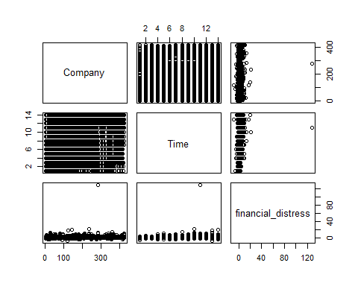

boxplot(data1[4:86]) # most outliers

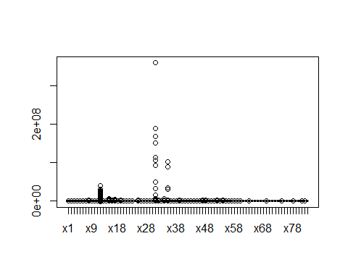

data1<-data1%>%  
 mutate(distress = ifelse(financial_distress > -0.5 ,0,1))  
data1%>%  
 select(Company,Time,financial_distress,distress)%>%  
 head()

## Company Time financial_distress distress  
## 1 1 1 0.0106360 0  
## 2 1 2 -0.4559700 0  
## 3 1 3 -0.3253900 0  
## 4 1 4 -0.5665700 1  
## 5 2 1 1.3573000 0  
## 6 2 2 0.0071875 0

data1$distress<-as.factor(data1$distress)

data1%>%  
 ggplot(aes(distress))+geom_bar(color="blue",  
 fill="red")

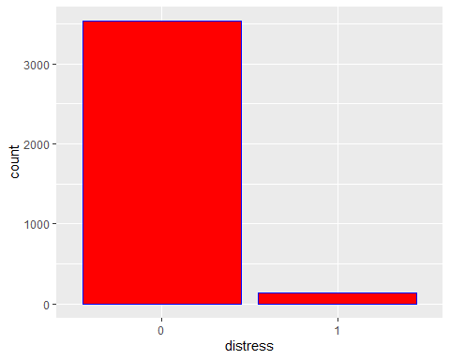

glm<-glm(financial_distress~.,data=data1)  
summary(glm) #build up the logistic regression, and most column x is insignificant

##   
## Call:  
## glm(formula = financial_distress ~ ., data = data1)  
##   
## Deviance Residuals:   
## Min 1Q Median 3Q Max   
## -34.470 -0.611 -0.068 0.477 82.003   
##   
## Coefficients:  
## Estimate Std. Error t value Pr(>|t|)   
## (Intercept) 3.295e+03 9.381e+03 0.351 0.725405   
## Company 5.193e-04 4.215e-04 1.232 0.218028   
## Time -2.104e-01 2.322e-01 -0.906 0.365055   
## x1 8.183e-02 9.150e-02 0.894 0.371206   
## x2 8.053e+00 1.374e+00 5.861 5.00e-09 ***  
## x3 -2.065e+04 8.603e+03 -2.401 0.016407 *   
## x4 -1.530e+00 2.242e-01 -6.823 1.04e-11 ***  
## x5 3.151e+00 9.634e-01 3.271 0.001083 **   
## x6 -6.827e+03 7.735e+03 -0.883 0.377523   
## x7 4.642e-02 1.431e-01 0.324 0.745662   
## x8 1.627e-03 2.715e-03 0.599 0.549068   
## x9 2.224e+00 2.263e-01 9.831 < 2e-16 ***  
## x10 -4.654e-01 6.100e-01 -0.763 0.445573   
## x11 6.829e+03 7.735e+03 0.883 0.377400   
## x12 2.045e-07 2.890e-08 7.075 1.79e-12 ***  
## x13 4.638e+02 1.763e+03 0.263 0.792446   
## x14 1.466e+02 5.753e+02 0.255 0.798941   
## x15 6.806e-07 3.175e-07 2.144 0.032104 *   
## x16 7.840e-02 1.180e-01 0.664 0.506428   
## x17 5.885e-06 3.904e-06 1.508 0.131759   
## x18 2.676e+00 1.220e+00 2.194 0.028274 *   
## x19 1.356e-03 2.191e-03 0.619 0.535945   
## x20 -1.964e-01 3.153e-01 -0.623 0.533377   
## x21 -9.442e-02 1.203e-01 -0.785 0.432744   
## x22 8.027e-05 1.772e-04 0.453 0.650483   
## x23 -1.636e+03 8.191e+03 -0.200 0.841709   
## x24 1.429e+04 8.917e+03 1.603 0.109028   
## x25 -2.238e-03 9.256e-05 -24.183 < 2e-16 ***  
## x26 2.229e-01 1.137e-01 1.960 0.050067 .   
## x27 1.081e-06 7.325e-06 0.148 0.882705   
## x28 1.800e-01 1.351e-01 1.333 0.182676   
## x29 2.112e+04 8.433e+03 2.504 0.012314 *   
## x30 -1.326e+00 7.477e-01 -1.773 0.076293 .   
## x31 -1.026e-08 4.925e-09 -2.084 0.037200 *   
## x32 -2.147e-03 3.650e-03 -0.588 0.556555   
## x33 -1.162e-02 1.203e+00 -0.010 0.992289   
## x34 -4.774e-06 3.079e-06 -1.550 0.121148   
## x35 1.663e-05 2.726e-05 0.610 0.541946   
## x36 3.187e-01 2.913e-01 1.094 0.273943   
## x37 -1.465e+02 5.753e+02 -0.255 0.799045   
## x38 -1.360e-02 2.102e-02 -0.647 0.517565   
## x39 -2.420e-07 7.496e-06 -0.032 0.974251   
## x40 -8.905e-03 3.428e-01 -0.026 0.979275   
## x41 3.742e-01 2.732e-02 13.700 < 2e-16 ***  
## x42 -4.628e-03 2.537e-03 -1.825 0.068131 .   
## x43 2.188e-04 6.497e-04 0.337 0.736339   
## x44 4.157e-04 1.957e-03 0.212 0.831793   
## x45 -1.452e-01 9.115e-02 -1.593 0.111241   
## x46 -3.315e-01 1.600e-01 -2.072 0.038313 *   
## x47 -3.759e-07 7.572e-07 -0.496 0.619600   
## x48 6.540e-04 4.951e-05 13.211 < 2e-16 ***  
## x49 -1.469e+02 5.753e+02 -0.255 0.798451   
## x50 -1.633e+03 8.191e+03 -0.199 0.841969   
## x51 -2.292e-01 1.112e-01 -2.060 0.039451 *   
## x52 -9.247e-02 1.414e-01 -0.654 0.513027   
## x53 3.096e+00 8.104e-01 3.820 0.000136 ***  
## x54 7.962e-06 3.818e-06 2.085 0.037127 *   
## x55 -2.719e-01 1.001e-01 -2.716 0.006640 **   
## x56 -1.214e+00 7.283e-01 -1.667 0.095610 .   
## x57 2.466e-03 1.343e-03 1.837 0.066350 .   
## x58 2.146e+00 1.333e+00 1.610 0.107471   
## x59 4.464e-02 7.446e-02 0.600 0.548872   
## x60 -1.267e+00 4.810e-01 -2.635 0.008455 **   
## x61 -3.226e+01 5.980e+01 -0.539 0.589625   
## x62 8.076e+01 7.298e+01 1.107 0.268559   
## x63 -1.623e+02 1.250e+02 -1.298 0.194210   
## x64 7.696e+01 6.440e+01 1.195 0.232149   
## x65 1.475e+01 9.494e+00 1.553 0.120442   
## x66 6.957e+01 7.224e+01 0.963 0.335638   
## x67 -1.099e+02 3.347e+02 -0.328 0.742651   
## x68 -2.392e-01 2.832e-01 -0.845 0.398361   
## x69 -3.192e+00 3.266e+00 -0.978 0.328364   
## x70 -4.607e+02 5.182e+02 -0.889 0.374040   
## x71 2.798e+01 3.154e+01 0.887 0.375031   
## x72 -3.374e+02 5.221e+02 -0.646 0.518183   
## x73 -7.216e+01 5.170e+01 -1.396 0.162866   
## x74 -1.197e+01 1.536e+01 -0.779 0.435801   
## x75 7.440e+01 4.772e+01 1.559 0.119057   
## x76 -2.450e+01 5.267e+01 -0.465 0.641821   
## x77 -1.340e+02 2.430e+02 -0.551 0.581484   
## x78 5.792e+02 6.375e+02 0.909 0.363667   
## x79 -3.837e+02 5.491e+02 -0.699 0.484792   
## x80 4.565e-03 4.888e-03 0.934 0.350373   
## x81 9.581e-01 6.816e-02 14.056 < 2e-16 ***  
## x82 1.907e-03 5.191e-03 0.367 0.713305   
## x83 -2.996e-04 3.415e-03 -0.088 0.930108   
## distress1 -1.009e+00 2.013e-01 -5.012 5.66e-07 ***  
## ---  
## Signif. codes: 0 '***' 0.001 '**' 0.01 '*' 0.05 '.' 0.1 ' ' 1  
##   
## (Dispersion parameter for gaussian family taken to be 4.193027)  
##   
## Null deviance: 25823 on 3671 degrees of freedom  
## Residual deviance: 15032 on 3585 degrees of freedom  
## AIC: 15772  
##   
## Number of Fisher Scoring iterations: 2

glm1<-glm(financial_distress~Company+Time,data=data1)  
summary(glm1) #removed the insignificant columns then make logistic regression

##   
## Call:  
## glm(formula = financial_distress ~ Company + Time, data = data1)  
##   
## Deviance Residuals:   
## Min 1Q Median 3Q Max   
## -10.226 -0.799 -0.351 0.360 127.071   
##   
## Coefficients:  
## Estimate Std. Error t value Pr(>|t|)   
## (Intercept) 0.3992815 0.1070453 3.730 0.000194 ***  
## Company -0.0004507 0.0003744 -1.204 0.228733   
## Time 0.0960421 0.0107800 8.909 < 2e-16 ***  
## ---  
## Signif. codes: 0 '***' 0.001 '**' 0.01 '*' 0.05 '.' 0.1 ' ' 1  
##   
## (Dispersion parameter for gaussian family taken to be 6.889074)  
##   
## Null deviance: 25823 on 3671 degrees of freedom  
## Residual deviance: 25276 on 3669 degrees of freedom  
## AIC: 17512  
##   
## Number of Fisher Scoring iterations: 2

glm1$coefficients

## (Intercept) Company Time   
## 0.3992815412 -0.0004506727 0.0960420632

set.seed(123)  
sample<-createDataPartition(data1$distress,  
 p=0.7,  
 list=FALSE)  
train<-data1[sample,]  
test<-data1[-sample,] #split data into train and test by 70% and 30%

dim(train);dim(test)

## [1] 2572 87

## [1] 1100 87

balance<-ovun.sample(distress~.,data=train,  
 p=0.5,seed=1,  
 method="both")$data  
summary(balance$distress)

## 0 1   
## 1336 1236

rf1<-randomForest(as.factor(train$distress)~.,train,ntree=100)  
rf1

##   
## Call:  
## randomForest(formula = as.factor(train$distress) ~ ., data = train, ntree = 100)   
## Type of random forest: classification  
## Number of trees: 100  
## No. of variables tried at each split: 9  
##   
## OOB estimate of error rate: 0.31%  
## Confusion matrix:  
## 0 1 class.error  
## 0 2476 0 0.00000000  
## 1 8 88 0.08333333

pred<-predict(rf1, test) #predictions  
summary(pred)

## 0 1   
## 1064 36

confusionMatrix(pred,as.factor(test$distress),positive="1") #matrix table

## Confusion Matrix and Statistics  
##   
## Reference  
## Prediction 0 1  
## 0 1060 4  
## 1 0 36  
##   
## Accuracy : 0.9964   
## 95% CI : (0.9907, 0.999)  
## No Information Rate : 0.9636   
## P-Value [Acc > NIR] : 2.738e-13   
##   
## Kappa : 0.9455   
##   
## Mcnemar's Test P-Value : 0.1336   
##   
## Sensitivity : 0.90000   
## Specificity : 1.00000   
## Pos Pred Value : 1.00000   
## Neg Pred Value : 0.99624   
## Prevalence : 0.03636   
## Detection Rate : 0.03273   
## Detection Prevalence : 0.03273   
## Balanced Accuracy : 0.95000   
##   
## 'Positive' Class : 1   
##

roc<-predict(rf1,test,type="prob")  
roc_all<-roc(test$distress, roc[,2])

## Setting levels: control = 0, case = 1

## Setting direction: controls < cases

auc<-as.numeric(round(roc_all$auc,4))  
plot(roc_all,lwd=2,col="blue")  
text(0.6,0.7,"AUC=")  
text(0.4,0.7,auc)

