DDS Group beer analysis for Q8 and Q9

Sophia Wu

7/4/2020

Note that the echo = FALSE parameter was added to the code chunk to prevent printing of the R code that generated the plot. # Data Analysis for questions 8 and 9

beers2 <- beers  
colnames(beers2)

## [1] "Name" "Beer_ID" "ABV" "IBU" "Brewery_id" "Style"   
## [7] "Ounces"

names(beers2) <- c("beername", "beerID", "beerABV", "beerIBU", "beer.brewery.id", "beerstyle", "beerOunce")  
head(beers2)

## beername beerID beerABV beerIBU beer.brewery.id beerstyle  
## 1 Pub Beer 1436 0.050 NA 409 American Pale Lager  
## 2 Devil's Cup 2265 0.066 NA 178 American Pale Ale (APA)  
## 3 Rise of the Phoenix 2264 0.071 NA 178 American IPA  
## 4 Sinister 2263 0.090 NA 178 American Double / Imperial IPA  
## 5 Sex and Candy 2262 0.075 NA 178 American IPA  
## 6 Black Exodus 2261 0.077 NA 178 Oatmeal Stout  
## beerOunce  
## 1 12  
## 2 12  
## 3 12  
## 4 12  
## 5 12  
## 6 12

brew2 <- breweries  
colnames(brew2)

## [1] "Brew_ID" "Name" "City" "State"

names(brew2) <- c("brewery.id", "brewery.name", "brewery.city", "brewery.state.abb")  
  
brew2 <- brew2 %>%  
 mutate(brewery.state.abb = trimws(brewery.state.abb))  
  
head(brew2)

## brewery.id brewery.name brewery.city brewery.state.abb  
## 1 1 NorthGate Brewing Minneapolis MN  
## 2 2 Against the Grain Brewery Louisville KY  
## 3 3 Jack's Abby Craft Lagers Framingham MA  
## 4 4 Mike Hess Brewing Company San Diego CA  
## 5 5 Fort Point Beer Company San Francisco CA  
## 6 6 COAST Brewing Company Charleston SC

#Insert State name and region

#makes a data frame with State abbreviation, name and region  
stateinf= data.frame(state.abb, state.name, state.region, state.x77, stringsAsFactors=FALSE)   
head(stateinf[1:5])

## state.abb state.name state.region Population Income  
## Alabama AL Alabama South 3615 3624  
## Alaska AK Alaska West 365 6315  
## Arizona AZ Arizona West 2212 4530  
## Arkansas AR Arkansas South 2110 3378  
## California CA California West 21198 5114  
## Colorado CO Colorado West 2541 4884

#Merge data brew2 with data stateinf and calculate breweries numbers are present in each state

brewstate<- merge(brew2, stateinf[1:5], by.x = "brewery.state.abb", by.y = "state.abb", all.x = TRUE)  
  
head(brewstate)

## brewery.state.abb brewery.id brewery.name brewery.city state.name  
## 1 AK 494 Broken Tooth Brewing Company Anchorage Alaska  
## 2 AK 224 Midnight Sun Brewing Company Anchorage Alaska  
## 3 AK 459 Kenai River Brewing Company Soldotna Alaska  
## 4 AK 454 Denali Brewing Company Talkeetna Alaska  
## 5 AK 558 Sleeping Lady Brewing Company Anchorage Alaska  
## 6 AK 271 Alaskan Brewing Company Juneau Alaska  
## state.region Population Income  
## 1 West 365 6315  
## 2 West 365 6315  
## 3 West 365 6315  
## 4 West 365 6315  
## 5 West 365 6315  
## 6 West 365 6315

beermerged <- merge(beers2, brewstate, by.x = "beer.brewery.id", by.y = "brewery.id")

beermerged$beeripaale<- ''  
  
head(beermerged)

## beer.brewery.id beername beerID beerABV beerIBU beerstyle  
## 1 1 Get Together 2692 0.045 50 American IPA  
## 2 1 Maggie's Leap 2691 0.049 26 Milk / Sweet Stout  
## 3 1 Wall's End 2690 0.048 19 English Brown Ale  
## 4 1 Pumpion 2689 0.060 38 Pumpkin Ale  
## 5 1 Stronghold 2688 0.060 25 American Porter  
## 6 1 Parapet ESB 2687 0.056 47 Extra Special / Strong Bitter (ESB)  
## beerOunce brewery.state.abb brewery.name brewery.city state.name state.region  
## 1 16 MN NorthGate Brewing Minneapolis Minnesota North Central  
## 2 16 MN NorthGate Brewing Minneapolis Minnesota North Central  
## 3 16 MN NorthGate Brewing Minneapolis Minnesota North Central  
## 4 16 MN NorthGate Brewing Minneapolis Minnesota North Central  
## 5 16 MN NorthGate Brewing Minneapolis Minnesota North Central  
## 6 16 MN NorthGate Brewing Minneapolis Minnesota North Central  
## Population Income beeripaale  
## 1 3921 4675   
## 2 3921 4675   
## 3 3921 4675   
## 4 3921 4675   
## 5 3921 4675   
## 6 3921 4675

#Get all different beers styles' numbers  
beermerged %>%count(beerstyle)

## beerstyle n  
## 1 5  
## 2 Abbey Single Ale 2  
## 3 Altbier 13  
## 4 American Adjunct Lager 18  
## 5 American Amber / Red Ale 133  
## 6 American Amber / Red Lager 29  
## 7 American Barleywine 3  
## 8 American Black Ale 36  
## 9 American Blonde Ale 108  
## 10 American Brown Ale 70  
## 11 American Dark Wheat Ale 7  
## 12 American Double / Imperial IPA 105  
## 13 American Double / Imperial Pilsner 2  
## 14 American Double / Imperial Stout 9  
## 15 American India Pale Lager 3  
## 16 American IPA 424  
## 17 American Malt Liquor 1  
## 18 American Pale Ale (APA) 245  
## 19 American Pale Lager 39  
## 20 American Pale Wheat Ale 97  
## 21 American Pilsner 25  
## 22 American Porter 68  
## 23 American Stout 39  
## 24 American Strong Ale 14  
## 25 American White IPA 11  
## 26 American Wild Ale 6  
## 27 Baltic Porter 6  
## 28 Belgian Dark Ale 11  
## 29 Belgian IPA 18  
## 30 Belgian Pale Ale 24  
## 31 Belgian Strong Dark Ale 6  
## 32 Belgian Strong Pale Ale 7  
## 33 Berliner Weissbier 11  
## 34 Bière de Garde 7  
## 35 Bock 7  
## 36 Braggot 1  
## 37 California Common / Steam Beer 6  
## 38 Chile Beer 3  
## 39 Cider 37  
## 40 Cream Ale 29  
## 41 Czech Pilsener 28  
## 42 Doppelbock 7  
## 43 Dortmunder / Export Lager 6  
## 44 Dubbel 5  
## 45 Dunkelweizen 4  
## 46 English Barleywine 3  
## 47 English Bitter 3  
## 48 English Brown Ale 18  
## 49 English Dark Mild Ale 6  
## 50 English India Pale Ale (IPA) 13  
## 51 English Pale Ale 12  
## 52 English Pale Mild Ale 3  
## 53 English Stout 2  
## 54 English Strong Ale 4  
## 55 Euro Dark Lager 5  
## 56 Euro Pale Lager 2  
## 57 Extra Special / Strong Bitter (ESB) 20  
## 58 Flanders Oud Bruin 1  
## 59 Flanders Red Ale 1  
## 60 Foreign / Export Stout 6  
## 61 Fruit / Vegetable Beer 49  
## 62 German Pilsener 36  
## 63 Gose 10  
## 64 Grisette 1  
## 65 Hefeweizen 40  
## 66 Herbed / Spiced Beer 9  
## 67 Irish Dry Stout 5  
## 68 Irish Red Ale 12  
## 69 Keller Bier / Zwickel Bier 3  
## 70 Kölsch 42  
## 71 Kristalweizen 1  
## 72 Light Lager 12  
## 73 Low Alcohol Beer 1  
## 74 Maibock / Helles Bock 5  
## 75 Märzen / Oktoberfest 30  
## 76 Mead 5  
## 77 Milk / Sweet Stout 10  
## 78 Munich Dunkel Lager 4  
## 79 Munich Helles Lager 20  
## 80 Oatmeal Stout 18  
## 81 Old Ale 2  
## 82 Other 1  
## 83 Pumpkin Ale 23  
## 84 Quadrupel (Quad) 4  
## 85 Radler 3  
## 86 Rauchbier 2  
## 87 Roggenbier 2  
## 88 Russian Imperial Stout 11  
## 89 Rye Beer 18  
## 90 Saison / Farmhouse Ale 52  
## 91 Schwarzbier 9  
## 92 Scotch Ale / Wee Heavy 15  
## 93 Scottish Ale 19  
## 94 Shandy 3  
## 95 Smoked Beer 1  
## 96 Tripel 11  
## 97 Vienna Lager 20  
## 98 Wheat Ale 1  
## 99 Winter Warmer 15  
## 100 Witbier 51

#filter missing value  
beermerged %>%  
 filter(beerstyle == '')

## beer.brewery.id beername beerID beerABV beerIBU beerstyle beerOunce  
## 1 30 Special Release 2210 NA NA 16  
## 2 67 OktoberFiesta 2527 0.053 27 12  
## 3 161 Kilt Lifter Scottish-Style Ale 1635 0.060 21 12  
## 4 167 The CROWLER™ 1796 NA NA 32  
## 5 167 CAN'D AID Foundation 1790 NA NA 12  
## brewery.state.abb brewery.name brewery.city state.name state.region  
## 1 TX Cedar Creek Brewery Seven Points Texas South  
## 2 TX Freetail Brewing Company San Antonio Texas South  
## 3 AZ Four Peaks Brewing Company Tempe Arizona West  
## 4 CO Oskar Blues Brewery Longmont Colorado West  
## 5 CO Oskar Blues Brewery Longmont Colorado West  
## Population Income beeripaale  
## 1 12237 4188   
## 2 12237 4188   
## 3 2212 4530   
## 4 2541 4884   
## 5 2541 4884

beermerged %>%  
 filter(beerstyle %in% c("American Double / Imperial IPA", "American IPA", "Belgian IPA", "English India Pale Ale (IPA)")) %>%  
 count(beerstyle)

## beerstyle n  
## 1 American Double / Imperial IPA 105  
## 2 American IPA 424  
## 3 Belgian IPA 18  
## 4 English India Pale Ale (IPA) 13

beeripa <- beermerged %>%  
 filter(beerstyle %in% c("American Double / Imperial IPA", "American IPA", "Belgian IPA", "English India Pale Ale (IPA)")) %>%  
 mutate(beeripaale= 'IPA')  
head(beeripa)

## beer.brewery.id beername beerID beerABV beerIBU beerstyle  
## 1 1 Get Together 2692 0.045 50 American IPA  
## 2 2 Citra Ass Down 2686 0.080 68 American Double / Imperial IPA  
## 3 2 Rico Sauvin 2678 0.076 68 American Double / Imperial IPA  
## 4 2 Pile of Face 2675 0.060 65 American IPA  
## 5 4 Habitus (2014) 2668 0.080 100 American Double / Imperial IPA  
## 6 4 Solis 2667 0.075 85 American IPA  
## beerOunce brewery.state.abb brewery.name brewery.city state.name  
## 1 16 MN NorthGate Brewing Minneapolis Minnesota  
## 2 16 KY Against the Grain Brewery Louisville Kentucky  
## 3 16 KY Against the Grain Brewery Louisville Kentucky  
## 4 16 KY Against the Grain Brewery Louisville Kentucky  
## 5 16 CA Mike Hess Brewing Company San Diego California  
## 6 16 CA Mike Hess Brewing Company San Diego California  
## state.region Population Income beeripaale  
## 1 North Central 3921 4675 IPA  
## 2 South 3387 3712 IPA  
## 3 South 3387 3712 IPA  
## 4 South 3387 3712 IPA  
## 5 West 21198 5114 IPA  
## 6 West 21198 5114 IPA

# Kilt Lifter Scottish-Style Ale (1635)  
beermerged[946,]

## beer.brewery.id beername beerID beerABV beerIBU beerstyle  
## 946 161 Kilt Lifter Scottish-Style Ale 1635 0.06 21   
## beerOunce brewery.state.abb brewery.name brewery.city state.name  
## 946 12 AZ Four Peaks Brewing Company Tempe Arizona  
## state.region Population Income beeripaale  
## 946 West 2212 4530

beermerged %>%  
 filter(!beerstyle %in% c("American Double / Imperial IPA", "American IPA", "Belgian IPA", "English India Pale Ale (IPA)")) %>%  
 filter(str_detect(beerstyle, "Ale") | beerID==1635) %>%  
 count(beerstyle)

## beerstyle n  
## 1 1  
## 2 Abbey Single Ale 2  
## 3 American Amber / Red Ale 133  
## 4 American Black Ale 36  
## 5 American Blonde Ale 108  
## 6 American Brown Ale 70  
## 7 American Dark Wheat Ale 7  
## 8 American Pale Ale (APA) 245  
## 9 American Pale Wheat Ale 97  
## 10 American Strong Ale 14  
## 11 American Wild Ale 6  
## 12 Belgian Dark Ale 11  
## 13 Belgian Pale Ale 24  
## 14 Belgian Strong Dark Ale 6  
## 15 Belgian Strong Pale Ale 7  
## 16 Cream Ale 29  
## 17 English Brown Ale 18  
## 18 English Dark Mild Ale 6  
## 19 English Pale Ale 12  
## 20 English Pale Mild Ale 3  
## 21 English Strong Ale 4  
## 22 Flanders Red Ale 1  
## 23 Irish Red Ale 12  
## 24 Old Ale 2  
## 25 Pumpkin Ale 23  
## 26 Saison / Farmhouse Ale 52  
## 27 Scotch Ale / Wee Heavy 15  
## 28 Scottish Ale 19  
## 29 Wheat Ale 1

beerale <- beermerged %>%  
 filter(!beerstyle %in% c("American Double / Imperial IPA", "American IPA", "Belgian IPA", "English India Pale Ale (IPA)")) %>%  
 filter(str_detect(beerstyle, "Ale") |beerID==1635) %>%  
 mutate(beeripaale= 'Ale')  
  
head(beerale)

## beer.brewery.id beername beerID beerABV beerIBU beerstyle beerOunce  
## 1 1 Wall's End 2690 0.048 19 English Brown Ale 16  
## 2 1 Pumpion 2689 0.060 38 Pumpkin Ale 16  
## 3 2 A Beer 2683 0.042 42 American Pale Ale (APA) 16  
## 4 2 Flesh Gourd'n 2681 0.066 21 Pumpkin Ale 16  
## 5 2 Sho'nuff 2680 0.040 13 Belgian Pale Ale 16  
## 6 2 Coq de la Marche 2677 0.051 38 Saison / Farmhouse Ale 16  
## brewery.state.abb brewery.name brewery.city state.name state.region  
## 1 MN NorthGate Brewing Minneapolis Minnesota North Central  
## 2 MN NorthGate Brewing Minneapolis Minnesota North Central  
## 3 KY Against the Grain Brewery Louisville Kentucky South  
## 4 KY Against the Grain Brewery Louisville Kentucky South  
## 5 KY Against the Grain Brewery Louisville Kentucky South  
## 6 KY Against the Grain Brewery Louisville Kentucky South  
## Population Income beeripaale  
## 1 3921 4675 Ale  
## 2 3921 4675 Ale  
## 3 3387 3712 Ale  
## 4 3387 3712 Ale  
## 5 3387 3712 Ale  
## 6 3387 3712 Ale

head(beermerged) %>%  
 mutate(beer.style.words = as.character(str_split(beerstyle, boundary("word")))) %>%  
 select(beer.style.words)

## beer.style.words  
## 1 c("American", "IPA")  
## 2 c("Milk", "Sweet", "Stout")  
## 3 c("English", "Brown", "Ale")  
## 4 c("Pumpkin", "Ale")  
## 5 c("American", "Porter")  
## 6 c("Extra", "Special", "Strong", "Bitter", "ESB")

# India Pale Ale  
IPA <- c("American Double / Imperial IPA", "American IPA", "Belgian IPA", "English India Pale Ale (IPA)")

total_beers_count <- dim(beermerged)[1]  
ipa_count <- dim(beeripa)[1]  
ale_count <- dim(beerale)[1]  
  
beercombined_ale <- rbind(beeripa, beerale)  
  
ipa_ale_count <- dim(beercombined_ale)[1]  
  
  
head(beercombined_ale)

## beer.brewery.id beername beerID beerABV beerIBU beerstyle  
## 1 1 Get Together 2692 0.045 50 American IPA  
## 2 2 Citra Ass Down 2686 0.080 68 American Double / Imperial IPA  
## 3 2 Rico Sauvin 2678 0.076 68 American Double / Imperial IPA  
## 4 2 Pile of Face 2675 0.060 65 American IPA  
## 5 4 Habitus (2014) 2668 0.080 100 American Double / Imperial IPA  
## 6 4 Solis 2667 0.075 85 American IPA  
## beerOunce brewery.state.abb brewery.name brewery.city state.name  
## 1 16 MN NorthGate Brewing Minneapolis Minnesota  
## 2 16 KY Against the Grain Brewery Louisville Kentucky  
## 3 16 KY Against the Grain Brewery Louisville Kentucky  
## 4 16 KY Against the Grain Brewery Louisville Kentucky  
## 5 16 CA Mike Hess Brewing Company San Diego California  
## 6 16 CA Mike Hess Brewing Company San Diego California  
## state.region Population Income beeripaale  
## 1 North Central 3921 4675 IPA  
## 2 South 3387 3712 IPA  
## 3 South 3387 3712 IPA  
## 4 South 3387 3712 IPA  
## 5 West 21198 5114 IPA  
## 6 West 21198 5114 IPA

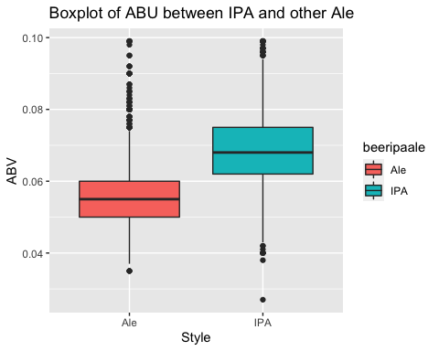

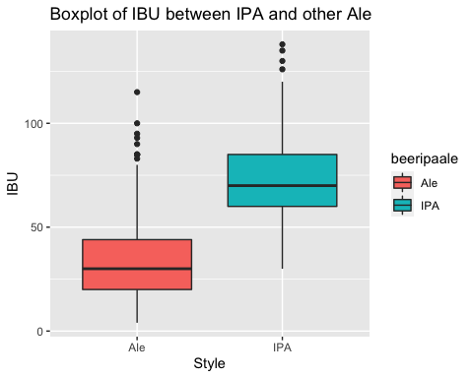

## `summarise()` ungrouping output (override with `.groups` argument)

## # A tibble: 2 x 4  
## beeripaale beers.abv.median beers.ibu.median count  
## <chr> <dbl> <dbl> <int>  
## 1 Ale 0.0545 30 552  
## 2 IPA 0.0685 70 384

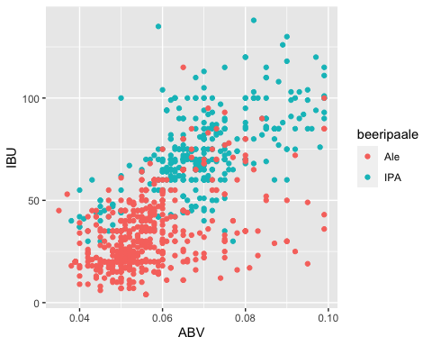

## [1] 936 15

## [1] 655 15

## [1] 281 15

## Confusion Matrix and Statistics  
##   
## classifications  
## Ale IPA  
## Ale 166 10  
## IPA 31 74  
##   
## Accuracy : 0.8541   
## 95% CI : (0.8073, 0.8932)  
## No Information Rate : 0.7011   
## P-Value [Acc > NIR] : 1.723e-09   
##   
## Kappa : 0.6752   
##   
## Mcnemar's Test P-Value : 0.001787   
##   
## Sensitivity : 0.8426   
## Specificity : 0.8810   
## Pos Pred Value : 0.9432   
## Neg Pred Value : 0.7048   
## Prevalence : 0.7011   
## Detection Rate : 0.5907   
## Detection Prevalence : 0.6263   
## Balanced Accuracy : 0.8618   
##   
## 'Positive' Class : Ale   
##

## Confusion Matrix and Statistics  
##   
## classifications  
## Ale IPA  
## Ale 159 17  
## IPA 37 68  
##   
## Accuracy : 0.8078   
## 95% CI : (0.7568, 0.8522)  
## No Information Rate : 0.6975   
## P-Value [Acc > NIR] : 1.881e-05   
##   
## Kappa : 0.573   
##   
## Mcnemar's Test P-Value : 0.009722   
##   
## Sensitivity : 0.8112   
## Specificity : 0.8000   
## Pos Pred Value : 0.9034   
## Neg Pred Value : 0.6476   
## Prevalence : 0.6975   
## Detection Rate : 0.5658   
## Detection Prevalence : 0.6263   
## Balanced Accuracy : 0.8056   
##   
## 'Positive' Class : Ale   
##

## Loop for many k and one training / test partition

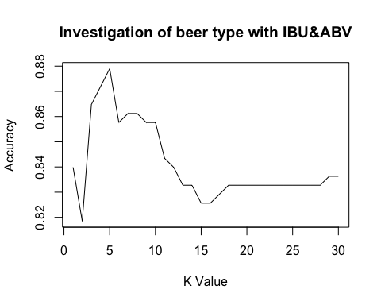 ## Loop for many k and many training / test partitions 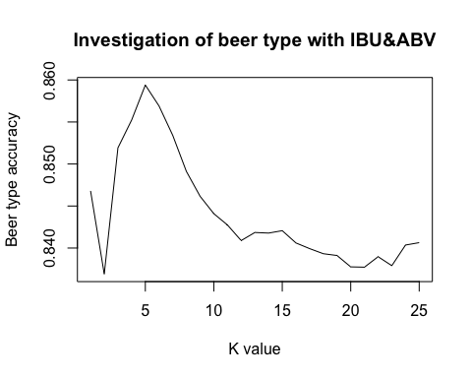

## [1] 5

## [1] 0.859395

## plot: [1,1] [=>------------------------------------------------------------] 4% est: 0s  
## plot: [1,2] [====>---------------------------------------------------------] 8% est: 1s  
## plot: [1,3] [======>-------------------------------------------------------] 12% est: 1s  
## plot: [1,4] [=========>----------------------------------------------------] 16% est: 1s

## Warning in ggally_statistic(data = data, mapping = mapping, na.rm = na.rm, : Removed 8 rows  
## containing missing values

## plot: [1,5] [===========>--------------------------------------------------] 20% est: 1s

## Warning in ggally_statistic(data = data, mapping = mapping, na.rm = na.rm, : Removed 8 rows  
## containing missing values

## plot: [2,1] [==============>-----------------------------------------------] 24% est: 1s  
## plot: [2,2] [================>---------------------------------------------] 28% est: 1s  
## plot: [2,3] [===================>------------------------------------------] 32% est: 1s  
## plot: [2,4] [=====================>----------------------------------------] 36% est: 1s

## Warning in ggally_statistic(data = data, mapping = mapping, na.rm = na.rm, : Removed 8 rows  
## containing missing values

## plot: [2,5] [========================>-------------------------------------] 40% est: 0s

## Warning in ggally_statistic(data = data, mapping = mapping, na.rm = na.rm, : Removed 8 rows  
## containing missing values

## plot: [3,1] [==========================>-----------------------------------] 44% est: 1s  
## plot: [3,2] [=============================>--------------------------------] 48% est: 0s  
## plot: [3,3] [===============================>------------------------------] 52% est: 0s  
## plot: [3,4] [==================================>---------------------------] 56% est: 0s

## Warning in ggally_statistic(data = data, mapping = mapping, na.rm = na.rm, : Removed 8 rows  
## containing missing values

## plot: [3,5] [====================================>-------------------------] 60% est: 0s

## Warning in ggally_statistic(data = data, mapping = mapping, na.rm = na.rm, : Removed 8 rows  
## containing missing values

## plot: [4,1] [=======================================>----------------------] 64% est: 0s

## Warning: Removed 8 rows containing missing values (geom_point).

## plot: [4,2] [=========================================>--------------------] 68% est: 0s

## Warning: Removed 8 rows containing missing values (geom_point).

## plot: [4,3] [============================================>-----------------] 72% est: 0s

## Warning: Removed 8 rows containing missing values (geom_point).

## plot: [4,4] [==============================================>---------------] 76% est: 0s

## Warning: Removed 8 rows containing non-finite values (stat_density).

## plot: [4,5] [=================================================>------------] 80% est: 0s

## Warning in ggally_statistic(data = data, mapping = mapping, na.rm = na.rm, : Removed 8 rows  
## containing missing values

## plot: [5,1] [===================================================>----------] 84% est: 0s

## Warning: Removed 8 rows containing missing values (geom_point).

## plot: [5,2] [======================================================>-------] 88% est: 0s

## Warning: Removed 8 rows containing missing values (geom_point).

## plot: [5,3] [========================================================>-----] 92% est: 0s

## Warning: Removed 8 rows containing missing values (geom_point).

## plot: [5,4] [===========================================================>--] 96% est: 0s

## Warning: Removed 8 rows containing missing values (geom_point).

## plot: [5,5] [==============================================================]100% est: 0s

## Warning: Removed 8 rows containing non-finite values (stat_density).

