# *IMPLEMENTATION OF 8/10 DECODER OF ETHERNET PHY USING PYTHON AND VERIFICATION USING MATLAB.*

*APRIL 10, 2022*

*FOLDER : https://drive.google.com/drive/folders/1otBIr0hru0VCBP826z43tjeTDj4B9lA9?usp=sharing*

1. ***NAME:*** *Nilay Arya*  ***ID NO:*** *2019AAPS1230H*
2. ***NAME:*** *Surya Chandra G*  ***ID NO:*** *2019AAPS1221H*
3. ***NAME:*** *Pavan Prathapa S*  ***ID NO:*** *2019AAPS1225H*

# *8B/10B ENCODER-DECODER*

*ACKNOWLEDGEMENT*

**We would like to thank Dr. Subhendhu Sahoo Kumar for giving this project on 8/10 decoder. It was a great opportunity to learn about encoders and decoders and to get some hands-on experience in python and MATLAB. We would also like to thank our friends who helped us with the project. It was a collaborative effort, and we learnt a lot about teamwork and delegation. Overall, it was a great learning experience.**

### *Contents*

* **INTRODUCTION**
* **FEATURES**
* **APPLICATION**
* **BLOCK DIAGRAMS**
* **8B/10B CODE MAPPING**
* **DISPARITY**
* **RUNNING DISPARITY**
* **8B/10B ENCODING-DECODING TABLES**
* **CODE IN PYTHON FOR DECODER**
* **DECODER VERIFICATION USING MATLAB**

## *INTRODUCTION*

* **8b/10b encoding was proposed by Albert X. Widmer and Peter A. Franaszek of IBM Corporation in 1983**
* **8B/10B Encoder encodes data for transmission where 8-Bit data converted to 10-Bit data.**
* **Single bit error detection is possible**
* **High-speed Serial data transmission protocols utilize 8B/10B Encoding scheme.**

## *FEATURES*

* **Encoding of 8-bit bytes into 10-bit symbols**
* **Decoding of 10-Bit symbols into 8-bit Bytes**

## *APPLICATIONS*

* **Gigabit Ethernet**
* **PCI-Express 1.x and 2.x**
* **JESD 204B**
* **USB 3.0**
* **Display Port**
* **Serial ATA (SATA)**
* **XAUI**
* **SAS**

## *BLOCK-DIAGRAM*

## *blockdiagram*

## *8B TO 10B CODE MAPPING*

* **Encodes 8-Bit Bytes to 10-Bit Symbols**
* **Code groups includes 256 data characters and 12 control characters**
* **Data character named as Dx.y :- 8-bit width**
* **Control character named as Kx.y :- 8-bit width**
* **This coding scheme breaks data in to two blocks**
  + **3 MSB Bits**
  + **5 LSB bits**
* **3 Bit encoded to 4 Bits**
* **5 Bit encoded to 6 Bits**
* **4-Bit and 6-Bit blocks combined and encoded into 10-Bit symbol**

**For example**

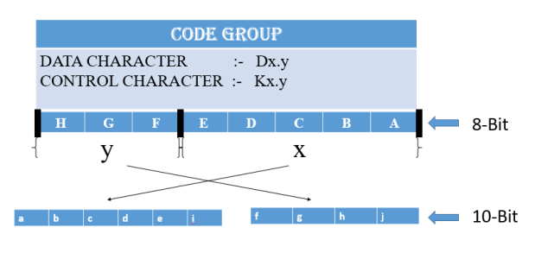

## *DISPARITY*

* **The disparity is required to the employed a balanced number of 0s and number of 1s**
* **The disparity of Block = number of 1s – the number of 0s**
* **The disparity of Block = 0 à “Disparity Neutral”**
* **The disparity of 4-Bit block and a 6-Bit block is Neutral then Disparity of 10-Bit block is neutral**
* **Disparity Neutral means perfect DC-balanced code stream.**

**For Example…………..**

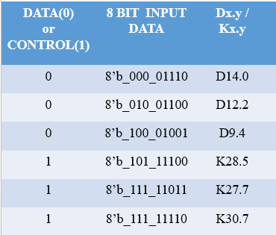

## *RUNNING DISPARITY*

* **Value of disparity of 10-Bit encoded data is +2 or -2 or 0.**
* **+1 or -1 is invalid running disparity of 10-Bit encoded data.**
* **The serial data stream is no longer DC-balanced if the disparity is +2 or -2**
* **Running disparity is introduce to transmit data stream DC-balanced**
* **In order to maintain a DC-balance data stream, each code group will be converted to one of the two possible values**
  + **RD+**
  + **RD-**
* **The RD- disparity will be +2 or 0**
* **The RD+ disparity will be -2 or 0**

**For example**

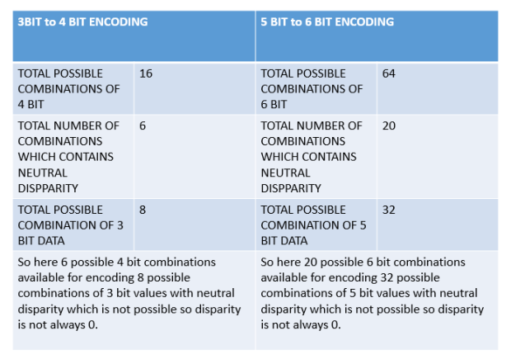

* **Transmitter assumes negative disparity(RD-) at startup.**
* **The encoder will pick one of the two values based on the calculation of current Running Disparity**
* **Receiver side or decoder side input 10-Bit data is not valid if a 10-Bit value is not there in the encoding-decoding table.**
* **Running disparity state diagram is given below**

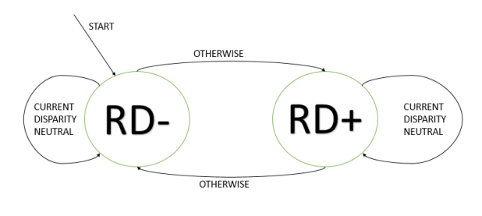

* **Every 8-Bit input data can be encoded to 10-Bit data by two possibilities first is positive disparity and second is a negative disparity.**

**For Example………..**

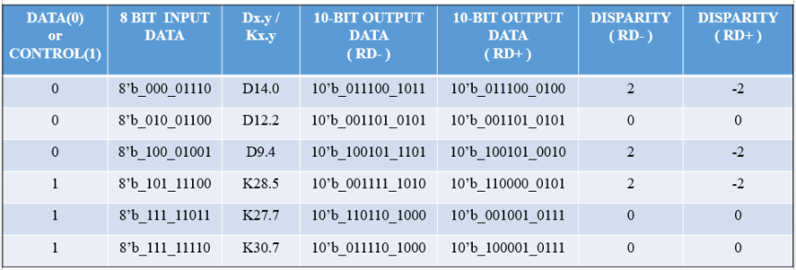

## *8B/10B ENCODING-DECODING TABLES*

* **Download Encoding-Decoding tables from following link……**

***LINK :-***[***ENCODER_AND_DECODER_TABLE***](https://akshayparmarvlsi.files.wordpress.com/2018/09/encoder_and_decoder_table.pdf)

## *PYTHON SIMULATION and CODES:*

*RESULTS:*

## *mATLAB SIMULATION CODE:*

*ASSUMTIONS FOR INPUT:*

The inputs given to the program are regular inputs as instructed by the assignment norms. The input is an 8 bit binary number and the output is a 10 bit binary encoded output.

Program is functioning without any errors and exceptions. Regular assumptions were made for coding of the encoder. Output is a RD- output.

*CONCLUSION*

**We can conclude that the above code for the 8b/10b decoder in python is working accurately and well as we have verified it using MATLAB. Hence the objective of the project has been met.**

# 

# *REFERENCES*

* Xu, Q., & Liu, H. (2012). 8b/10B encoder design. *Proceedings of the 2nd International Conference on Computer Application and System Modeling*. https://doi.org/10.2991/iccasm.2012.25
* Wikimedia Foundation. (2022, March 3). *8b/10b encoding*. Wikipedia. Retrieved April 10, 2022, from https://en.wikipedia.org/wiki/8b/10b_encoding

THANK YOU

# 