Model Architecture

For every model :-

* Learning rate = 0.005
* Batch size = 32
* Epochs = 30

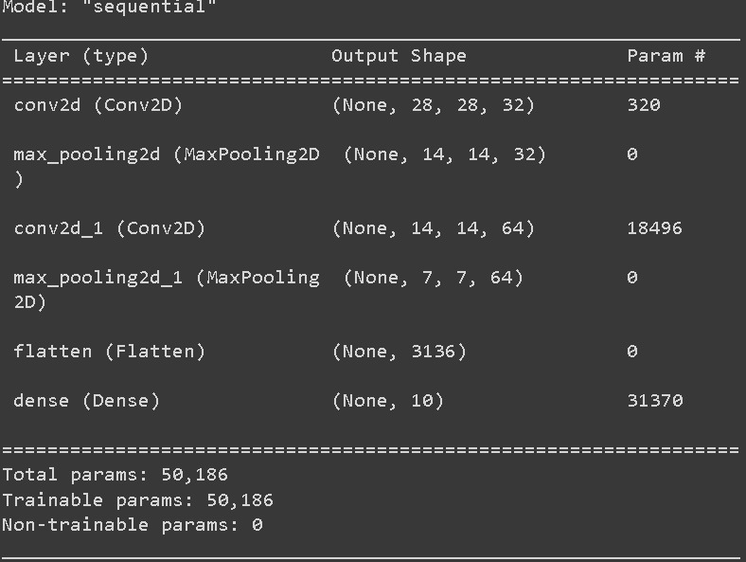

Accuracy vs Epochs and Loss vs Epochs

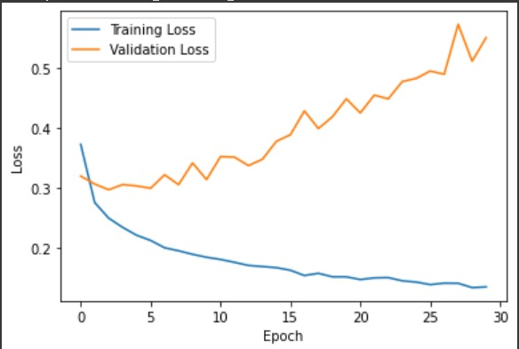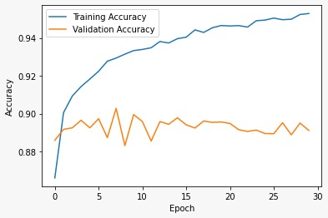

Confusion Matrix

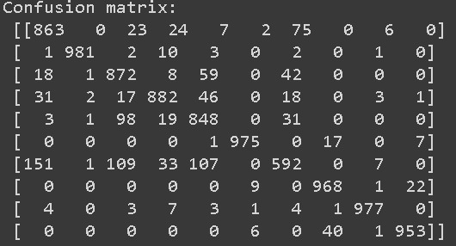

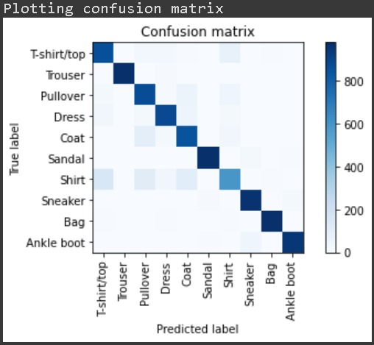

Classification Report

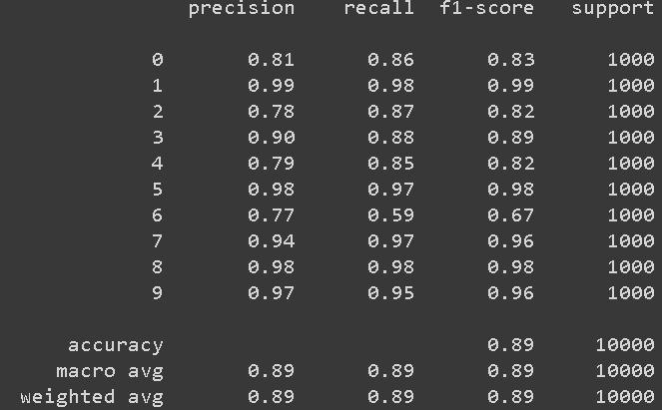

It achieved a good accuracy of 89.11% on the validation set.

The training accuracy was 95.29% which shows that it did not overfit.