Evaluation Warning: The document was created with Spire.Doc for JAVA.

万年青 1

玫瑰 1

风信子 1

Flowers

# 万年青

万年青是一种小花。Ornithogalum is a genus of perennial plants mostly native to southern Europe and southern Africa belonging to the family Asparagaceae.

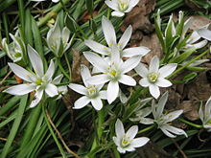

## 玫瑰

玫瑰是一种常见的美丽花朵。A rose is a woody perennial flowering plant of the genus Rosa, in the family Rosaceae, or the flower it bears. There are over a hundred species and thousands of cultivars.

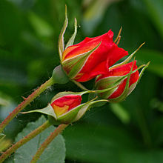

### 风信子

风信子是一种少见的花朵。Hyacinthus is a small genus of bulbous.

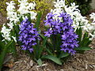

Several species of Brodiea, Scilla.

| **国家** | **首都** | **大洲** | **区域** | **人口** |
| --- | --- | --- | --- | --- |
| Argentina | Buenos Aires | South America | 2777815 | 32300003 |
| Bolivia | La Paz | South America | 1098575 | 7300000 |
| Cuba | Havana | North America | 114524 | 10600000 |
| America | Washington | North America | 9363130 | 249200000 |
| Uruguay | Montevideo | South America | 176140 | 3002000 |
| Venezuela | Caracas | South America | 912047 | 19700000 |