Capstone Proposal

Kuan-Yu Chen, Rocky J Luo, Tung-Tsan Wu
College of Professional Studies, Northeastern University
ALY 6140: Python & Analytics Technology
Professor Richard He
October 10, 2025

Introduction
Sports analytics is a popular field that uses data science, statistics, and machine learning to analyze athletic performance and game strategy. It transforms a large amount of raw data to actionable insight that could help teams win and players improve. In the data-rich world of Major League Baseball (MLB), teams pay more attention to seek a competitive advantage by leveraging data analysis to enhance players’ capability and predict future success. Pitcher, as the most impactful role in the game, a pitcher’s main goal is to prevent the opponent from scoring.
This project utilizes a dataset of MLB pitching data and salary from 2011 to 2024. The methodology includes a data analysis pipeline. Starting with data cleaning to handle missing values. Subsequently, using three different models like: regression model, classification model and random forest model to investigate the linear and non-linear relationship between variables and its inherent capability to rank features by their predictive importance, providing a direct answer to our research question.
Proposed questions
In this Capstone Project, the main questions guiding this analysis are:
1. What key pitching statistics are the most important factors affecting a pitcher's earned run average (ERA), and how can we quantify their respective impacts?
2. How accurately can we predict a pitcher’s performance tier or salary level based on these statistical indicators using machine learning models?
3. Can Major League Baseball pitchers be classified as elite or non-elite based on their season performance and career statistics?

Exploratory Data Analysis
The chosen dataset is the MLB Pitching Data from Kaggle, which contains 21,094 records and 18 features, including whole-season summaries and detailed pitch-level data, such as innings pitched, wins above replacement, and earned runs. The time spanned from 2011 to 2024, with 3788 unique players’ data. The data is not clean, as many performance statistics, such as WAR, W, and IP, contain over 8,600 missing values. To ensure the integrity of the model, a data cleanup process was implemented. Missing values in the key statistical columns (WAR, IP, SO, BB, WHIP, and ERA) were imputed using the median value of their respective columns. In addition, to build a fairness comparison benchmark, considering each pitcher's workload is different workload. Using rate-based statistics, like strikeouts per nine innings (SO9), could resolve this issue by standardizing performance. For instance, pitcher’s SO9 is calculated as (SO / IP) * 9 = 9.0., ensuring all pitchers have an identical SO9.
Figure 1
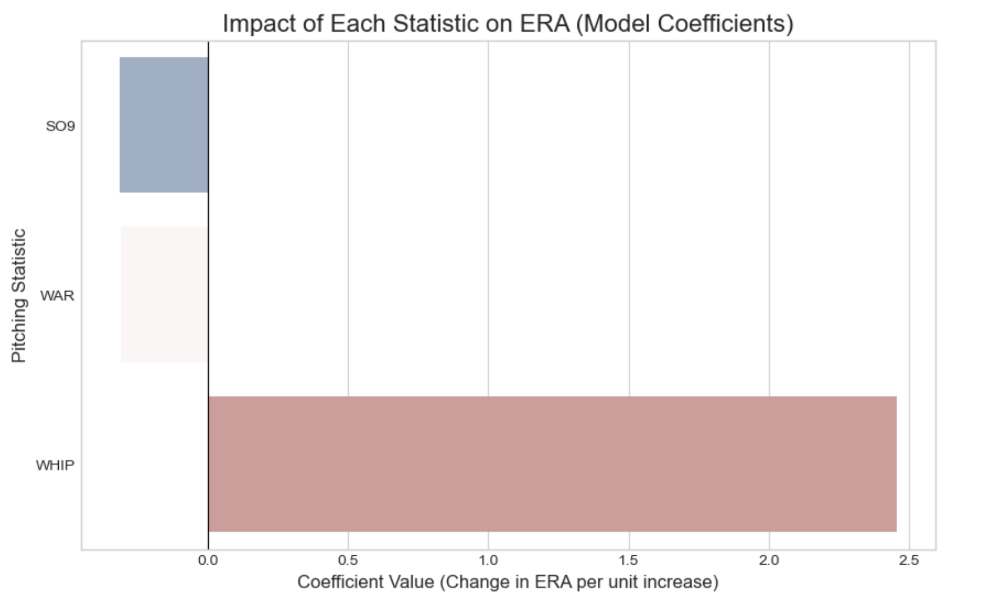
Figure 1 shows the standardized regression coefficients for each variable, illustrating their relative impact on ERA. The horizontal bars represent the magnitude and direction of each variable’s effect. The bar extending to the right indicates positive associations with ERA. Conversely, the bar extending to the left indicates negative associations. Bar length corresponds to the strength of the relationship.
The metric WHIP demonstrates the strongest effect on ERA (β = 3.77), This indicates that pitchers with higher WHIP values tend to have substantially higher ERAs. SO9 and WAR with coefficients of approximately -0.29 and -0.23. This suggests that higher strikeout rates and higher player value are associated with lower ERAs. The figure representation clearly shows WHIP as the dominant predictor, with an effect size approximately 13 times larger than WAR and SO9.
Figure 2
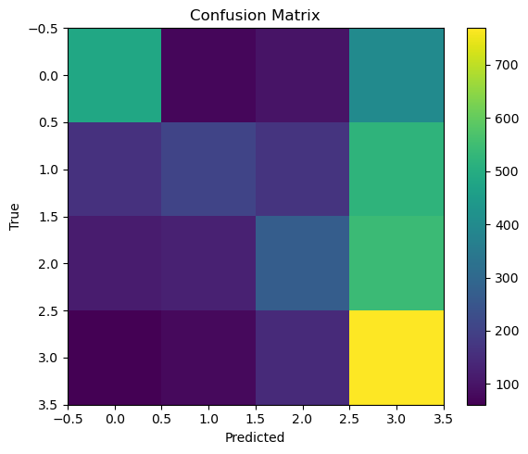
Figure 2 presents the confusion matrix of the salary-tier classification model. Each cell represents the number of predictions for a true salary group. Darker diagonal cells indicate correct classifications, while lighter off-diagonal cells denote misclassifications. The model shows stronger performance in distinguishing the highest (T4) and lowest (T1) salary tiers, whereas confusion between T2 and T3 reflects overlapping pitching statistics among mid-tier players. Overall, the figure demonstrates that the decision tree effectively captures general salary trends based on performance metrics, but struggles to accurately separate players whose statistics place them close together in adjacent salary tiers (James et al., 2021; Tang & Zhang, 2020).

Figure 3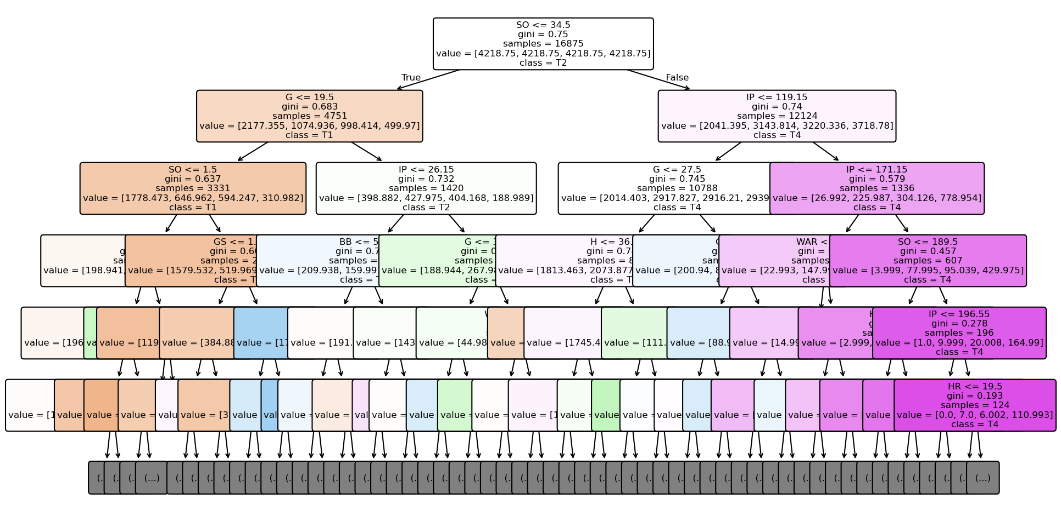
Figure 3 uses a visual decision tree model to categorize pitchers into four salary tiers, ranging from T1 to T4.
Internal nodes show data performance.Each branch divides into purer grouping criteria.Within the node, salary categories are defined based on the following variables: number of games played (G), number of strikeouts (SO), and innings pitched (IP) (Albert & Bennett, 2003; Baumer et al., 2015).
The model indicates that pitchers with higher number of appearances and strikeouts are more likely to be classified into the T3-T4 salary tiers. Pitchers with fewer appearances and lower durability are more likely to be classified as T1-T2.
This hierarchical structure demonstrates that both pitching workload and pitching performance jointly determine salary levels.This aligns with the actual logic of baseball evaluation. (Breiman et al., 1984; Quinlan, 1986).
Figure 4
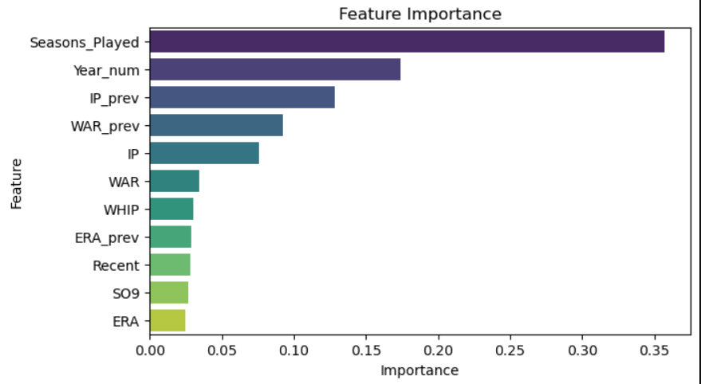
Figure 4 presents the importance of visualization from the Random Forest model that shows the main factors that influence the pitcher’s salary level. The bars represent how important the feature effect is. Seasons_Played emerged as the most influential feature, and Year_num, IP_prev, and WAR_prev followed the first. This suggests that career experience, consistency, and prior-season performance play a substantial role in distinguishing elite pitchers. While efficiency measures such as WHIP and ERA also contribute, their lower relative importance indicates that salary decisions in Major League Baseball depend not only on immediate season outcomes but also on sustained career performance and durability. The visual representation emphasizes that experience-based variables collectively outweigh single-season indicators in predicting elite compensation status.
Experiments and results
- Regression Model:
To seek the relationship between ERA and other features like WAR, SO9, and WHIP, linear regression was selected because it provides interpretable coefficients that could directly quantify predicted variables’ impact on ERA (James, Witten, Hastie, & Tibshirani, 2013), which was crucial for relative importance of pitching statistics. The choice of these specific metrics is grounded in established sabermetric research, where WAR, strikeout rates, and WHIP are recognized as fundamental indicators of pitcher effectiveness (Baumer & Zimbalist, 2019; Slowinski, 2010).
Figure 5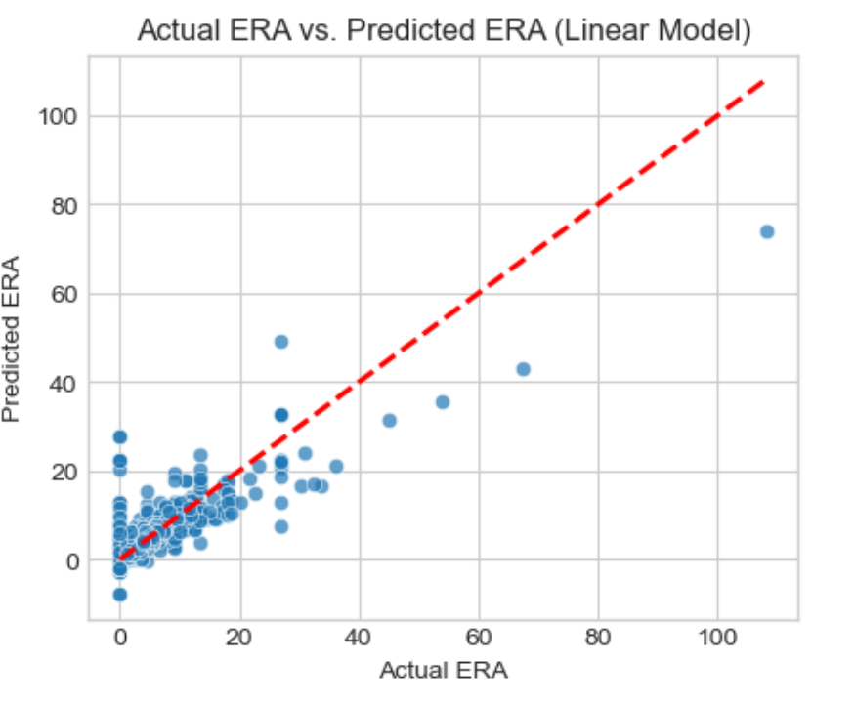
Figure 5 presents a scatter plot to compare actual ERA against model-predicted ERA. The red line displays perfect prediction, where predicted values would exactly match actual values. The majority of observations cluster near this identity line, particularly in the lower ERA, indicating strong predictive accuracy for typical major league pitcher performance. However, several notable outliers are evident, including one extreme case where actual ERA over 100 while predicted ERA is approximately 75. The density of points decreases for ERA values over 50, reflecting the relative rarity of poor pitching performance in the dataset. The figure alignment of most observations with the identity line corroborates the model’s R² of about 0.68, demonstrating that the model captures the general trend in ERA variation while showing greater prediction uncertainty for extreme values (Kutner, Nachtsheim, Neter, & Li, 2005). Therefore, the strong visual agreement between predictions and actual values in the primary range of interest validates the model’s utility for practical applications in pitcher evaluation.
- Classification Model:
This project develops a classification model to predict a pitcher’s salary tier based on season performance metrics (Pedregosa et al., 2011).
To enable categorical prediction, the continuous salary variable (“Total Cash”) was converted into four quartile-based categories:
T1 – Lowest 25%, T2 – 25–50%, T3 – 50–75%, T4 – Highest 25% (Major League Baseball, 2024).
After the data is preprocessed, the train_test_split function is called to split the predictions in the ratio of 80% training set and 20% test set. This is in line with scikit-learn (Pedregosa et al., 2011).
The team decided to choose to implement the classification task using decision trees. The decision tree has good interpretability and captures the nonlinear relationships of pitching statistics such as the number of plate appearances G, the number of innings pitched IP, and the number of strikeouts SO (Quinlan, 1986; Breiman et al., 1984).
Ultimately, the final configuration (max_depth = 6, min_samples_leaf = 10, ccp_alpha = 0.0) strikes a balance between accuracy and interpretability.
Five-fold cross-validation yielded a macro-average F1 score of 0.37, and the hold-out test achieved Accuracy = 0.41 and F1_macro = 0.39.
By analyzing the results, the team found out that the model can be accurate in classified T1 and T4 pitchers, but there are some degree of error when classified T2 and T3 pitchers. According to Tang and Zhang, the error reflects the overlap in statistical characteristics among mid-level pitchers (Tang & Zhang, 2020).
In addition, number of games played (G), innings pitched (IP), and strikeouts (SO) these three variables had the greatest impact on the predicted outcomes. According to Albert et al. pitchers' workload, durability, and performance consistency remain key determinants of player compensation (Albert & Bennett, 2003; Baumer et al., 2015).
- Random Forest Model:
The Random Forest Classifier was created to deal with complex patterns and improve predicting accuracy, such as nonlinear relationships between performance and salary tiers. The Random Forest algorithm was selected to enhance the decision tree model because it worked with multiple trees that can help result be more stable and avoid the overfitting situation (Géron, 2023). The model created 500 trees (n_estimators = 500) with a maximum depth of 20 and balanced class weights to fit with the non-balanced data, and only the top 25% of pitchers were marked as “HighPay” because only 50% might not show the elite. Training and testing accuracy scores were 0.85 and 0.81. There weren't a large number of differences between them, so it can be told that wasn't overfitting. The threshold of classification was adjusted from 0.5 to 0.6 to reduce the possibility that normal pitchers were selected to be good pitchers, and it improved overall testing accuracy to 0.83.
Figure 6
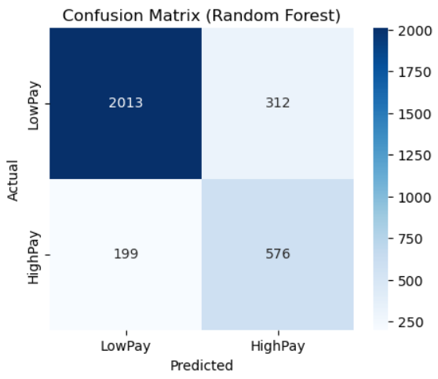
Figure 6 shows that the Random Forest model picked most elite pitchers and made few mistakes with mid-level salary groups. It picked 74% of elite players correctly from the testing. The feature importance chart shows that Seasons_Played, Year_num, and WAR_prev are the most important factors. These results mean that both a pitcher’s experience and past performance have a big effect on pay levels. This finding supports earlier research which showed that steady and consistent performance helped increase MLB player salaries more than single-season success (Vrooman, 2023). The Random Forest’s interpretability and predictive stability make it an effective tool for understanding the multidimensional nature of pitcher value in professional baseball analytics (James et al., 2023).
Interpretive & Conclusion
In order to predict MLB pitcher performance and salary, the team used multiple predictive models, including a linear regression model, a decision tree classifier, and a Random Forest model. Different models can help the team to analyze data within different angels. Ranging from linear relationship to more complex nonlinear decision prediction.
The analysis outcome demonstrates that pitchers’ ERA can be effectively predicted through four key variables, they are WAR, SO9, HR9, and WHIP. The linear regression model explained about 68% of ERA variance. The WHIP causes the most effective impact in prediction. All predicted variables show linear relation with ERA, which shows the effectiveness of the model. Although the model performs effectively in player evaluation and team management, future research should focus more on other modeling approaches to increase the accuracy of prediction. The decision tree model is developed based on the pitcher's performance, to predict pitchers’ salary tiers (Breiman et al., 1984; Pedregosa et al., 2011).
After parameter tuning, the final decision tree has a structure of six layers. Each leaf node has at least ten samples. The parameters are as follows: max_depth = 6, min_samples_leaf = 10, ccp_alpha = 0.0
The model had a macro F1 score of 0.37 and a test set accuracy of 0.41, indicating moderate predictive ability (James et al., 2021).
The confusion matrix (Figure 2) shows that the model has errors in dividing between T2 and T3 pitchers, but performs accurately in dividing the performance of T4 and T1 pitchers.
This outcome suggests that extreme performers are more easily distinguishable due to clear statistical differences in their workloads and effectiveness, whereas mid-tier pitchers share overlapping performance characteristics, making classification inherently more challenging (Tang & Zhang, 2020).
Feature analysis highlights Games (G), Innings Pitched (IP), and Strikeouts (SO) as the most influential predictors, reinforcing the idea that workload, endurance, and control are the dominant factors in determining player compensation (Albert & Bennett, 2003; Baumer et al., 2015).
Despite only moderate accuracy, the interpretable decision tree structure provides valuable insight into how individual metrics influence salary outcomes (Quinlan, 1986; Breiman et al., 1984).
The results demonstrate the practical potential of machine learning in salary prediction and talent evaluation—providing a transparent framework that aligns well with established baseball evaluation logic (Tang & Zhang, 2020; James et al., 2021).
The Random Forest model was created to capture more complex patterns (Géron, 2023). It used 500 trees with a maximum depth of 20 and class balanced to handle the smaller number of high-salary pitchers. The model reached a training accuracy of 0.85 and a testing accuracy of 0.81, which means it can generalize well. After adjusting the decision threshold from 0.5 to 0.6, the accuracy improved slightly to 0.83. The most important factors were Seasons_Played, Year_num, and WAR_prev, showing that experience and steady performance over time have a strong effect on salary. Compared to the decision tree, the Random Forest was more stable and accurate.
Overall, the three models together show that MLB pitchers’ salaries can be predicted from their performance and career data. The linear regression model is simple and clear, the decision tree is easy to explain, and the Random Forest gives the best accuracy. With all three methods, we can understand much better about how player performance and experience influence pay levels in baseball.
Contributions
Tung-Tsan Wu: Slide Production, Multiple Linear Regression model
Rocky J Luo: Slike Production, Classification model
Kuan-Yu Chen: Slike production, Random Forest model

References
Albert, J., & Bennett, J. (2003). Curve ball: Baseball, statistics, and the role of chance in the game. Springer.
https://doi.org/10.1007/978-1-4613-0045-0
Baumer, B. S., Jensen, S. T., & Matthews, G. J. (2015). OpenWAR: An open-source system for evaluating overall player performance in Major League Baseball. Journal of Quantitative Analysis in Sports, 11(2), 69–84.
https://doi.org/10.1515/jqas-2014-0098
Breiman, L., Friedman, J. H., Olshen, R. A., & Stone, C. J. (1984). Classification and regression trees. Wadsworth International Group.
Géron, A. (2023). Hands-on machine learning with Scikit-Learn, Keras, and TensorFlow (3rd ed.). O’Reilly Media.
Grömping, U. (2009). Variable importance assessment in regression: Linear regression versus random forest. The American Statistician, 63(4), 308–319.
https://doi.org/10.1198/tast.2009.08199
James, B., Albert, J., & Bennett, J. (2023). Analyzing baseball data with R (2nd ed.). CRC Press.
James, G., Witten, D., Hastie, T., & Tibshirani, R. (2021). An introduction to statistical learning: With applications in R (2nd ed.). Springer.
https://www.statlearning.com/
Kutner, M. H., Nachtsheim, C. J., Neter, J., & Li, W. (2005). Applied Linear Statistical Models (5th ed.). McGraw-Hill/Irwin.
Major League Baseball. (2024). Official MLB statistics. Retrieved October 10, 2025, from https://www.mlb.com/stats
Obie. (2025). MLB pitching data and salary [Data set]. Kaggle.
https://www.kaggle.com/datasets/obie06/mlb-pitching-data
Pedregosa, F., Varoquaux, G., Gramfort, A., Michel, V., Thirion, B., Grisel, O., Blondel, M., Prettenhofer, P., Weiss, R., Dubourg, V., Vanderplas, J., Passos, A., Cournapeau, D., Brucher, M., Perrot, M., & Duchesnay, É. (2011). Scikit-learn: Machine learning in Python. Journal of Machine Learning Research, 12, 2825–2830.
https://jmlr.org/papers/v12/pedregosa11a.html
Quinlan, J. R. (1986). Induction of decision trees. Machine Learning, 1(1), 81–106.
https://doi.org/10.1007/BF00116251
Slowinski, D. (2010, February 12). What is WAR?. FanGraphs Sabermetrics Library. Retrieved from https://library.fangraphs.com/war/what-is-war/
Tang, T., & Zhang, J. (2020). Machine learning applications in sports analytics: A review. Applied Sciences, 10(24), 8828. https://doi.org/10.3390/app10248828
Vrooman, J. (2023). Competitive balance and salary structures in Major League Baseball: A post-pandemic perspective. Managerial and Decision Economics, 44(3), 1674–1689. https://doi.org/10.1002/mde.3671

