付款通知书

|  |  |  |  |  |  |  |
| --- | --- | --- | --- | --- | --- | --- |
| 付款通知书编号:[${entity.NO}](xpl:)  客户 ID: [${entity.id}](xpl:) |  | |  |  | | --- | --- | | 抬头: | 收货方: | | [${entity.taitou}](xpl:) | [${entity.consignee}](xpl:) | |

|  |  |  |  |  |  |  |
| --- | --- | --- | --- | --- | --- | --- |
| 日期 | 订单编号 | 销售代表 | 离岸价 | 发货方式 | 条款 | 税号 |
| [<c:for>](xpl:%3cc:for%20var=%22order%22%20items=%22$%7bentity.orders%7d%22%3e)[${}](expr:order.saleDate) | [SN18090](expr:order.orderNo) | [李四](expr:order.salesman) | [5000](expr:order.price)元 | [快递](expr:order.delivery) | [附录A](expr:order.terms) | [T11090](expr:order.taxNumber)[</>](xpl:%3c/c:for%3e) |

|  |  |  |  |  |  |  |
| --- | --- | --- | --- | --- | --- | --- |
| 货物明细 | | | | | | |
| 数量 | 货物 | 说明 | 折扣 | 应纳税 | 单价 | 总计 |
| [<c>](xpl:%3cc:for%20var=%22goods%22%20items=%22$%7bentity.goodsList%7d%22%3e)[amount](expr:goods.amount) | [name](expr:goods.name) | [desc](expr:goods.desc) | [discount](expr:goods.discount??'/') | [tax](expr:goods.tax) | [price](expr:goods.price) | [total](expr:goods.total)[</>](xpl:%3c/c:for%3e) |
| 人工费 | | | | | | |
| 种类 | | | | 人数 | 单价 |  |
| [<c:for>](xpl:%3cc:for%20var=%22cost%22%20items=%22$%7bentity.laborCosts%7d%22%3e)[type](expr:cost.type) | | | | [num](expr:cost.num) | [price](expr:cost.price) | [price*num](expr:cost.price*cost.num)[/>](xpl:%3c/c:for%3e) |
| 总共：[{{total}}](expr:entity.totalCost) | | | | | | |

|  |  |
| --- | --- |
| 小计: | [{{subtotal}}](expr:entity.subtotal) |
| 税额: | [${entity.tax}](xpl:) |
| 运输: | [{{transform}}](expr:entity.transform) |
| 其他: | [{{other}}](expr:entity.other) |
| 未付余额: | [{{unpay}}](expr:entity.unpay) |

[<c:for var='i' items="${[1,2]}">](xpl:%3cc:for%20var='i'%20items=%22$%7b[1,2]%7d%22%3e)

内容

[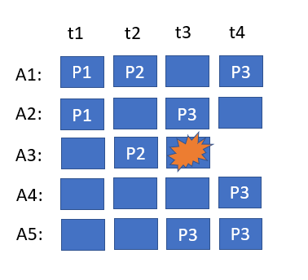](expr:images[i])

内容[2](expr:i)

[</c:for>](xpl:%3c/c:for%3e)

|  |  |
| --- | --- |
| XplGenConfig |  |
| dump | true |
| dumpFile | dump-payment.doc.xml |
| importLibs |  |
| beforeGen | <c:script>  logDebug("test")  </c:script> |
| afterGen |  |