**Report2 -CNN Model**

目录

重要代码 1

实验结果 4

## 重要代码

glove预训练的embedding读取

下载下来的glove文件形式如下



每一行为一个词，以及其所对应的向量。我将词存入words, 将向量存入vectors, 并通过python的pickle库以及numpy.save来保存这些数据结构。（如果每次任务运行时再读取glove embedding, 太浪费时间了）

文件在task2-RNN/Glove-read.py

with open('glove_wordvec/glove6B200d.txt', 'rb') as f:

for line in f:

line = line.decode().split()

word = line[0]

words.append(word)

Word_Index[word] = idx

vector = np.array(line[1:])

vectors[idx, :] = vector

idx = idx + 1

vectors = vectors.reshape((400000, 200)).astype('float')

print(vectors[0:4, :])

with open('glove_wordvec/words200d.pickle', 'wb') as handle:

pickle.dump(words, handle, protocol=pickle.HIGHEST_PROTOCOL)

with open('glove_wordvec/Word_Index200d.pickle', 'wb') as handle:

pickle.dump(Word_Index, handle, protocol=pickle.HIGHEST_PROTOCOL)

with open('glove_wordvec/wordVectors200d.npy', 'wb') as f:

np.save(f, vectors)

根据Glove Embedding创建相应的参数矩阵（每个词所对应的embedding）.同时考虑了out-of-vocabulary word (idx = 0),以及没有对应glove embedding 的词—随机生成一个embedding.

def create_weights_matrix(DICT_SIZE, glove, INDEX_WORD, embedding_dim):

weights_matrix = np.zeros((DICT_SIZE, embedding_dim))

# idx = 0 指向out_of_vocabulary word

weights_matrix[0] = np.random.normal(scale=0.6, size=(embedding_dim, ))

for idx in INDEX_WORD.keys():

try:

weights_matrix[idx] = glove[INDEX_WORD[idx]]

except KeyError:

weights_matrix[idx]=np.random.normal

(scale=0.6, size=(embedding_dim, ))

return weights_matrix

embedding layer

def create_embedding_layer(weights_matrix, non_trainable=False):

(num_of_embeddings, embedding_dim) = weights_matrix.shape

emb_layer = nn.Embedding(num_of_embeddings, embedding_dim)

emb_layer.load_state_dict({'weight': weights_matrix})

if non_trainable:

emb_layer.weight.requires_grad = False

return emb_layer

利用了pyTorch提供的Dataset机制，使得mini-batch的划分更加简便

train_ds = TensorDataset(x_train, y_train)

valid_ds = TensorDataset(x_val, y_val)

train_dl, valid_dl = getdata(train_ds, valid_ds, bs=bs)

def fit(epochs, opt, model, loss_func, train_dl, valid_dl, config):

# 记录training_set, validation_set的loss,用于作图

loss_train = []

loss_valid = []

for epoch in range(epochs):

model.train()

epoch_loss = 0

**for xb, yb in train_dl:**

pred = model(xb)

# loss_func 似乎不支持Long类型数据，所以进行类型转换

loss = loss_func(pred.float(), yb)

with torch.no_grad():

epoch_loss += loss

loss.backward()

opt.step()

opt.zero_grad()

model.eval()

loss_train.append(epoch_loss/len(train_dl))

with torch.no_grad():

val_loss = sum(loss_func(model(xb).float(), yb)

for xb, yb in valid_dl)

loss_valid.append(val_loss/(len(valid_dl)))

print(epoch, val_loss/(len(valid_dl)))

# 保存模型

torch.save(model.state_dict(), config.savepath + str(epochs))

return loss_train, loss_valid

最后是CNN模型， 参考的模型如下，同时也参考了

<https://github.com/649453932/Chinese-Text-Classification-Pytorch/blob/master/models/TextCNN.py>， 但是最后自己还是大体上理解了该算法。

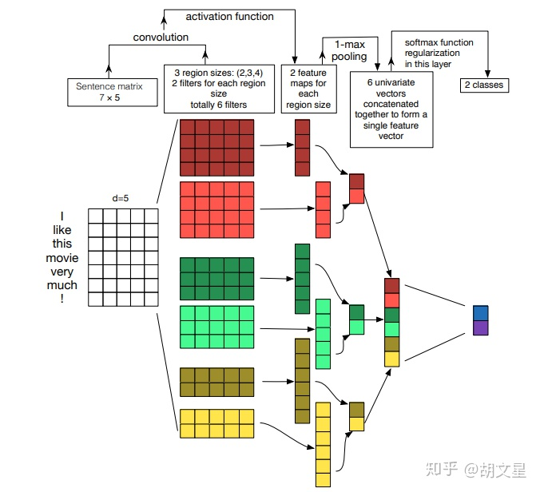

class Min_CNN(nn.Module):

def __init__(self, config):

super().__init__()

self.config = config

# num_embeddings 是文本的词典大小

self.embedding = config.embedding_layer

# 卷积层， 输入vocab_size = embedding_dim *1 (31*256*1)

# 2*embedding_dim, 3*embedding_dim, 4*embedding_dim 的filter各256个

self.convs = nn.ModuleList([

nn.Conv2d(in_channels=1, out_channels=

self.config.num_of_filter, kernel_size=

(h, self.config.embedding_dim))

for h in self.config.filter_size])

self.dropout = nn.Dropout(self.config.dropout_rate)

# 全连接层 参照图片，输入=filter的总数 输出-- class的数量（5）

self.fc = nn.Linear(self.config.num_of_filter

* len(self.config.filter_size), config.num_of_labels)

def conv_and_pool(self, x, conv):

# squeeze: dimension(A*1*B) -> (A*B)

# parameter: dim: 哪个维度的1要删掉

x = F.relu(conv(x)).squeeze(3)

**# 这个max_pool1d的参数不大明白 x.size(2)是channel?**

x = F.max_pool1d(x, x.size(2)).squeeze(2)

return x

def forward(self, xb):

out = self.embedding(xb)

out = out.unsqueeze(1)

out = torch.cat([self.conv_and_pool(out, conv) for conv in self.convs], 1)

out = self.dropout(out)

out = self.fc(out)

return out

## 实验结果

使用SGD optimizer

|  |  |  |
| --- | --- | --- |
| condition | train-accuracy | validation-accuracy |
| 1.bs=800, lr=0.2, epochs=20,  dropout_rate = 0.5 | 74.32% | 56.09% |
| 2.bs=800, lr=0.15, epochs=30,  dropout_rate = 0.5 | 74.59% | 56.31% |

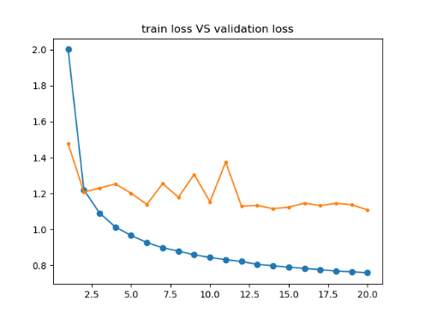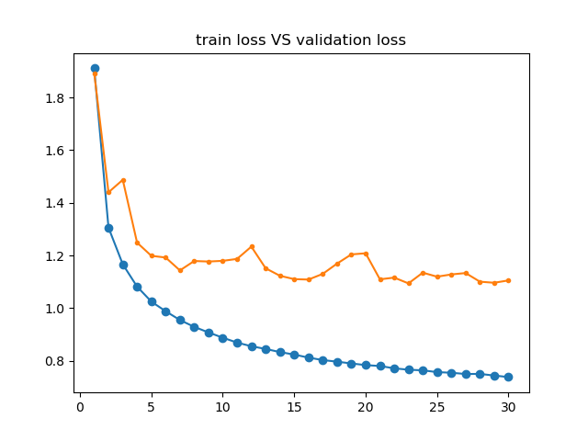

1. train loss vs validation loss 2. train loss vs validation loss

使用Adam Optimizer, 准确率方面改进不大

|  |  |  |
| --- | --- | --- |
| condition | train-accuracy | validation-accuracy |
| 3. bs=800, lr =1e-4,  epochs=15,  dropout_rate = 0.5 | 70.36% | 55.66% |
| 4.bs=800, lr=2e-4, epochs=25,  dropout_rate = 0.5 | 77.21% | 57.71% |

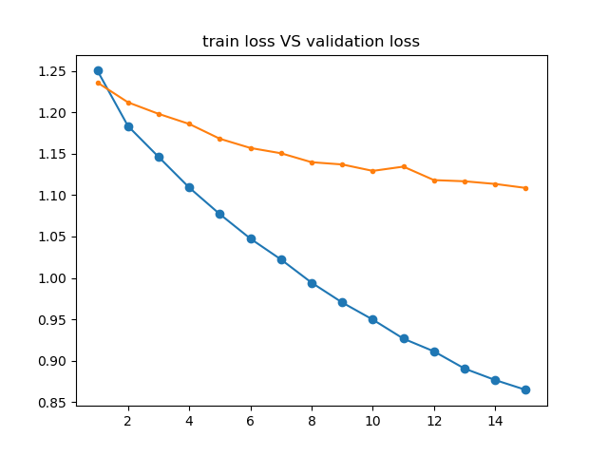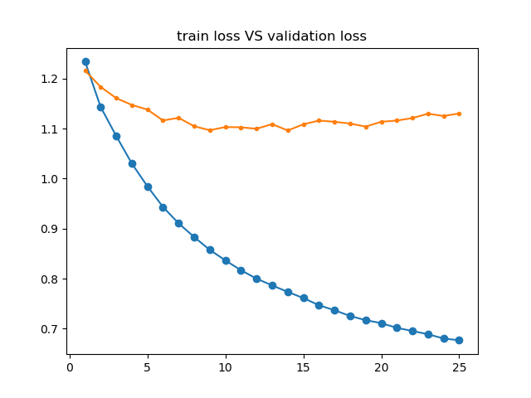

3.train loss vs validation loss 4. train loss vs validation loss

观察图像可知，训练集准确率存在进一步提升的空间，但验证集准确率难以大幅度的提高（57%左右）

由于没出现过拟合，我考虑降低dropout_rate

|  |  |  |
| --- | --- | --- |
| condition | train-accuracy | validation-accuracy |
| 5.bs=800, lr =1e-4,  epochs=25， dropout_rate = 0.1 | 78.26% | 56.39% |

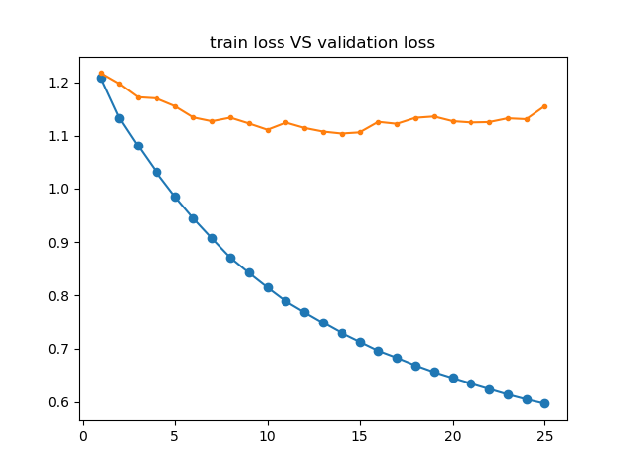

5.train loss vs validation loss

验证集准确率还是没有提高

采用预训练的glove embedding, 测试集准确率提高了2%-3%

|  |  |  |
| --- | --- | --- |
| condition | train-accuracy | validation-accuracy |
| 6.bs=800, lr =5e-4, epochs=6， dropout_rate = 0.1 | 67.82% | 59.61% |

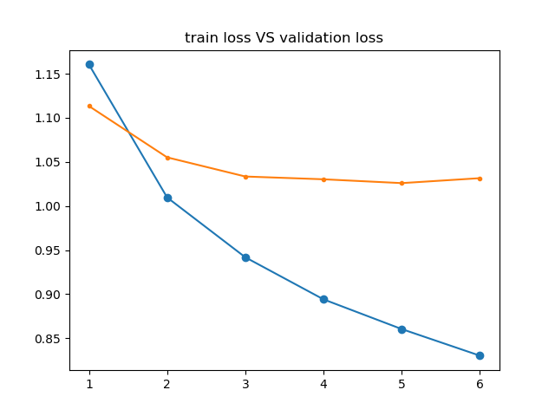

6.train loss vs validation loss

**PS: 在写报告重新检查代码时，我发现之前没有对训练数据进行shuffle, 那么看看把样本重新排序后的训练效果**

|  |  |  |
| --- | --- | --- |
| condition | train-accuracy | validation-accuracy |
| 7.bs=800, lr =5e-4, epochs=6， dropout_rate = 0.1 + shuffle | 66.97% | 64.53% |
| 8.bs=800, lr =5e-4,  epochs=10， dropout_rate = 0.1 + shuffle | 70.51% | 65.73% |

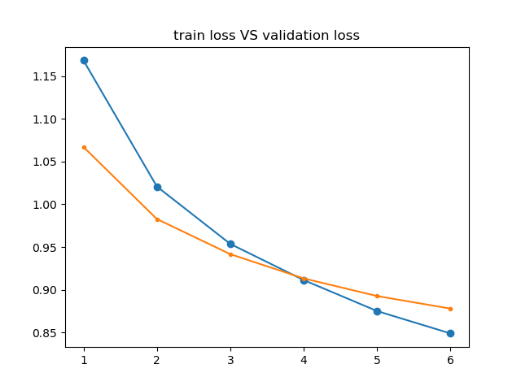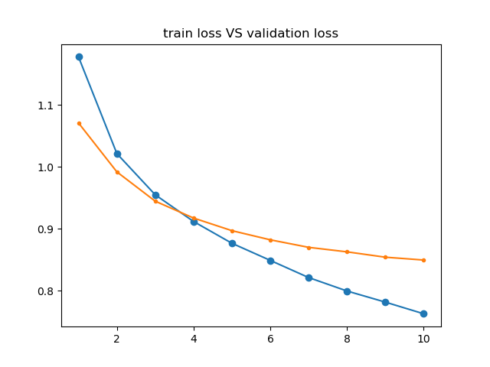

7. train loss vs validation loss 8. train loss vs validation loss

**事实证明，训练数据的随机排列非常非常重要。看似不起眼的一步，能够带来5%左右的准确率提升。**