**2D FEM with Higher Order Basis Functions**

*Authors: Adedayo Lawal and Blake Levy*

**Abstract – A two dimensional finite element method (FEM) simulation is presented. An obliquely incident plane wave propagates through an inhomogeneous media backed with a perfect electric conductor (PEC).**

1. **INTRODUCTION**

In various types of computational sciences, the reduction of one spatial dimension can reduce the computational cost. For an obliquely incident plane wave onto an inhomogeneous dielectric slab in two-dimensional space, analysis can be performed without any loss of generality in a one-dimensional space. Figure 1 shows an obliquely incident plane wave on a dielectric space backed by a PEC in two dimensions and its reduction into one dimension respectively.

Figure 1 Left: 2D problem. Right: 1D simplified version

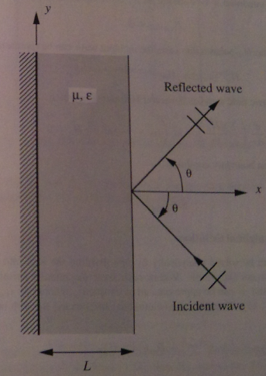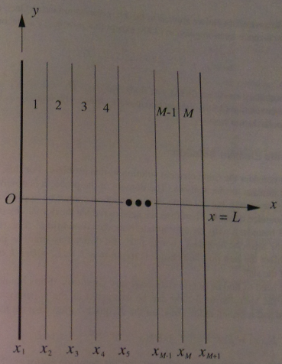

1. **FORMULATION**
   1. **Parameter Initiation**

The dielectric slab used in the project was required to be inhomogeneous. While there are an infinite number of permittivity profiles, we chose to use the same variation as defined by Jin [1] where inside the slab the relative permittivity and permeability varied as follows: and . Adjacent to the slab on one side was a medium filled with free space whereas the other side consisted of a PEC material.

As a result of the one dimensional analysis, the dielectric slab can easily be split into M elements with N number of nodes as shown in Figure 1. In the subsequent section it is evident that error decreases as M and N increase.

* 1. **Fundamental Equations**

The given geometry and source excitation characterize this problem as a one dimensional boundary value problem. The generalized differential equation to define this problem is given by equation (2.2.1). For this particular problem, the electric field inside the dielectric slab is defined by equation (2.2.2). The constants α,β,ϕ, and *f* will also be defined by matching the specified differential equation to the generalized form.

* 1. **Boundary Condition**

The use of a PEC boundary at one end of the dielectric slab requires the electric field to be zero. At the interface between the dielectric slab and free space, it can be proven that the electric field should follow equation 2.3.2.

* 1. **Higher Order Basis Functions**

In the finite element method, basis functions are used to approximate a particular solution. Linear basis functions or first order elements have advantages and disadvantages. Linear elements are typically simpler to code than higher order elements, however they suffer from slow convergence and poorer accuracy. For this reason, we have established solutions based on quadratic and cubic order basis functions.

Quadratic basis functions incorporate an extra discretization node normally positioned in the center of each element. Elements are defined for three nodes and for this reason, equations (2.2.3) and (2.2.4) can be used for simulation provided the limits on integration extend from to .

Similarly to quadratic elements, cubic elements incorporate an additional node to the quadratic element. Where linear elements only contained two nodes, cubic elements contain four nodes equally spaced. Figure XX shows the nodal position for linear, quadratic, and cubic elements. The integral equations for the cubic functions are the same as the quadratic functions provided the limits on integration extend from to .

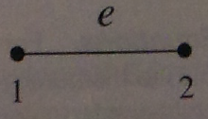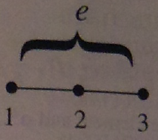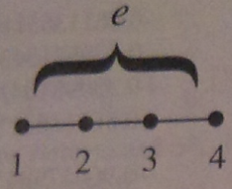

Figure 2 Nodal Discretization Left: Linear Middle: Quadratic Right: Cubic[1]

Matrix equations for quadratic/cubic basis:

1. **RESULTS**
   1. **Error**

An analytic and numerical solution can be found for the given one dimensional boundary value problem. Closed form expressions have been provided by [1] for the reflection coefficient at the *mth* and *(m+1)th* layer as referred back to Figure 1 in equations (3.1.1) and (3.1.2). The analytical solution will be taken as the benchmark to compare our numerical results to.

One metric to measure error may be determined as the difference between the numerical and analytical results. Figure XX shows the analytical, linear elements, quadratic elements, and cubic elements reflection coefficient as a function of incident angle.

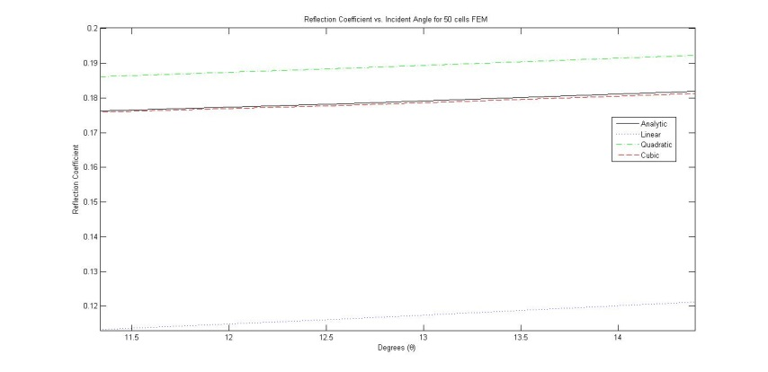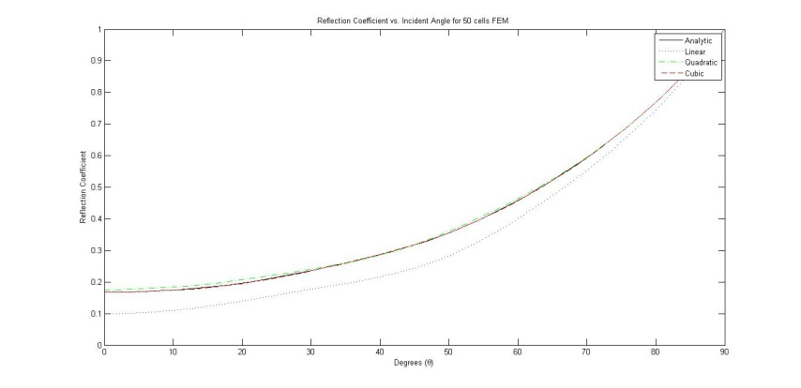

* 1. **Gaussian Quadrature**

1. **CONCLUSION**
2. **REFERENCES**
3. J. Jin, *The Finite Element Method in Electromagnetics*, 2nd edition, Wiley, 2002.