**2D TEz MOM Analysis**

*Authors: Adedayo Lawal and Blake Levy*

**Abstract – A two dimensional method of moments (MOM) simulation is presented. A normally incident plane impinges upon an infinitely long perfect electric conducting cylinder.**

1. **INTRODUCTION**
2. **FORMULATION**
   1. **Discretization**

Unlike other methods in computational electromagnetics, the geometrical mesh does not include the free space environment. The discretization occurs on the boundaries of the objects of interest. Figure XX shows an example of a cylinder divided into 8 segments with their midpoints represented by circles.

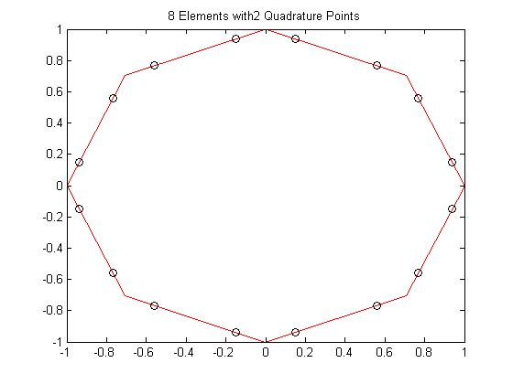

Figure 1 Circular Mesh of 8 segments with midpoints

* 1. **Boundary Conditions (D- EFIE, B-MFIE)**

For a TEz incident plane wave, the boundary conditions on the surface of the cylinder are determined by equations (2.2.1) and (2.2.2). The fields outside of the cylinder are represented with a subscript of 2 whereas the fields inside the cylinder are represented with a subscript of 1. The problem calls for a perfectly conducting cylinder which makes the fields inside the cylinder identically equal to zero.

* 1. **Fundamental Equations (D-EFIE,B-MFIE)**
     1. **MFIE**

The magnetic field integral equation begins with the boundary condition shown in equation (2.2.1). The exterior field is comprised of both the incident and scattered magnetic field. The tangential component of the exterior field is equal to the surface current at the boundary of the PEC cylinder as seen from equation (2.3.1).

$${\left.\hat{n}×\left({\overline{H}}^{inc}+{\overline{H}}^{sc}\right)\right|}_{s}= \overline{J_{s}} (2.3.1)$$

The use of the magnetic vector potential, A, is used to determine the scattered magnetic field. The magnetic vector potential in Equation (2.3.2) uses an outward propagating Green’s function equal to a first order Hankel function of the second kind.

$$\overline{A}=∯{J_{s}\left(\overline{r}\right)G\left(\overline{r},{\overline{r}}^{'}\right)ds^{'}} (2.3.2)$$

The scattered field is now evaluated from equation (2.3.3). A singularity occurs if the Green’s function is equal to zero. To account for the singularity, a principle value integral is used and the subsequent incident magnetic field integral equation is found by equation (2.3.4).

$${\overline{H}}^{sc}= \frac{∇×\overline{A}}{μ_{o}} (2.3.3)$$

$$H_{z}^{inc}=-\frac{J_{s}\left(t\right)}{2}-\int_{0}^{L}{\left(\sin{Ω\left(t\right)\frac{x-x^{'}}{P}}-\cos{Ω\left(t\right)\frac{x-x^{'}}{P}}\right)∙\left(\frac{k}{4j}J_{t}\left(t^{'}\right)H_{1}^{2}\left(kP\right)\right)dt^{'}} (2.3.4)$$

Source coordinates are differentiated from the observer coordinates with the use of a prime. The use of the letter, $t$, represented the parameterized tangential components on the surface of the PEC cylinder.

* + 1. **EFIE**

EFIE solution for scattering on a PEC cylinder starts with a different set of boundary conditions (2.2.2). However, both the electric and magnetic fields are inside zero inside a PEC cylinder. The tangential component of the incident field is therefore related to the scattered field (2.3.2).

$$\hat{n}×{\hat{E}}^{inc}|_{C}=-\hat{n}×{\vec{E}}^{scat}|_{C} (2.3.2)$$

$${\vec{E}}^{scat}\left(\vec{r}\right)=-jk_{0}η_{0}\vec{A}\left(\vec{r}\right)+\frac{η_{0}}{jk_{0}}∇∇⋅\vec{A}\left(\vec{r}\right) (2.3.3)$$

$$\vec{A}\left(\vec{r}\right)=\int_{C}{\frac{1}{4j}H_{o}^{2}\left(k_{0}\left|\vec{r}-r'\right|\right){\vec{J}}_{s}\left(\vec{r}\right)dl^{'}} (2.3.4)$$

Using (2.3.2-2.3.4) we can formulate the TEz EFIE equation. The higher order derivatives on the vector potential will increase the differentiability requirements on and test functions.

* + 1. **Point Matching**
    2. **N-Point Quadrature**
  1. **Matrix Formulation (D-EFIE, B-MFIE)**
     1. **Singularity Extraction**

1. **RESULTS**
   1. **Error**

Analytic solutions for both the surface current and bistatic echo width are shown in equations 3.1.1 and 3.1.2 respectively. The simulation results determine the coefficients for the surface current on each element.

* 1. **Convergence**

1. **Future Work**

Figure 2 Top: Ez Reflection Coefficient Bottom: Hz Reflection Coefficient Comparison to [1]

* 1. **CFIE**
     1. **Internal Resonance**
  2. **TMz**

1. **CONCLUSION**
2. **REFERENCES**
3. J. Jin, *The Finite Element Method in Electromagnetics*, 2nd edition, Wiley, 2002.