**2D TEz MOM Analysis**

*Authors: Adedayo Lawal and Blake Levy*

**Abstract – A two dimensional method of moments (MOM) simulation is presented. A normally incident plane wave impinges upon an infinitely long perfect electric conducting cylinder.**

1. **INTRODUCTION**

Similar to other methods in computational electromagnetics, Method of Moments (MOM) provides a way to calculate complicated structures and fields in electromagnetics. This method, however, deals with boundary conditions which may reduce the number of mesh points used in other methods.

An infinitely long perfect electric conducting (PEC) cylinder oriented in the z-direction is analyzed. A transverse electric (TEz) plane wave is normally incident upon the cylinder. Figure XX demonstrates the geometry under analysis. The radius of the cylinder was equal to which gave a corresponding value of equal to .

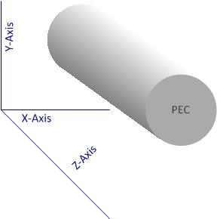

Figure 1Problem Geometry

1. **FORMULATION**
   1. **Discretization**

Unlike other methods in computational electromagnetics, the geometrical mesh does not include the free space environment. The discretization occurs on the boundaries of the objects of interest. Figure XX shows an example of a cylinder divided into 8 segments with their midpoints represented by circles.

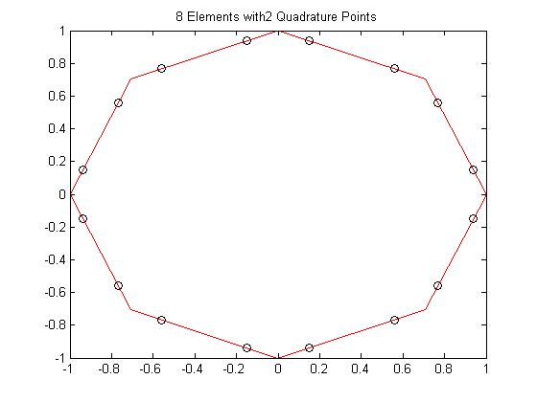

Figure 2 Circular Mesh of 8 segments with midpoints

* 1. **Boundary Conditions (D- EFIE, B-MFIE)**

For a TEz incident plane wave, the boundary conditions on the surface of the cylinder are determined by equations (2.2.1) and (2.2.2). The fields outside of the cylinder are represented with a subscript of 2 whereas the fields inside the cylinder are represented with a subscript of 1. The problem calls for a perfectly conducting cylinder which makes the fields inside the cylinder identically equal to zero.

* 1. **Fundamental Equations (D-EFIE,B-MFIE)**
     1. **MFIE**

The magnetic field integral equation begins with the boundary condition shown in equation (2.2.1). The exterior field is comprised of both the incident and scattered magnetic field. The tangential component of the exterior field is equal to the surface current at the boundary of the PEC cylinder as seen from equation (2.3.1).

The use of the magnetic vector potential, A, is used to determine the scattered magnetic field. The magnetic vector potential in Equation (2.3.2) uses an outward propagating Green’s function equal to a first order Hankel function of the second kind.

The scattered field is now evaluated from equation (2.3.3). A singularity occurs if the Green’s function is equal to zero. To account for the singularity, a principle value integral is used and the subsequent incident magnetic field integral equation is found by equation (2.3.4).

Source coordinates are differentiated from the observer coordinates with the use of a prime. The use of the letter, , represented the parameterized tangential components on the surface of the PEC cylinder.

The surface current, , can then be approximated by equation (2.3.4) where represents the pulse basis functions used upon each element. A solution can be obtained with the use of testing functions which are considered in a subsequent section.

* + 1. **EFIE**
    2. **Point Matching**
    3. **N-Point Quadrature**
  1. **Matrix Formulation (D-EFIE, B-MFIE)**
     1. **Singularity Extraction**

As mentioned previously, a principle value integral was needed for the magnetic field integral equation. Any method used will have a singularity if the source and observer cells overlap. After applying the principle value integral, the entries Z[i,i] will be equal to a value of -1/2. If the source and observer distance is within a tolerance, ε, the singularity extraction in equation (2.4.1) is used. A small argument approximation for the Hankel function was used to numerically extract the singularity. The resultant of this extraction was then added to the integral of the small argument approximation which was determined analytically.

1. **RESULTS**
   1. **Error**

Analytic solutions for both the surface current and bistatic echo width are shown in equations (3.1.1) and (3.1.2) respectively. The simulation results determine the coefficients for the surface current on each element which can be easily referenced to an angular dependence on the surface of the cylinder.

After the current coefficients are determined, bistatic echo width can be implemented from equation (3.1.3). As seen from equation (3.1.3), Far-field approximations are made when echo width is considered.

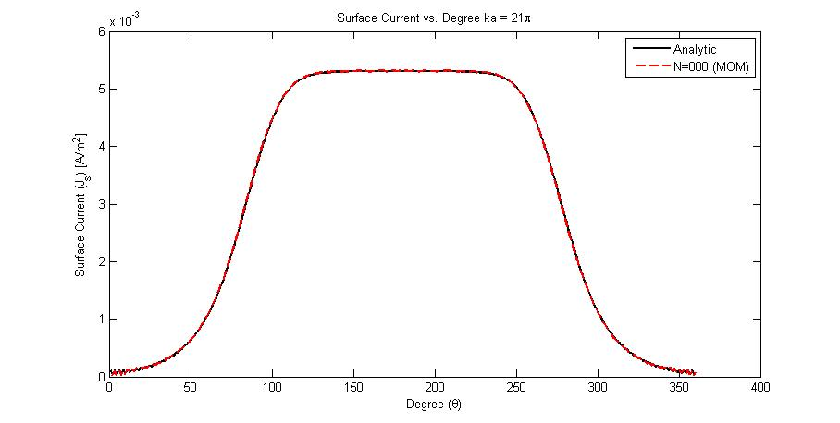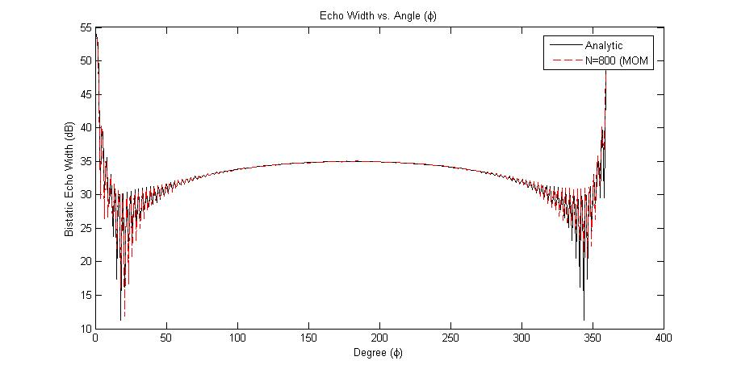

Figure 3 Left: Surface Current Right: Echo Width

Error was determined from equation (3.1.4) where results from the MOM simulation were compared to the analytical approach. Magnitudes were considered for the error calculation as phase shifts between the analytic and simulated were noticed. Incident field may lead to the shift in phase between the two values.

* 1. **Convergence**

Convergence was determined for the magnetic field integral equation. For a value of , error was determined as the number of cells increased. Figure XX shows the corresponding error (in dB) as number of cells is increased.

1. **Future Work**
   1. **CFIE**

Without the use of triangular basis functions for the MFIE method, a combined field integral equation (CFIE) cannot be determined. Internal resonances of the PEC cylinder correspond to ambiguous results solely relying on the use of MFIE. A parameteric study of number of iterations performed for an iterative solver versus frequency may show where the internal resonances are.

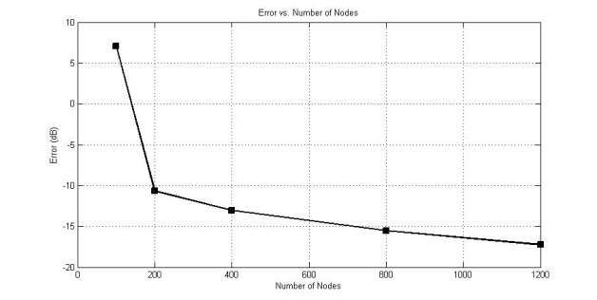

Figure 4 Error vs. Number of nodes

* 1. **TMz**

1. **CONCLUSION**

A 2D analysis was performed on an infinitely long PEC cylinder. Magnetic and electric field integral equations were considered for analysis. Error and convergence were determined for increasing number of elements.

1. **REFERENCES**
2. Garg, Ramesh. *Analytical and Computational Methods in Electromagnetics*. Boston, Mass.: Artech House, 2008. Print.
3. Jin, Jian. Theory and Computation of Electromagnetic Fields. Chicester: Wiley, 2011. Print.
4. Balanis, Constantine A.. Advanced engineering electromagnetics. New York: Wiley, 1989. Print.
5. Gedney, Stephen. "TEz scattering by a Circular PEC Cylinder (Analytic Solution)." EE525. Stephen Gedney. University of Kentucky, Lexington. 13 May 2013. Reading.