[](http://www.google.com.tw/url?sa=i&rct=j&q=&esrc=s&source=images&cd=&cad=rja&uact=8&ved=0ahUKEwjnj8bt9pvUAhWEoZQKHVyPD7QQjRwIBw&url=http://www.logoinlogo.tw/Dining-logo/&psig=AFQjCNHGIWAAqgj-b-qdq0gsGO7bF0pjfQ&ust=1496381632744708)

[](http://www.google.com.tw/url?sa=i&rct=j&q=&esrc=s&source=images&cd=&cad=rja&uact=8&ved=0ahUKEwjnj8bt9pvUAhWEoZQKHVyPD7QQjRwIBw&url=http://www.tutu001.com/vector/sc_nature/vector_29713.html&psig=AFQjCNHGIWAAqgj-b-qdq0gsGO7bF0pjfQ&ust=1496381632744708)

[](http://www.google.com.tw/url?sa=i&rct=j&q=&esrc=s&source=images&cd=&cad=rja&uact=8&ved=0ahUKEwiL8--X95vUAhWGm5QKHTfCD4kQjRwIBw&url=http://www.taopic.com/vector/201610/1041231.html&psig=AFQjCNECsIlGQrByJ-P2XFSJilcJPScpqQ&ust=1496381902721206)

[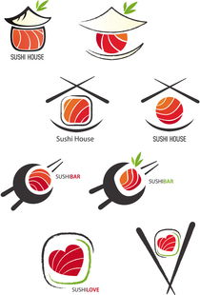](http://www.google.com.tw/url?sa=i&rct=j&q=&esrc=s&source=images&cd=&ved=0ahUKEwjztrSr95vUAhXJnJQKHexCDIsQjRwIBw&url=http://fangogoo.po369.com/tupian/5pel5pys6aSQ6aWubG9nbw.html&psig=AFQjCNECsIlGQrByJ-P2XFSJilcJPScpqQ&ust=1496381902721206)

[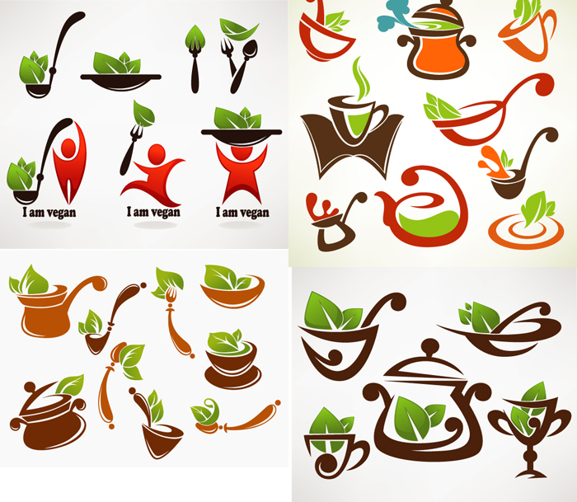](http://www.lanrentuku.com/vector/logo/jingmeisushicanyintubiao-shiliangsucai.html)

[](http://www.google.com.tw/url?sa=i&rct=j&q=&esrc=s&source=images&cd=&cad=rja&uact=8&ved=0ahUKEwi2mu7x95vUAhWGI5QKHZ54AkAQjRwIBw&url=http://www.pentaxgroup.com/index/55Sf5rS75LiK55qE5qCH5b+X5Zu+54mH.html&psig=AFQjCNECsIlGQrByJ-P2XFSJilcJPScpqQ&ust=1496381902721206)

[](http://www.google.com.tw/url?sa=i&rct=j&q=&esrc=s&source=images&cd=&ved=0ahUKEwiLqsiP-JvUAhVFmpQKHWC6BJUQjRwIBw&url=http://www.paoban.net/canyinlogoshejizuopinxinshang/%E9%A4%90%E9%A5%AElogo%E8%AE%BE%E8%AE%A1%E4%BD%9C%E5%93%81%E6%AC%A3%E8%B5%8F.html&psig=AFQjCNECsIlGQrByJ-P2XFSJilcJPScpqQ&ust=1496381902721206)

http://www.16sucai.com/2016/09/91532.html

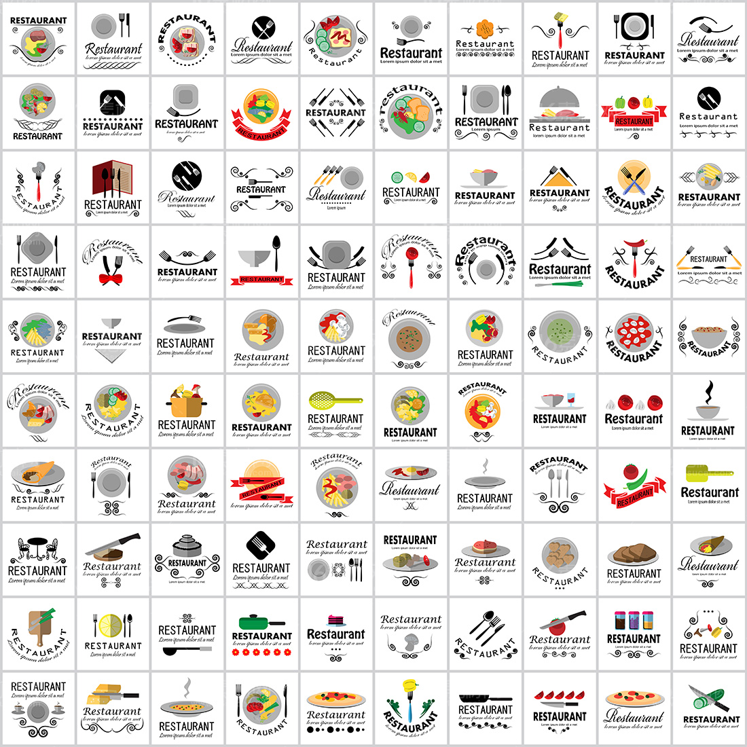

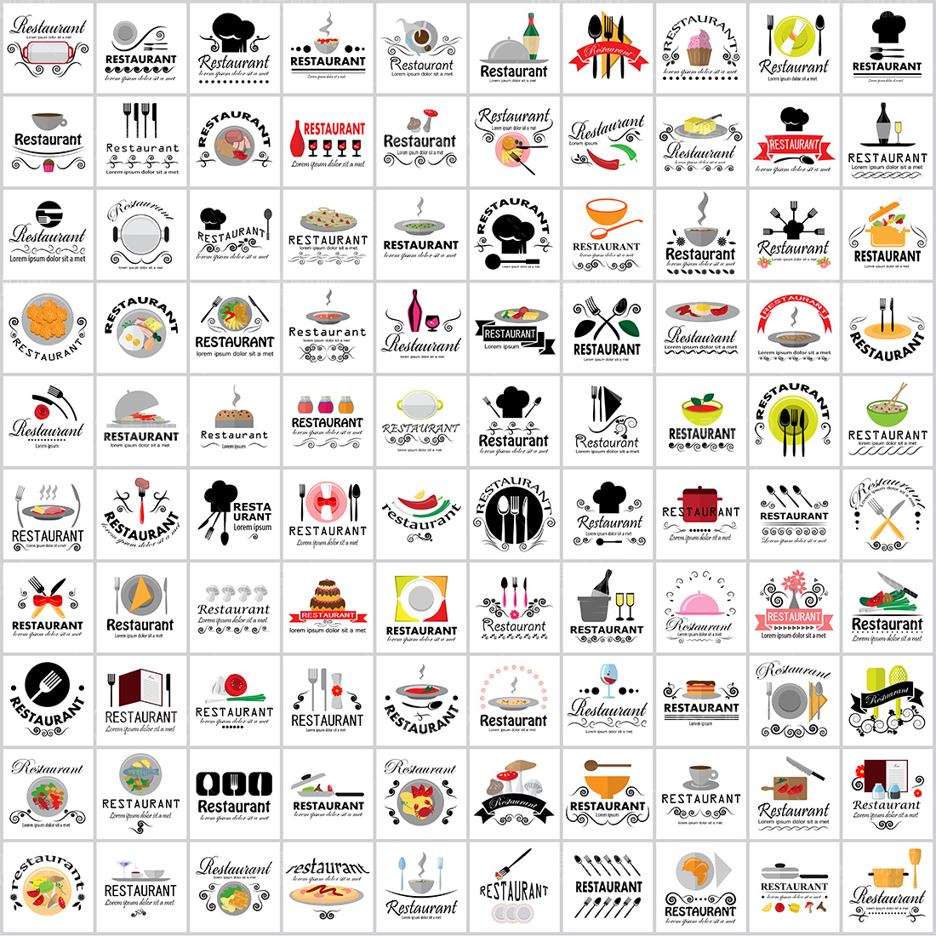

<https://www.google.com.tw/search?safe=active&hl=zh-TW&authuser=0&biw=1067&bih=485&tbm=isch&sa=1&q=%E7%AD%B7%E5%AD%90+logo&oq=%E7%AD%B7%E5%AD%90+logo&gs_l=img.12...0.0.0.1683.0.0.0.0.0.0.0.0..0.0....0...1..64.img..0.0.0.D-dpOc0TjSw>



<http://www.nipic.com/show/13793570.html>

[](http://www.google.com.tw/url?sa=i&rct=j&q=&esrc=s&source=images&cd=&cad=rja&uact=8&ved=0ahUKEwj6l4uw-pvUAhUBppQKHTkaCa0QjRwIBw&url=http://www.012logo.com/showar.asp?id=7611&psig=AFQjCNFKoPDZ2hsSaAiUI_5HBM3OIUpqXQ&ust=1496382532867167)

[](http://www.google.com.tw/url?sa=i&rct=j&q=&esrc=s&source=images&cd=&cad=rja&uact=8&ved=0ahUKEwj6l4uw-pvUAhUBppQKHTkaCa0QjRwIBw&url=http://safemen1992.com/image/985477207/&psig=AFQjCNFKoPDZ2hsSaAiUI_5HBM3OIUpqXQ&ust=1496382532867167)



[](http://www.globaljeacar.com/list/%E7%AD%B7%E5%AD%90logo/)

[](http://www.google.com.tw/url?sa=i&rct=j&q=&esrc=s&source=images&cd=&cad=rja&uact=8&ved=0ahUKEwiRzPru-5vUAhVDjZQKHfBVAUcQjRwIBw&url=http://www.havelogo.com/category/286504.php&psig=AFQjCNFKoPDZ2hsSaAiUI_5HBM3OIUpqXQ&ust=1496382532867167)



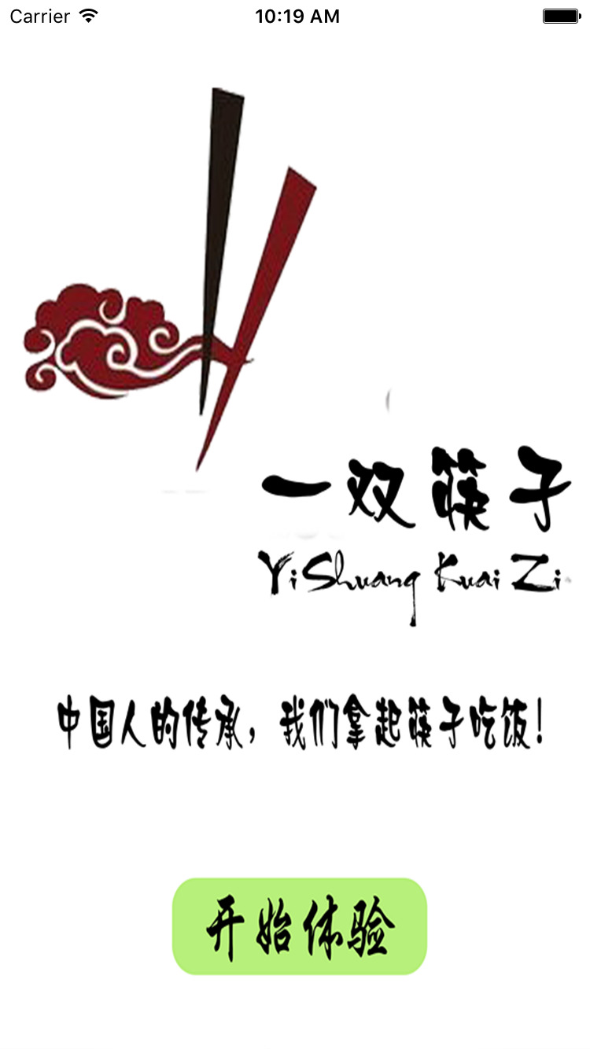



[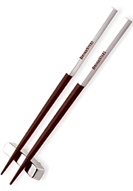](https://www.google.com.tw/url?sa=i&rct=j&q=&esrc=s&source=images&cd=&cad=rja&uact=8&ved=0ahUKEwiWu5vk_ZvUAhVCjZQKHd-_AoYQjRwIBw&url=https://www.branders.com/category/personalized-chopsticks/&psig=AFQjCNHbDdRnkEBXD8W8wlAn_GhZzmh4CQ&ust=1496383499615827)

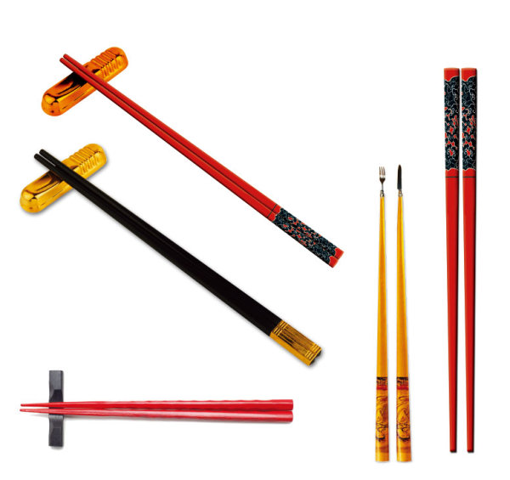



[](http://www.google.com.tw/url?sa=i&rct=j&q=&esrc=s&source=images&cd=&cad=rja&uact=8&ved=0ahUKEwjZgI2g_5vUAhWBEpQKHZS5CaUQjRwIBw&url=http://cargocollective.com/jvaughndesigns/Logo-Design&psig=AFQjCNHbDdRnkEBXD8W8wlAn_GhZzmh4CQ&ust=1496383499615827)

[](https://www.google.com.tw/url?sa=i&rct=j&q=&esrc=s&source=images&cd=&cad=rja&uact=8&ved=0ahUKEwi__p2q_5vUAhVFJpQKHXBxApoQjRwIBw&url=https://www.brandsoftheworld.com/critique/taipeii&psig=AFQjCNHbDdRnkEBXD8W8wlAn_GhZzmh4CQ&ust=1496383499615827)



<https://www.google.com.tw/search?q=chopsticks+logo&hl=zh-TW&authuser=0&safe=active&tbm=isch&tbs=rimg:Cf-R39VLRqqRIjh2OjtMXXDL4VLRyKEft8SEF0B7pXjG_1l18cK9NLERSuZDZSxlZv9VagQd70ck8o2RaCgow10Q6XyoSCXY6O0xdcMvhEdvPFTnus-RPKhIJUtHIoR-3xIQRsp22WdvD8mEqEgkXQHuleMb-XREdZEhz_1eavKioSCXxwr00sRFK5EawZqUj_1qhz-KhIJkNlLGVm_11VoRbC7vfgBAwQUqEgmBB3vRyTyjZBH3gKp2QMpGlSoSCVoKCjDXRDpfEeEnA3rmsTVw&tbo=u&sa=X&ved=0ahUKEwiM3q29_5vUAhUGJJQKHQWKDtQQ9C8IHA&biw=1067&bih=485&dpr=1.5#imgrc=_&spf=1496297800479>





<https://www.google.com.tw/search?q=chopsticks+logo&hl=zh-TW&authuser=0&safe=active&tbm=isch&tbs=rimg:CbfPGkMZ_1VOQIjjzOEYLQcAlaVMvgLNSIbv3SlUGaj4zTEI5KPzpuaBTic6apVQMuthkhj15MMgRrpc14ApDl1KdpioSCfM4RgtBwCVpEWBfiRm0Uux3KhIJUy-As1Ihu_1cR9t7-2RepxckqEglKVQZqPjNMQhFnS0UGl8sMVyoSCTko_1Om5oFOJEQhNRpOFSdFcKhIJzpqlVAy62GQR7l9Ek9bD3bIqEgmGPXkwyBGulxG4woDGiCPjyCoSCTXgCkOXUp2mEVxEUKoLwqAy&tbo=u&sa=X&ved=0ahUKEwiysvuAgZzUAhWEUZQKHeKsCL0Q9C8IHA&biw=1067&bih=485&dpr=1.5>

[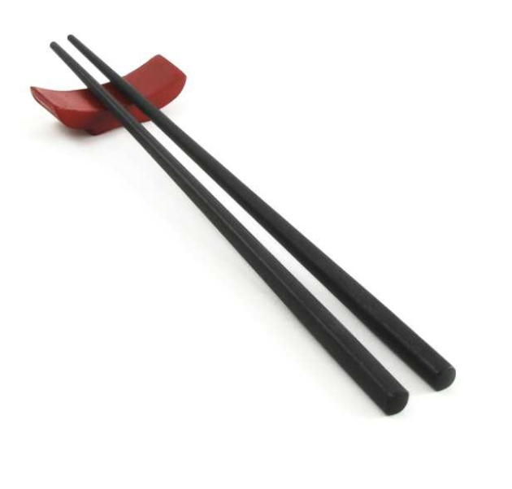](http://www.google.com.tw/url?sa=i&rct=j&q=&esrc=s&source=images&cd=&cad=rja&uact=8&ved=0ahUKEwjLzZKWgZzUAhUKGpQKHZI5BakQjRwIBw&url=http://infojam.tistory.com/38&psig=AFQjCNEqZhsD2xdrg4a4BTtc_MC6KfmUSg&ust=1496384572859287)