<http://116.62.236.184:5000/homepage/>

返回如下图所示的json

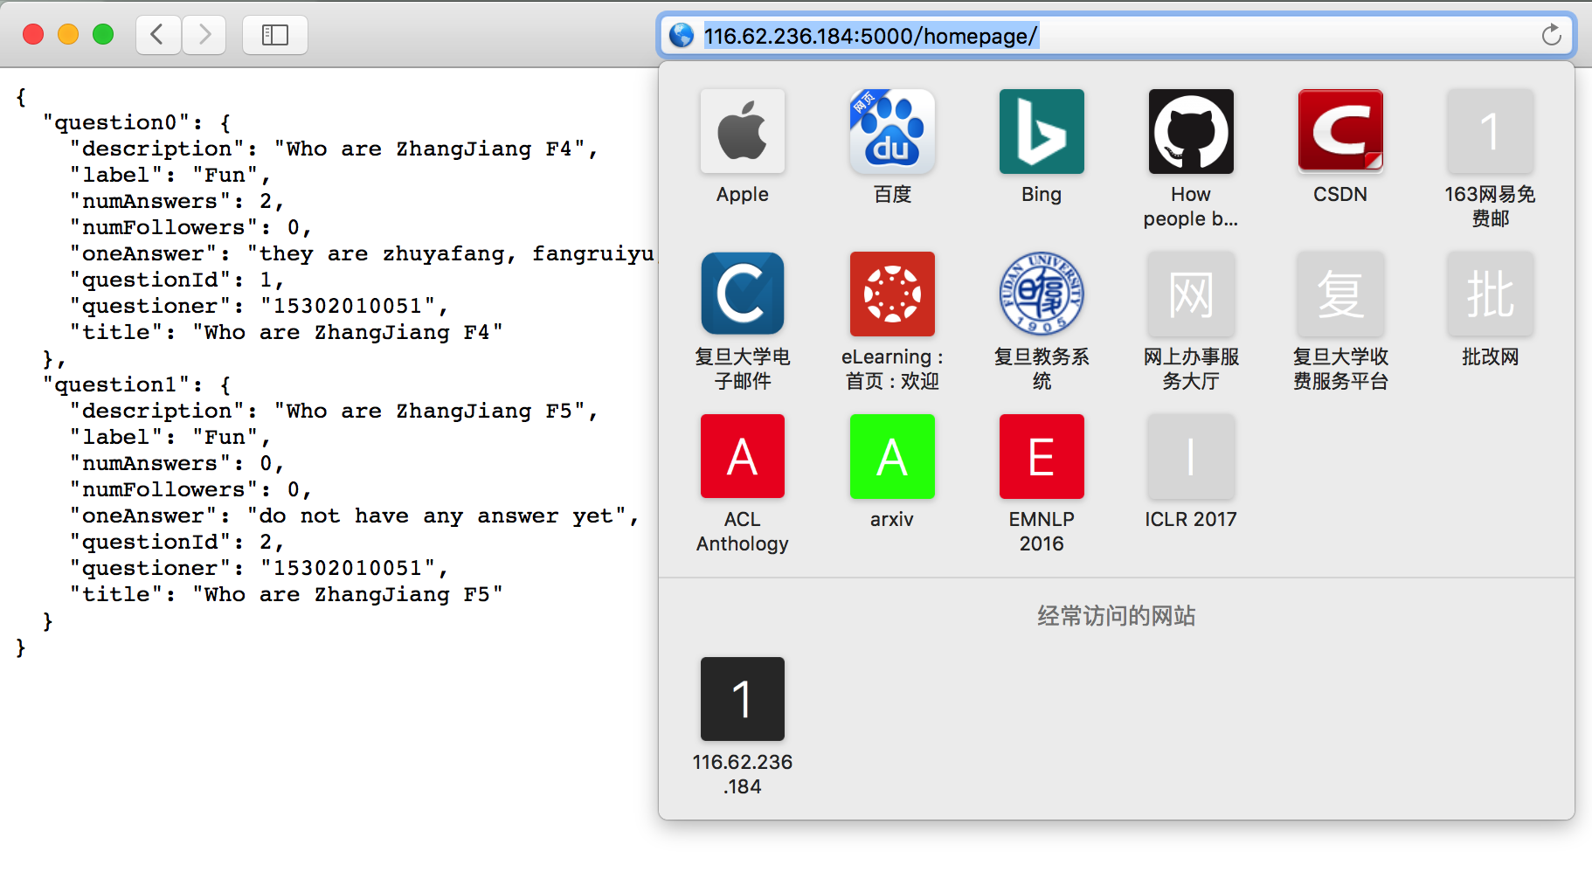

<http://116.62.236.184:5000/add_question/>

需要的信息为questioner(学号), title, label, description, isPublished

用json传？

<http://116.62.236.184:5000/answers_list/?questionId=1>

需要的信息为问题id，希望直接用url传~~~

返回如下图所示的json

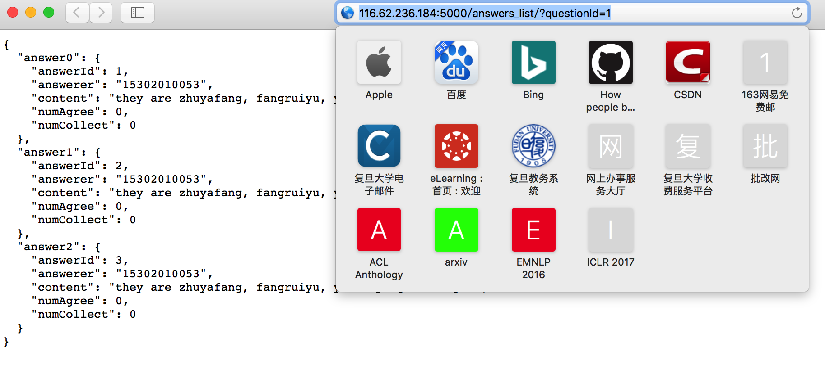

<http://116.62.236.184:5000/add_answer/>

需要的信息为answerer(学号), questionID(回答哪个问题), content

用json传？