# See ...A Student's Guide to R...

# From Project Mosaic

# If you have not already done so, the "mosaic" package must be installed.

# This should be installed but once. The "Require" statements below

# must be employed to load mosaic and mosaicData whenever you run R.

install.packages("mosaic") # note the quotation marks

options(digits=3)

# this will make lattice graphics available to the session

# as well as the Births dataset

require(mosaic); require(mosaicData)

Births78

xyplot( births ~ dayofyear, data=Births78)

Births78$dayofyear; Births78$date

?mosaic.options()

Moore

?tally

tally(~partner.status, data=Moore)

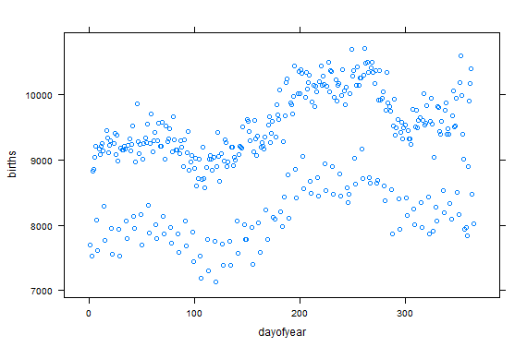

Why are there two series?