Web Programming
PHP arrays assignment
2017-02-16
William Gillespie
Part1 screenshot

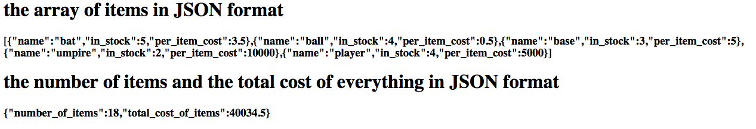

Part 2 screenshot

Part 3 screenshot

Part 4 screenshot

Part 5 screenshot

