COSC 616: Bioinformatics
Assignment 5: Clustering Genes
William Gillespie

All of my work is located at this repository: https://github.com/Wubuntu88/COSC616_Bioinformatics/tree/master/hw05_clustering
You can clone or download the repository for the entire class to test everything I have done for this project, as well as see additional figures.
Part1) Find 50 genes from golub_test7129.txt by SAM (as last time)
Done. The results are here:
https://github.com/Wubuntu88/COSC616_Bioinformatics/blob/master/hw05_clustering/significant_genes_processed.csv
Note that I was not able to get 50 genes because the slider in the MeV tool would not let me select 50. Instead I chose 52 because that was the closest value I could get on the slider.

Part 2) Apply HC with 3 linkages and 2 distances, use known labels to evaluate the results.

%%-------- distance: correlation, linkage: average

dist = pdist(test52, 'correlation');
tree = linkage(dist, 'average');
%dendrogram(tree);
clusters = cluster(tree, 'maxclust', 2);
%clustergram(test52, 'linkage', 'average', 'standardize', 'col');

labels(1:20, 1) = 1;
labels(21:34, 1) = 2;

error = nnz(labels - clusters);
fprintf('error: %d\n', error)
error: 1
diary off

%%-------- distance: correlation, linkage: single

dist = pdist(test52, 'correlation');
tree = linkage(dist, 'single');
%dendrogram(tree);
clusters = cluster(tree, 'maxclust', 2);
%clustergram(test52, 'linkage', 'single', 'standardize', 'col');

labels(1:20, 1) = 2;
labels(21:34, 1) = 1;

error = nnz(labels - clusters);
fprintf('error: %d\n', error)
error: 13
diary off
%%-------- distance: correlation, linkage: complete

dist = pdist(test52, 'correlation');
tree = linkage(dist, 'complete');
%dendrogram(tree);
clusters = cluster(tree, 'maxclust', 2);
%clustergram(test52, 'linkage', 'complete', 'standardize', 'col');

%switch labels because this clustering method assigns '2' to the first cluster
labels(1:20, 1) = 2;
labels(21:34, 1) = 1;

error = nnz(labels - clusters);
fprintf('error: %d\n', error)
error: 1
diary off
%%-------- distance: euclidean, linkage: average

dist = pdist(test52, 'euclidean');
tree = linkage(dist, 'average');
%dendrogram(tree);
clusters = cluster(tree, 'maxclust', 2);
%clustergram(test52, 'linkage', 'average', 'standardize', 'col');

labels(1:20, 1) = 1;
labels(21:34, 1) = 2;

error = nnz(labels - clusters);
fprintf('error: %d\n', error)
error: 2
diary off
%%-------- distance: euclidean, linkage: single

dist = pdist(test52, 'euclidean');
tree = linkage(dist, 'single');
%dendrogram(tree);
clusters = cluster(tree, 'maxclust', 2);
%clustergram(test52, 'linkage', 'single', 'standardize', 'col');

labels(1:20, 1) = 2;
labels(21:34, 1) = 1;

error = nnz(labels - clusters);
fprintf('error: %d\n', error)
error: 13
diary off
%%-------- distance: euclidean, linkage: complete

dist = pdist(test52, 'euclidean');
tree = linkage(dist, 'complete');
%dendrogram(tree);
clusters = cluster(tree, 'maxclust', 2);
%clustergram(test52, 'complete', 'single', 'standardize', 'col');

labels(1:20, 1) = 1;
labels(21:34, 1) = 2;

error = nnz(labels - clusters);
fprintf('error: %d\n', error)
error: 2
diary off

Note: I have created Dendrograms and heatplots for the pearson distances and all linkages. They are located here if you would like to see them: https://github.com/Wubuntu88/COSC616_Bioinformatics/tree/master/hw05_clustering/part2
The results are under the Dendrograms and Heatplots folders

Part 3) Apply KMC with k=2, then 2 distances, run 3 times, use known labels to evaluate the results.

%----RUN 1
>> %----- kmeans; distance: correlation

[clusters, centers] = kmeans(test52, 2, 'dist', 'correlation');
labels(1:20, 1) = 2;
labels(21:34, 1) = 1;
error = nnz(clusters - labels);
fprintf('error: %d\n', error);
error: 1

%----RUN 2
>> %----- kmeans; distance: correlation

[clusters, centers] = kmeans(test52, 2, 'dist', 'correlation');
labels(1:20, 1) = 2;
labels(21:34, 1) = 1;
error = nnz(clusters - labels);
fprintf('error: %d\n', error);
error: 1

%----RUN 3
>> %----- kmeans; distance: correlation

[clusters, centers] = kmeans(test52, 2, 'dist', 'correlation');
labels(1:20, 1) = 2;
labels(21:34, 1) = 1;
error = nnz(clusters - labels);
fprintf('error: %d\n', error);
error: 1

The results are consistent from run to run.

Part 4) Apply PCA then 2 scatter plots, cross examine HC and KMC, list few consistency
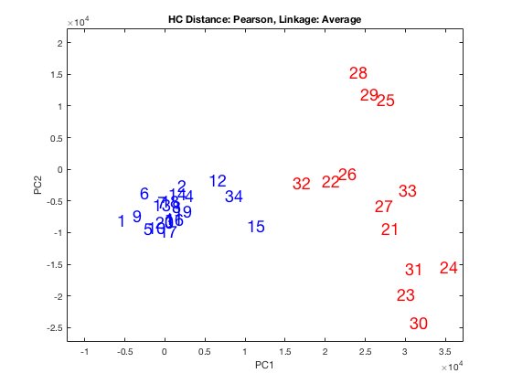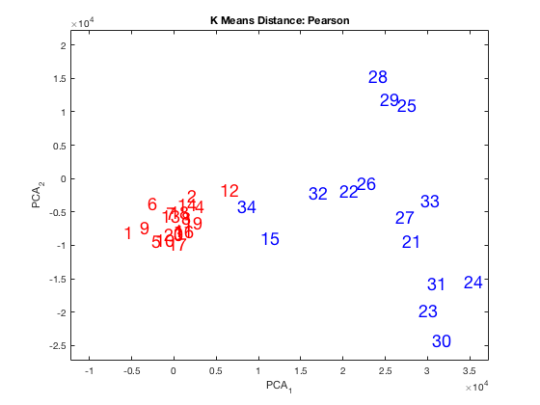
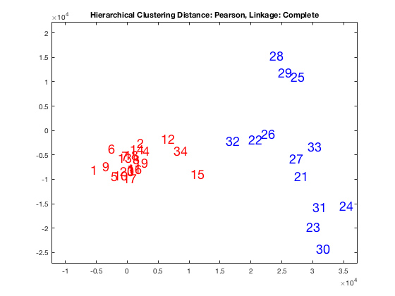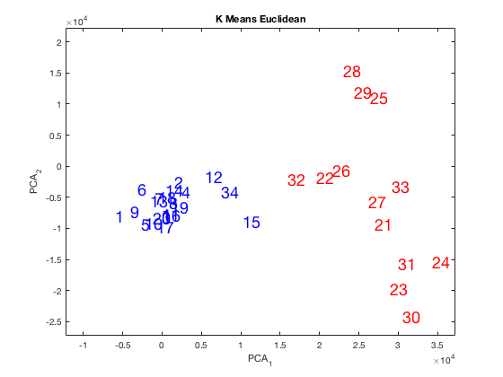

As you can see from the two HC examples on the right (Average and Complete), they are both the same, even though the colors are different. The two K means examples (Pearson and Euclidean) are different from each other. The Euclidean K means is the same as the two HCs. The only different one is the K means with Pearson distance. That one’s blue cluster took away 15 and 34 from the opposing cluster. 34 looks like it might belong to the red group but was assigned to the blue group. It should be noted that the clustering was done on the original features (not the principle components). This entails that even though 34 looks like it should be part of the red cluster, the data that was used to cluster was the feature set before PCA was done. The data points may be farther away than the PCA plot may lead you to believe.
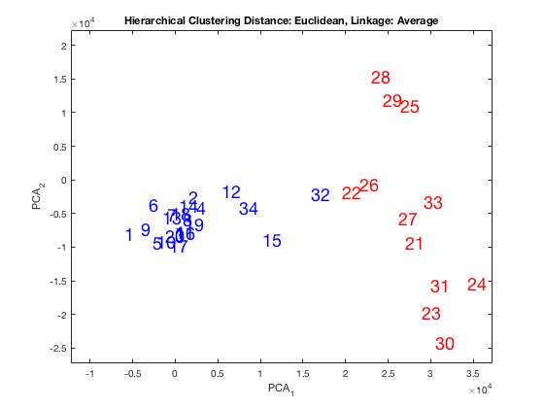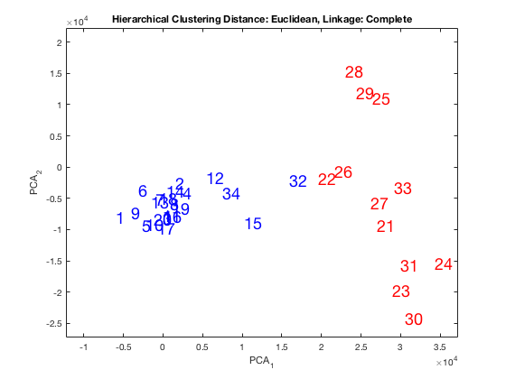
I will now compare the two figures above (HC with Euclidean Distance) with the plots for k means clustering. The two plots for HC have taken the point ‘32’ from the cluster on the right.
Part 5) Apply SOM with your best set of parameters, illustrate the results and compare with HC and KMC.
>> test52 = load('significant_genes_processed.csv');
test52 = test52';
[num_rows, num_cols] = size(test52);

labels = zeros(num_rows, 1);

%------ SOM 1
Q = test52;
Q = Q';
net = newsom([min(Q, [], 2) max(Q,[],2)], [3, 1], 'hextop');
net.trainParam.epochs = 100;
net = train(net, Q);
clusters = vec2ind(net(Q))
Sory function drawnow not implemented.

clusters =

Columns 1 through 14

1 1 1 1 1 1 1 1 1 1 1 2 1 1

Columns 15 through 28

2 1 1 1 1 1 3 3 3 3 3 3 3 3

Columns 29 through 34

3 3 3 2 3 2

>> labels(1:20, 1) = 1;
labels(21:34, 1) = 3;

error = nnz(clusters' - labels);
fprintf('error: %d\n', error);
error: 4
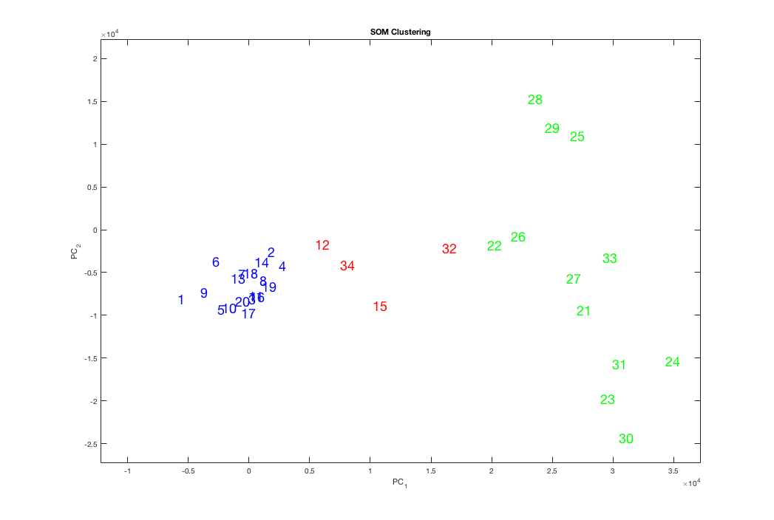
The scatter plot above is an example of SOM clustering. As you can see, it made 3 clusters instead of 2 (which was the number of classes). The error was slightly greater than both HC and KMEANS (except for HS single linkage, which was terrible). SOM can make more clusters than there really are because it does not allow the user to select the number of clusters they desire. (with K means and HC, one can choose the number of clusters). You can see that SOM clustered in a geographically reasonable way; the four red dots could conceivably be in one cluster.

