The effect of Auto Recalls on a Company’s Stock Price
William Gillespie
2017-03-06

Short Abstract

The impact of major car recalls on stock market returns is investigated using the mean-adjusted return model and the market return model. A paired t-test was also used to test stock price decreases. Based on data from Ford and Toyota, there is some evidence that stock returns decrease after a major recall.

Medium Abstract

The impact of major car recalls on stock market returns is investigated using 2 different event-based econometric models: (1) the mean-adjusted return model, and (2) the market return model. Models used windows of 100 or 30 market days before and after the recall event. Model (1) compares the stock returns after a recall event to the average returns before the event. Model (2) compares a market index (S&P 500) to the stock returns during the recall event window. Additionally, paired t-tests were used to test whether the stock price decreased ten days after the event or ten days before the event. Based on data from Ford and Toyota, there is evidence that stock returns decrease after a major recall of Ford cars, but not after a Toyota recall.

Introduction
This paper examined the impact of major recalls (>500,000 cars) on the stock returns of the car manufacturer. My hypothesis is that recalls of this magnitude will have a measureable effect on stock returns in a post-recall window of up to 100 market days. We investigated this hypothesis for Ford and Toyota, each of which has a long history with stock market data and several recalls with over 500,000 affected units.
We used two sources of data. The first is auto recall data hosted by www.kaggle.com and provided by the Department of Transportation’s National Highway Traffic Safety Administration (NHTSA). This is a .csv file that contains information about every US vehicle and tire recall from 1967 to the present. Information about the recall date, the make and model of the car, the estimated number of affected vehicles, and the vehicle manufacturer are in this file (see Appendix A).
The second data source contains stock data for various car manufacturers. Raw stock data are not readily available online for free, but we found stock price data within the Mathematica software that we were able to extract and convert to .csv format. The stock data has the price of a stock for a given day, from the date it began trading until the present (February 2017) (see Appendix A).
We used Event Study methods to evaluate the impact of each recall on stock returns, and summarize the results across recall events and car manufacturers. In general, event studies detect if there is a noticeable impact of an event on some aspect of a company. In the case of auto recalls, sales, stock price, or revenue can all be factors that are impacted by the event. In this report, we use three methods to evaluate whether car recalls have an impact on stock returns.

Literature Review
We give an overview of one model: (1) Assessing Sales Loss from Automobile Recalls through Event Study: A Toyota Case Study. We begin by summarizing the first paper and explain how we took the model (the mean-adjusted return model) the authors used and implemented it in my project. The second model that was used (the market return model) is only described in the model section below.
In the Toyota case study, the authors examined the Toyota Motor Company’s (TMC) recall data from the NHTSA database (from 2012), as well as monthly market share data (based on sales data) for Toyota Vehicles (Toyota, Lexus, and Scion). The authors chose to limit recalls to ‘major recalls’ (those that affected 500,000 cars or more). This weeds out small, potentially insignificant recalls, and decreases the chance that event or estimation windows for various recalls overlap (because there are fewer considered recalls). In our analyses, monthly market share data were used instead of sales data because sales are influenced by seasonal trends.
The authors tested to see if auto recalls had a significant impact on market share. The mean-adjusted return model was chosen due to ease of implementation. The mean-adjusted return model is described in the model section. The authors used this model with several different event window sizes. They discovered that market share was negatively affected for up to 5 months (approximately 150 days) after the recall event.
We utilized the same mean-adjusted return model in my analysis of recall data, but we used stock market returns instead of market share data. We fit this model using data from 2 car companies: Ford and Toyota. We first chose a threshold of 2 million vehicles because that made it easy to avoid overlapping event and estimation windows, it yielded a manageable number of recall events, and it ensured that only major recalls were included. We then used a threshold of 500,000 vehicles.

Model
We selected two event study models: the mean-adjusted return model and the market return model. Both models attempt to detect whether the stock returns are significantly different in the period after a recall compared to the returns before a recall. Returns can be thought of as percent changes, but in decimal form. The event, the estimation window, and the event window are shown in the figure below. In my application, the estimation window directly precedes the event, and the event window occurs directly after the event. This situation occurs because we measure stock market returns, which react quickly to news.


In these models, several general things are done:
- Calculate or model the normal returns in the estimation window (before the event) to get a basis. We chose an estimation window of 100 (or 30) market days.
- Calculate or model the abnormal returns in the event window (after the event). We chose an event window of 100 (or 30) market days.
- Perform a statistical test of the difference between the returns before vs. after the event. The null hypothesis is that there is no difference. Either a 2-sided or a 1-sided alternative hypothesis can be used, but a 1-sided test answers the question of most interest, i.e., whether returns decrease after an event.

Mean-Adjusted Return Model

Calculation of a Basis from normal returns
First, normal returns (i.e., returns in the absence of any disturbance) are calculated in the estimation window. The index i can refer to a set of companies or a set of recall events for the same company. In this report, we consider i as a set of recall events within a company. In the equation below, M is the stock price of the company at time t (prior to the ith recall event), R is the return of the company at time t (prior to the ith recall event). and

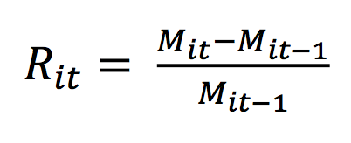
Using the returns in the estimation window, a basis (mean) is calculated:
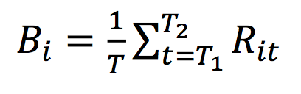
where B is the basis of the company returns prior to recall event i, and T is the number of market days in the estimation window.

Calculation of abnormal returns
To calculate abnormal returns, the basis is subtracted from each return value in the event window:
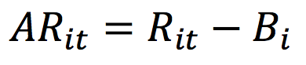
Where AR is the abnormal return for the company at time t after the ith recall event.
Then, the cumulative abnormal returns (CAR) is calculated. The CAR is the sum of the abnormal returns for a company during a period after the ith recall event.
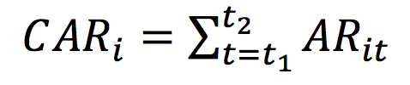

Finally, the cumulative average abnormal return (CAAR) is calculated. This is the average of the abnormal returns over all recall events for a company.
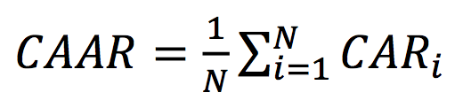

Calculate a test statistic
A hypothesis test is used to test whether the abnormal returns (post-event) are different from the normal returns (pre-event). First we calculate the standard deviation (s) of the CAR values. The standard error of CAAR is s/sqrt(N), and the ratio of CAAR to its standard error is a t-statistic with N-1 degrees of freedom.
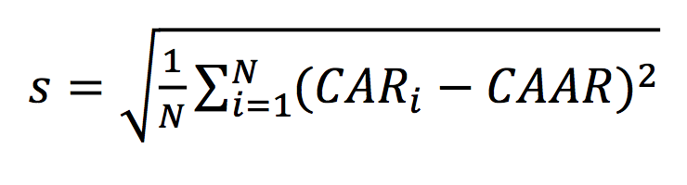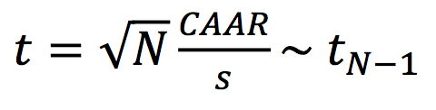

Market Returns Model

The Market Return Model compares the returns of the company’s stock to the value of a market index during the event window. There is no estimation window in this model. The abnormal returns for this model are calculated using the following equation:
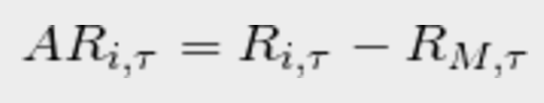
i: event 𝛕: market day in event window M: represents the Market Index (S&P 500)
The abnormal returns for event i for the market days 𝛕 in the event window equal the returns of the company at event i during the market days 𝛕 minus the returns of the market at event i during the market days 𝛕.
Once the abnormal returns are calculated, the test statistic is generated the same way as in the mean-adjusted return model.

Ten Days Before and After Check

A final simple check was performed in which the stock price ten days before the event was compared to the price on the day of the recall event to see if the stock price decreased over that time frame (which it was not expected to). Another check compared the price on the day of the recall event to the price 10 days later (which was expected to decrease). The differences were calculated for all of the events. Once the differences were calculated, two one-sample t tests were performed: (1) to test whether the stock price differences over the pre-event time windows were statistically significantly different from the population mean (0 in this case), and (2) to test whether the stock price differences over the post-event time windows were different from 0. This was equivalent to doing two paired t-tests, with stock prices paired by market day.

Results
What follows is two analysis: one of 6 Ford recall events where the estimated affected units’ threshold was above 2 million cars, and a second of two event and estimation windows for Ford and Toyota Recalls.

High threshold case study
This model was performed with a threshold of greater than 2 million affected vehicles, which resulted in only 6 Ford recall events and no Toyota events of that magnitude. The Ford CAR results for each recall event are: -0.37, -0.32, -0.36, -0.23, 0.54, -0.32. Negative numbers indicate decreases from the bases following the recall. In this case, 5 out of 6 recall events were followed by a decrease in stock returns. All 5 had similar CAR estimates, ranging from -0.37 to -0.23, in stark contrast to the single positive CAR value of 0.54. This particular recall event deserves further investigation to see if there were special circumstances resulting in such a positive market reaction.

Mean-Adjusted Return Model
t statistic: -1.33
DoF: 5
p-value: 0.1205 (one-sided t-test)

While the p-value is above 0.05, it is still rather low. This indicates that the negative t statistic may not be due to chance alone. Increasing the sample size of recalls may give a significant t statistic. After all, the degrees of freedom are small, making it hard to achieve a significantly low p-value. To increase the sample size, the threshold of recalls was lowered.
The graphs of the stock prices before and after the recall for the 6 events are shown below. Recall events are shown as black vertical lines. As you can see, all but one shows lower returns in the event period as opposed to the estimation (pre-event) period.

Figure 1. Stock price movements relative to recall events for 6 major recall events (Ford data).
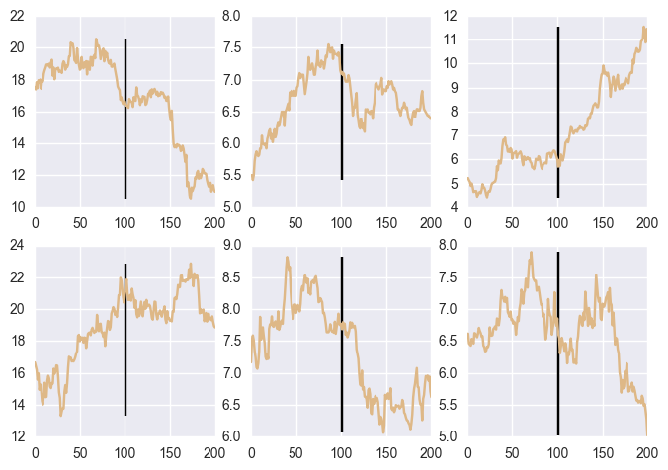

The stock returns for all 6 recalls are shown in the following figure. It is difficult to see any pattern when the returns are graphed.

Figure 2. Stock price returns movements relative to recall events for 6 major events.

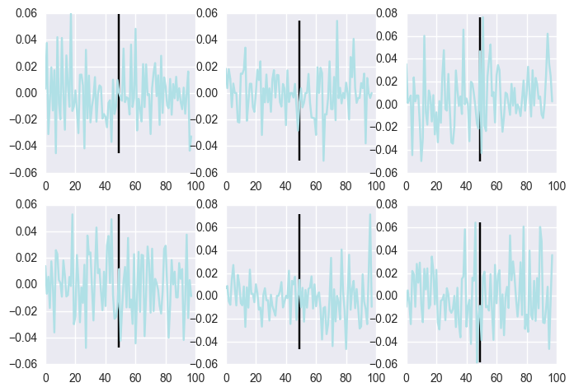

Systematic Testing and Negative Control for Mean-Adjusted Return Model

Event studies were conducted using a threshold of > 500k Cars with 100 and 30 Market days, for both Ford and Toyota recalls. T-statistics and p values were calculated for each event study. In addition, the results of a simulated negative control is shown for each event study.

The results for all of these comparisons are given in Table 1. Details of each comparison are then discussed.

Table 1. Results of mean-adjusted return model
Threshold | Event  Window | Ford | Toyota
> 500k Cars | 100  Market days | T stat: -1.70  P value: 0.048  Negative Control P-Value: 0.07 | T stat: 1.22  P value: 0.884  Negative Control P-Value: 0.87
> 500k Cars | 30  Market days | T stat: -0.35  P value: 0.37  Negative Control P-Value: 0.381 | T stat: 1.28  P value: 0.85  Negative Control P-Value: 0.84

The event window with 100 market days for Ford stock has the lowest t statistic (-1.70) and lowest p value (0.048). Since the t statistic is negative and the p value is less than 0.05, this would seem to suggest that auto recalls do decrease the stock price. When the event window is lowered to 30 market days, the t statistic is still negative (-0.35), but the p value is not significant (0.37). This does not give us evidence that auto recalls cause the stock to decrease. Furthermore, this event window would seem to be a more realistic because it is smaller, and one would expect the stock market to react quickly.
As for Toyota, The t statistics for both event window sizes was around 1.2 with p values of around 0.85. The unusually high t statistics and hight p values indicate that the stock price was rising in the event window relative to the estimation windows in general, but not statistically significantly so. It is very unusual that Toyota’s stock went up after the recalls.
A simulated negative control was also performed. In this simulation, 30 random dates were chosen in the company stock market range, and these dates asumed the role of fake events. A simulation of 3,000 event studies was done, each with 30 random recall dates. The t statistic from each iteration was saved and used to make a histogram showing the distribution of t statistics. This simulated control was done for the event window sizes 100 and 30. The t statistics achieved from the real recall dates are shown in a black verticle line on each graph.

Negative Control for Ford:
Figure 3. Histogram of t statistic for 3,000 event study simulations for randomly generated recall dates in the Ford data, with overlaid t distribution (DoF=29). The black bars are the t statistics from Table 1.
Left Panel: event window = 100 days Right Panel: event window = 30 days
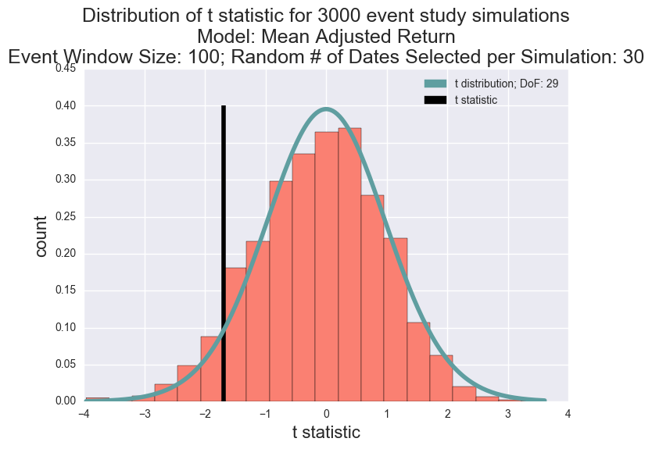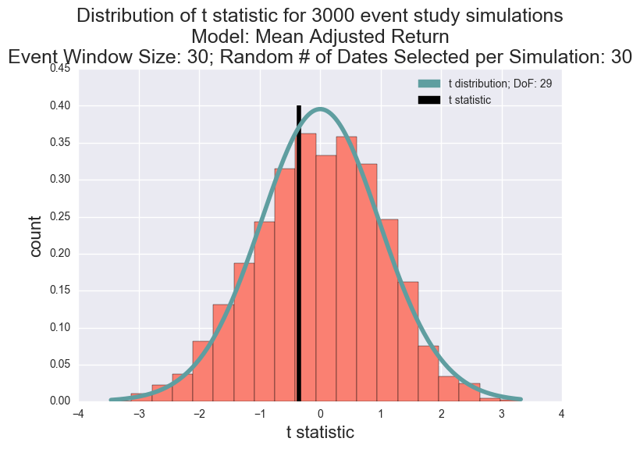
As can be seen above, the histogram of the simulated t statistics generally matches with a t distribution. The p values for the negative controls are remarkably similar to those of the original p values. This indicates that the original t statistics were valid.

Negative Control for Toyota
Figure 4. Histogram of t statistic for 3,000 event study simulations for randomly generated recall dates in the Toyota data, with overlaid t distribution (DoF=29). The black bars are the t statistics from Table 1.
Left Panel: event window = 100 days Right Panel: event window = 30 days

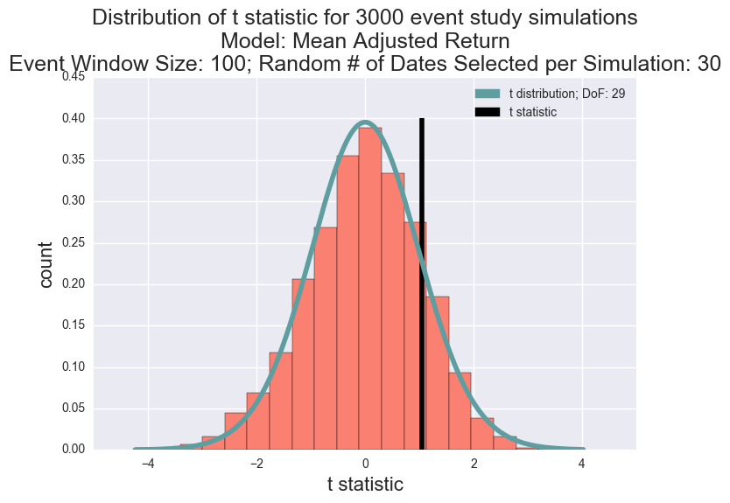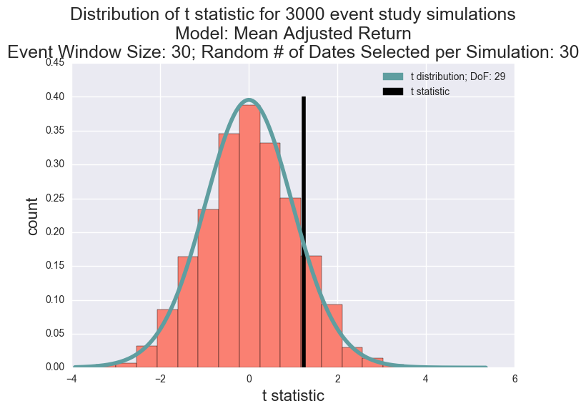
Surprisingly, the t statistics for both event windows are positive. This indicates an increase in stock price after a recall event. These results would not have been statistically significant, even if a two-sided test had been performed. However, given the consistently negative t statistics with Ford, these positive t statistics are unexpected.

Market Returns Model

The market return model did not give any results that would suggest that recalls cause the stock price to decline. It is somewhat disconcerting that the t statistics were all positive, as this would indicate the price of the company stock increase relative to the market index (S&P 500), even though the p-values were not significant. The S&P 500 might reflect too many other sources of market variability, and not be a good indicator for car company stock performance. There is also a posibility that an error was made in the computation.

Table 2. results of market adjusted return model.
Threshold | Event  Window | Ford | Toyota
> 500k Cars | 100  Market days | T stat: 0.92  P value: 0.81 | T stat: 0.8  P value: 0.79
> 500k Cars | 30  Market days | T stat: 1.54  P value: 0.93 | T stat: 0.08  P value: 0.54

Ten Days Before and After Recall Check
The results of the before and after checks based on paired t-tests of stock prices 10 days apart are shown for Ford recall events above the threshold of 500,000 cars involed.

Table 3. Results for ten days before and after check ‘model’
 | Pre-recall Difference | Post-recall Difference
Threshold | (Day of the Recall) –  (10 Days Before the Recall)  (negative means a decrease) | (10 Days After the Recall) -  (Day of the Recall)  (negative means a decrease)
> 500k Cars | T stat: -1.55  P value: 0.127 | T stat: -2.32  P value: 0.025

The first comparison shows no significant difference between stock prices ten days before a recall and the stock prices on the day of the recall announcement. The second comparison shows a statistically significant mean decrease in the stock price ten days after a recall announcement. This result is consistent with the result given in the mean-adjusted return model in Table 1 for the 100 day event window for Ford. The histograms of the Pre-recall and Post-recall differences are shown below. It is surprising that this simple test, without data manipulation or searching for the ‘best’ interval, yielded a result stronger than either of the market models shown above.

Figure 5. Histogram of differences beween stock prices before and after an event for each recall.
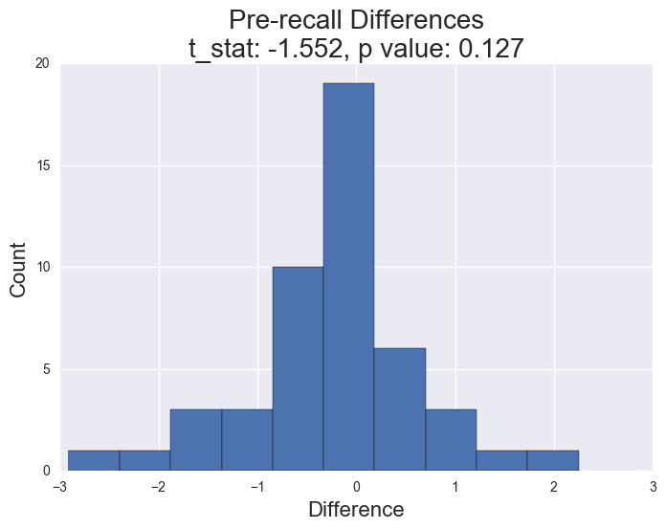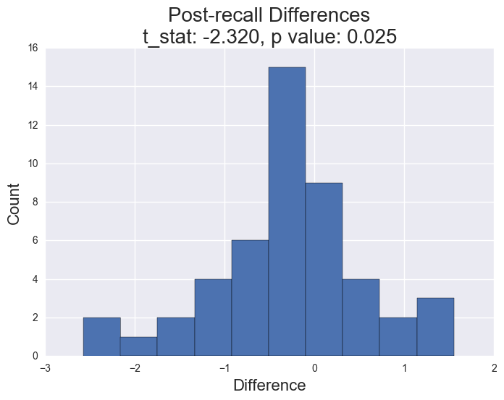

Conclusions
For the mean-adjusted return model, the t-statistic was not significant for the high-threshold model (Ford), but was low enough to suspect that with a larger sample size of recall events, we could demonstrate that major auto recalls do negatively affect the stock price. This is in fact what happened for the 100-day event window mean-adjusted return model. However, the 30-day event window, which might be expected to give a stronger result since the interval is closer to the recall event, showed a negative but non-significant decrease. In contrast, Toyota did not demonstrate any decrease in stock returns following recall events.

The market return model did not produce any convincing result that stock prices decline after an event. This could be due to noise in the market index (S&P 500), an error in computation, or the possibility that the model is unreliable.

The ‘ten days before and after check’ provided the best evidence that company stock price falls after a recall. For Ford, the differences between the ten days after price and the event day price had a negative t statistic (-2.32) and a statistically significant p value (0.025). Evidence on whether the stock price declined before the recall was not conclusive in this test. Similar to the first model, Toyota did not show any decrease in stock returns following recall events.

We expected different car companies to have similar effects. We also expected different modeling methods to yield similar effects, although the fit of the model will contribute to the quality of the estimates. These models did not give similar results, but the simplest method (the paired t test) did give convincing evidence that recalls decreased the stock price of Ford.

Bibliography
1) Communications of the IIMA, Volume 12 | Issue 4 | Article 4, 2012
Title: Assessing Sales Loss from Automobile Recalls through Event Study: A Toyota Case Study
Authors / universities: Heechang Shin / Iona College, Robert Richardson / Iona College, Oredola Soluade / Iona College
http://scholarworks.lib.csusb.edu/cgi/viewcontent.cgi?article=1199&context=ciima

3) Contains information on different event study models
http://eventstudymetrics.com/index.php/event-study-methodology/

Appendix A

Here are the first few rows of the recall data (some fields omitted):

Vehicle Make | Vehicle Model | Model Year | Vehicle Manufacturer | Recall Type | Recall Component | Estimated Units | Recall  Notification Date
FORD | FOCUS | 2001 | FORD MOTOR COMPANY | VEHICLE | ELECTRICAL SYSTEM:BATTERY:  CABLES | 291854 | 20030210
FORD | FOCUS | 2000 | FORD MOTOR COMPANY | VEHICLE | ELECTRICAL SYSTEM:BATTERY:  CABLES | 291854 | 20030210
JAYCO | FT EAGLE 10 SG | 2003 | JAYCO, INC. | VEHICLE | EQUIPMENT:OTHER:  LABELS | 86 | 20020923

Here are the first few fields of the stock data for Ford.

Date | Price
1972 6 1 | 0.335125
1972 6 2 | 0.334494
1972 6 5 | 0.334494
1972 6 6 | 0.330707

