“COP Engine 0.2”
API Reference and Explanation of how it works!

By Colin Phillips

TABLE OF CONTENTS
0.0 Introduction

Part I – API Reference ………………………………………………………………………………………………1
1.0 COP Engine Overview
2.0 Getting Started
3.0 Variables and Functions List
3.1 Variables List
3.2 Functions List
4.0 Variables
5.0 Functions

Part II – COP Engine Explained……………………………………………………………………………………13

0.0 Introduction

Welcome to the COP Engine ‘API Reference’ and ‘COP Engine Explained’ document. This document is intended as both a quick reference to using the COP Engine, and as a guide for those who wish to know more about the inner workings and techniques used in the COP Engine. Hence, this document is aimed at developers that need to use a graphics engine and developers who wish to create their own graphics engine.

The document is broken into two main sections –

- API Reference – This consists of a list of the functions, variables, and recommended methodology of the COP Engine i.e. The Do’s and Don’ts.
- COP Engine Explained – This covers the underlying ideas behind the COP Engine, how it works, what techniques are used, problems encountered, and how to get around them, over them, or just blow them up!

For more information about the COP Engine, there is the Hydraman, Hydra Is Alive, and COP Test demos which all use the COP Engine (in both SPIN and native PChip ASM code). Looking at real code, that makes calls to the engine can help clear up any details missed out in this document.

Part 1 – API Reference

1.0 COP Engine Overview
Figure 1.1 – Hydra Is Alive Demo.
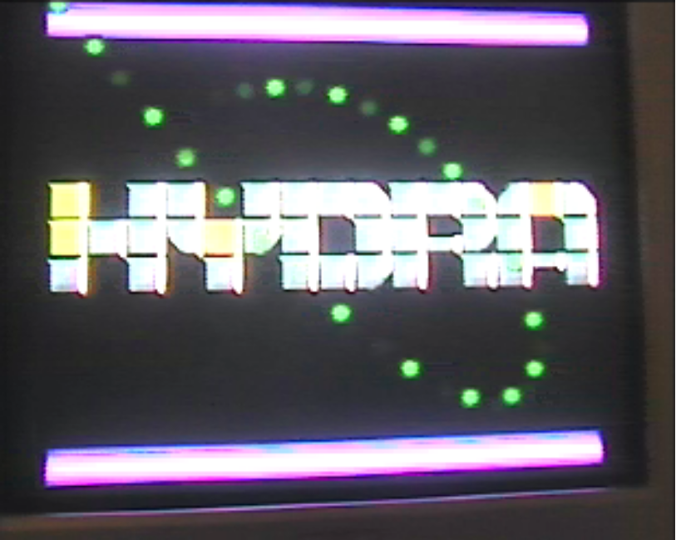

The COP Engine was the first graphics engine developed outside of Parallax Inc. It was also the first ASM code project that I had developed for the Hydra and PChip. Therefore some of the methodology used is not the most ideal.

This graphics engine uses two cogs running in parallel, closely synchronized to generate an NTSC Video Signal to the TV. Running at a resolution of 256 by 224 (which is the same as the SNES game console resolution), with a ‘true color’ depth (86 colors per pixel – 1 byte per pixel), using Tile Mapped graphics. Some fairly impressive 80’s style action games can be created.

To sum up the key features of this graphics engine –

- NTSC Video Output.
- Dual Cog interlaced scanline rasterizing.
- 256 x 224 pixel resolution.
- 86 colors per pixel.
- 60 Frames Per Second.
- Transparency.
- Vertical Scrolling Tilemap (16 tiles by any Height) (Non Transparent).
- Up to 40 sprites per frame (Up to 8 per scanline) (Transparency-supported).
- Plain background layer.

As you can see the technical specifications of the COP Engine are similar to that of the 8 and 16 bit games consoles of the 80’s.

2.0 Getting Started
This is a quick start tutorial to getting the COP Engine to display sprites and a background map. This simply covers all of what is needed to incorporate the COP Engine into your SPIN code.
Refer to the CP_COPTUT_001.spin file…
1) In the CON Section…
obj_n = 24 ' Number of Objects
obj_size = 6 ' registers per object.
obj_total_size = (obj_n*obj_size) ' Total Number of registers (LONGS)

These constants are simply copied from those found in cop_drv_011.spin the purpose of these are to define the size of the OBJ (Sprite) Attribute data in memory. In this case the above settings allocate for 24 sprites on the screen. Each sprite requires 6 LONG’s of data to store it’s X position (X), Y position (Y), Width (W), Height (H), Sprite Index (I), and Color Modifier (M). So in total this is 144 LONG’s (576 bytes) of memory, this approaches the limit of memory inside the cog, so you wouldn’t want to increase it much further, unless you remove unessential code from the COP Engine. In this program, these constants are just used for allocating the size of the cop_obj array, mentioned in the next section.

2) In the VAR Section…

long cop_status
long cop_control
long cop_debug
long cop_phase0
long cop_monitor0
long cop_monitor1
long cop_config
long cop_vram
long cop_tile
long cop_panx
long cop_pany
long cop_bgcolor
' |
' |
' LAST
long cop_obj[obj_total_size] ' 24 sprites

These are all the variables which the COP Engine uses to control its operations, from changing the intensity of the debug LED, to displaying sprites, and a portion of the tiled map on the screen. As you can see at the end of this structure, there is the cop_obj array mentioned earlier, which is allocated to cover the maximum number of sprites (24) that will be used on screen at any one time.

3) In the OBJ Section…

cop : "cop_drv_011.spin" ' instantiate a cop object - Color Co Processor
tiles : "cp_coptut_tiles_001.spin" ' data object. (128x128 block of sprites)
map : "cp_coptut_map_001.spin" ' data object. (16x32 map)

Out of the three objects instantiated here, the cop_drv_011.spin (cop), object instantiation is the only absolutely essential one, as this is the one that brings in the COP Engine to handle all the TV output necessary for the program. The other two are ‘data objects’. That is they’re there so that you can see tiles/sprites on the screen - cp_coptut_tiles_001.spin (tiles) – and view a pre-generated scrollable tilemap - cp_coptut_map_001.spin (map). Both are generated using XGSBMP (see cp_coptut_doit.bat). However, if you wish you can use your own tools to generate the data, or generate the data run-time.

4) In the PUB Section…

' start cop engine
cop.setup(tiles.data,128,128, $00, map.data) ' pass parameters to tile data and map data.
cop.start(@cop_status) ' start and boot two cogs

These lines simply pass some parameters to the COP Engine, and boot the cogs. The cop.setup(…) line basically says “COP Engine, the address of the tileset data is at tiles.data, the dimensions of this tileset is 128x128, Perform $00 XOR operation on all color pixels in tiles.data i.e. has no effect on the pixels, and use map.data as the tilemap”. As for the cop.start(…) line it says “COP Engine, boot the two cogs, and use the engine parameters which start at cop_status in the VAR section of this program“. Essentially this is all there is to initializing and starting the COP Engine.

From this point on, whatever is in the tilemap data and the sprite table will be shown to the screen at 60FPS. Now all you need to know is how to control this.

So further on in this section we have…

cop_bgcolor := $00000000 ' background color quadpixel BLACK.
cop_pany := 0 ' map pan position (0,0)
cop_debug := $0 ' initial debug led intensity (0%)

These set the Background color to BLACK, Map vertical pan to 0 (the origin), and turns the Debug LED to 0% or “OFF”.

Then enter the main loop…

'' Clear Sprites for new Frame.
cop.newframe

At the start of every new frame, this should be one of the first functions to be called, since this clears out all the sprites in the table, so that you can place down new coordinates of sprites.

'' Draw a Sprite - centered position 128,120, dimensions 64x64, using VRAM source data 0,0
cop.sprite(128-32,120-32,64,64,0,0)

Here we’re adding a sprite to the table for this frame. The sprite is of a large bullet situated in the middle of the screen.

'' Adjust Pan Y
cop_pany += pan_dir
if(cop_pany==-128)
pan_dir := 1
else
if(cop_pany==128)
pan_dir := -1

This simply changes the map’s vertical position (cop_pany), causing an up and down panning motion.

'' Adjust Debug LED
cop_debug += debugled_dir
if(cop_debug==0)
debugled_dir := -debugled_dir
else
if(cop_debug==$fc000000)
debugled_dir := -debugled_dir

This simply changes the Debug LED’s intensity (cop_debug), causing the light to increase and decrease brightness, a cool glowing effect ☺

'' Synchronize to the Vertical Sync of the COP Engine TV output.
cop.waitvsync

Last but not least, we have the VSYNC synchronizing code, always important in any video game system ☺ This is always placed near the end of the frame loop, or near the beginning of the frame loop (depending on perspective). This is there to keep the process code running at a fixed rate, in this case 60 Frames Per Second, provided the frame load doesn’t exceed 1/60th of a second. Locking onto the VSYNC also contributes to the smoothness of animated computer graphics.

3.0 Variables and Functions List
Below is a quick summary of the variables and functions used for interfacing with the COP engine…

3.1 Variables List
long cop_status – Current scanline row (0 = Overscan, 1…224 = current active scanline row number being rasterized)
long cop_control – Internal, used for cog booting.
long cop_debug – Debug LED Brightness (Pin 0) – 32 bit value $0 = 0% intensity, $FFFFFFFF = 100% intensity.
long cop_phase0 – Internal, used for cog syncing.
long cop_monitor0 – Unused. For cog #0 debugging.
long cop_monitor1 – Unused. For cog #1 debugging.
long cop_config – Configuration parameter (log₂ VRAM width) e.g. set to 7 if the VRAM width is 128.
long cop_vram – Pointer to VRAM data (where sprite and tilemap data is stored) RAW 1 byte per pixel data.
long cop_tile – Pointer to Tilemap data RAW 1 word (2 bytes) per tile. Referencing tile’s start pixel offset from VRAM.
long cop_panx – Unused. Planned for Horizontal panning.
long cop_pany – Vertical Tilemap panning parameter. Set to -224 or less to show a plain background of cop_bgcolor
long cop_bgcolor – Background color pattern (quadpixel). Scroll up (-ve) to reveal background.
long cop_obj[obj_total_size] – Sprite Attribute table. (6 LONG’s per sprites)

3.2 Functions List
PUB _vram_ws – Returns VRAM width/pitch in log₂ scale (useful for shifting) e.g. if VRAM width is 128, then returns 7
PUB start(copptr) – Starts COP Engine, by booting two cogs. copptr points to cop parameter table in hub memory.
PUB waitvsync – Waits for Vertical Retrace Sync. (returns on first active scanline)
PUB colormodify(ptr, len, _xor) – Performs XOR operation on all color pixels in the designated buffer.
PUB setup(_vram_addr, _vram_w, _vram_h, _xor, _vram_tile) – Sets up variables for the COP Engine.
PUB newframe – Starts a new frame, by setting ALL sprites to off screen.
PUB sprite(x,y,w,h,offx,offy) – Adds a sprite to the screen at position x,y of dimensions w by h from offx,offy in VRAM

4.0 Variables
This section covers the variables in more detail.

long cop_status
During the initial cog-boot phase of the COP Engine, this parameter is used to tell the cogs which one is 0, and which one is 1, essentially which one is to rasterize the EVEN scanlines and which one is to rasterize the ODD scanlines.
After booting, this variable is used to give you an idea of where the scanline rasterizer is, down to the nearest scanline. At the start of the Top Overscan section this cop_status is set to 0, and at the start of every new active scanline, cop_status is incremented by 1. This is mostly used for synchronizing a game or application to 60 FPS, providing for smooth, flicker-free graphics.
Figure 4.1 – Sections of the Screen
VSYNC
First active scanline
(cop_status = 1)
Top Overscan
(cop_status = 0)

Last active scanline
(cop_status = 224)

Bottom Overscan

long cop_control
This parameter is used to help synchronize the two cogs during the booting phase. After which it has no use.

long cop_debug
This parameter is used to control the intensity of the Hydra’s debug LED (pin 0). This is done by changing the ON/OFF state of the LED at 15,720Hz (i.e. on a per scanline basis). By varying the amount of ON’s to OFF’s (the duty cycle), the system is capable of generating an analog voltage and subsequent analog LED brightness. cop_debug is a value between $0 (LED off – 0%) and $FFFFFFFF (LED full on – 100%).
For instance if we wanted the LED to appear at 50% brightness we would set cop_debug := $80000000.
For 25% brightness cop_debug := $40000000
For 33% brightness cop_debug := $55555555
For 66% brightness cop_debug := $AAAAAAAA
For 75% brightness cop_debug := $C0000000

long cop_config
This parameter is used to specify the VRAM width shift amount. This is used during the initial booting phase. After which it has no use. cop_config should be set to log₂ of the VRAM buffer’s width or pitch. That is if you have a VRAM buffer 128x128 pixels in size, containing within, various tiles and sprites. Then cop_config should be set to 7. This way the internal workings of the cop engine can shift Y values left by 7 bits to achieve a multiplication of 128, saving time and code space in comparison to running a multiplication algorithm.

long cop_vram
This parameter is used to specify the VRAM base address. Typically a game or application would have an area of memory pre-loaded with an array of sprites. Perhaps 16x16 sprites, placed in an 8 by 8 arrangement like that in Hydraman. With this parameter set, the COP Engine can interpret tile offset addresses inside the 16-bit (word) Tilemap array and determine the correct address of the pixel data inside the Tileset. Note: This has no effect on how Sprites reference their data.
Figure 4.2 – Hydraman Tileset in relation to PChip Memory

128 pixels
ROM
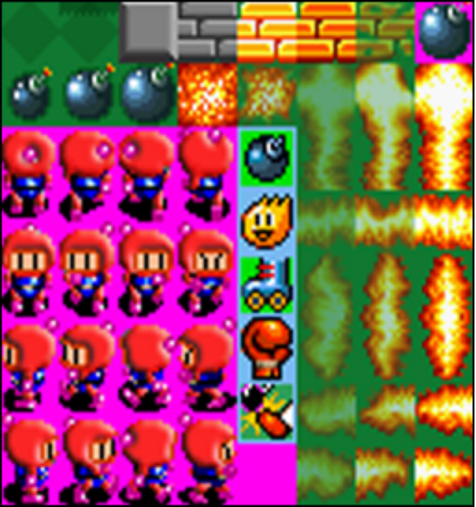
128 pixels

VRAM
(16k)
CODE
Stack / Free
ROM Area
$8000-$FFFF
RAM Area
$0000-$7FFF

long cop_tile
This parameter is used to specify the address of where the Tilemap array resides in memory. The Tilemap’s storage system is a little unusual, in that instead of referencing 16x16 tile indices i.e. 0, 1, 2 etc. the Tilemap holds 16-bit offset addresses specifying the pixel offset (must be 4-byte aligned) inside the VRAM memory for the tile. What this means is that if we wish to refer to the first sprite inside the Hydraman Tile set, we refer to it as $0 since the top left pixel of that sprite is at (0,0). However, if we wish to refer to the 2nd sprite (going across) inside the Tile set, we refer to it as $10 since the top left pixel of that sprite is at (16,0), it is sixteen pixels further across from the origin. For the 8th sprite, (or the first sprite on the second row), we would refer to it as $800, since the top left pixel of that sprite is at (0,16), it starts sixteen lines further down from the origin, with each line containing 128 pixels ($80 bytes), 16 lines contain 2048 pixels ($800 bytes).
The basic math behind this is:
Source_Address = Source_Y * VRAM_WIDTH + Source_X

long cop_panx
This parameter is reserved for future horizontal panning of the tilemap.

long cop_pany
This parameter is used for vertically panning of the Tilemap. cop_pany specifies by how many pixels you wish to raise the tilemap. For instance to view the Tilemap from 50 pixels down i.e. (0,50), you would set cop_pany to 50, To view the Tilemap from 50 pixels up i.e. (0,-50), you would set cop_pany to -50. The latter would result in the Tilemap starting from 50 pixels down the screen, with the top 50 lines of the screen defaulting to cop_bgcolor, i.e. the background color.
Figure 4.3 – Tilemap layer scrolled.
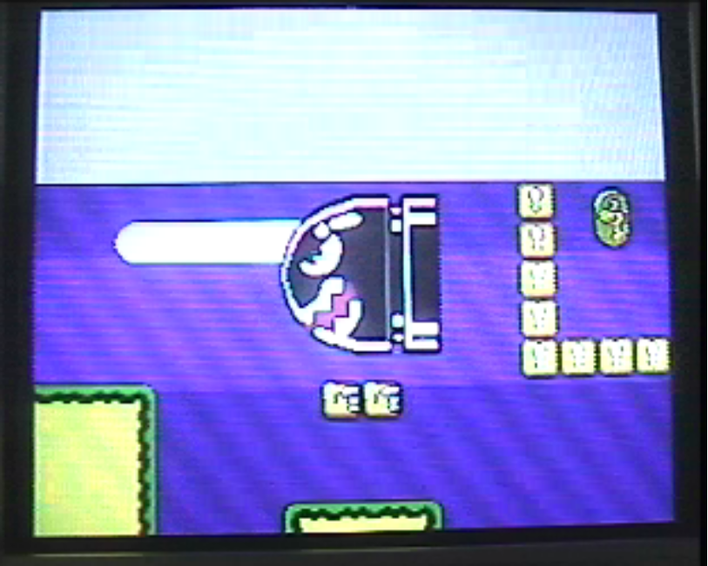

long cop_bgcolor
This parameter is used for specifying the color of the background (where the Tilemap layer is not obscuring the background i.e. cop_pany is at some –ve value). It takes a quadpixel value, that is it holds the color values of 4 adjacent pixels. These 4 pixels are stamped across the screen, every 4 pixels, as a 4x1 pixel repeating tile. For the most part you would want to just set the quadpixel colors in cop_bgcolor to all the same value e.g. $00000000 for black.

5.0 Functions
This section covers the functions in more detail.

PUB _vram_ws
This function simply returns the vram_ws variable “VRAM Width Shift”. The vram_ws variable is set to log₂(vram_w). This can be useful when you wish to shift a Y coordinate left by a number of bits to achieve the equivalent functionality of multiplying that coordinate by the VRAM Width (vram_w). This is also the same value that is passed to the cop_config parameter.

PUB start(copptr)
This function starts the COP Engine, passes the parameters, helps synchronize and give unique identities to the two cogs, sets the map panx and pany coordinates to the origin (0,0), and sets all the sprites to offscreen. Note: This function MUST be called after setup(…)

PUB waitvsync
This function waits until the COP Engine is at the start of the very first active scanline (The first line of the 256x224 screen). If this function is called even just after the first active scanline, it will wait until the first active scanline on the next frame i.e. 16.7ms later. This uses the cop_status variable to determine the vertical position of the rasterizer, and wait for the appropriate position. The reason for waiting until the start of the first active scanline, is that during the VSYNC and Top/Bottom Overscan areas of rasterizing, the COP Engine performs operations such as copying Sprite Attribute data, tilemap panning coordinates etc. Unexpected results would occur if the COP Engine were copying these variables while you were in the process of modifying them in your game/application code.

PUB colormodify(ptr, len, _xor)
This function performs an XOR operation on all the color pixels inside the buffer specified by ptr. i.e. BYTE[ptr…ptr+len-1] XORing each pixel with the value _xor. The main purpose of this is to help convert graphics encoded with the hues intended for Parallax Inc’s original graphics engine. This is not necessary when using the converter tool XGSBMP 1.07 or higher. This function can also be used to perform some effects on graphics, such as flipping hue colors.

PUB setup(_vram_addr, _vram_w, _vram_h, _xor, _vram_tile)
This function helps you set up the most important parameters of the COP Engine. This should be called FIRST, before you call start(…) .
_vram_addr – pointer to the start of your VRAM memory. Typically points to your Tileset.
_vram_w – width or pitch of your VRAM memory. Typically refers to the width of your Tileset image, e.g 128.
_vram_h – height of your VRAM memory. Typically refers to the height of your Tileset image, e.g. 128
_xor – value to XOR onto every pixel of the VRAM. Typically is $F0. Not necessary when using XGSBMP 1.07 or higher.
_vram_tile – pointer to the start of your Tilemap memory. This is where you hold the 16-bit tile offset addresses.

PUB newframe
This function clears the sprites from the screen. Technically it doesn’t do much, this is a small feat for a tile engine like this. Essentially newframe sets all the sprite’s Y coordinates to 255, which is below the active screen, so that they are not rendered, and resets the sprite counter (sprite_n = 0).

Figure 5.1 – Blank screen with only background layer.

PUB sprite(x,y,w,h,offx,offy)
This function adds a sprite to the screen, with the upper left pixel of the sprite starting at the specified (x,y) coordinate, the sprite is of width (w), and height (h), the contents of the sprite is sourced from where offx,offy point to inside the VRAM memory. By ‘adding’ a sprite to the screen, what is actually happening is sprite_n ‘s attributes are being set to that specified by the parameters of this function, then the sprite counter sprite_n is incremented, i.e. moves on to the next sprite (which defaults to off screen by newframe). If the sprite limit is reached, then the function will not add another, and just return.

Figure 5.2 – Sprite added to screen.


