Hydra Tiny Basic by Robert Woodring
woodringr@msn.com

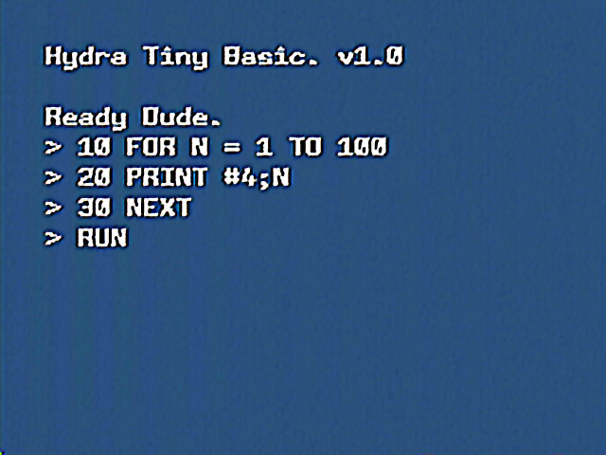
Figure 1.0 – HT Basic running on the Hydra system.
Hydra Tiny Basic (HT Basic) is based on Dr. Dobb’s Journal’s various implementations of Tiny Basic. My version is loosely based on the work of Li Chen Wang’s Palo Alto tiny Basic and more so the version by Gordon Brandly’s 68000.
The language is rather simple but should implement most statements and function to make a surprisingly useful implementation.

Editor
The editor is very simple. You can edit one line at a time. To enter a line, precede it with a line number. To delete a line, just enter the line number to delete with not other detail.
You can enter SHIFT+UP ARROW to bring back the last line entered into the line editor.

Abbreviations and Spaces
You may use spaces freely within a program with the exception that numbers, command keywords, and function names cannot have embedded spaces. You can abbreviate all command keywords and functions names by using a period anytime after the first character of the keyword has been entered.
Examples:
P.
PR.
PRI.
PRIN.
PRINT
All will be parsed as the keyword PRINT. However, when an abbreviated keyword is LISTed, the full keyword is displayed. In some cases, the same abbreviation may apply to different keywords. For example:
P.
Could stand for PRINT or POKE or PEEK. The system will assign what it thinks to be the correct keyword according the order that the keywords appear in the token in the source code. Currently the order is:
LIST
LOAD
NEW
RUN
SAVE
NEXT
LET
IF
GOTO
GOSUB
RETURN
REM
FOR
INPUT
PRINT
POKE
STOP
TO
STEP
PEEK
RND
ABS
SIZE
NOTE | You can omit the keyword LET in a LET command as this is the default command to be run. You can use the ? symbol as a keyboard shortcut for the PRINT command.

Numbers
All numbers are 32 bit signed integers. The range is such that it is possible to represent the values from 2,147,483,647 to -2,147,483,684.
All variables and array elements are stored as long values (4 bytes).

Variables
There are 26 variables, A through Z, with a single array @(x). The dimension of this array is set to make use of all the free memory space. As you add source lines, the available memory for the array is reduced at run time. You can query the size of the array with the SIZE function (see below).

Expressions
The expression parser is rather simple but is able to handle almost any level of recursion (limited to available stack memory) The Stack size is fixed but you can change the ASM_STK_SIZE constant to fit your needs and recompile.
NOTE | Multiply and Divide each work on 16 bit values only. I used the examples from the Hydra manual for these routines.

Operators
The standard operators are supported with appropriate operator precedence binding. The lower the precedence value, the tighter the binding. You can override that with the standard () wrapped around the expression portion of interest.
Operator | Precedence | Description
- | 1 | Unary Minus
* | 2 | Multiply
/ | 2 | Divide
+ | 3 | Add
- | 3 | Subtract
>= | 4 | Greater then or Equal
<> | 4 | Not Equal
<= | 4 | Less Than or Equal
> | 4 | Greater Than
= | 4 | Equal
< | 4 | Less Than

NOTE | NOTE: Due to the way the parser is designed, Unary Minus can only be used in the first order expression. (See below for more details)

Functions
There are 4 functions.
- ABS(X)
Gives the absolute value of X
- RND(X)
Gives a random number between 1 and X. Upon program start, the random number generator is seeded with a semi random value generated by the system. If you ever want to generate a new seed value then pass X as a zero value.
Example: “A=RND(0)” re-seeds the random number generator..
- SIZE
Returns the number of free BYTES. The Array variable will take up this free space. Since the array var holds only long values, divide the result of size by 4 to get the current dimension size of the @() Array.
- PEEK(X)
Returns the BYTE value at memory location X.

Commands
- LET
This is the default statement. Once the interpreter decides that it cannot parse any other statement, the system will then assume it is a LET statement without the leading LET keyword. Multiple LET statements can be placed on one line of source as long as they are separated by a comma.
Example:
LET N=123+8*2, P=N/2, C=5*(2+1), @(C+3)=122
Will Set the following results:
N will equal 139
P will equal 69
C will equal 15
@(18) will equal 122
- LIST
List will list the BASIC program to the screen, scrolling as needed. The default line to start listing at is the first line in the program. You can include a starting line number to override the default.
Example:
LIST 100
Will list the program starting from line 100. Note: You can pause a long listing using CTRL-S on the keyboard or CTRL-C to terminate the listing and return the ready prompt.
- NEW
NEW will cause the program memory to be cleared and ready the system for a new program to be entered. Note: Variable space is NOT cleared when executing this command.
- RUN
RUN will start or continue execution of a program. The default line to run is the first line in the program. You can include a line number to override the default. Note: Variable space is NOT cleared when executing this command.
- REM
REM allows you to place comments in your program. The parser does not change the case of text in a REM line.
Example:
REM This is a test
- PRINT or ?
The print command will allow you to print the results of a numeric expression, a string constant expression, a single character expression or screen control operators.
You can type the shortcut character ? in place of the full keyword. The ? will be expanded to the full keyword when the line is parsed and listed.
A semicolon can be used to separate multiple print items in one print statement and a lone semicolon at the end of a print statement will suppress the automatic CR-LF the is generated when the print command has finished.
Numeric expressions are printed to 11 spaces as the default but you can override this by using the # print operator to specify the current numeric width. Once set, the new width remains in effect until another # operator is encountered or a new PRINT command is run.
Example:
PRINT 123; #3; 45
Will result in the following..
________123_45 (where _ = a space)
String constant expressions can use either single or double quotes but the starting and ending quote types must match.
Example:
PRINT “Hello World”
Note: The parser does not change the case of characters between quotes nor in REM statements.
You can use the $ print operator to send control codes or bytes to the screen output.
Example:
PRINT $10
This will send an extra LF to the screen driver.
The underscore print operator will send a CR to the screen driver. This is useful for the times when you may want to overwrite the same screen location.
Example:
10 FOR N = 1 TO 10000
20 PRINT #4; N; _;
30 NEXT
- INPUT
INPUT will allow the program to wait for input from the user. The simplest format is just to include the variable name that the users answer is to be stored in.
Example:
INPUT A
The system will print the variable’s name and a colon and wait for the users input (terminated by the ENTER key). You can include multiple input items by separating them with a colon.
Example:
INPUT A,B,C
The system will prompt for A then B then C each in turn.
You can include your own prompt in place of the default by preceding the variable name with a string constant expression. The string rules are the same as for the PRINT command (see above).
Example:
INPUT “What is your age?”A
This will show the prompt “What is your age?” then wait for the user’s answer and store the result in the variable A. Note: There is no separator between prompt and the input variable.
You can enter complete expressions as well as numbers. The runtime will parse the expression before assigning the results to the variable. This allows for an interesting trick.
10 LET Y=9999
20 INPUT “Are you having fun?A
30 IF A=Y THEN PRINT “YEAH!!!”
When the user types the Y for an answer the expression parser will evaluate Y and set A = 9999. This trick makes the test IF A=Y THEN… self-explanatory and the code much more readable.
- POKE(x,y)
the POKE command will store the byte value in memory location y.
- FOR/NEXT
The stand syntax for the FOR/NEXT statements are used with the exception that you do not specify the loop variable in the NEXT statement. This is because the loop variable is already known and save a lot of program space in the interpreter with not having to deal with catching any syntax exceptions. You can nest FOR/NEXT loops to any level up to the limit of the set stack size.
Example:
10 FOR N = 1 TO 100
20 PRINT N
30 NEXT
You can include a STEP value for the loop. The default is a step of 1. The step can be negative.
Example:
10 FOR N = 1 TO 100 STEP 2
20 PRINT N
30 NEXT
Note: GOSUB creates a new stack frame. You cannot issue a NEXT statement for FOR/NEXT loops running outside the current subroutine.
Example: the following is invalid and will generate an error:
10 FOR N = 1 TO 100
20 GOSUB 400
30 NEXT
400 PRINT N
410 NEXT
- LOAD/SAVE
You can LOAD or SAVE a Basic program to a PC via the USB serial interface.
A new version will be released that will load and save to the Hydra memory card shortly.
For now, load up Hyperterm on the PC and set the correct port for the Hydra. You can use the F5 key in the Propeller IDE to find the serial port the Hydra is connected to.
LOAD:
Run the LOAD command on the Hydra. In Hyperterm, either cut and paste a previously saved program, or use the file load feature of hyperterm. Once the program transfers, Basic will return to the command prompt where you can then list or run the program
SAVE:
Setup Hyperterm and issue the SAVE command on the Hydra. You will see the program transfer to the PC. You can then cut and paste the results from Hyperterm to a file or use the file save feature of Hyperterm.
- IF
Conditional testing is possible with the IF statement. Unlike regular basic, you do not supply the THEN keyword.
Example:
10 IF N = 100 PRINT “YES”
You can include multiple commands separated by colons. They will only be executed if the test condition evaluates to TRUE.

Stopping the Program
You can stop the program and return to the READY prompt at any time by pressing CTRL-C on the keyboard. Additionally you can pause a program listing by pressing CTRL-S on the keyboard then pressing any key to continue.

Error messages

