SAFED AGENT INSTALLATION AND CONFIGURATION GUIDE

Table of Contents

1 Installation of Safed for Windows 1
2 Configuration of Safed for Windows 2
2.1 Network Configuration 3
2.2 Objective Configuration 4
2.3 Log Configuration 7
2.4 Remote Control Configuration 9
2.5 Get and Set Configuration 10
2.6 Apply Configuration 10
3 Installation of Safed for Linux 11
4 Configuration of Safed for Linux 11
4.1 Network Configuration 11
4.2 Log Configuration 13
4.3 Remote Control Configuration 14
4.4 Get and Set Configuration 15
4.5 Apply Configuration 16

Installation of Safed for Windows
In order to install the Safed agent on Win XP/2003 or Win Vista/2008, please execute Safed_xbit_1_2_0.msi or Safedvista_xbit_1_2_0.msi file selecting the right OS bit version.

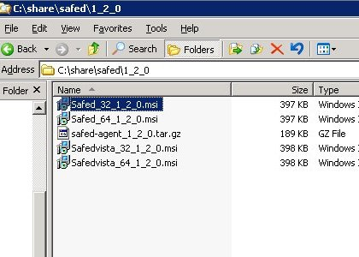
When the installation is terminated the Safed service will be started automatically an it could be controlled with the Windows Services Administrative Tool

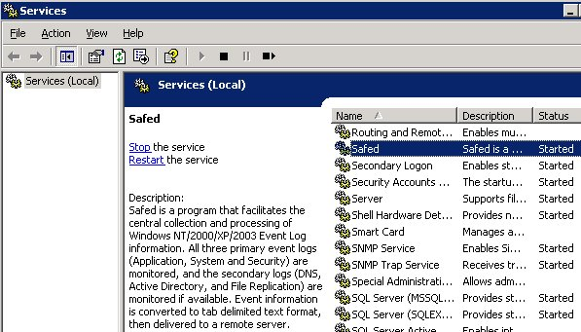

Configuration of Safed for Windows
Once the installation is terminated it is possible to connect to the web interface of the agent with your favorite browser at http://host_address:6161/
The version of the Safed agent and the status of the connection to the rsyslog server will be shown. Pay attention, the status of the connection is updated only when a message is sent to the server.
On the left side of the page the menu is displayed.

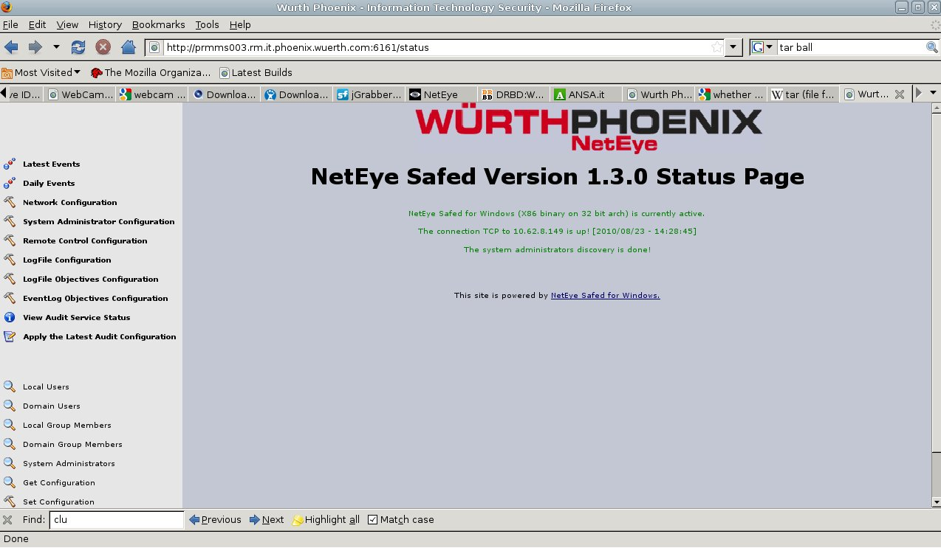
Network Configuration
In order to set the network connection it should be selected the 'Network Configuration' item.
Using the Network configuration page it is possible to set the rsyslog host, port (the default is 514) and the desired protocol (tcp or udp). Some interesting features could be enabled, namely the local cache and the numbers of days this cache is rotated.
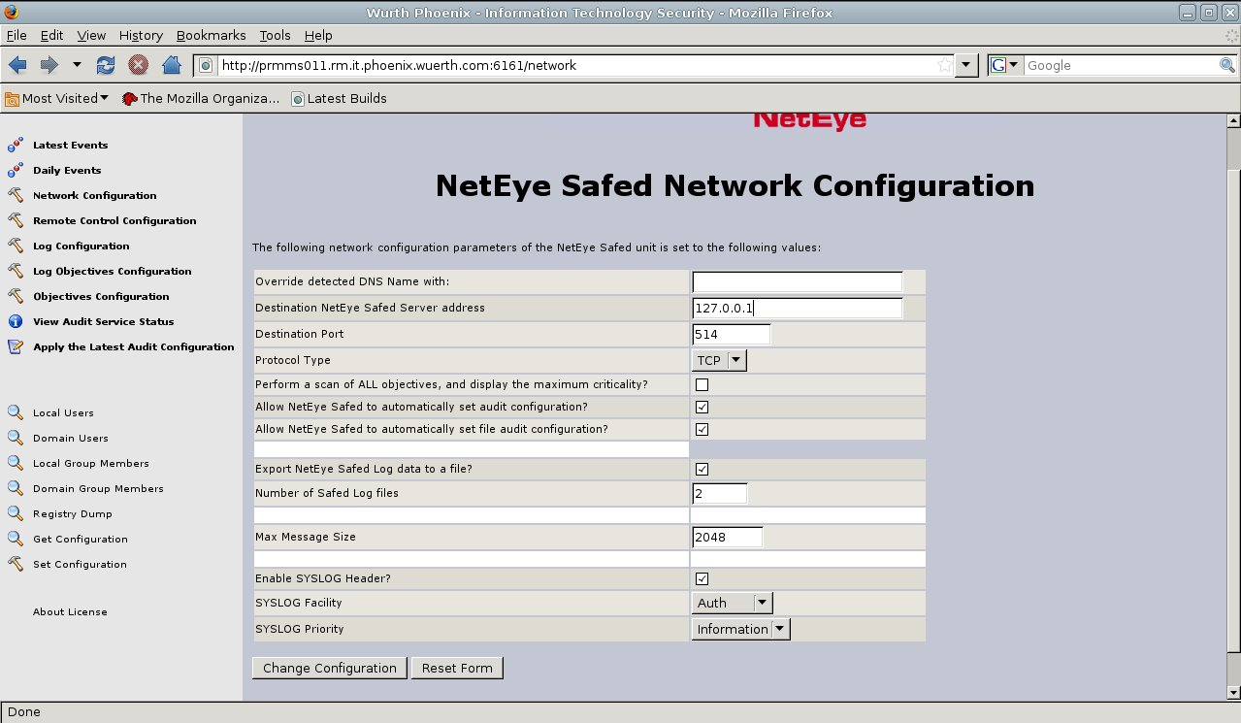
Brief description of the main fields:
- Destination NetEye Safed Server address
values: maximum of 100 characters
description: IP address of the log server.
- Destination Port
values: integer between 1 and 65535; default 514
description: the log server port number.
- Protocol Type
values: UDP or TCP
description: determines the used protocol. When selecting UDP the log transmission is connectionless and there is no guarantee about log delivery, and therefore very fast. On the other hand selecting TCP the SAFED transmission
is connection - based and the protocol guarantee the log delivery, features the slows down the transmition.
- Allow NetEye Safed to automatically set audit configuration?
values: yes or no; default YES
description: set automatically the audit configuration. Put it always YES
- Allow NetEye Safed to automatically set file audit configuration?
values: yes or no; default YES
description: set automatically the file audit configuration. Put it always YES
- Export NetEye Safed Log data to a file?
values: yes or no; default NO
description: Safed will write a cache log file to the client system32 path.
- Number of Safed Log files
values: integer; default 2
description: Number of daily cache log files left on the client side .
- Max Message Size
values: integer; default 2048
description: max size of the transmitted log message.
- Enable SYSLOG Header?
values: yes or no; default YES
description: determines whether a SYSLOG header will be added to the event record. Put it always YES
- SYSLOG Facility
values: set defined in rfc5424;
description: determines the SYSLOG Facility.
- SYSLOG Priority
values: et defined in rfc5424;
description: determines the SYSLOG severity.

Objective Configuration
In order to set the Event Log monitoring configuration it should be selected the 'Objective Configuration' item
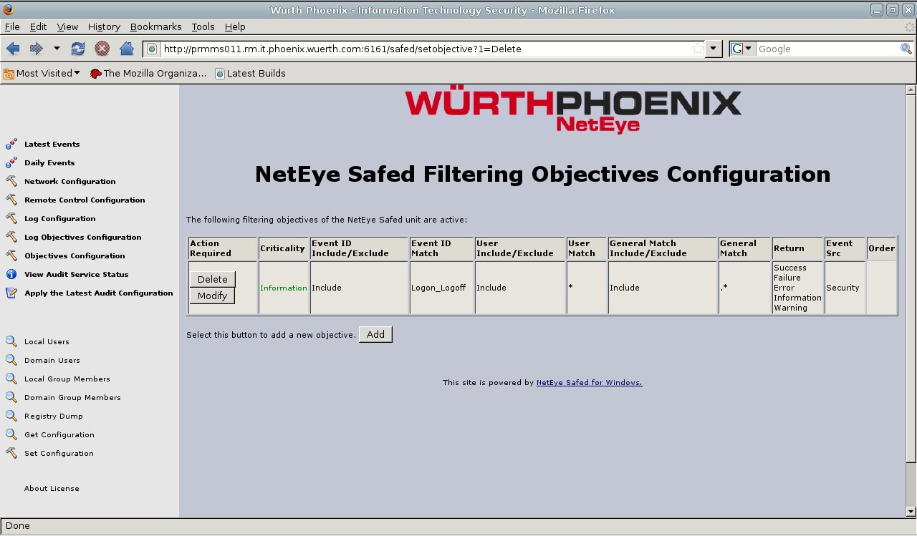

Here it is possible to add a new windows group of events to be monitored through the add button.

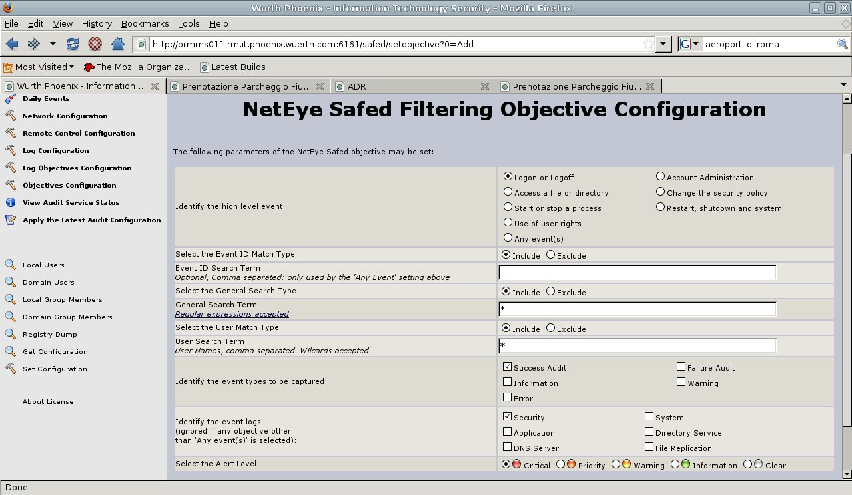
In this page it is possible to select the group of Windows events that should be monitored or selecting 'Any events' it is possible to specify only the events one is interested in. In the last case the include/exclude radio button should be selected and the list of events comma separated should be inserted in the EventId field
The second filter on the Windows events that could be selected is based on the User field of the event. The include/exclude radio button should be selected and the list of users comma separated should be inserted in the User Search Term field. Pay attention, in some cases the Windows Log Events don't fill that field and the string SYSTEM is put instead. In that cases it is possible to filter the payload part of the Windows Event Log selecting the include/exclude radio button and inserting the filtering regular expression in the General Search Term field
In this page Event Type and Alert Level could be selected as well.
Brief description of the main fields:
- High level event
values: Logon_Logoff, File_Events, Process_Events, User_Right_Events, User_Group_Management_Events, Security_Policy_Events, Reboot_Events or Any_Event
description: some high level groups of events to be captured are available. When customized list of events is required select Any_Event
- Event ID Match Type
values: include or exclude ; default include
description: only used by the 'Any Event' setting above.
- Event ID Search Term
values: max of 256 characters
description: Comma separated list of events to be captured (528,533 - A user is/is not logged on to a computer). Only used by the 'Any Event' setting above.
- General Search Term
values: max of 512 characters
description : An additional filter for captured events applied to the event payload. Regular expressions are accepted. For example admin(0|1).*|.?dministrator|pb00164|oms accepts admin023, admin123, administrator, Administrator, oms.
- User Match Type
values: include or exclude ; default include
description: Filter on UserId is included/excluded
- User Search Term
values: max of 512 characters
description: Comma separated list of UserId . An event may be selected or discarded based these UserIds, or partial match of a UserId (wildcard are accepted)
- Event types to be captured
values: Success Audit, Failure Audit,Information, Warning and Error
description: Windows allows for five different audit event types. Select the type or types of interest.
- Event logs
values: Security, System, Application, Directory Service, File Replication and DNS Server
description: On Windows Servers, all six event logs may be found, however on Workstation installations only three of these event logs (Security, System and Application) are available
Ignored if any objective other than 'Any event(s)' is selected.
- Alert Level
values: Critical, Priority, Warning, Information and Clear
description: Indicates the severity of the event.

Log Configuration
If the Safed agent is used to monitor files the 'Log Configuration' and the 'Log Objective Configuration' item of the left menu should be used.
In the Log Objective Configuration page it is possible to specify the search term for the filter. It should be a regular expression. Pressing the add button it is possible to add new filtering rules.

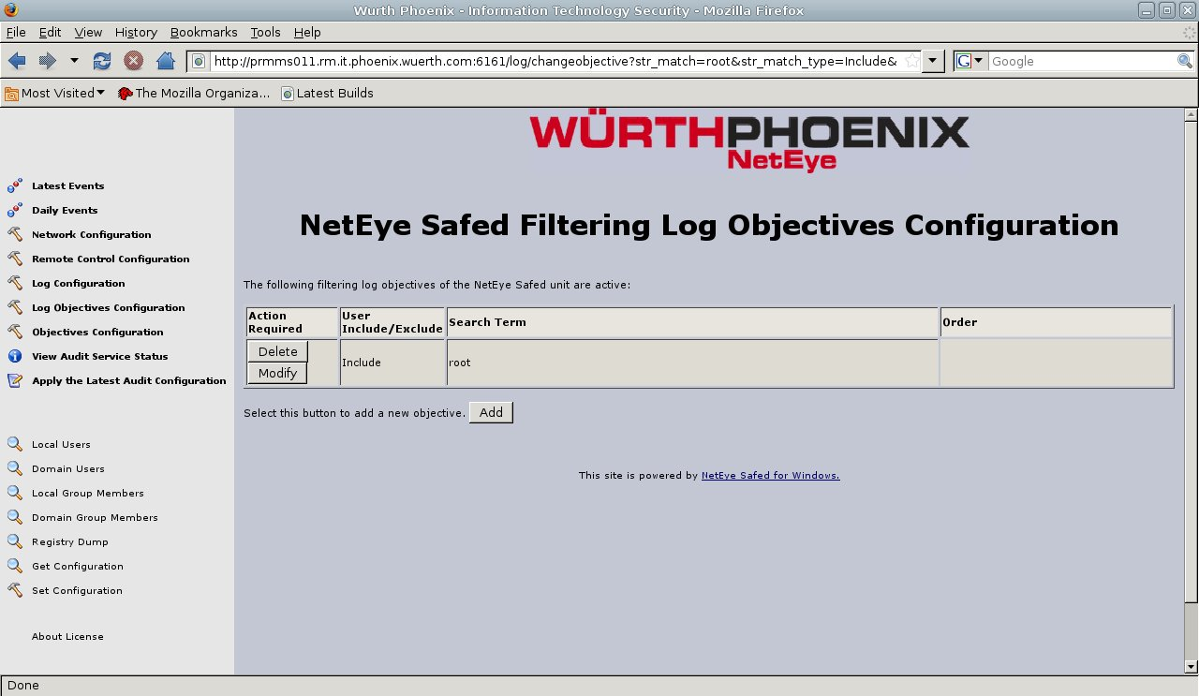
Brief description of the main fields:
- General Search Term
values: max of 512 characters
description : This is the filter expression. Regular expressions are accepted.
For example .*root.* filters rows containing the root user from the monitored file
- Select the Match Type
values: include or exclude ; default include
description: Filtered lines are included/excluded

In the Log Configuration page it is possible to specify the the file to be monitored. Here it is possible the include/exclude comment lines and to specify line separators. Pressing the add button it is possible to add new monitored files.

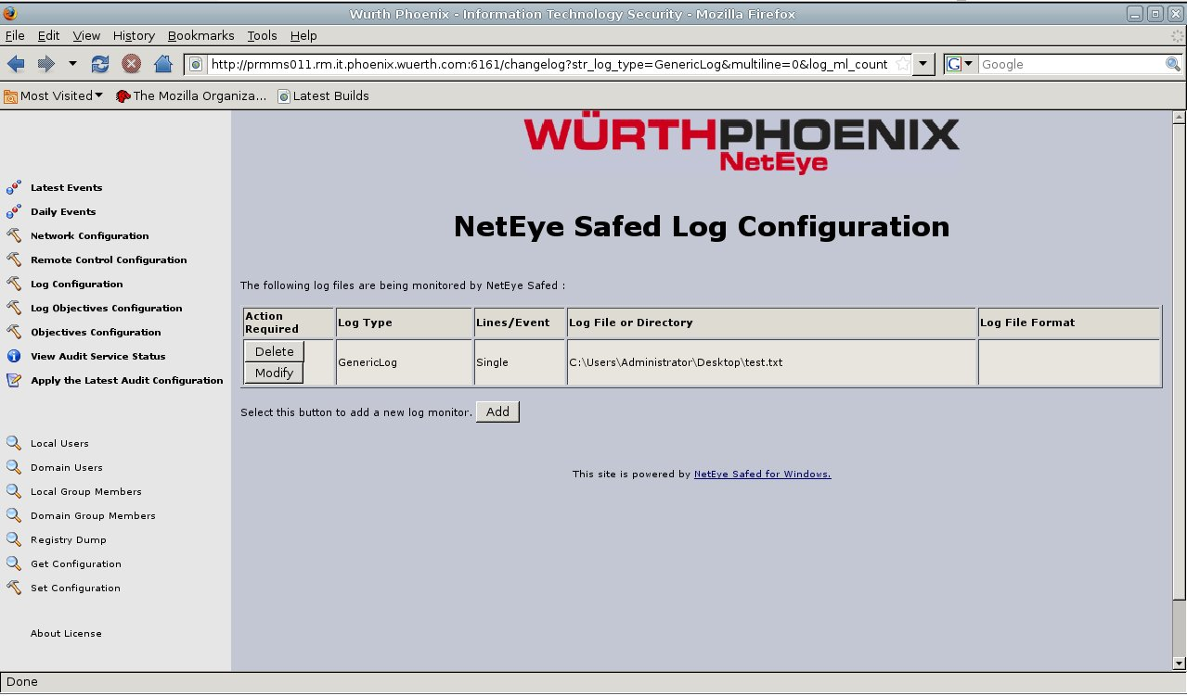
Brief description of the main fields:
- Log Type
values: an enumeration; default “Generic log file”
description : It is optional and it is used to inform the server how to process the data stream.
- Log Path
values: max 260 characters;
description: The LogPath is the fully qualified path to the log file that needs to be monitored OR the fully qualified path to the directory containing date stamped log files of the form *YYMMDD* (in this case a trailing backslash ('\') is required). Spaces are valid, except at the start of the term.
- Log Format
values: max 260 characters;
description: A percent sign (%) is used the represent the date format YYMMDD. Wildcards are acceptable.
e.g. log names like ISALOG_20060913_WEB_000.w3c would be represented as ISALOG_20%_WEB_*.w3c. If this field is not defined, the first matching entry will be used (this is fine in most cases).
- Send Comment
values Yes or No; default No
description: Select whether to include ore exclude commented lines. By default, lines starting with '#' will be ignored;
- Multi-Line Format
values: max 32 characters
description: Describe the line separator. By default \n is considered. It is possible also to consider a fixed number of lines.

Remote Control Configuration
Through the “Remote Control Configuration” web page it is possible to configure some features of the integrated web server inside the Safed Agent.
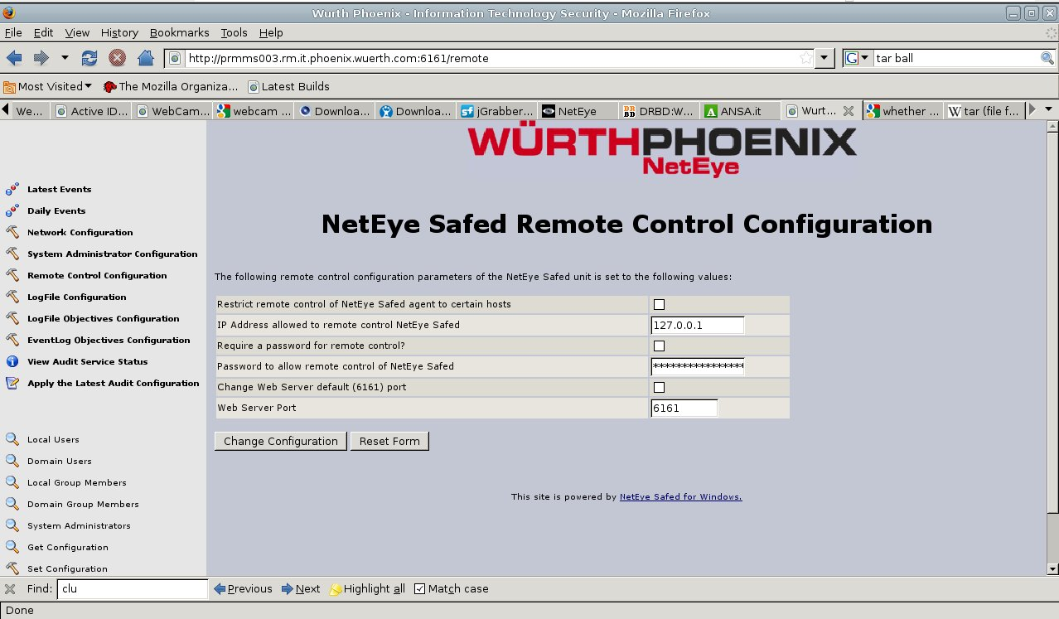
Brief description of the main fields:
- Restrict remote control of NetEye Safed agent to certain hosts
values: Yes or No; default No
description : It is possible to restrict the access to the web server to a given host.
- IP Address allowed to remote control NetEye Safed
values: max 256 characters;
description: Remote control actions may be limited to a
given host. This host, entered as an IP address in this field, will only allow remote
connections to be effected from the stated IP address
- Require a password for remote control?
values: Yes or No; default No
description: A password may be set so that only authorized individuals may access the remote control functions
- Password to allow remote control of NetEye Safed
values: max 256 characters;
description: The password which will be encrypted using the MD5 hashing algorithm
- Change Web Server default (6161) port
values: Yes or No; default No
description: signal whether the web port should be changed or not.
- Web Server Port
values: integer; default 6161
description: The port of the embedded web server.

Get and Set Configuration
Using the 'Get Configuration' and 'Set Configuration' items of the left menu it is possible to receive/submit the entire configuration of the agent

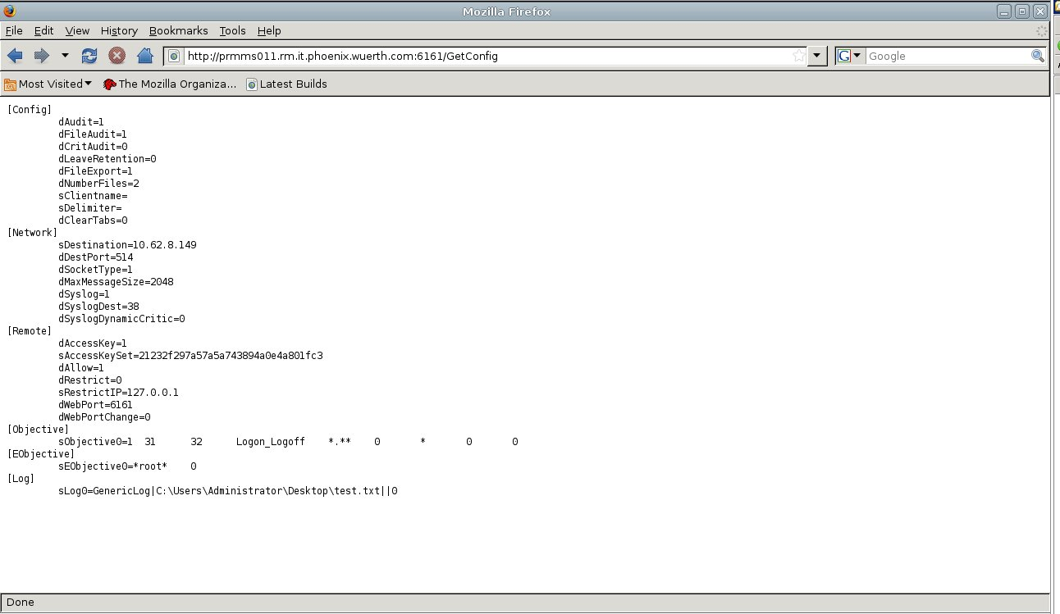
Apply Configuration
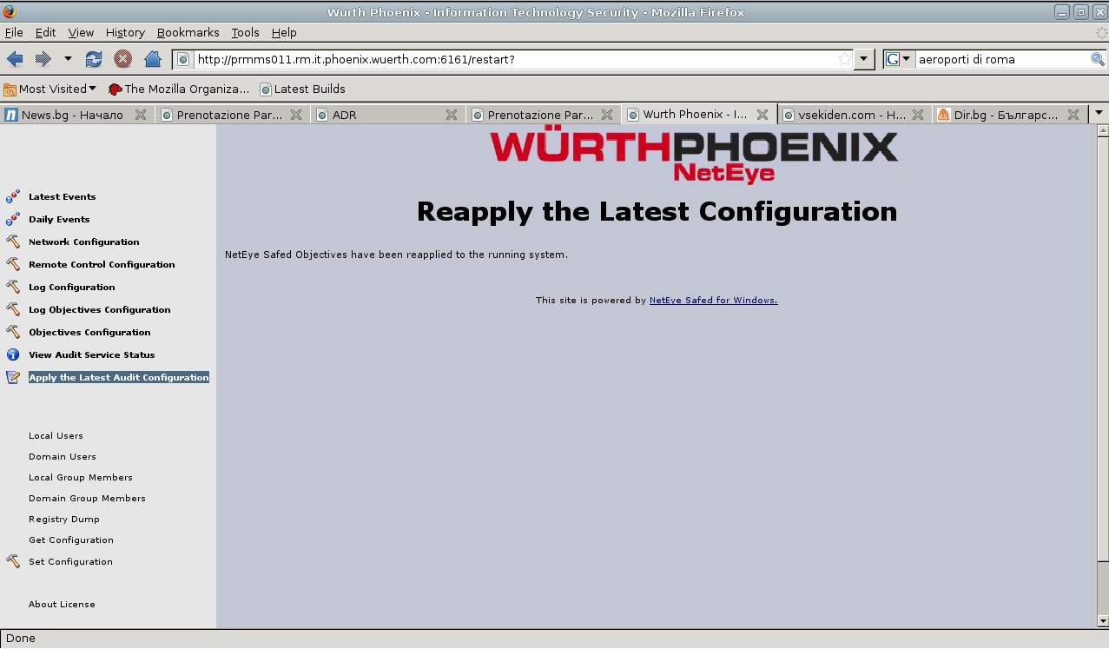
The configuration of the Safed agent, both uploaded via the set configuration function or set by the web server pages should be applied through the 'Apply the Latest Audit Configuration' menu item, in order to make it effective.

Installation of Safed for Linux
In order to install the Safed agent on Linux, please start with the tarball safed-agent_1_2_0.tar.gz in your installation directory:
tar -zxvf safed-agent_1_2_0.tar.gz
In the extracted ./safed-agent directory run the install.sh script which will install and run the Safed agent. A single configuration file is required to correctly run Safed . The file safed.conf is copied to the /etc/safed/ directory on your local filesystem during the installation process. To check if the agent is running, please execute the command ps -ef|grep safed.
In order to uninstall Safed use the script uninstall.sh

Configuration of Safed for Linux
Once the installation is terminated it is possible to connect to the web interface of the agent with your favorite browser at http://host_address:6161/
The version of the Safed agent and the status of the connection to the rsyslog server will be shown. Pay attention, the status of the connection is updated only when a message is sent to the server.
On the left side of the page the menu is displayed.

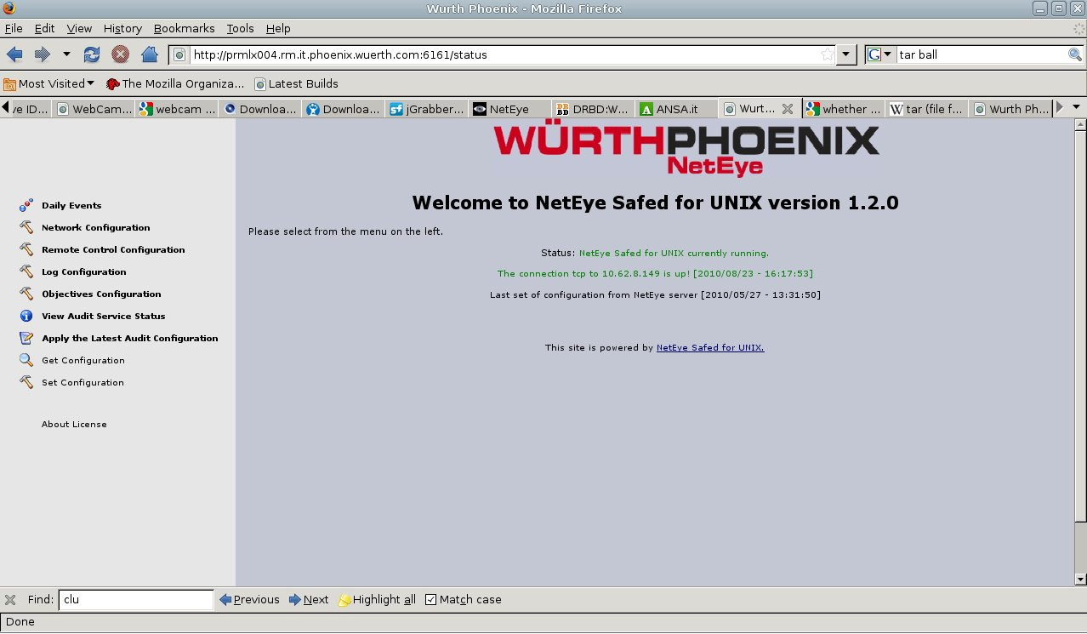

Network Configuration
In order to set the network connection it should be selected the 'Network Configuration' item
Using the Network configuration page it is possible to set the rsyslog host, port (the default is 514) and the desired protocol (tcp or udp). Some interesting features could be enabled, namely the local cache and the numbers of days this cache is rotated.

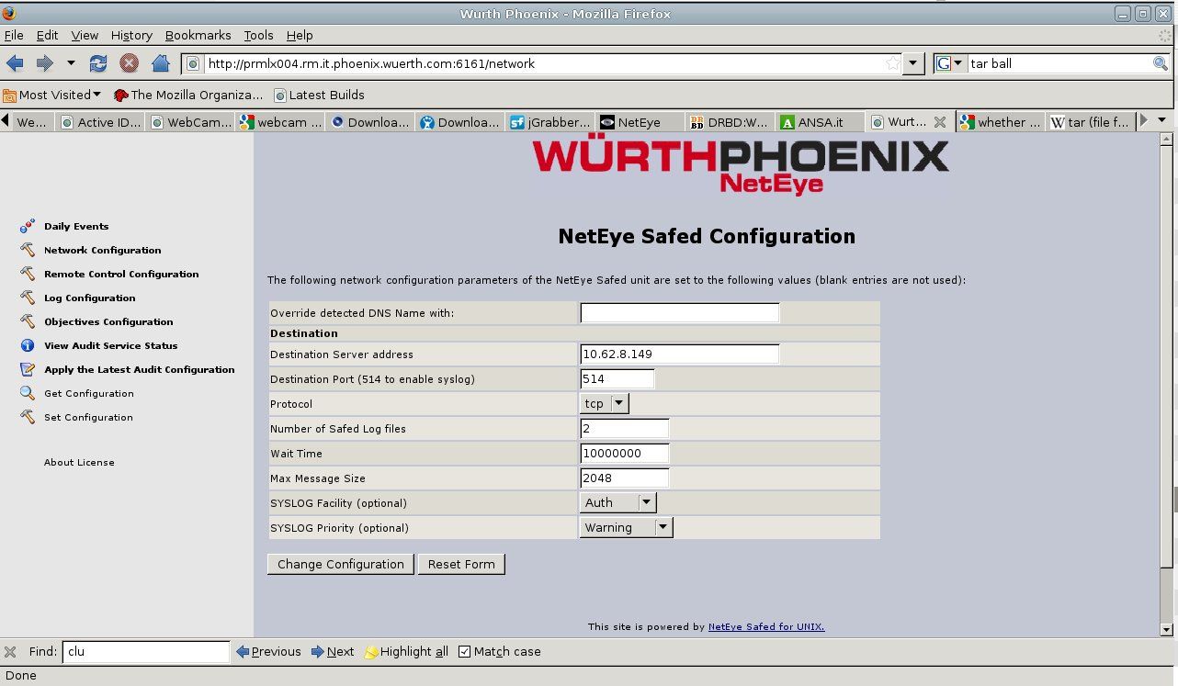

Brief description of the main fields:
- Destination Server address
values: maximum of 256 characters
description: IP address of the log server.
- Destination Port
values: integer between 1 and 65535; default 514
description: the log server port number.
- Protocol Type
values: UDP or TCP
description: determines the used protocol. When selecting UDP the log transmission is connectionless and there is no guarantee about log delivery, and therefore very fast. On the other hand selecting TCP the SAFED transmission is connection - based and the protocol guarantee the log delivery, features the slows down the transmission.
- Number of Safed Log files
values: integer; default 2
description: Number of daily cache log files left on the client side .
- Wait Time
values: integer; default 10000000
description: The agent will check each”Wait Time” for new matching items.
- Max Message Size
values: integer; default 256
description: max size of the transmitted log message.
- SYSLOG Facility
values: a set defined in rfc5424;
description: determines the SYSLOG Facility.
- SYSLOG Priority
values: a set defined in rfc5424;
description: determines the SYSLOG severity.

Log Configuration
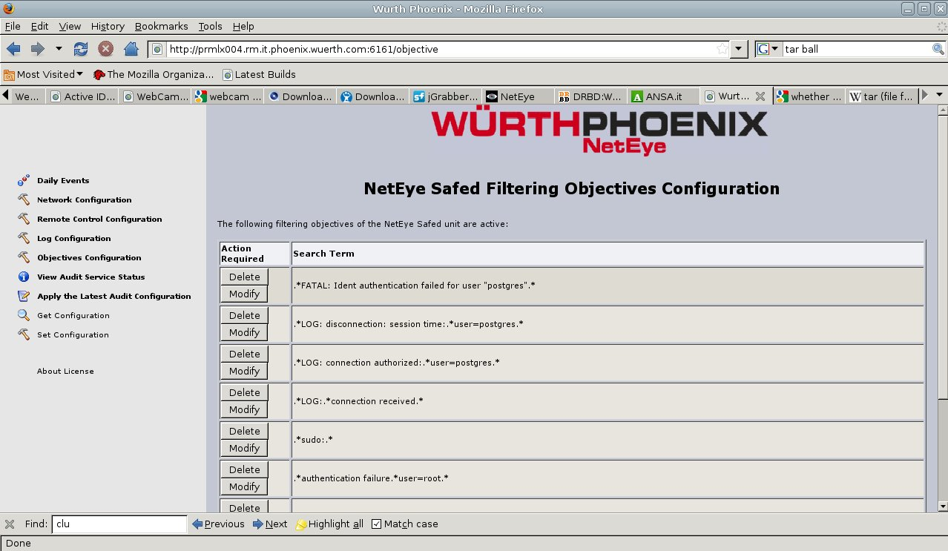
The Safed agent is used to monitor files and it is possible through the Objective Configuration page to specify the search term for the filter. It should be a regular expression.

Here it is possible to add new filtering rules pressing the add button.
Brief description of the main fields:
- Search Term
values: max of 8192 characters
description : This is the filter expression. Regular expressions are accepted.
For example .*root.* filters rows containing the root user from the monitored file
- Select the General Match Type
values: include , exclude or 'Match Any String'; default ' Match Any String'
description: Filtered lines are included/excluded. If ' Match Any String' is selected the matching rule is .*
In the Log Configuration page it is possible to specify the the file to be monitored. Pressing the add button it is possible to add new monitored files.
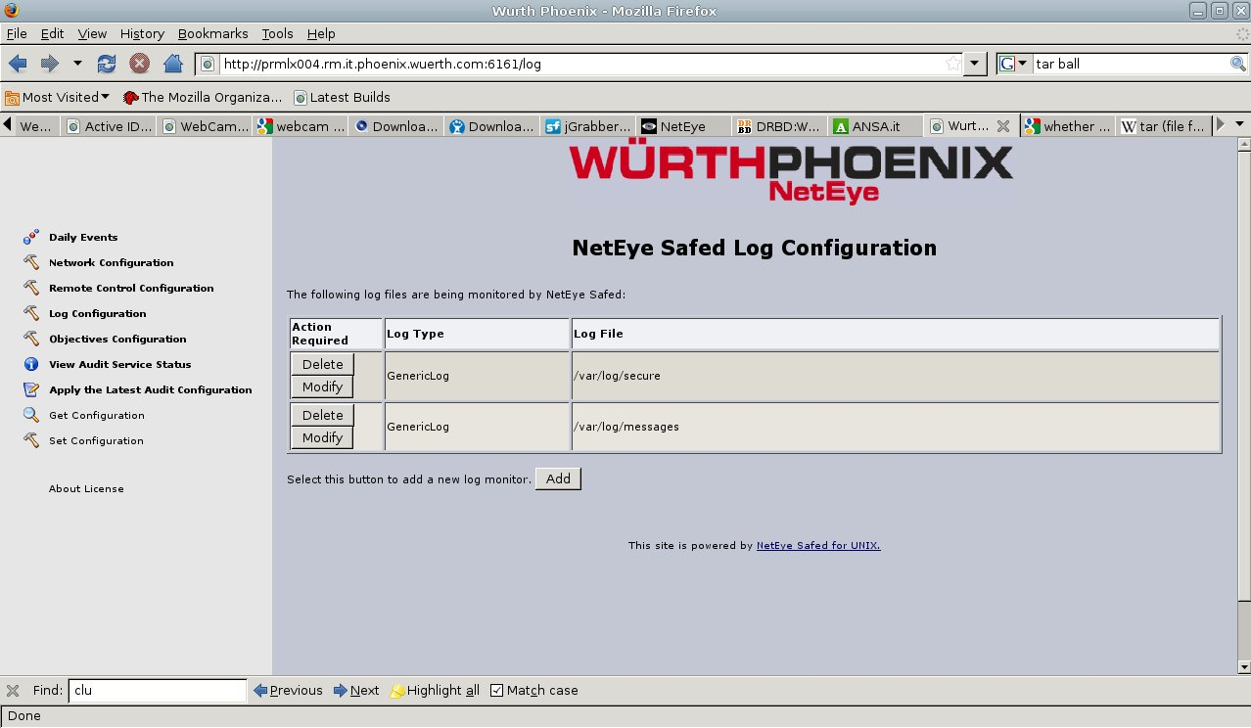
Brief description of the main fields:
- Log Type
values: an enumeration; default “Generic log file”
description : It is optional and it is used to inform the server how to process the data stream.
- Log File
values: max 1024 characters;
description: The Log File is the fully qualified path to the log file that needs to be monitored. Spaces are valid, except at the start of the term.

Remote Control Configuration
Through the “Remote Control Configuration” web page it is possible to configure some features of the integrated web server inside the Safed Agent.
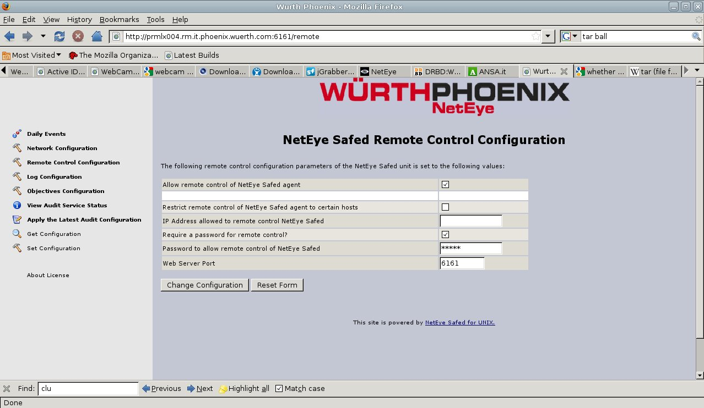
Brief description of the main fields:
- Allow remote control of NetEye Safed agent
values: Yes or No; default Yes
description : The remote control of theNetEye Safed agent is allowed or denied
- Restrict remote control of NetEye Safed agent to certain hosts
values: Yes or No; default No
description : It is possible to restrict the access to the web server to a given host.
- IP Address allowed to remote control NetEye Safed
values: max 256 characters;
description: Remote control actions may be limited to a
given host. This host, entered as an IP address in this field, will only allow remote
connections to be effected from the stated IP address
- Require a password for remote control?
values: Yes or No; default No
description: A password may be set so that only authorized individuals may access the remote control functions
- Password to allow remote control of NetEye Safed
values: max 256 characters;
description: The password which will be encrypted using the MD5 hashing algorithm
- Web Server Port
values: integer; default 6161
description: The port of the embedded web server.

Get and Set Configuration
Using the 'Get Configuration' and 'Set Configuration' items of the left menu it is possible to receive/submit the entire configuration of the agent

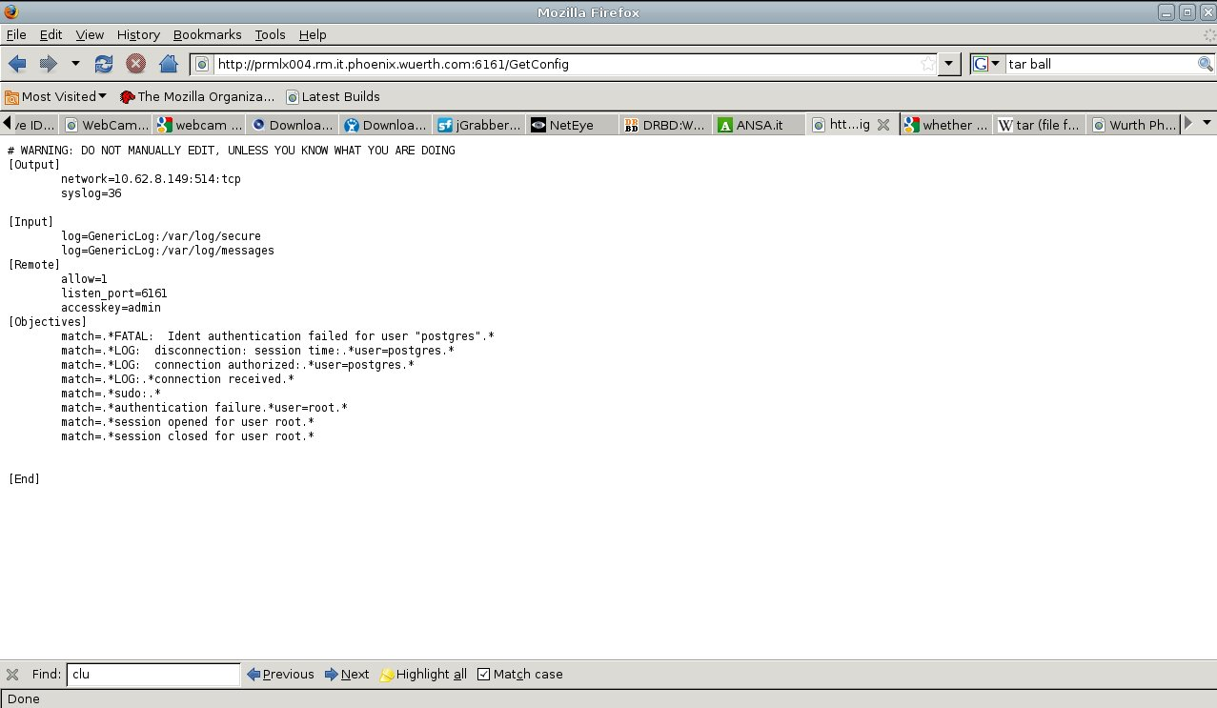

Apply Configuration
The configuration of the Safed agent, both uploaded via the set configuration function or set by the web server pages should be applied through the 'Apply the Latest Audit Configuration' menu item, in order to make it effective.

