Visual Studio Project Notes

The Safed agent for Windows is using the regex library for regular expression manipulation (http://gnuwin32.sourceforge.net/packages/regex.htm)
and the wolfssl library for secure communication though a TLS connection between Safed and the rsyslog server, and HTTPS access to the embedded Safed web server
(https://github.com/wolfSSL/wolfssl)

Set the project environment as shown in the following images using the installation path of the third part libraries.
Additional Include Directories for Win32 and x64:
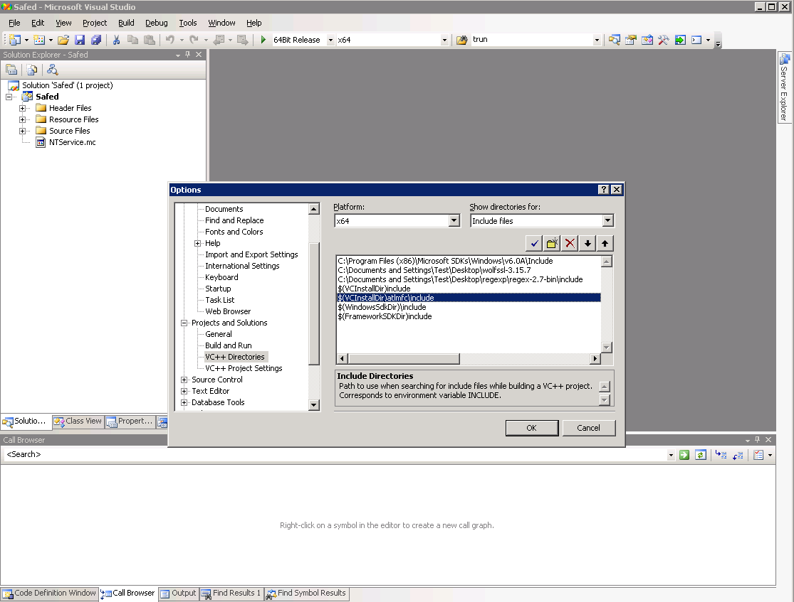

Additional dlls: wolfssl.dll and regex2.dll:

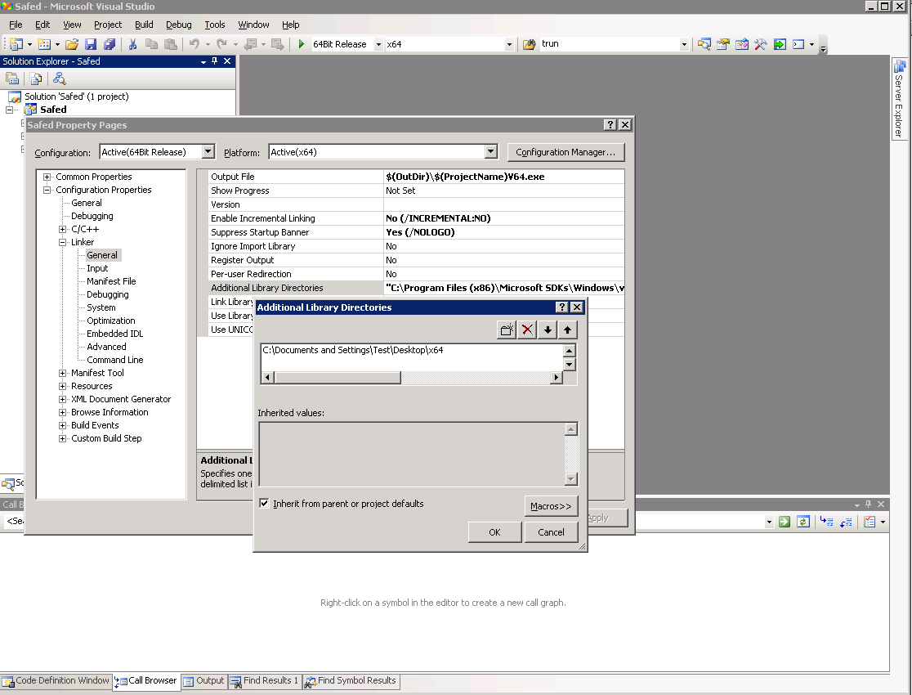

Additional libs: wolfssl.lib and regex2.lib

