Safed Agent Installation on windows > 2008 r2

1. Unzip Safed_1_10_1.zip and open a command prompt as administrator

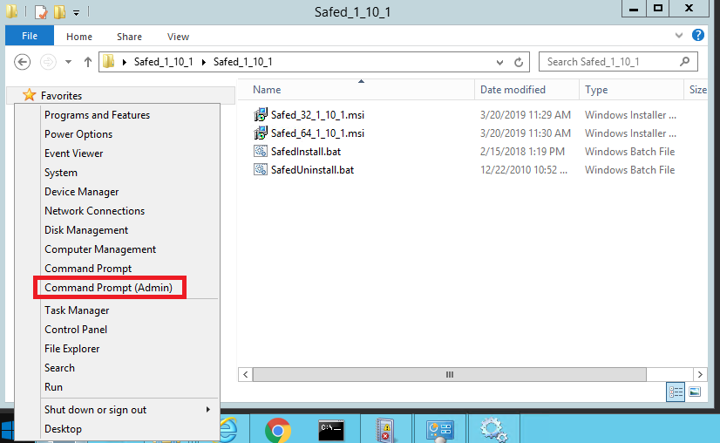

2. Run SafedInstall.bat inside the command prompt and check that the installation of Safed is successful

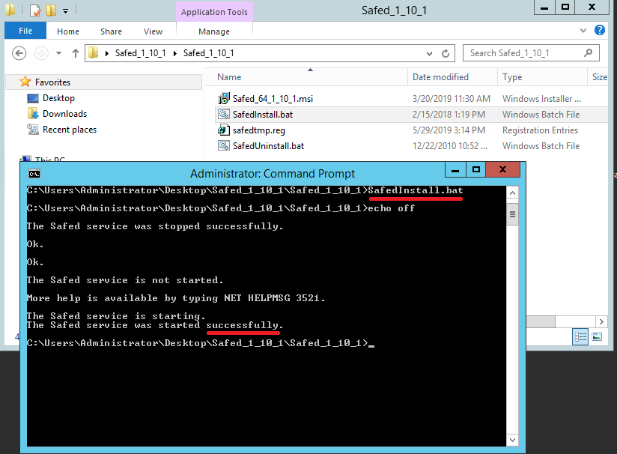

3. Connect to http://localhost:6161

