The 2024 Paris Olympic Games were over. China’s Olympic team won 91 medals (奖牌), including 40 gold, 27 sliver and 24 bronze. All eyes are on the Chinese diving dream team (中国跳水梦之队). For the first time, it won all eight gold medals in the diving (跳水) events of the Olympics. In the team, Quan Hongchan stood out with her wonderful diving.
When Quan was just seven, she started to learn diving. The diving platform (跳台) is very high and she is still so young. Sometimes she is afraid of it, but she always tries her best. Quan practices for eight hours every day, but she never complains (抱怨) about the training from day to night. In the women’s 10-meter platform final, she won gold again, just as she did in Tokyo Olympics.
Quan told the reporter (记者), “Everyone says I am a genius (天才). But I think it’s more about hard-working. I must practice over and over again. Practice makes perfect. That’s me, Quan Hongchan, from China.”
1．This passage (文章) is mainly about________.
A．the Paris 2024 Olympic Games B．the Chinese diving dream team C．the diver Quan Hongchan
2．The Chinese diving dream team won ________ gold medals.
A．8 B．10 C．40
3．Quan Hongchan started to learn diving when she was ________.
A．17 B．14 C．7
4．We can know that Quan Hongchan ________.
A．is not afraid of the diving platform B．works hard to practice diving C．thinks she is a genius
5．What can we learn from Quan Hongchan?
A．A genius doesn't need to practice. B．Don’t be afraid of losing. C．Practice makes perfect.

【答案】1．C 2．A 3．C 4．B 5．C
【难度】0.65
【来源】广东省珠海市香洲区2024-2025学年七年级上学期9月统一调研考试英语试卷
【导语】本文主要讲述了跳水运动员全红婵的故事。
1．主旨大意题。根据文章内容可知，本文主要讲述了跳水运动员全红婵的故事。故选C。
2．细节理解题。根据“For the first time, it won all eight gold medals in the diving (跳水) events of the Olympics.”可知，中国跳水梦之队赢得了8枚金牌。故选A。
3．细节理解题。根据“When Quan was just seven, she started to learn diving.”可知，全红婵在7岁时开始学习跳水。故选C。
4．细节理解题。根据“Quan practices for eight hours every day, but she never complains (抱怨) about the training from day to night.”可知，全红婵每天练习八个小时，但她从不抱怨训练。故选B。
5．推理判断题。根据“Everyone says I am a genius (天才). But I think it’s more about hard-working. I must practice over and over again. Practice makes perfect.”可知，全红婵认为勤奋练习才能取得成功。故选C。
School News
Welcome back to school! For all the students here, we hope you’re ready for another great year. Do you take part in the after-school activities? If not, don’t worry! There’s still time. Here are some of the activities you can check out.
Do you like sports? How about joining the football team? You can have a try next Monday and Tuesday at 3:00 p.m. Last year, our school football team won the first prize, but many of our best players left us for high school. For more information, meet our sports teacher, Mr. White.
This year the school art club plans to paint a mural on the wall by the office. So they need new members! Are you interested in drawing, painting, or taking photographs? This club is for you. The first meeting of the school year is next Wednesday at 3:15 p.m. in Room 221.
There are some new activities you can take part in. Try the new after-school science club if you want to try building a robot. Meet Ms. Matte in the Room 103 for more details (细节). The club meets every Thursday.
Do you like acting? Are you good at singing? The school play this year is The Sound of Music. We meet every Monday and Wednesday afternoon in the school hall. Read the posters on the wall outside Room 145.
For all the activities, visit our school website or stop by the advisor’s office in Room 101.
6．How many after-school activities are talked about in the passage?
A．2. B．3. C．4. D．5.
7．新考法·图片理解题 Which of the following won a big competition?
A．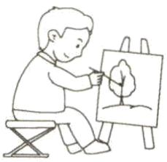 B． C．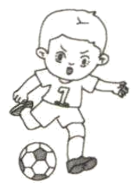 D．
8．What does “mural” mean in Paragraph 3?
A．壁画 B．彩陶 C．雕塑 D．剪纸
9．When does the science club meet?
A．On Monday. B．On Tuesday. C．On Wednesday. D．On Thursday.
10．What can we learn from the news?
A．Students can know about all the activities in two ways.
B．There are no activities in the new year.
C．The members of the school play meet once a week.
D．Students can only join one of all the after-school activities.

【答案】6．C 7．C 8．A 9．D 10．A
【难度】0.65
【来源】广东珠海文园中学2024-2025学年七年级上学期第三次月考英语测试卷
【导语】本文介绍了学校社团及课后活动情况。
【详解】6．细节理解题。根据第二段“How about joining the football team?”，第三段“This year the school art club plans to paint a mural on the wall by the office. So they need new members!”，第四段“Try the new after-school science club if you want to try building a robot.”和第五段“Do you like acting? Are you good at singing? The school play this year is The Sound of Music.”各介绍了一项课后活动，总共谈到了四种课后活动。故选C。
7．推理判断题。根据第二段“Last year, our school football team won the first prize, but many of our best players left us for high school.”可知，足球队赢了比赛。故选C。
8．词义猜测题。根据第三段“paint a mural on the wall”可知，要在墙壁上画画。画线词“mural”在此处表示“壁画”。故选A。
9．细节理解题。根据第四段“The club meets every Thursday.”可知，科学俱乐部周四碰面。故选D。
10．细节理解题。根据最后一段“For all the activities, visit our school website or stop by the advisor’s office in Room 101.”可知，学生有两种方式来了解所有活动。故选A。

After-school Lessons for Grade 7
Student name: Cindy
What language (语言) did you study in primary school? Chinese
Number the following languages in order of preference (按喜好顺序):
3 | French | 2 | German | 4 | Japanese
5 | Chinese | 1 | English
Number the following elective (选修的) Arts subjects in order of preference:
3 | Art
1 | Dance
2 | Movies
4 | Music
Number the following elective sports activities in order of preference:
2 | Badminton
1 | Football
3 | Ping-pong
Notice: 1. “1”＝ like very much → “5”＝don’t like
2. Students choose (选择) one elective subject to study every term.
3. Elective subjects are only for students in Grade 7.
11．Cindy learned ________ in primary school.
A．English B．French C．Chinese D．German
12．What language does Cindy like best? ________
A．Chinese. B．Japanese. C．French. D．English.
13．What are Cindy’s favorite Arts subject and sports activity? ________
A．Art and Badminton.
B．Movies and Ping-pong.
C．Dance and Football.
D．Dance and Badminton.
14．How many electives can Cindy choose this term? ________
A．One. B．Two. C．Three. D．Five.
15．Who is this text for? ________
A．Teachers in Grade 7.
B．Students in Grade 7.
C．Teachers in Primary school.
D．Students in primary school.

【答案】11．C 12．D 13．C 14．A 15．B
【难度】0.65
【来源】广东省珠海市斗门区2023-2024学年七年级上学期期末英语试题
【导语】本文主要是关于七年级学生辛迪对课外辅导课程的喜好情况。
【详解】11．细节理解题。根据“What language (语言) did you study in primary school? Chinese”可知是中文，故选C。
12．细节理解题。根据“Number the following languages in order of preference (按喜好顺序)”以及“‘1’＝ like very much”可知被标注1的是English，因此最喜欢英语，故选D。
13．细节理解题。根据“1Dance”以及“1Football”可知跳舞和足球都被标注1，因此是最爱。故选C。
14．细节理解题。根据“Students choose (选择) one elective subject to study every term.”可知只有1门，故选A。
15．细节理解题。根据“What language (语言) did you study in primary school?”以及“After-school Lessons for Grade 7”，可知对象是7年级学生，故选B。
The men’s Rugby World Cup 2023 (橄榄球世界杯赛) starts on September 8th in France. The first game is between France and New Zealand. France may feel a little scared (害怕的). New Zealand is a small country, but it has the best rugby team in the world!
Sione Mulipola, 36, is a rugby player and coach (教练) from New Zealand. Rugby is very important there because it’s the national (国家的) sport. “People start playing from a young age, just like I did,” he said.
Rugby is different from other sports, like soccer. You need to tackle (抱摔) people. “As a coach, I see many players feel scared about getting hurt, but we teach them the rules and the right ways to tackle,” said Mulipola.
A good rugby player can run fast and has a strong body. “They also need to think quickly. This makes the game so exciting to watch and play,” said Mulipola. It is said more than 100, 000, 000 people will watch the Rugby World Cup 2023.
16．Where does the Rugby World Cup 2023 start?________
A．In China. B．In France.
C．In New Zealand. D．In England.
17．Which shows the importance (重要性) of rugby in New Zealand?________
A．Many rugby players are from New Zealand.
B．Rugby is the country’s national sport.
C．There are many rugby teams in the country.
D．People start playing it from a young age.
18．How does Mulipola help new players?________
a. He lets them watch games.
b. He teaches them the rules.
c. He shows them the right ways to tackle.
d. He helps them learn to think slowly.
A．ab B．ac C．bc D．bd
19．Which of the following is Mulipola’s idea?________
A．It is easy to become a good rugby player.
B．Soccer players can play rugby well.
C．Rugby players don’t need to run fast.
D．Rugby games are fun and exciting to watch.
20．Which is the best title of this passage?________
A．Rugby World Cup, an Exciting Game
B．The First Game Between France and New Zealand
C．Mulipola, a Good Rugby Player
D．New Zealand, the Best Rugby Team

【答案】16．B 17．B 18．C 19．D 20．A
【难度】0.65
【来源】广东省珠海市斗门区2023-2024学年七年级上学期期末英语试题
【导语】本文讲述了2023年男子橄榄球世界杯将于9月8日在法国开始。首场比赛将在法国和新西兰之间展开。
16．细节理解题。根据第一段“The men’s Rugby World Cup 2023 (橄榄球世界杯赛) starts on September 8th in France.”可知，2023年男子橄榄球世界杯赛 9月8日在法国开始。故选B。
17．细节理解题。根据第二段“Rugby is very important there because it's the national (国家的) sport.”可知，橄榄球在那里非常重要，因为它是国家的运动。故选B。
18．细节理解题。根据第三段“You need to tackle (抱摔) people. ‘As a coach, I see many players feel scared about getting hurt, but we teach them the rules and the right ways to tackle,’ said Mulipola.”可知，穆利波拉教新球员规则和正确的铲球方法。故选C。
19．细节理解题。根据第四段“A good rugby player can run fast and has a strong body. ‘They also need to think quickly. This makes the game so exciting to watch and play,’ said Mulipola.”可知，看橄榄球比赛既有趣又刺激。故选D。
20．最佳标题题。根据第一段“The men’s Rugby World Cup 2023 (橄榄球世界杯赛) starts on September 8th in France. The first game is between France and New Zealand.”及通读全文内容可知，这篇文章的最佳标题是橄榄球世界杯，一场激动人心的比赛。故选A。
I’m Lisa. Good news! Good news! We have a new house. The rooms are small but they are all nice. There are many rooms in our new house.
My bedroom is my favorite room in our house. I make the room full of green color because I like green best. First, I paint the wall green. Then I put some pictures on the wall. The pictures are all about plants, flowers and the sky. I put a big red bed in the middle of the room. The quilt is like a big tree. You can see a bird sleeping in the tree. There is a green table on the left side of the bed. And there is a green desk on the right side of the bed. I am so happy because there are many storybooks on it. I love reading very much. Reading makes me wise. There is a big orange bookcase in the room. I also put my things in the bookcase: my schoolbag, CDs, history books, and the model plane.
My second favorite room is the kitchen because I like cooking. My mother is a good cook, so I want to be a cook.
I love my new house. Welcome to my new house.
26．What is Lisa’s favorite color?
A．Red. B．Green. C．Yellow. D．Black.
27．Where is the green table?
A．On the left side of the bed. B．On the desk. C．Under the bed. D．Behind the desk.
28．The underlined word “wise” means “_______”.
A．beautiful B．sad C．boring D．clever
29．Why does Lisa want to be a cook?
A．Because her father is a cook. B．Because her brother is a cook.
C．Because her mother is a cook. D．Because her sister is a cook.
30．What is the best title of the passage?
A．My new house B．My old house C．My family D．My mother

【答案】26．B 27．A 28．D 29．C 30．A
【难度】0.65
【来源】广东省珠海市金湾区2023-2024学年七年级上学期期末考试英语试题
【导语】本文主要介绍了Lisa的新房子。
【详解】26．细节理解题。根据“I make the room full of green color because I like green best.”可知，Lisa最喜欢绿色，故选B。
27．细节理解题。根据“And there is a green desk on the right side of the bed.”可知，床的右边有一张绿色的桌子，所以桌子在床左边，故选A。
28．词义猜测题。根据“Reading makes me...”结合常识可知，阅读可以让人聪明，故选D。
29．细节理解题。根据“My mother is a good cook, so I want to be a cook”可知，因为她妈妈是一个好厨师，故选C。
30．最佳标题题。根据“I’m Lisa. Good news! Good news! We have a new house. The rooms are small but they are all nice. There are many rooms in our new house.”可知，文章主要介绍了Lisa的新房子，故选A。

Wendy’s Clothes Shop
 | DRESSColor: blue, yellow, black  Price: ¥170 each. But ¥320 for two | 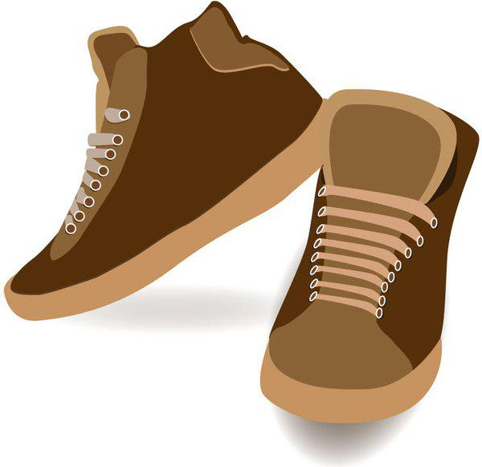 | SHOESColor: brown, green, black  Price: ¥78 and get the socks for free
 | TROUSERSColor: red, white, black  Price: ¥99 each. But ¥188 for two |  | COATColor: purple, pink  Price: ¥280 each
Open time: 8: 00 a. m.—5 p. m. on weekdays
31．How much are two pairs of trousers?
A．¥188. B．¥199. C．¥88. D．¥189.
32．If you buy a pair of shoes, you can get _______ for free.
A．coats B．socks C．gloves D．scarf
33．You can’t buy _______ at Wendy’s Clothes shop.
A．a pink coat B．a pair of red trousers C．a pair of green shoes D．a white dress
34．Your favorite color is purple, and you just have ¥280. You can buy _______.
A．a dress B．a pair of shoes C．a coat D．a pair of trousers
35．Which of the following sentence is NOT TRUE?
A．Two dresses are 320 yuan. B．Lisa can buy a black dress in the shop.
C．Mike can buy a pair of brown shoes in the shop. D．We can go shopping at Wendy’s shop at 6 p. m.

【答案】31．A 32．B 33．D 34．C 35．D
【难度】0.94
【来源】广东省珠海市金湾区2023-2024学年七年级上学期期末考试英语试题
【导语】本文是一篇应用文，文章中介绍了服装店的商品的信息。
【详解】31．细节理解题。根据表格“TROUSERS”中的信息“Price: ¥99 each. But ¥188 for two”可知两条裤子是188元。故选A。
32．细节理解题。根据表格“SHOES”中的信息“Price: ¥78 and get the socks for free”可知如果买一双鞋子，能够得到免费的袜子。故选B。
33．细节理解题。根据表格“DRESS”中的信息“Color: blue, yellow, black”可知，商店里没有白色的裙子。故选D。
34．细节理解题。根据表格中“COAT”中的信息“Color: purple, pink”以及“Price: ¥280 each”可知如果有280元，且喜欢紫色，可以买一件外套。故选C。
35．细节理解题。根据表格中的“Open time: 8: 00 a. m.—5 p. m. on weekdays”可知商店下午5点关门了，因此D选项描述错误。故选D。
Do you know the marathon (马拉松)? It’s a long running race of 42 km. The 2023 Zhuhai Marathon is on November 26th. Over 10,000 runners from across China and the world take part in it.
It begins at 7:30 AM at Zhuhai Sports Center. The fastest runners begin running first, and the others run behind them. When they are running, they can see some famous places and buildings, such as Zhuhai Library, Zhuhai Opera House, and Hong Kong—Zhuhai—Macao Bridge. It ends at Lvyangwan, a beautiful beach park.
It takes the winners about 2 hours to finish the race. Most people need 3 or 4 hours. Many families bring their kids to join in the running. They only run 6 km. They just run for fun, so people call it Fun Run.
Running makes the runners sweat a lot. Along the way, they pick up cups of water to drink or to pour over their heads, to cool down. It’s good for them to eat some bread, rice and potatoes after the race.
The Zhuhai Marathon is not just about running. It brings people together, shows our beautiful city to the world, and calls for a healthy lifestyle. Do you want to join in the marathon next year? You can visit its website at www.zhuhai-marathon.com.
41．The 2023 Zhuhai Marathon is ________.
A．on the morning of November 26th B．on the afternoon of December 26th
C．on the morning of December 26th D．on the afternoon of November 26th
42．What does the underlined word “sweat” mean?
A．流泪 B．流汗 C．着凉 D．晕倒
43．Which of the following statements is TRUE?
A．All the runners can begin running at 7:30 AM.
B．Only the winners can enjoy the beauty of the city.
C．Fun Run runners run 1/7 of the marathon.
D．Bread, rice and tomatoes are good food for the runners after the race.
44．The right structure (结构) of this passage is ________.
A．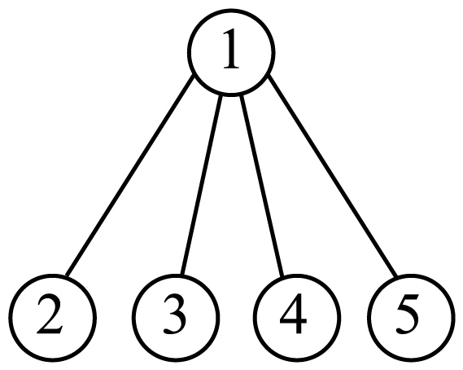 B．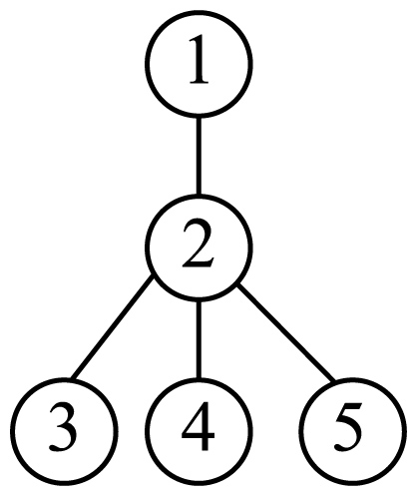 C．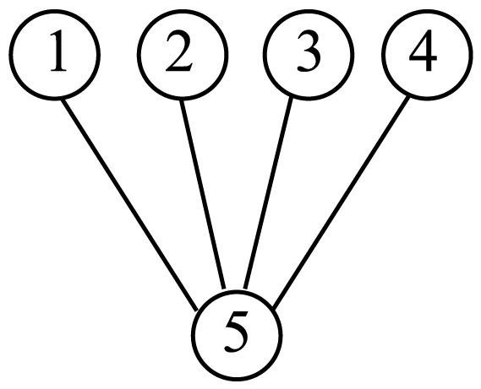 D．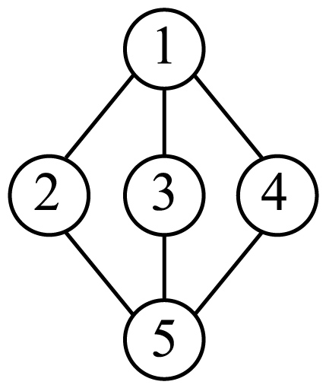
45．Which can be the best title for the passage?
A．Running Keeps People Healthy B．The 2023 Zhuhai Marathon
C．A Good Sport—Marathon D．Many People Run A Marathon

【答案】41．A 42．B 43．C 44．D 45．B
【难度】0.65
【来源】广东省珠海市香洲区2023-2024学年七年级上学期期末英语试题
【导语】本文是一篇说明文，主要介绍2023珠海马拉松赛。
41．细节理解题。根据“The 2023 Zhuhai Marathon is on November 26th.”可知，2023珠海马拉松赛将于11月26日举行。故选A。
42．词句猜测题。根据“Running makes the runners sweat a lot. Along the way, they pick up cups of water to drink or to pour over their heads, to cool down.”可知，一路上，跑步者拿起水杯喝，或者倒在头上降温。这是因为跑步出汗，故选B。
43．推理判断题。根据“It’s a long running race of 42 km.”和“They only run 6 km. They just run for fun, so people call it Fun Run.”可知，马拉松全程42公里，Fun Run只要跑6公里，也就是全程的七分之一，故选C。
44．篇章结构题。分析文章内容可知，第一段引出对珠海马拉松赛的介绍，第二、三、四段具体介绍珠海马拉松的具体过程，第五段总结并呼吁大家参加明年的马拉松。故选D。
45．最佳标题题。本文主要介绍2023珠海马拉松赛，选项B“2023珠海马拉松赛”符合主题，故选B。

Hello, my name is Miss Williams and I am your English teacher. This will be my fourth year teaching seventh graders at Guangming Middle School. I am so excited to meet you in my class. I think we are going to have a school year full of fun and learning.

My Favorites Food: sandwiches
 Drink: hot chocolate
 Flower: roses
 Season: summer
 Sports: swimming, hiking
 Hobbies: travelling, writing
 Book: The Little Prince
 Subjects: Science, Art
Welcome to the Seventh Grade!
I am glad to welcome you to the 2023—2024 school year! You will learn a lot of new knowledge (知识) this year. As a student, your job is to read, learn, think, ask questions and make mistakes. My job is to help you love learning. I will also teach you some life skills in my class. I wish a great school year with all of you! Contact Me Please feel free to ask me questions at any time.
E-mail: meganwilliams@gmss.edu.com
Tel: 420-564-1516
51．Which photo is the right one for Miss Williams?
A． B． C． D．
52．What can we know about Miss Williams?
A．She can’t swim. B．She loves winter best.
C．She loves hot dogs. D．She likes science and art best.
53．Miss Williams wants her students to _______.
① know about her ② learn much knowledge ③ learn some swimming skills
④ read books with her ⑤ go to school on time ⑥ ask her questions
A．①②③⑥ B．①②④⑥ C．②④⑤⑥ D．①③④⑤
54．Tom has some questions when he does homework at home. He can ask Miss Williams in ________ way (s).
A．four B．three C．two D．one
55．The readers of this passage are ________.
A．seventh graders’ parents of Guangming Middle School
B．seventh graders of Guangming Middle School
C．all the students of Guangming Middle School
D．teachers of Guangming Middle School

【答案】51．A 52．D 53．B 54．C 55．B
【难度】0.65
【来源】广东省珠海市香洲区2023-2024学年七年级上学期期末英语试题
【导语】本文作者是一名英语老师，对新同学进行了自我介绍并表示欢迎。
【详解】51．细节理解题。根据“Hello, my name is Miss Williams and I am your English teacher.”可知，威廉姆斯小姐是英语老师，A选项图片符合，故选A。
52．细节理解题。根据“My Favorites”中的“Subjects: Science, Art”可知，她最喜欢科学和美术，故选D。
53．细节理解题。根据“My Favorites”可知，这是老师向学生介绍自己的最爱，希望学生了解自己；根据“You will learn a lot of new knowledge (知识) this year. As a student, your job is to read, learn, think, ask questions and make mistakes. My job is to help you love learning. I will also teach you some life skills in my class. ”可知，威廉姆斯小姐也希望学生阅读、学习、思考、提问和犯错。结合选项可知，B选项符合，故选B。
54．细节理解题。根据“E-mail: meganwilliams@gmss.edu.com Tel: 420-564-1516”可知，可以发电子邮件和打电话，有两种方式，故选C。
55．细节理解题。根据“This will be my fourth year teaching seventh graders at Guangming Middle School.”可知，这篇文章的读者是光明中学的七年级学生。故选B。
Bonnie: Look at my erasers! They are interesting. They look like bread. I love collecting (收集) interesting and beautiful erasers, pens and many other things.
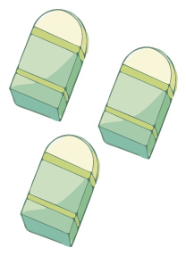
Robert: This is my pen. It is from my sister. It is one of her “little carrots”. My sister often gives me her pens and rulers. I think she buys too many of these things. She also wants to give me her schoolbag, but I don’t want it. She does this because (因为) she wants to get a new one.

Neil: This is my father’s watch. But now he gives it to me! I’m very happy. I can use it to look at the time. It can also tell me about my health (健康状况). And it can play music, too!
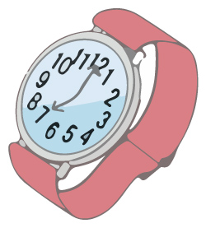
56．The interesting erasers are ________.
A．Neil’s B．Neil’s sister’s C．Bonnie’s D．Bonnie’s father’s
57．Bonnie loves ________.
A．eating bread B．collecting things
C．using her father’s watch D．buying new school things
58．Robert’s sister’s “little carrots” are ________.
A．pens B．watches C．erasers D．pencils
59．Robert’s sister wants to give her schoolbag to Robert because ________.
A．Robert likes the schoolbag B．she wants a new schoolbag
C．Robert’s schoolbag is too old D．her schoolbag is a little small
60．Neil can use his watch to ________.
① look at the time ② call his father ③ listen to music ④ know about his health
A．①②③ B．①②④ C．②③④ D．①③④

【答案】56．C 57．B 58．A 59．B 60．D
【难度】0.65
【来源】广东省珠海市九洲中学2023-2024学年七年级上学期期中英语试题
【导语】本文主要介绍了三个人的物品。
【详解】56．细节理解题。根据“Bonnie: Look at my erasers! They are interesting.”可知，这些有趣的橡皮是Bonnie的。故选C。
57．细节理解题。根据“I love collecting (收集) interesting and beautiful erasers, pens and many other things.”可知，Bonnie喜欢收集有趣的东西。故选B。
58．细节理解题。根据“Robert: This is my pen. It is from my sister. It is one of her ‘little carrots’.”可知，小萝卜是钢笔。故选A。
59．细节理解题。根据“She also wants to give me her schoolbag, but I don’t want it. She does this because (因为) she wants to get a new one.”可知，Rober的姐姐把她的书包给他是为了要个新的。故选B。
60．细节理解题。根据“I can use it to look at the time. It can also tell me about my health (健康状况). And it can play music, too!”可知，Neil能够使用手表看时间，听音乐以及了解健康状态。故选D。
Zhao Youzhu is 29 years old. She is a student at Xiamen University (大学). She comes from Liaoyang, Liaoning. She can speak and read, but she can’t hear.
Zhao has short hair and wears glasses(眼镜). She likes reading very much. She has many books at home. “I often go to the library,” Zhao says. “That is my favorite place.” Sometimes, she also reads in parks.
Zhao’s parents are doctors. They often help their daughter. They are her teachers and friends, too. They love their daughter, and Zhao loves them, too.
Zhao has a sister. She is not in Xiamen, but she often talks with Zhao on the Internet (网络). Zhao often tells her some interesting stories.
“I have a nice family, good teachers and many good friends,” Zhao says. “They make me strong and happy.”
61．What is Zhao’s problem (问题)?
A．She can’t see. B．She can’t read.
C．She can’t hear. D．She can’t speak.
62．划线单词“That”指代的是 ________.
A．My home. B．The park. C．My school. D．The library.
63．We can learn about Zhao’s parents in ________.
A．paragraph (段落) 2 B．paragraph 3 C．paragraph 4 D．paragraph 5
64．Zhao often tells interesting stories to her ________.
A．sister B．mother C．friends D．teachers
65．What do we know from the passage?
A．Zhao is from Xiamen. B．Zhao has long hair.
C．Zhao’s father is a doctor. D．Zhao’s sister is a teacher.

【答案】61．C 62．D 63．B 64．A 65．C
【难度】0.65
【来源】广东省珠海市九洲中学2023-2024学年七年级上学期期中英语试题
【导语】本文介绍赵蚰竹及其家人的情况。
【详解】61．细节理解题。根据“She can speak and read, but she can’t hear.”可知，她听不见。故选C。
62．词义猜测题。根据“I often go to the library”可知，“that”指的是图书馆，故选D。
63．细节理解题。根据“Zhao’s parents are doctors.”可知，第三段介绍了她的父母，故选B。
64．细节理解题。根据“Zhao has a sister. She is not in Xiamen, but she often talks with Zhao on the Internet (网络). Zhao often tells her some interesting stories.”可知，她经常给妹妹讲有趣的故事。故选A。
65．细节理解题。根据“Zhao’s parents are doctors.”可知，她的父母是医生。故选C。
Hello! My name is Jack, an American boy. Now I’m in a middle school in Beijing. This week, I am busy in my new school because we have a lot of activities.
On Monday, we have a School & Family Day. On that day, parents come to school to take part in our activities. My parents are in New York, so my uncle and aunt come to school to help me. How kind they are!
On Wednesday, we have a school sale (销售活动) in the morning. At the school sale, students can buy different kinds of things from each other. Li Ming buys a black cap and it looks cool. Chen Lin buys a T-shirt from Lu Wen. I buy a toy bus from Zhang Wei and a book from Liu Xia. In the afternoon, we have a soccer game. Many of my classmates can play it well. In the end, we win the game. We are very happy!
On Sunday, our class go to the beach(海滩). Our Chinese teacher, Ms. Chen, goes with us. She is so nice, we all like her very much. This is a busy but happy week.
66．Who helps Jack on the school day?
A．His parents. B．His classmates. C．His uncle and aunt. D．Ms. Chen
67．What does Jack buy on the school sales?
A．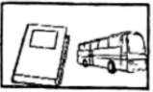 B．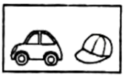
C．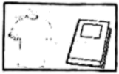 D．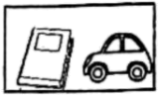
68．The underlined word “win” means ________ in Chinese.
A．参加 B．放弃 C．赢得 D．失败
69．When does Ms. Chen go to the beach with the class?
A．On Monday. B．On Wednesday. C．On Saturday. D．On Sunday.
70．What is the best title (标题) for the passage?
A．Jack’s New School B．Jack’s Busy Week
C．Jack’s Kind Teachers D．Jack’s Nice Classmates

【答案】66．C 67．A 68．C 69．D 70．B
【难度】0.85
【来源】广东省珠海市第十一中学2023-2024学年七年级上学期期中检测英语试题
【导语】本文是Jack介绍了本周忙碌的学校活动。
【详解】66．细节理解题。根据“My parents are in New York, so my uncle and aunt come to school to help me.”可知，他的叔叔和婶婶去帮他，故选C。
67．细节理解题。根据“I buy a toy bus from Zhang Wei and a book from Liu Xia.”可知，Jack买了一个玩具巴士和一本书，故选A。
68．词义猜测题。根据“In the end, we win the game. We are very happy!”可知，赢了比赛所以很开心，故选C。
69．细节理解题。根据“On Sunday, our class go to the beach(海滩). Our Chinese teacher, Ms. Chen, goes with us.”可知，周日和老师去海滩，故选D。
70．最佳标题题。根据“This week, I am busy in my new school because we have a lot of activities.”可知，本文是Jack介绍了本周忙碌的学校活动，故选B。
Good morning, I’m Ms. Smith. You can call me Alice. I am an art teacher. Students in my art club are from different grades and classes. Let’s see who they are!
Name | Age | Country(国家) | Class & Grade | QQ number
Alice Black | 12 | the USA | Class 9, Grade 7 | 58963386
Lisa Green | 14 | the UK | Class 2, Grade 8 | 85344956
Jack Potter | 15 | Canada | Class 1, Grade 9 | 68291348
Xu Ting | 14 |  | Class 2, Grade 8 | 67827856
71．Lisa is ________ years old.
A．eleven B．twelve C．thirteen D．fourteen
72．Alice is from ________.
A．the USA B．Canada C．China D．the UK
73．Xu Ting’s QQ number is ________.
A．58963386 B．68291348 C．67827856 D．85344956
74．________ are in the same (相同的) class.
A．Alice and Jack B．Lisa and Xu Ting
C．Lisa and Jack D．Alice and Xu Ting
75．What can we know from the chart (表格)?
A．It shows the information (信息) of four classes
B．It shows the information of four girls.
C．It shows the information of four families.
D．It shows the information of four students.

【答案】71．D 72．A 73．C 74．B 75．D
【难度】0.94
【来源】广东省珠海市第十一中学2023-2024学年七年级上学期期中检测英语试题
【导语】本文是史密斯老师介绍了美术俱乐部的学生。
【详解】71．细节理解题。根据“Lisa Green: 14”可知，Lisa是14岁，故选D。
72．细节理解题。根据“Alice Black: the USA”可知，Alice来自美国，故选A。
73．细节理解题。根据“Xu Ting: 67827856”可知，Xu Ting的电话号码是67827856，故选C。
74．细节理解题。根据“Lisa Green: Class 2, Grade 8”及“Xu Ting: Class 2, Grade 8”可知，Lisa和Xu Ting在同一个班级，故选B。
75．细节理解题。根据“Students in my art club are from different grades and classes. Let’s see who they are!”可知，这个表格介绍了四个同学的情况，故选D。
Family is the most important（重要的） to all of us. But many of us don’t understand（理解） this. We have problems with our family members. How can we get on well with our family members? Here are three tips（小建议）.
First, spend（花） more time with them. Don’t spend too much time playing computer games. You can ask one of your family members to play with you—your dad, mom, grandpa or grandma. If they are busy, sometimes you can even play with your aunt, uncle or their daughters and sons.
Second, share（分享） your feelings and ask for help. You want your family members to help you when you’re unhappy, but they may not know that. Tell them what has happened（发生） and you’ll be glad（高兴的）after that.
At last, do your best at what you do. When you do your best, you make your family happy. Why? Because it lets them know you’re good and they have a great kid.
86．The writer thinks ________ is (are) the most important in our life.
A．friends B．classmates C．family D．teachers
87．How many tips are there for the kids to get on well with their family?
A．Two. B．Three. C．Four. D．Five.
88．What does the underlined phrase（划线短语）“get on well with” mean?
A．talk with B．spell C．meet with D．get along with
89．Your parents will be happy if ________.
A．you try your best at what you do B．you say nothing when you are unhappy
C．you don’t ask your parents to help you D．you spend much time playing computer games
90．What does this passage mainly（主要） tell us?
A．How kids can do their best at school.
B．What kids can play with their family members.
C．What family members should do to teach their kids.
D．How kids can have a good relationship（关系） with their family members.

【答案】86．C 87．B 88．D 89．A 90．D
【难度】0.85
【来源】广东省珠海市珠峰实验学校、梅华中学2023-2024学年七年级上学期期中考试英语试题
【导语】本文主要给出了如何和家人和睦相处的三点建议。
【详解】86．细节理解题。根据“Family is the most important to all of us.”可知，作者认为家人是最重要的，故选C。
87． 细节理解题。根据“Here are three tips（小建议）.”可知，一共给出了三点建议，故选B。
88．词义猜测题。根据下文的几点建议“First, spend more time with them...Second, share your feelings and ask for help...At last, do your best at what you do. ”可知，这些都是为了让我们与家人和谐相处，所以推断划线词语表示“与……和谐相处”，与get along with同义。故选D。
89．细节理解题。根据“When you do your best, you make your family happy.”可知，当你尽力而为的时候，你的家人会很高兴，故选A。
90．主旨大意题。本文主要给出了如何和家人和睦相处的三点建议，告诉我们如何和家人保持良好的家庭关系。故选D。
Elsa and Anna are sisters. They are from an interesting film FrozenⅡ(《冰雪奇缘2》). In the film, Elsa,the queen of Arendelle, defeats（打败） the bad guys with the help of Anna finally. In this film, they wear trousers. And the two girls are in trouble again. There is something wrong with Elsa’s magical powers（魔力）.This puts her homeland in danger（危险）. One day, Elsa with Anna goes to find where her magical powers come from. On their way, they meet some friends. Now let’s know more about them.
Elsa
She is beautiful. She has long hair. She was born with strong magical powers, but sometimes they bring her some trouble.
Anna
She’s Elsa’s younger sister. She always looks happy. When Elsa is in danger, she tries to help Elsa.
Kristoff
He’s a strong ice harvester（采冰者） . He’s always there for the girls.
Olaf
He’s a cute snowman. Elsa makes him with her magical powers.
91．Elsa is Anna’s ________.
A．sister B．brother C．aunt D．uncle
92．Which one is not right about Elsa?
A．She wears trousers. B．She has strong magical powers.
C．She is a beautiful girl. D．Her hair is short and brown.
93．How does Anna look every day?
A．Happy. B．Sad. C．Angry. D．Healthy.
94．What is Kristoff good at?
A．Swimming. B．Dancing. C．Harvesting ice. D．Reading.
95．What’s the best title（标题） for this passage?
A．Two popular girls B．An interesting film
C．Elsa’s new friends D．Girls’ favorite trousers

【答案】91．A 92．D 93．A 94．C 95．B
【难度】0.85
【来源】广东省珠海市珠峰实验学校、梅华中学2023-2024学年七年级上学期期中考试英语试题
【导语】本文介绍了《冰雪奇缘2》这部电影的主要情节和里面的角色。
【详解】91．细节理解题。根据“Elsa and Anna are sisters.”和“Anna She’s Elsa’s younger sister.”安娜是艾尔莎的妹妹，可知艾尔莎是安娜的姐姐。故选A。
92．细节理解题。根据“Elsa She is beautiful. She has long hair.”可知艾尔莎有长头发。因此D选项的表达是错误的。故选D。
93．细节理解题。根据“Anna She’s Elsa’s younger sister. She always looks happy.”可知安娜每天都看起来很开心。故选A。
94．细节理解题。根据“Kristoff He’s a strong ice harvester（采冰者）”可知克里斯托弗是一个采冰者，因此他擅长采冰。故选C。
95．最佳标题题。本文介绍了《冰雪奇缘2》这部电影的主要情节和里面的角色。因此An interesting film“一部有趣的电影”适合作标题。故选B。

