A．回答问题
请阅读下面短文，根据所提供的信息，回答五个问题，并将答案写在答题卡对应题目的答题位置上。要求所写答案语法正确、信息完整。
Hello, everyone! My name is Mike Brown. I come from New York, USA and now live in Zhuhai. I love Chinese food very much, like hot pot and Mapo tofu. And my favorite Chinese food is jiaozi.
Do you want to know about my school life? Well, I’m in Class 1, Grade 7. I have a twin sister and her name is Anna. We are not in the same class. She is in Class 5, Grade 7. As an American, I can speak English very well, but my Chinese isn’t good. So I help my classmates with English and they help me with Chinese. It’s great to help each other!
I have many friends in our school. We all love sports and often play basketball after class. We often study together on weekends, too. That’s all about me. Do you want to be my friend?
361．Where does Mike live now?
____________________________________________________________________________________________
362．What’s Mike’s favourite Chinese food?
____________________________________________________________________________________________
363．Are Mike and Anna in the same class?
____________________________________________________________________________________________
364．How do Mike and his classmates help each other?
____________________________________________________________________________________________
365．When does Mike often play basketball with his friends?
____________________________________________________________________________________________
B．书面表达
请根据要求完成短文写作。
366．假如你是李明，和Mike在同一个学校上学，你在看到上文Mike的自我介绍后想跟他交朋友。请你根据以下思维导图内容提示，用英文写一封信给Mike。
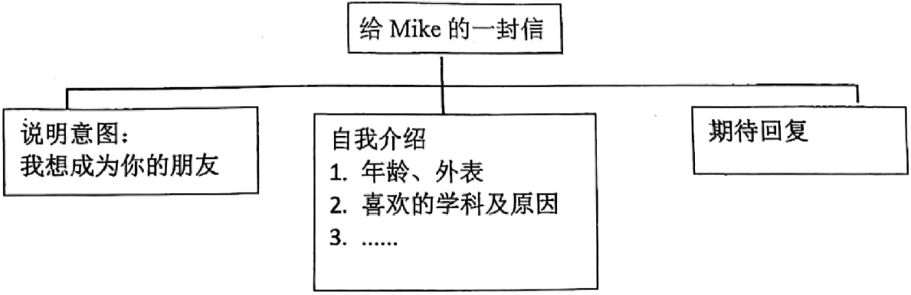
注意：
(1)可在思维导图内容提示的基础上适当拓展信息。
(2)不能照抄原文，不得在作文中出现真实校名、地名和考生的真实姓名。
(3)语句连贯，词数50以上。作文的开头和结尾已经给出，不计入总词数。
Dear Mike,
I’m Li Ming. _____________________________________________________________________________________________________________________________________________________________________________________________________________________________________________________________________
Best,
Li Ming

【答案】361．
He lives in Zhuhai./In Zhuhai. 362．
Jiaozi./His favourite Chinese food is jiaozi. 363．
No, they aren’t. 364．
He helps his classmates with English and they help him with Chinese. 365．
After class./He often plays basketball with his friends after class. 366．
例文
Dear Mike,
I’m Li Ming. I am very glad to read your introduction. I want to make friends with you because we are in the same school.
Now let me introduce myself to you. I am a 13-year-old boy who is tall and strong. I have short black hair and big eyes. My favorite subject is English because I think it is very interesting and useful. I know your English is very good, so maybe we can practice it together. Besides, I also like playing basketball very much. We can play it together after class.
I am looking forward to your reply.
Best,
Li Ming
【难度】0.74
【来源】广东珠海市文园中学2026-2027学年上学期暑假学情自我反馈七年级英语试卷
【导语】本文介绍了Mike Brown的个人信息、学校生活以及与同学互相帮助的情况。
【详解】361．第一段明确说“now live in Zhuhai”，可知他现在住在珠海，直接提取。
362．第一段说“my favorite Chinese food is jiaozi”，可知他最喜欢吃饺子，直接提取。
363．第二段说“We are not in the same class.”，可知不在一个班，直接提取否定信息。
364．第二段说“I help my classmates with English and they help me with Chinese.”，可知他帮助同学学习英语，同学则帮助他学习中文。
365．第三段说“often play basketball after class”，可知是在下课后，直接提取时间。故
366．写作步骤
[第一步：审题立意]
确定文体：应用文——书信体（交友信），以一般现在时为主
明确要点：说明交友意图、自我介绍（年龄、外表、喜欢的学科及原因、喜欢的运动）、期待回复
确定人称：第一人称（I/my）和第二人称（you）
注意事项：词数50以上（开头结尾已给，不计入总词数）；不得出现真实校名、地名和真实姓名；可适当拓展信息
[第二步：构思布局]
三段式结构：
开头段：问候，说明想交朋友的意图
主体段：自我介绍（年龄、外表、喜欢的学科及原因、喜欢的运动）
结尾段：期待回复
[第三步：要点展开]
要点一：说明交友意图
意图：I want to make friends with you because we are in the same school./I’d like to be your friend./I hope we can become good friends./I am writing to make friends with you.等
要点二：自我介绍
年龄：I am a 13-year-old boy./I am 13 years old./I’m a thirteen-year-old student.等
外表：tall and strong./I have short black hair and big eyes./I am of medium height with short hair./I wear glasses and have short hair.等
喜欢的学科：My favorite subject is English./I like English best./I enjoy learning English.等
喜欢该学科的原因：because I think it is very interesting and useful./because it helps me communicate with others./because it is fun and helpful.等
喜欢的运动：I also like playing basketball very much./I enjoy sports./I like reading and playing basketball.等
要点三：期待回复
期待回复：I am looking forward to your reply./I hope to hear from you soon./Looking forward to your reply./Write back soon.等
A．回答问题。
When you move from primary school to middle school, you will find differences in many ways. Here are some tips to help you start a new school life.
1. Making Friends in a Bigger School
In middle school, we may meet many new classmates. We can start a conversation by smiling, saying hello and asking simple questions like “What’s your name?” or “Do you like playing basketball?”
2. Learning New Subjects
We will learn more new subjects like history, geography, or science. Don’t worry if they are difficult at first. Listening carefully in class and taking notes will help us learn better.
3. Knowing Important Places in School
Middle schools are sometimes bigger. In the first week, find important places like your classroom, the library, the science lab, and the lunchroom. This will help us move around easily.
4. Joining Fun Clubs
There are many clubs in middle school, such as sports teams, art clubs, or English corners. Go to the club office to choose a club. It’s a fun way to make friends and learn new things.
5. Talking About How You Feel
Many students may feel a little nervous about middle school. We can try to talk to parents, teachers or a good friend. It will help us feel better.
367．How can we start a conversation?
______________________________________________________________________________________________
368．What will help us learn better?
______________________________________________________________________________________________
369．Where can we go to choose a club?
______________________________________________________________________________________________
370．Why should you find the library and lunchroom in the first week?
______________________________________________________________________________________________
371．Who can we talk to if we feel nervous about middle school?
______________________________________________________________________________________________
B．书面表达。
372．刚才我们讨论了如何适应初中的新生活，而朋友在这个过程中往往能给我们特别的帮助。在七年级，你可能会认识一位让你印象深刻的新朋友。请你写一篇文章，介绍一位你在七年级认识的新朋友，并说说他/她如何帮助你适应新环境，内容包含：
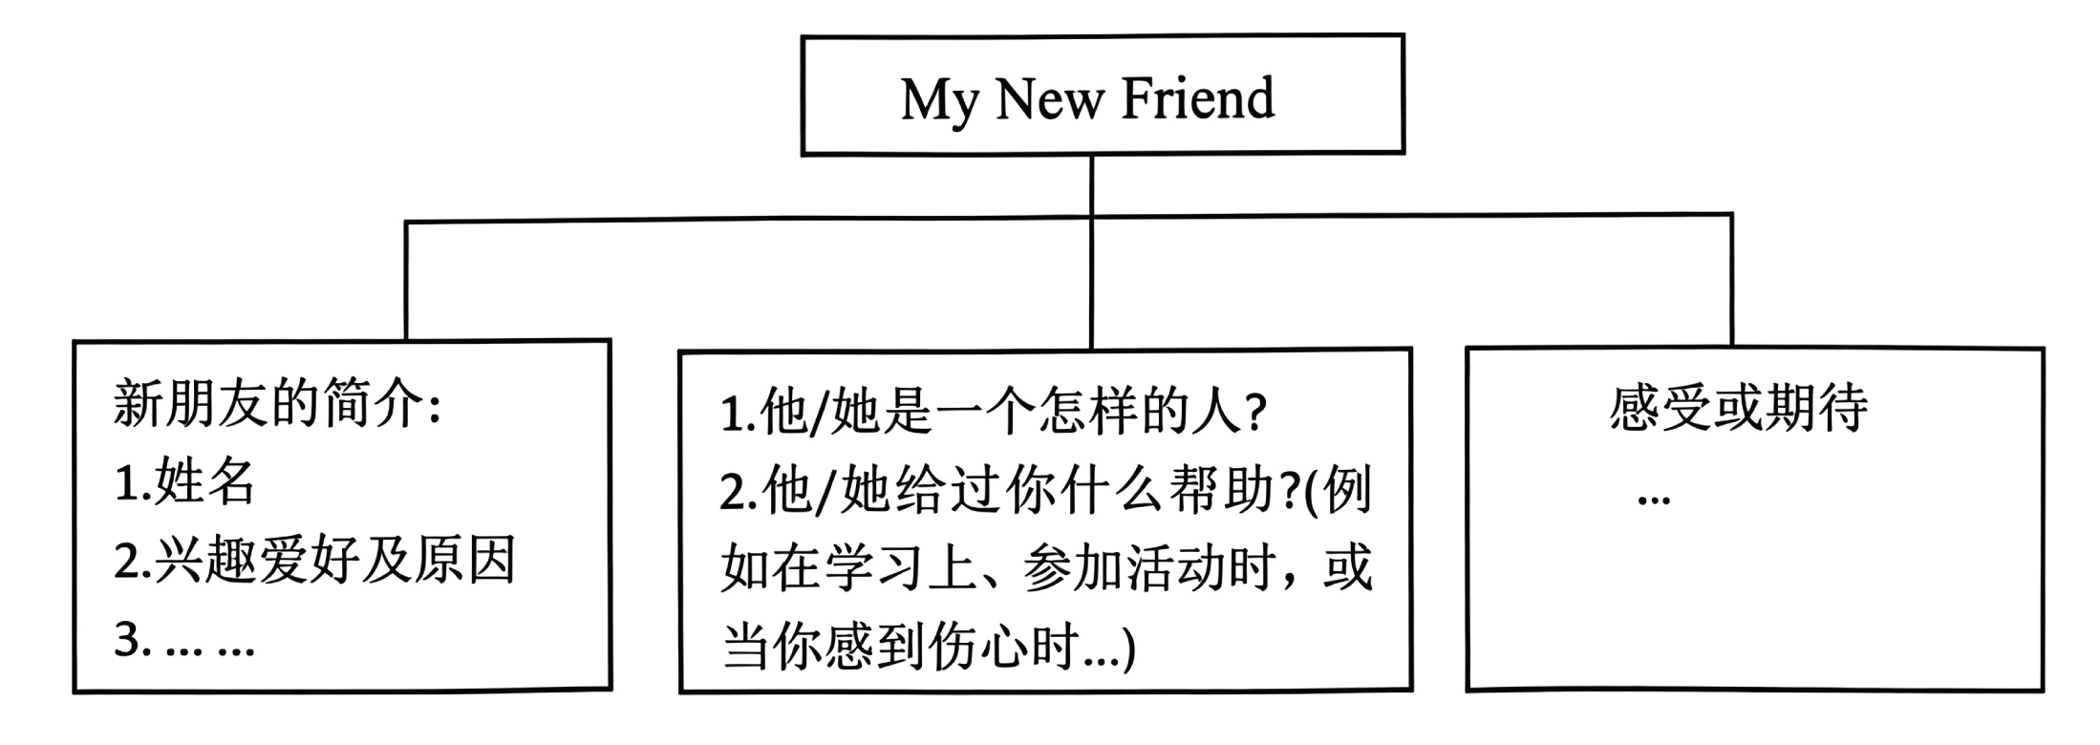
作文要求：
1. 不能照抄原文；
2. 不得在作文中出现学校真实的名称和学生的真实姓名；
3. 语句连贯，词数60个以上。题目已经给出，不计入总词数。
My New Friend_______________________________________________________________________________________________________________________________________________________________________________________________________________________________________________________________________________________________________________________________________________________________________________________________________________________________________________________________________________________________________________________________________________________________________________________________________________________________________________________________________

【答案】367．By smiling, saying hello and asking simple questions. 368．Listening carefully in class and taking notes. 369．The club office. 370．Because it/this will help us move around easily. 371．Parents, teachers or a good friend. 372．范文:
My New Friend
Life in Grade 7 is full of new things. Luckily, I met a wonderful new friend, Lily.
Lily is a kind girl. She loves reading because she thinks books are like windows to the world. When I find my math homework difficult, she always explains it to me clearly. Last month, I felt nervous about joining the school art club. Lily encouraged me. Now, we enjoy drawing every week. When I miss my old friends and feel sad, she listens to me and tells funny stories to cheer me up.
I’m thankful to have such a good friend. She makes me feel warm in the new school. I hope we can be best friends forever.
【难度】0.64
【来源】广东省斗门2025-2026学年度第一学期义务教育阶段质量监测七年级英语试题
【导语】本文给出五条建议，帮助小学升入初中的学生尽快适应初中新生活：结交朋友、学习新学科、熟悉校内场所、参加社团、倾诉内心感受。
【详解】367．文章第一部分“Making Friends in a Bigger School”中“We can start a conversation by smiling, saying hello and asking simple questions like ‘What’s your name?’ or ‘Do you like playing basketball?’”说明我们可以通过微笑、打招呼以及问一些简单的问题开启对话，直接提取信息。
368．文章第二部分“Learning New Subjects”中“Listening carefully in class and taking notes will help us learn better.”说明课堂认真听讲并且记笔记会帮助我们学得更好，直接提取信息。
369．文章第四部分“Joining Fun Clubs”中“Go to the club office to choose a club.”说明可以去社团办公室选择一个社团，答案几乎是原文引述。
370．文章第三部分“Knowing Important Places in School”中“This will help us move around easily.”说明因为这会帮助我们方便地四处活动，直接提取原因信息。
371．文章第五部分“Talking About How You Feel”中“We can try to talk to parents, teachers or a good friend.”说明我们可以和父母、老师或者好朋友聊聊，答案几乎是原文引述。
372．写作步骤
[第一步：审题立意]
确定文体：介绍性记叙文，用一般现在时为主
明确要点：朋友简介(姓名、兴趣爱好及原因)、人物性格以及给予自己的帮助、感受与期待
确定人称：第三人称(she)、第一人称(I/my)
注意事项：不得透露真实姓名和学校名称，不能照抄原文， 语句连贯，词数60个以上
[第二步：构思布局]
三段式结构：
开头段：开门见山，点明主题
主体段：详细介绍朋友的特点以及对自己的帮助
结尾段：总结感受与期待，升华主题
[第三步：要点展开]
要点一：朋友简介
姓名选择：Lily/Daming/Lucy/Linda等
爱好描述：reading/singing/dancing/drawing等
原因介绍：books are like windows to the world/makes her relaxed/forget all my pressure/record beautiful moments等
要点二：人物性格以及给予自己的帮助
性格说明：kind/friendly/nice/honest等
帮助说明：encouraged me/gives me useful advice/teaches me not to give up easily/helps me work out difficult problems等
要点三：感受与期待
感受说明：thankful/feel lucky/feel happy/feel moved等
期待说明：be best friends forever/share more interesting experiences together/grow better together等
A．回答问题
请阅读下面短文，根据所提供的信息，回答5个问题。要求所写答案语法正确、语义完整切题，并将答案写在答题卡对应题目的答题位置上。
Do you want to be my friend?
Friends are important because they can bring us a lot of fun and help us. We can make friends in schools, clubs, and other places. With the Internet (网络) , we can even make friends with people from all over the world easily. Would you like to make some friends?
FORUM (论坛)
 | Hello! My name is Paul and I’m thirteen years old. I live in Australia with my family. My father is a doctor and my mother is a teacher. I have a brother and a little sister. I love reading. There are about 200 books in my room. I also like playing chess. Do you want to be my friend?
 | Dear Paul,  I’m Tom. I’d like to be your friend. I’m fourteen and I’m from Singapore. There are six people in my family. They are my grandparents, my parents, my brother and me. My hobbies are listening to music and going bike riding.
 | Hello, I’m Emma. I’m fifteen years old. I come from the UK, but I’m on a study tour in China with three of my classmates these days. Chinese people are friendly. I really like the noodles here. They are so delicious. I’d like to have a Chinese friend.
 | Dear Emma,  My name is Li Yue. I’m happy to make friends with you. We are the same age. I live in Zhuhai with my family. It is a great city in China. My mother is an English teacher. With her help, I can speak English well. If you are interested in China, I’d like to tell you a lot about my country.
373．Why are friends important?
____________________________________________
374．How many people are there in Paul’s family?
____________________________________________
375．What does Tom like doing?
____________________________________________
376．Where is Emma from?
____________________________________________
377．How old is Li Yue?
____________________________________________
B．书面表达
378．请根据要求完成短文写作，并将写作内容写在答题卡对应题目的答题位置上。
朋友是时光的馈赠，“唯以心相交，方能成其久远”。近些年，网络的发展拉近了与朋友的距离。假如你是李华，暑假过后，你和你的小学朋友夏鹏分别去了不同的初中，他通过email告诉你他在新学校很好，并询问你新学校的情况，请你给他回信。
My Wonderful School life
学校设施及功能：  1. 图书馆：读书  2. …… | 学校日常：  1. 最喜欢的科目及原因  2. 参与的社团及时间和地点 | 感受：  学校生活忙碌但快乐
注意：
(1) 可在思维导图内容提示的基础上适当拓展信息。
(2) 不能照抄原文；不得在作文中出现真实校名、地名和考生的真实姓名。
(3) 语句连贯，词数80左右。作文标题、开头和结尾已经给出，不计入总词数，也不必抄写在答题卡上。
Dear Xia Peng,
It is so exciting to get an email from you. I am glad to tell you my wonderful new school life. ______________________________________________________________________________________________________________________________________________________________________________________________________________________________________________________________________________________________________________________________________________________________
I am looking forward to hearing from you soon.
Yours,
Li Hua

【答案】373．Because they can bring us a lot of fun and help us. 374．
There are five people in Paul’s family. 375．Tom likes listening to music and going bike riding. 376．Emma is from the UK. 377．Li Yue is fifteen years old. 378．例文：
Dear Xia Peng,
It is so exciting to get an email from you. I am glad to tell you my wonderful new school life.
My new school is very good. There is a big library where I can read many interesting books. We also have a nice playground for sports. My favorite subject is English because it’s very interesting and useful for me. I join the Reading Club and we meet every Friday afternoon in the library. My school life is busy but happy. I make many new friends here and we often help each other. I really enjoy my school life.
I am looking forward to hearing from you soon.
Yours,
Li Hua
【难度】0.65
【来源】广东省珠海市金湾区2025-2026学年度第一学期义务教育阶段质量监测 七年级期末英语试题
【导语】本文是一篇论坛交友帖，介绍了Paul、Tom、Emma和Li Yue的个人信息。
【详解】373．根据“Friends are important because they can bring us a lot of fun and help us.”可知，朋友重要是因为他们能给我们带来很多乐趣并帮助我们。故填Because they can bring us a lot of fun and help us.
374．根据“I live in Australia with my family. My father is a doctor and my mother is a teacher. I have a brother and a little sister.”可知，Paul家有爸爸、妈妈、哥哥、妹妹和他自己，共五口人。故填There are five people in Paul's family.
375．根据“My hobbies are listening to music and going bike riding.”可知，Tom喜欢听音乐和骑自行车。故填Tom likes listening to music and going bike riding.
376．根据“I come from the UK”可知，Emma来自英国。故填Emma is from the UK.
377．根据“I’m fifteen years old.”以及Li Yue的回复“We are the same age.”可知，Li Yue十五岁。故填Li Yue is fifteen years old.
378．【总体分析】①题材：本文是一篇书信；
②时态：时态为 “一般现在时”；
③提示：写作要点已给出，注意不要遗漏要点，可适当添加细节，并突出写作重点。
【写作步骤】第一步，开篇回应来信，引出新学校生活的介绍；
第二步，具体介绍学校设施、最喜欢的科目及原因、参与的社团及时间地点；
第三步，书写感受，表达对学校生活的喜爱，最后收尾期待回信。
【亮点词汇】①exciting令人兴奋的
②interesting有趣的
③useful有用的
【高分句型】①There is a big library where I can read many interesting books. (where引导的定语从句)
A．回答问题
阅读下面短文，根据提供的信息，回答问题。要求所写答案语法正确、语义完整。
John is an English boy. He comes to China with his father and mother this year. John’s parents come to China for work and John comes here for study.
John is in No. 9 Middle School and he is in Class 5, Grade 7. He gets up early at 7 o’clock every morning and gets to school at 7:50, 10 minutes before the school starts. So he is never late for school. He studies maths very hard and always gets good grades. John can read and write English very well. He always helps us with our English after class. But John is not good at Chinese, so we help him with his Chinese. After school, he likes playing basketball and riding a bike. He is friendly and helpful, so many students want to make friends with him.
On Sundays, John helps his mother clean the room. Sometimes, they go hiking together and he likes that. He always says his life in China is great fun.
379．Where is John from?
__________________________________________
380．When does the school start?
__________________________________________
381．What subjects is John good at?
__________________________________________
382．What are John’s hobbies?
__________________________________________
383．Why does John have so many friends?
__________________________________________
B．书面表达
384．假设你是李华，你朋友Peter想了解你的初一生活。请你根据以下思维导图提示，给Peter写一封信。内容包括：
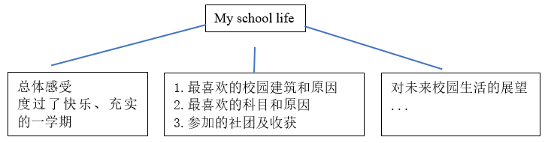
作文要求：
(1)可在思维导图内容提示的基础上适当拓展信息；
(2)不得抄袭原文，不得在作文中出现学校的真实名称和学生的真实姓名；
(3)语句连贯，词数70个左右。作文开头已经给出，不计入总词数。
My School life
Dear Peter,
I am glad to hear from you. ________________________________________________________________________________________________________________________________________________________________________________________________________________________________________________________________________________________________________________________
Yours,
Li Hua

【答案】379．He is from England. 380．The school starts at 8:00. 381．He is good at maths and English. 382．He likes playing basketball and riding a bike. 383．Because he is friendly and helpful. 384．例文：
Dear Peter,
I am glad to hear from you. I have spent a happy and fulfilling semester in junior high school. I am looking forward to more fun in the future.
My favorite building is the library because it is quiet and full of interesting books. My favorite subject is English because I enjoy learning new words and cultures. I joined the English club and have improved my speaking skills a lot.
I hope you can visit my school one day!
Yours,
Li Hua
【难度】0.65
【来源】广东省珠海市文园中学2025-2026学年度上学期七年级期末模拟英语试题
【导语】本文介绍了John的学校生活。
379．根据“John is an English boy.”可知他是一个英国的男孩，所以他来自于英国。故填He is from England.
380．根据“He gets up early at 7 o’clock every morning and gets to school at 7:50, 10 minutes before the school starts.”他每天早上7点起床，7点50到达学校，在学校开始之前10分钟，所以学校开始的时间是8点。故填The school starts at 8:00.
381．根据“He studies maths very hard and always gets good grades. John can read and write English very well. He always helps us with ourEnglish after class.”可知他非常努力的学习数学，总是得到好的成绩。John英语读和写都很好，他在课后总是帮助我们的英语。所以John擅长的科目是数学和英语。故填He is good at maths and English.
382．根据“After school, he likes playing basketball and riding a bike.”可知在放学后，他喜欢打篮球和骑自行车。所以他的爱好是打篮球和骑自行车。故填He likes playing basketball and riding a bike.
383．根据“He is friendly and helpful,so many students want to make friends with him.”可知他友好又乐于助人，所以许多人想要和他成为朋友。故填Because he is friendly and helpful.
384．[总体分析]
①题材：本文是一篇书信作文；
②时态：一般现在时；
③提示：写作要点已给出，考生注意不要遗漏要点，并适当添加细节，突出重点。
[写作步骤]
第一步：介绍总体感受和校园生活；
第二步：对未来校园生活的展望。
[亮点词汇]
①fulfilling令人满足的、有意义的
②look forward to期待、盼望
③improve提高、改善
[高分句型]
①My favorite building is the library because it is quiet and full of interesting books. (because引导的原因状语从句)
请阅读下面这篇文章，根据所提供的信息，回答下列问题。要求所写答案语法正确，语义完整，并把答案写在答题卡指定的位置。

“Long time no see!”, says Michael, an English teacher from the UK. He always uses it to greet his friends. Is this Chinglish sentence right? Yes, and it is a popular way of greeting.
In the past, people often laughed at Chinglish because of the wrong grammar. However, with the rising international influence (影响) of Chinese culture (文化), Chinglish becomes a special cultural language. For example, you can find “guanxi”, “lose face” and “paper tiger” in the Oxford dictionary. You can also hear “tuhao” or “dama” here and there. These phrases are not only funny, but also show Chinese culture in a new way.
By using Chinglish, we open a window for the international conversations. From this window, many people from different countries see a different China. They want to know more about Chinese culture because of these funny Chinglish. As many people come to live, travel and study in China, they begin to make up new phrases with both Chinese and English. For example, “City bu city?” gets popular on the Chinese Internet these days. Drinking a cup of milk tea with friends is “city”. Driving on Hong Kong-Zhuhai-Macao Bridge is super “city”.
Chinglish changes some old ideas on language learning. It makes students know that they need to not only learn grammar and pronunciation, but also get the ability to use language smartly.
385．What does Michael always say to greet his friends?
_____________________________________
386．How many Chinglish examples are there in Paragraph 2?
_____________________________________
387．Who wants to know more about Chinese culture?
_____________________________________
388．Where does “City bu city?” get popular these days?
_____________________________________
389．What changes some old ideas on language learning?
_____________________________________
390．书面表达
根据要求完成短文写作，请将作文写在答题卡指定的位置。
中式英语反向输出的现象彰显了我们的文化自信，让世界各地的人们感知中国文化的博大精深。假如你是李华，来自英国的交换生Peter对你校各社团开展的中国传统文化活动非常感兴趣，请你根据以下四个传统文化社团海报信息提示，写一封e-mail，向Peter介绍这些社团活动的内容和地点，并邀请他参加社团活动。
内容：
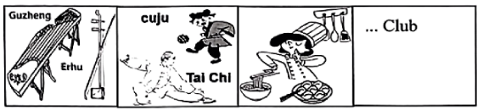
注意：(1) 可在文字和图片内容提示的基础上适当拓展信息；
(2) 不可照抄原文；不得在作文中出现真实校名、地名和考生的真实姓名；
(3) 语句连贯，词数80左右。作文的开头和结尾已给出，不计入总词数。
Dear Peter,
Welcome to my school. There are different kinds of Chinese traditional cultural activities in my school clubs. __________________________________________________________________________________________________________________________________________________________________________________________________________________________________________________________________________________________________________________________________________________________________________________________________________________________________________________________________________________________________________________________________________________________________________________________
Yours,
Li Hua

【答案】385．Long time no see!/He says “Long time no see”. 386．5./Five./Five Chinglish examples./Five examples. 387．Many people from different countries./Many people from different countries want to know more about Chinese culture. 388．On the Chinese Internet. 389．Chinglish./Chinglish changes some old ideas on language learning. 390．例文
Dear Peter,
Welcome to my school. There are different kinds of Chinese traditional cultural activities in my school clubs.
In the music room, the music club teaches you to play the guzheng and erhu—you can practice with partners and learn classic tunes. On the sports field, the sports club offers cuju (an ancient football game) and Tai Chi, which helps relax your body. In the dining hall, the cooking club lets you learn to make delicious dumplings and sweet tangyuan. My favorite paper-cutting club is in the art room: you can make beautiful patterns as gifts.
Come and join us! You’ll have a great time here!
Yours,
Li Hua
【难度】0.4
【来源】广东省珠海市香洲区 2024—2025 学年七年级上学期期末英语试题
【导语】本文介绍了中式英语的现状：从曾被嘲笑到如今成为传播中国文化的方式，还提及它对语言学习观念的改变。
【详解】385．根据“‘Long time no see!’, says Michael... He always uses it to greet his friends.”可知，Michael常用“Long time no see!”来问候朋友。故填Long time no see!/He says “Long time no see”.
386．根据第二段中“‘guanxi’, ‘lose face’, ‘paper tiger’, ‘tuhao’ and ‘dama’”可知，第二段有5个中式英语例子。故填5./Five./Five Chinglish examples./Five examples.
387．根据“From this window, many people from different countries... They want to know more about Chinese culture”可知，不同国家的很多人想要更多了解中国文化。故填Many people from different countries./Many people from different countries want to know more about Chinese culture.
388．根据“‘City bu city?’ gets popular on the Chinese Internet these days.”可知，这个表达在中文互联网上流行。故填On the Chinese Internet.
389．根据“Chinglish changes some old ideas on language learning.”可知，是中式英语改变了语言学习的旧观念。故填Chinglish./Chinglish changes some old ideas on language learning.
390．[总体分析]
①题材：本文是一封电子邮件；
②时态：时态以“一般现在时”为主；
③提示：根据社团海报信息，介绍活动内容与地点，邀请Peter参加，注意语句连贯，避免照抄原文。
[写作步骤]
第一步，介绍学校有各种各样的文化社团；
第二步，说明各社团的活动的地点和具体内容；
第三步，发出参加邀请。
[亮点词汇]
①teach sb. to do sth.教某人做某事
②learn to do sth.学习做某事
③join sb.加入某人
[高分句型]
On the sports field, the sports club offers cuju (an ancient football game) and Tai Chi, which helps relax your body. (which引导的非限定性定语从句)
A．回答问题
请阅读下面短文，根据所提供的信息，回答五个问题，并将答案写在答题卡对应的答题位置上。要求所写答案语法正确、信息完整切题。
I am Li Hua, a 13-year-old boy. I’m happy to tell you about my school life. My school is great and beautiful. There are many modern buildings. For example, next to the teachers’ building, there is a large sports field. All the students go there and do exercises together in the morning. It’s amazing!
There are forty students in my class. My school begins at 9 o’clock. I have seven classes at school every day. Each lesson is 40 minutes long. I love Thursday afternoons because we have a biology class. Miss Baker is our teacher, and she works hard to make the class interesting. The afternoon lessons begin at 2:30 and finish at 5:30. After school, I usually play sports with friends on the sports field.
That’s my school life. Welcome to my school!
391．Is there a large sports field next to the teachers’ building?
_____________________________________________________
392．How many classes does Li Hua have every day?
_____________________________________________________
393．How long is each lesson at Li Hua’s school?
_____________________________________________________
394．Why does Li Hua love Thursday afternoons?
_____________________________________________________
395．What does Li Hua usually do after school?
_____________________________________________________
B．书面表达
请根据要求完成短文写作，并将短文写在答题卡对应题目的答题位置上。
396．假设你叫李明，你打算向你在美国的笔友Tony写一封电子邮件，向他描述一下你的学校生活。请你根据以下思维导图的提示，用英文写一封邮件。
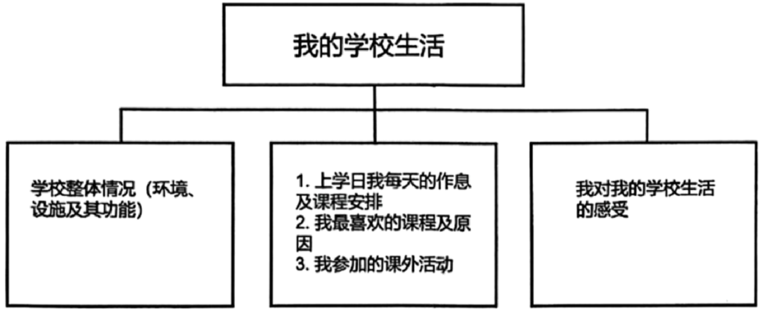
注意：
（1）可在思维导图内容提示的基础上适当拓展信息。
（2）不能照抄原文；不得在作文中出现真实校名、地名和考生的真实姓名。
（3）语句连贯，词数80左右。作文的标题和开头已经给出，不计入总词数，也不必抄写在答题卡上。
Dear Tony,
How is it going? Let me tell you something about my school life today._____________________________________________________________________________________________________________________________________________________________________________________________________________________________________________________________________________________________________________________________________________________________________________________________________________________________________________________________________________________________________________________________________________________________________________________
Yours,
Li Ming

【答案】391．Yes, there is. 392．He has seven classes every day. /Seven classes. /Seven. 393．40 minutes. 394．He loves Thursday afternoons because he has a biology class. /Because he has a biology class. 395．He usually plays sports with friends after school. 396．例文
Dear Tony,
How is it going? Let me tell you something about my school life today. My school is great and tidy. There are many buildings in my school like the classroom building. On school days, I usually get up at 7 o’clock. Then I get dressed and have breakfast. At 7:20, I go to school. There are eight classes every day. My favourite subject is English because it’s useful and my English teacher is really nice. After school, I often play football on the sports field.
I love my school life. It’s busy but really interesting.
Yours,
Li Ming
【难度】0.65
【来源】广东省珠海市金湾区2024-2025学年七年级上学期期末英语试卷
【导语】本文主要介绍了李华的学校生活。
【详解】391．根据“For example, next to the teachers’ building, there is a large sports field.”可知在教师办公楼旁边，有一个大型运动场，故填Yes, there is.
392．根据“I have seven classes at school every day.”可知李华每天有7节课，故填He has seven classes every day. /Seven classes. /Seven.
393．根据“Each lesson is 40 minutes long.”可知每节课是40分钟，故填40 minutes.
394．根据“I love Thursday afternoons because we have a biology class.”可知李华喜欢周四下午是因为他们有生物课，故填He loves Thursday afternoons because he has a biology class. /Because he has a biology class.
395．根据“After school, I usually play sports with friends on the sports field.”可知放学后李华通常和朋友们在运动场上一起做运动，故填He usually plays sports with friends after school.
396．[总体分析]
①题材：本文是一篇应用文，为电子邮件；
②时态：时态以“一般现在时”为主；
③提示：写作要点已给出，考生应注意不要遗漏提示，并适当添加细节，注意字母大小写以及标点符号。
[写作步骤]
第一步，向对方介绍自己学校的整体情况；
第二步，介绍自己上学日的作息及课程安排；介绍自己喜欢的课程及原因；介绍自己参加的课外活动；
第三步，介绍自己对学校生活的感受。
[亮点词汇]
①great and tidy很好且整洁
②get dressed穿好衣服
[高分句型]
①There are eight classes every day.（there be句型）
②My favourite subject is English because it’s useful and my English teacher is really nice.（because引导原因状语从句）
回答问题。
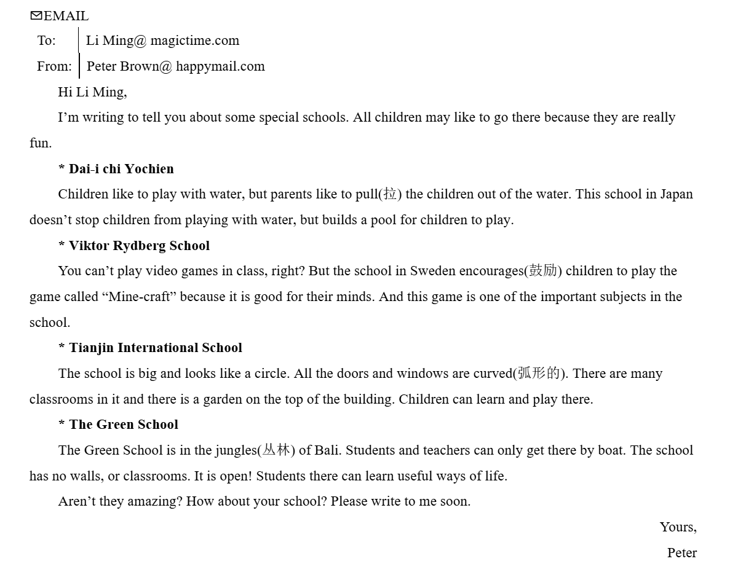
397．Why do children like to go to these special schools?
____________________________________________________________________________________________
398．Who doesn’t like children to play with water?
____________________________________________________________________________________________
399．What can children do in Tianjin International School?
____________________________________________________________________________________________
400．How can students and teachers get to the Green School?
____________________________________________________________________________________________
401．How many schools does the passage talk about?
____________________________________________________________________________________________
书面表达。
402．温馨的校园令人向往，有趣的校园生活更让人回味。看了Peter对几所学校的介绍，你有何感想?假如你是Li Ming，请用英文给Peter写一封回信，谈谈自己的校园生活，内容包括：
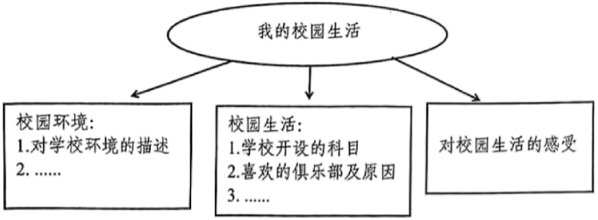
作文要求：
(1) 不能照抄原文；
(2) 不得在作文中出现学校真实的名称和学生的真实姓名；
(3) 语句连贯，词数60个以上。开头已经给出，不计入总词数。
Dear Peter,
Thank you for your letter. I am writing to share my school life with you.____________________________________________________________________________________________________________________________________________________________________________________________________________________________________________________________________________________
Best wishes!
Yours,
Li Ming

【答案】397．Because the schools are really fun. 398．Parents. 399．They can learn and play there. 400．By boat. 401．Four. 402．例文：
Dear Peter,
Thank you for your letter. I am writing to share my school life with you.
My school has a beautiful environment: there are lush trees and colorful flowers around the teaching buildings, and a clean playground where we often play sports. We have various subjects like Chinese, math, English, and art—they help me learn different skills. My favorite club is the robotics club, because I can design small robots with my classmates. After class, we also have group activities like book-sharing meetings.
I really enjoy my school life.
Best wishes!
【难度】0.65
【来源】广东省珠海市斗门区2024-2025学年七年级上学期期末统考英语试题
【导语】本文主要讲述了Peter向Li Ming介绍了四所特别的学校，分别介绍了每所学校的特色之处。
【详解】397．根据“All children may like to go there because they are really fun.”可知，孩子们喜欢去这些特别的学校是因为这些学校非常有趣，故填Because the schools are really fun.
398．根据“Children like to play with water, but parents like to pull (拉) the children out of the water.”可知，不喜欢孩子玩水的是父母，故填Parents.
399．根据“Tianjin International School...Children can learn and play there.”可知，孩子们在天津国际学校可以学习和玩耍，故填They can learn and play there.
400．根据“The Green School...Students and teachers can only get there by boat.”可知，学生和老师只能乘船到达绿色学校，故填By boat.
401．根据邮件中提到的“Dai-i chi Yochien、Viktor Rydberg School、Tianjin International School、The Green School”可知，文章一共介绍了4所学校，故填Four.
402．[总体分析]
①题材：本文是一篇书信作文；
②时态：主要为“一般现在时”；
③提示：需包含分享学校生活的核心要点，围绕学校环境、所学课程、喜爱的俱乐部及课后活动展开，适当添加环境细节并突出对学校生活的喜爱之情。
[写作步骤]
第一步，阐述写作意图，明确说明写作意图是向Peter分享自己的学校生活；
第二步，详细介绍了学校生活的具体内容，包括学校优美的环境、所学的各类科目及科目作用、喜爱的机器人俱乐部及俱乐部活动、课后小组活动；
第三步，通过总结表达对学校生活的喜爱，收束全文并送上祝福。
[亮点词汇]
①share分享
②lush繁茂的
③various各种各样的
④design设计
⑤enjoy享受
[高分句型]
①My school has a beautiful environment: there are lush trees and colorful flowers around the teaching buildings, and a clean playground where we often play sports. (where引导定语从句)
②My favorite club is the robotics club, because I can design small robots with my classmates. (because引导原因状语从句)
A．回答问题
请阅读下面短文，根据所提供的信息，回答五个问题，并将答案写在答题卡对应题目的答题位置上。要求所写答案语法正确、信息完整切题。
Hello! I’m Miss Smith. To help my students get to know each other, we play a game in our first English class. First, I tell them what to ask. Then two students make up a group. They need to ask and answer seven questions.
Here are two students’ answers in my class.
My name is Lily Green. I’m 13 years old. I’m from the UK. There are seven people in my family. I have a cute pet cat at home. My favourite food is Beijing roast duck and I think it’s great! I love music and I’m good at playing the guitar.
I am David Smith. I come from Australia. There are three people in my family—my mum, my dad and me. I keep a dog at home and it is Max. I like Mapo tofu best and my mum often makes it for me. Tennis is very interesting, so it is my favourite sport. I often play it with my friends.
403．What is Miss Smith’s job?
____________________________________________________________________________________________
404．How many questions do the students need to answer?
____________________________________________________________________________________________
405．What is Lily’s pet cat like?
____________________________________________________________________________________________
406．Who can make Mapo tofu in David’s family?
____________________________________________________________________________________________
407．Why does David love tennis?
____________________________________________________________________________________________
B．书面表达。
408．假设你是Li Ming，看到 Peter Brown在中学生国际论坛上发的希望交更多新朋友的帖子，想和他做朋友。请根据下面的思维导图，给他写一封回信。
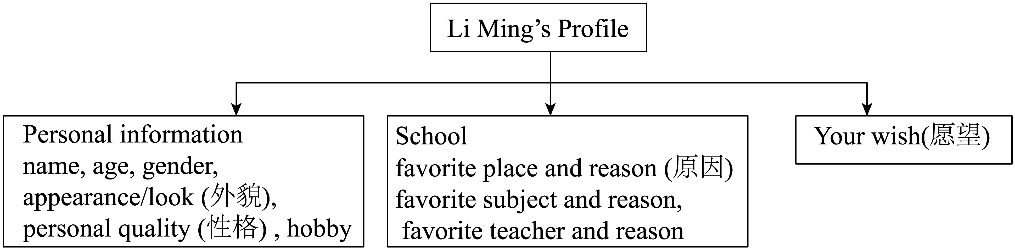
要求：
(1) 内容可在思维导图基础上自由发挥，开头已给出。
(2) 语句通顺，表达流畅，80词左右 (文中已给出内容不计入总词数) 。
(3) 请不要出现真实的校名和姓名。
Dear Peter,
Thanks for your post. ________________________________________________________________________________________________________________________________________________________________________________________________________________________________________________________________________________________________________________________________________________________________________________________________________________________________________________________________________________________________________________________________________________________________
Yours,
Li Ming

【答案】403．She is an English teacher. 404．Seven. 405．It’s cute. 406．His mum. 407．Because he thinks it is very interesting. 408．例文：
Dear Peter,
Thanks for your post. I’d love to be your friend! My name is Li Ming, a 15-year-old from China. I have short black hair, wear glasses, and always smile. I’m outgoing and enjoy helping others.
At school, I love the library because it’s quiet and full of books. History is my favorite subject because learning about the past is like solving mysteries! Mr. Wang, my history teacher, makes lessons fun with vivid stories.
I hope we can share cultures and learn together. Let’s chat soon!
Yours,
Li Ming
【难度】0.65
【来源】广东省珠海市横琴子期实验中学2025-2026学年七年级上学期期中考试英语试卷
【导语】本文主要讲述了史密斯老师为了帮助学生互相了解，在第一节英语课上组织了一个问答游戏，并给出了两位学生莉莉和大卫的回答示例。
【详解】403．根据文中“Hello! I’m Miss Smith. To help my students get to know each other, we play a game in our first English class.”可知，史密斯小姐的身份是一名老师，且从英语课可推测出是英语老师。故填She is an English teacher.
404．根据文中“They need to ask and answer seven questions.”可知，学生们需要回答七个问题。故填Seven.
405．根据文中莉莉的回答“I have a cute pet cat at home.”可知，莉莉的宠物猫很可爱。故填It’s cute.
406．根据文中大卫的回答“I like Mapo tofu best and my mum often makes it for me.”可知，大卫的妈妈会做麻婆豆腐。故填His mum.
407．根据文中大卫的回答“Tennis is very interesting, so it is my favourite sport.”可知，大卫喜欢网球是因为他认为网球非常有趣。故填Because he thinks it is very interesting.
408．[总体分析]
①题材：本文是一篇应用文，为书信（回信）；
②时态：时态为“一般现在时”；
③提示：写作要点已通过思维导图给出，考生应注意不要遗漏“思维导图”中关于个人信息、学校以及愿望的介绍要点，适当添加细节，并突出写作重点。
[写作步骤]
第一步，表明写作意图。借用“感谢帖子并表达交友意愿”来引出重点介绍的内容；
第二步，具体阐述写作内容。从“个人信息、学校（最喜欢的地方、学科和老师）以及愿望”几个方面重点介绍；
第三步，书写结语。表达“希望尽快交流”的愿望。
[亮点词汇]
①would love to愿意做某事
②outgoing外向的
③be full of充满
④solve mysteries解谜
⑤make lessons fun使课程有趣
⑥vivid生动的
[高分句型]
①At school, I love the library because it’s quiet and full of books.（because引导的原因状语从句）
②History is my favorite subject because learning about the past is like solving mysteries!（because引导的原因状语从句）
A回答问题
请阅读下面短文，根据所提供的信息，回答5个问题。要求所写答案语法正确、语义完整切题。
Zhao Youzhu is 20 years old. She is a student at Xiamen University. She comes from Liaoyang, Liaoning. She can speak and read, but she can’t hear.
Zhao has short hair and wears glasses. She likes reading very much. She has many books at home. “I often go to the library,” Zhao says, “That is my favourite place.” Sometimes, she also reads in parks.
Zhao’s parents are doctors. They often help their daughter. They are her teachers and friends too. They love their daughter and Zhao loves them too.
Zhao has a sister. She is not in Xiamen, but she often talks with Zhao on the Internet. She often tells Zhao some funny stories and they are very glad. “I have a nice family, good teachers and many good friends,” Zhao says, “They make me strong and happy.”
409．What is Zhao’s problem?
_____________________________________________________________
410．What does Zhao look like?
_____________________________________________________________
411．What do Zhao’s parents do?
_____________________________________________________________
412．Who does Zhao often talk with on the Internet?
____________________________________________________________
413．What do you think of Zhao’s family?
____________________________________________________________
B书面表达
414．假如你是李梅，你想和上文的 Zhao Youzhu 成为朋友，请你根据以下要求给她写一封信：
（1）简单介绍你自己（姓名，年龄，身份，兴趣爱好）。
（2）简单介绍你的家庭（人数，家庭成员简介）。
（3）表达你想要交朋友的想法。
作文要求：
（1）不能照抄原文；不得在作文中出现真实校名、地名和考生的真实姓名。
（2）语句连贯，词数80词左右。作文的开头已给出，不计入总词数。
Dear Youzhu,
____________________________________________________________________________________________________________________________________________________________________________________________________________________________________________________________________________________
Yours,
Li Mei

【答案】409．She can’t hear. 410．She has short hair and wears glasses. 411．They are doctors. 412．Her sister. 413．It’s a nice family. The family love her and make her strong and happy.（答案不唯一，合理即可） 414．例文
Dear Youzhu,
My name is Li Mei, a 13-year-old student. I love reading and playing basketball in my free time. There are four people in my family: my parents, my younger brother and me. My father is a doctor and my mother is a teacher. They are both very kind. My brother is cute and we often play together. I really want to make friends with you because I think we can share a lot of interesting things and learn from each other. I hope we can become good friends soon.
Yours,
Li Mei
【难度】0.65
【来源】广东省珠海市梅华中学2025-2026学年七年级上学期期中质量检测英语试题
【导语】本文主要介绍了20岁的厦门大学学生赵有珠的相关情况，包括她的身体状况、外貌、兴趣爱好、家庭情况等。
409．根据第一段“She can speak and read, but she can’t hear.”可知，赵有珠的问题是她听不见。故填She can’t hear.
410．根据第二段“Zhao has short hair and wears glasses.”可知，赵有珠留着短发，戴着眼镜。故填She has short hair and wears glasses.
411．根据第三段“Zhao’s parents are doctors.”可知，赵有珠的父母是医生。故填They are doctors.
412．根据第四段“Zhao has a sister. She is not in Xiamen, but she often talks with Zhao on the Internet.”可知，赵有珠经常在网上和她的姐姐聊天。故填Her sister.
413．根据最后一段“I have a nice family, good teachers and many good friends,” Zhao says, “They make me strong and happy.”可知，赵有珠认为她有一个很好的家庭，有好的老师和很多好朋友，他们让她变得坚强和快乐。所以可以认为赵有珠的家庭很好，家人很爱她，让她坚强又快乐。故填It’s a nice family. The family love her and make her strong and happy.（答案不唯一，合理即可）
414．[总体分析]
①题材：本文是一篇书信作文；
②时态：为“一般现在时”；
③提示：写作要点已明确给出，包括自我介绍、家庭介绍以及表达交友想法，考生应注意不要遗漏这些要点，并适当添加细节，以使内容更加丰富。
[写作步骤]
第一步，表明写作意图和自我介绍。通过简单介绍自己的姓名、年龄和身份，以及兴趣爱好，来引出后续的内容；
第二步，具体阐述家庭情况。从家庭人数和家庭成员简介两个方面进行介绍，使读者对自己的家庭有一个清晰的了解；
第三步，表达交友意愿。明确表达自己想要和对方成为朋友的想法，并说明原因，如可以分享有趣的事情和互相学习。
[亮点词汇]
①in my free time在我的空闲时间
②both两者都
③make friends with与……交朋友
④learn from each other互相学习
[高分句型]
I really want to make friends with you because I think we can share a lot of interesting things and learn from each other.（原因状语从句）
请阅读下面短文，根据所提供的信息，回答5个问题，要求所写答案语法正确，语义完整切题，并把答案写在答题卡对应题目的答题位置上。
Mike is an English boy. He wants to have a Chinese friend. He has healthy eating habits. He likes fruit and vegetables. He often has vegetables for breakfast and fruit salad for dinner. He likes sports too. He often plays football with his classmates after school.
Mike’s school is not big but beautiful and modern. There is a library in it. Students can read many kinds of books, including (包括) e-books. Next to the library is a lovely garden. You can see many plants and flowers there.
A store is next to his home. It sells clothes at very good prices. Today, Mike wants to buy a new jacket. He goes to the clothes store with his mother. The jackets are $30 each. Mike likes yellow best, so he takes a yellow one.
Do you like him? Do you want to be his friend? You can email him at mike6156@126.com.
415．What does Mike often have for dinner?
_____________________________________________________________________
416．Is Mike’s school big?
_____________________________________________________________________
417．Where is the garden?
_____________________________________________________________________
418．How much is a jacket?
_____________________________________________________________________
419．What’s Mike’s email address (地址)?
_____________________________________________________________________
420．假如你是李华，你打算和上文中的Mike交朋友。请你根据以下表格内容提示用英文写一封电子邮件，介绍自己。
 | 自我介绍 | 1. 年龄  2. 性格或者爱好
 | 介绍自己的家庭和学校 | 1. 家庭：家庭成员；家庭爱好（不少于两点）  2. 学校：学校环境；学校活动（不少于两点）
 | 表达交友愿望 | 邀请Mike成为朋友
注意:
1可在表格内容提示的基础上适当拓展信息。
2不能照抄原文；不得在作文中出现学校的真实名称和学生的真实姓名。
3语句连贯，词数不少于70。作文的开头和结尾已经给出，不计入总词数。
Dear Mike，
I’m writing to you to introduce myself so that you can get to know more about me. ________________________________________________________________________________________________________________________________________________________________________________________________________________________________________________________________________________________________________________________________________________________________________________________________________________________________________________________________________________________________________________________________________________________________________________________________________________________________________________
Yours,
Li Hua

【答案】415．He often has fruit salad for dinner. 416．No, it isn’t. 417．It’s next to the library. 418．A jacket is thirty dollars. 419．Mike’s email address is mike6156@126.com. 420．范文
Dear Mike,
I’m writing to you to introduce myself so that you can get to know more about me.
I’m 15 years old, a friendly and outgoing boy who loves playing basketball and reading science fiction. My family has four members: my parents, my little sister and me. We often hike on weekends and have movie nights every Friday, which brings us closer. My school is beautiful with big gardens and a modern library. We have interesting activities like English speech contests and art festivals every year, which I always enjoy.
I really hope we can become good friends—we can share hobbies and talk about our lives. Would you like to be my friend?
Yours,
Li Hua
【难度】0.65
【来源】广东省珠海市部分学校2025-2026学年七年级上学期期中考试英语试题
【导语】本文主要介绍了英国男孩迈克的基本情况，包括他的饮食习惯、爱好、学校情况以及购物情况，最后给出了他的电子邮箱地址，询问是否有人想和他做朋友。
【详解】415．根据“He often has vegetables for breakfast and fruit salad for dinner.”可知迈克晚餐经常吃水果沙拉。故填He often has fruit salad for dinner.
416．根据“Mike’s school is not big but beautiful and modern.”可知迈克的学校不大。故填No, it isn’t.
417．根据“Next to the library is a lovely garden.”可知花园在图书馆旁边。故填It’s next to the library.
418．根据“The jackets are $30 each.”可知一件夹克30美元。故填A jacket is thirty dollars.
419．根据“You can email him at mike6156@126.com.”可知迈克的电子邮箱地址是mike6156@126.com。故填Mike’s email address is mike6156@126.com.
420．[总体分析]
① 题材：本文是一篇应用文，为电子邮件；
② 时态：时态主要为“一般现在时”；
③ 提示：根据所给提示完成写作，确保不遗漏信息，并以第一人称进行叙述；需注意不要遗漏“信息提示”中的每一项内容，同时适当添加细节以丰富内容，并突出写作重点。
[写作步骤]
第一步，简要介绍自己的基本信息，包括年龄和性格爱好；
第二步，详细介绍自己的家庭情况，包括家庭成员和家庭爱好；
第三步，描述自己的学校环境及学校活动；
第四步，表达交友愿望，邀请Mike成为朋友。
[亮点词汇]
① get to know more about 了解更多关于……
② so that 以便
③ bring sb closer 使某人关系更亲密
[高分句型]
① I’m 15 years old, a friendly and outgoing boy who loves playing basketball and reading science fiction.（who引导的定语从句，修饰先行词boy）
② We often hike on weekends and have movie nights every Friday, which brings us closer.（which引导的非限制性定语从句，对前面整个句子进行补充说明）
③ I really hope we can become good friends—we can share hobbies and talk about our lives.（宾语从句，hope后接that省略的宾语从句，同时破折号后进行进一步说明）
请阅读下面这篇文章，根据所提供的信息，回答5个问题。要求所写答案语法正确，语义完整。
Dear friends,
My name is David Green. I’m from the UK. I live in London with my brother and my parents. I’m thirteen years old. I’m studying in Brighton Middle School. I’m in Class 3, Grade 7. I have short brown hair and blue eyes. I like playing football with my friends after school. And I love making pottery (陶器), too. I am friendly and outgoing, so I like making friends with others. At the weekend, my family and I usually do some housework together. My favorite animal is the dog, so we have a pet dog. My favorite color is orange. There are many orange things in my bedroom. My orange schoolbag is in my desk. My orange shoes are under my bed. My Chinese teacher is from China. She is Miss Xu. She teaches us Chinese and tells us lots of things about China. She is really tall with big eyes and black hair. And she is always nice and patient (有耐心的) with us. We all like her very much. I am also good at speaking Chinese. What about you?
I am very glad to be your pen pal. I am looking forward to your reply.
Yours,
David
421．Where is David from?
___________________________________________________
422．How many people are there in David’s family?
___________________________________________________
423．What do David’s family usually do at the weekend?
___________________________________________________
424．What is David’s favorite color?
___________________________________________________
425．Why do David and his classmates like Miss Xu?
___________________________________________________
426．书面表达
假如你是李华，是光明中学七年级（2）班的学生，你们学校的广播站正在为“空中英语”栏目招聘主持人（host），请写一封应聘英文信给校广播站负责老师Mr Lin。
自我介绍
基本情况介绍  姓名、年龄…… | 应聘理由  1.擅长英语  2. …… | 表达愿望
作文要求：
1. 不能照抄原文，不得在作文中出现真实校名和真实姓名；
2. 语句连贯，词数80左右。开头和结尾已经给出，不计入总词数。
Dear Mr Lin,
I know that you are looking for a host for the Air English programme.
_____________________________________________________________________________________________________________________________________________________________________________________________________________________________________________________________________________________________________________________________________________________________________________________________
Yours,
Li Hua

【答案】421．He is from the UK. 422．There are four people. 423．They usually do some housework together. 424．Orange. 425．They like Miss Xu because she is nice and patient. 426．例文
Dear Mr Lin,
I know that you are looking for a host for the Air English programme. My name is Li Hua. I’m 13 years old and I study in Class 2, Grade 7 at Guangming Middle School.
I really want to be the host for two reasons. First, I am good at English. I enjoy learning it and I can speak it well. Second, I am outgoing and like talking to people. I also love listening to English programmes.
I will try my best to make the programme interesting if I get the job.
Yours,
Li Hua
【难度】0.65
【来源】广东省珠海市桃园中学2025-2026学年七年级上学期期中质量监测英语试卷
【导语】本文主要介绍了David的个人信息，家庭情况以及学校老师。
421．根据“My name is David Green. I’m from the UK.”可知，David来自英国。故填He is from the UK.
422．根据“I live in London with my brother and my parents.”可知，David家里有父母和弟弟，因此，他家里有四口人。故填There are four people.
423．根据“At the weekend, my family and I usually do some housework together.”可知，在周末，他们通常一起做家务。故填They usually do some housework together.
424．根据“My favorite color is orange.”可知，他最喜欢的颜色是橙色。故填Orange.
425．根据“And she is always nice and patient with us. We all like her very much.”可知，由于她总是对我们很好，很有耐心，所以，我们都很喜欢她。故填They like Miss Xu because she is nice and patient.
426．[总体分析]
①题材：本文是一篇书信作文；
②时态：主要为一般现在时；
③提示：写作要点已给出，注意不要遗漏要点，可适当添加细节，并突出写作重点。
[写作步骤]
第一步，简要介绍基本情况；
第二步，具体阐述应聘理由；
第三步，书写结尾，表达愿望。
[亮点词汇]
①look for寻找
②be good at擅长
③enjoy doing sth.喜欢做某事
[高分句型]
I will try my best to make the programme interesting if I get the job. (if 引导条件状语从句)
回答问题
请阅读下面这篇文章，根据所提供的信息，回答下面问题。要求所写答案语法正确、语义完整。
Hello, I am Kate. I study at Zhuhai No. 1 Middle School. After school, I usually go back to my home near Hengqin. I am in my bedroom now. You can see a picture on my desk. Who are they in the picture? They are my friends Jenny and Betty. The girl in a white T-shirt is Jenny. She’s twelve and lives in Xiangzhou District. The girl with glasses is Betty. We are in the same class, and we are the same age as Jenny.
Jenny is good at sports. Her favorite sport is basketball. Every weekend, she goes to play basketball in Zhuhai Sports Center with her dad. Wang Junjie is her favorite basketball star. She often watches his games on TV. But Betty likes to read stories about famous people, such as Rong Hong and Yang Pao’an when she is free. Last week, she borrowed a book about Rong Hong from Zhuhai Library and shared it with us in class.
Next Sunday is Jenny’s birthday. Jenny invites Betty and me to her birthday party at a restaurant near Meihua Road. I want to buy her a nice photo of Wang Junjie. What about Betty? She knows Jenny needs new sports shoes for practice, so she wants to buy her a pair of white sports shoes from Huafa Mall. She thinks Jenny will look cool in white shoes.
427．Where is Kate now?
________________________________
428．How old is Jenny?
________________________________
429．What does Betty like to do in her free time?
________________________________
430．When will Jenny have her birthday party?
________________________________
431．Who will give Jenny a pair of shoes?
________________________________
432．书面表达
假设你是李华，近期通过学校交流活动，认识了一位来自英国的新笔友Peter。Peter在第一封来信中，特意询问了你及你的家庭情况，刚升入初一的新班级学习环境。请你根据以下思维导图提示，给Peter写一封回信，解答他的疑问。
成员情况 | 新班级情况 | 期待回信
1. 自我介绍（名字，爱好等）  2. 爸爸40岁，教师，读书。  3. 妈妈38岁，…… | 1. 在七年级四班  2. 教室干净整洁  3. …… | 表示继续保持联系，期待回信。
注意：语句连贯80词左右；开头已经给出，不计入总数；不能出现真实的学校名字。
Dear Peter,
Thank you for your letter. I am glad to introduce my family and my new class to you. ________________________________________________________________________________________________________________________________________________________________________________________________________________________________________________________________________________________________________________________________________________________________________________________________________________________________________________________________________________________________________________________________________________________________________________________________________________________________________________________________________________________________________________________________________________________

【答案】427．She is in her bedroom now. 428．She is twelve years old. 429．She likes to read stories about famous people in her free time. 430．Next Sunday. 431．Betty. 432．例文：
Dear Peter,
Thank you for your letter. I am glad to introduce my family and my new class to you.
My name is Li Hua and I like playing basketball. There are three people in my family. My father is 40 years old. He is a teacher and he likes reading books. My mother is 38. She is a doctor and loves cooking for us.
I am now in Class 4, Grade 7. Our new classroom is very clean and tidy. I like my new classmates and teachers. They are all very friendly to me.
I hope we can keep in touch. I am looking forward to your reply.
Yours,
Li Hua
【难度】0.65
【来源】广东省珠海市文园中学（集团）2025-2026学年七年级上学期期中考试英语试题
【导语】本文是凯特的自我介绍，她分享了关于自己和朋友珍妮、贝蒂的信息，包括她们的外貌、爱好，并提到了为珍妮准备生日派对和礼物的计划。
【详解】427．根据“I am Kate…I am in my bedroom now.”可知，凯特现在在她的卧室里。故填She is in her bedroom now.
428．根据“They are my friends Jenny and Betty. The girl in a white T-shirt is Jenny. She’s twelve…”可知，珍妮十二岁。故填She is twelve years old.
429．根据“But Betty likes to read stories about famous people…when she is free.”可知，贝蒂空闲时喜欢读关于名人的故事。故填She likes to read stories about famous people in her free time.
430．根据“Next Sunday is Jenny’s birthday. Jenny invites Betty and me to her birthday party…”可知，珍妮的生日派对将在下周日举行。故填Next Sunday.
431．根据“…so she wants to buy her a pair of white sports shoes…”可知，贝蒂想给珍妮买一双运动鞋作为礼物。故填Betty.
432．[总体分析]
①题材： 本文是一篇材料作文；
②时态：时态是“一般现在时”；
③提示：材料所给思维导图提示完整表达，不得遗漏，可适当增加细节，以使行文连贯。
[写作步骤]
第一步：点明写信主旨，即回信介绍自己的家庭和新班级；
第二步：详细阐述表格中的要点，包括自我介绍、家庭成员情况以及新班级的情况；
第三步：结尾，表达希望保持联系和期待回信的愿望。
[亮点词汇]
①introduce…to…把……介绍给……
②clean and tidy干净整洁
③friendly to sb.对某人友好
④keep in touch保持联系
⑤look forward to期待
[高分句型]
①I am glad to introduce my family and my new class to you. (运用了be glad to do sth.句型)
②I am looking forward to your reply. (运用现在进行时表达期待)

There is a photo on Becky’s desk. It is a photo of her family. There are four people in it. All of them are smiling happily.
The handsome man on the right is Becky’s father. He is thirty-eight years old. He is a doctor. He likes fishing. He spends some time going fishing by the sea on his holidays. The beautiful woman next to him is Becky’s mother. She is thirty-seven years old. She can speak English well. She is an English teacher at a middle school.
There is a boy and a girl in the photo. They are Becky and her brother. Now, Becky is twelve years old and her brother is two years older than her. She wears a pink dress. It’s her favourite colour. She enjoys reading funny stories. They always make her feel happy. When she reads, she always can’t help laughing. Her brother is beside her. He can play basketball and football. He loves sports very much and he is on the school basketball team. Becky and her brother are in the same school, but they are in different grades. They go to school and go home together every day.
This is Becky’s family, it’s small but happy.
A．回答问题
433．How many people are there in Becky’s family?
_______________________________________________________________________
434．What does Becky’s father do?
_______________________________________________________________________
435．Where does Becky’s mother work?
_______________________________________________________________________
436．How old is Becky’s brother?
_______________________________________________________________________
437．Who does Becky go to school with?
_______________________________________________________________________
B．书面表达
438．假如你是李欣，也带了一张全家福照片，在英语课上要介绍自己和父母、妹妹的情况。请根据思维导图完成短文写作，词数60左右。注意：须包含所有提示要点，可适当发挥；不能照抄原文；开头和结尾部分内容已给出，不计入总词数。
父母、妹妹和我
介绍全家福照片 | 父母的年龄和职业  你和妹妹的爱好  …… | 个人情感：我爱我家，……
Hello, everyone! My name is Li Xin. Here is my family photo. There are ___________________________________________________________________________________________________________________________________________________________________________________________________________________________________________________________________________________________________________________________________________________________________________________________

【答案】433．There are four people in Becky’s family. 434．He is a doctor. 435．She works at a middle school. 436．He is fourteen years old. 437．Becky goes to school with her brother. 438．例文：
Hello, everyone! My name is Li Xin. Here is my family photo. There are four people in it—my parents, my sister and me.
My father is 40 and he’s a driver. My mother is 38, and she works as a nurse. My sister and I love different things. I like reading storybooks, and she enjoys drawing cartoons. We often play together after school. I love my family so much. It always makes me feel warm and happy!
【难度】0.85
【来源】广东省珠海市香洲区珠海市紫荆中学2024-2025学年七年级上学期11月期中英语试题
【导语】本文是一篇记叙文，围绕贝基家的照片，介绍家人的年龄、职业、爱好等，展现家庭虽小但幸福的氛围。
【详解】433．根据“There are four people in it.”可知，贝基家有四口人，故填There are four people in Becky’s family.
434．根据“He is a doctor.”可知，贝基的父亲是一名医生，故填He is a doctor.
435．根据“She is an English teacher at a middle school.”可知，贝基的妈妈在一所中学工作，故填She works at a middle school.
436．根据“Now, Becky is twelve years old and her brother is two years older than her.”可知，贝基12岁，她哥哥比她大两岁，所以她哥哥14岁，故填He is fourteen years old.
437．根据“Becky and her brother are in the same school...They go to school and go home together every day.”可知，贝基和她哥哥一起上学，故填Becky goes to school with her brother.
438．[总体分析]
①题材：本文是一篇记叙文，为材料作文；
②时态：时态为“一般现在时”；
③提示：写作要点已给出，考生注意不要遗漏思维导图中的提示，并适当添加细节，突出重点。
[写作步骤]
第一步，引出这是自己的家庭照；
第二步，介绍家人信息，说明父母的年龄与职业，对比自己和妹妹的爱好；
第三步，抒发对家庭的喜爱，点明家庭带来的温暖感受。
[亮点词汇]
①work as a nurse当护士
②enjoy drawing cartoons喜欢画漫画
③play together一起玩
④feel warm and happy感到温暖又开心
[高分句型]
①There are four people in it—my parents, my sister and me.（There be句型）
②I like reading storybooks, and she enjoys drawing cartoons.（and连接的并列句）
A．请阅读文章，根据所提供的信息，回答5个问题，要求所写答案语法正确、语义完整。
Friendship Day (友谊日) is on the first Sunday of August every year. People in the US celebrate (庆祝) it from 1935. And now people in other countries are interested in it, too.
In 1997, the United Nations named Winnie the Pooh as the world’s symbol (象征) of Friendship Day.
On that day, people usually meet friends and exchange (交换) cards, flowers and gifts. Some may have parties with their friends. Some may have lunch or dinner together. Others may go out to watch movies on this special day. They do many things to have fun.
Although (虽然) Friendship Day and its celebrations may have changed over the years, the idea behind the festival (节日) is always the same. People show love and care to their friends. As you know, love and care are the most-important parts in friendship.
439．When is Friendship Day?
___________________________
440．Which country is Friendship Day from?
___________________________
441．Who is the symbol of Friendship Day?
___________________________
442．What do people usually do on Friendship Day?
___________________________
443．What are the most important parts in friendship?
___________________________
444．B．请根据要求完成短文写作，并将写作内容写在答题卡对应题目的答题位置上。
朋友是我们成长中不可缺少的重要伙伴。假如你是李静，请以“My Friend”为题，根据下面的思维导图，写一篇短文，介绍一下你的英国好朋友Emma。
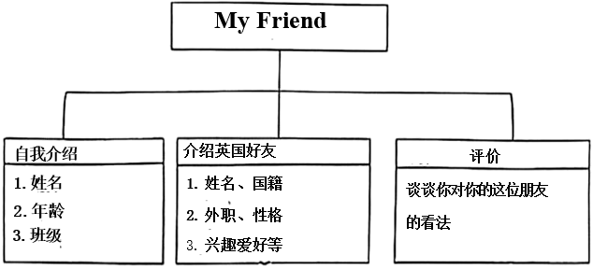
注意：
(1)不能照抄原文；不得在作文中出现真实校名、班级和考生的真实姓名；
(2)语句连贯，词数70词左右。作文标题和开头不计入总词数；
(3)给出的开头无需抄到答题卡上。
My Friend
Hello! My name is Li Jing. ___________________________________________________________________________________________________________________________________________________________________________________________________________________________________________________________________________________________________________________________________________________________________________________________________________________________________________________________________________

【答案】439．It is on the first Sunday of August every year. 440．It is from the US. 441．Winnie the Pooh is the symbol of Friendship Day. 442．People usually meet friends and exchange cards, flowers and gifts. Some may have parties with their friends. Some may have lunch or dinner together. Others may go out to watch movies on this special day. 443．Love and care are the most important parts in friendship. 444．例文
My Friend
Hello! My name is Li Jing. I am 14 years old, and I’m in Class Three, Grade Nine.
I have a good friend from England named Emma. She is 24 years old. She is tall and always smiles at others. She works as a teacher, and she is kind and helpful. She loves reading and playing tennis in her free time. I think she is a wonderful friend. She often helps me with my studies. I really value our friendship.
【难度】0.65
【来源】广东省珠海市文园中学（集团）2024-2025学年上学期期中考试七年级英语试卷
【导语】本文是一篇说明文。文章主要介绍了友谊日的时间、起源国家、象征物、人们在友谊日的常见活动，以及友谊日背后的核心意义——向朋友表达爱与关怀。。
439．根据第1段“Friendship Day is on the first Sunday of August every year.”可知，友谊日是每年八月的第一个星期日。故填It is on the first Sunday of August every year.
440．根据第1段“People in the US celebrate it from 1935.”可知，友谊日起源于美国。故填It is from the US.
441．根据第2段“In 1997, the United Nations named Winnie the Pooh as the world’s symbol of Friendship Day.”可知，1997年，联合国将小熊维尼命名为世界友谊日象征。故填Winnie the Pooh is the symbol of Friendship Day.
442．根据第3段“On that day, people usually meet friends and exchange cards, flowers and gifts. Some may have parties with their friends. Some may have lunch or dinner together. Others may go out to watch movies on this special day.”可知，在那一天，人们通常会见朋友，交换卡片、鲜花和礼物。有些人可能会和他们的朋友开派对。有些人可能会一起吃午饭或晚饭。其他人可能会在这个特殊的日子出去看电影。故填People usually meet friends and exchange cards, flowers and gifts. Some may have parties with their friends. Some may have lunch or dinner together. Others may go out to watch movies on this special day.
443．根据最后一段“As you know, love and care are the most-important parts in friendship.”可知，爱和关心是友谊中最重要的部分。故填Love and care are the most important parts in friendship.
444．[总体分析]
①题材：本文是一篇记叙文，为材料作文；
②时态：一般现在时；
③提示：写作要点已给出，考生注意不要遗漏要点，并适当添加细节，突出重点。
[写作步骤]
第一步，介绍自己的个人信息；
第二步，介绍朋友的信息和对朋友发表评价。
[亮点词汇]
①good friend好朋友
②smiles at others对他人微笑
③playing tennis打网球
[高分句型]
①She loves reading and playing tennis in her free time. (并列结构)
②I think she is a wonderful friend. (宾语从句)
A、回答问题
请阅读下面短文，根据所提供的信息，回答5个问题。要求所写答案语法正确、语义完整切题，并将答案写在答题卡对应题目的答题位置上。
Hi, I’m Peter Brown. I am a 12-year-old boy from England. I am tall and I have blue eyes. There are four people in my family. They are my parents, my sister and me. My father is a doctor. He works in a big hospital. My mother is a teacher in Westfield School. She likes children very much. My sister is 3 years old. She likes drawing.
I am a student in Greenway School. My school is large and modern. My classroom is on the third floor of the classroom building. There are thirty-nine desks and thirty-eight chairs. A teacher’s desk is in the front of the classroom. There is a computer on the front wall of the classroom. We can study easily by using the computer. There is also a reading corner at the back of our classroom. It is my favourite place because I like reading.
Can you tell me something about you? Please write to me soon!
445．How old is Peter Brown?
____________________
446．Who likes drawing in Peter’s home?
____________________
447．Which school does Peter Brown study in, Westfield School or Greenway School?
____________________
448．Where is the computer?
____________________
449．Why does Peter like the reading corner?
____________________
B、书面表达
450．假设你是李华，你想和Peter交笔友，请根据以下思维导图内容提示，写一封E-mail给他，介绍你自己的概况。
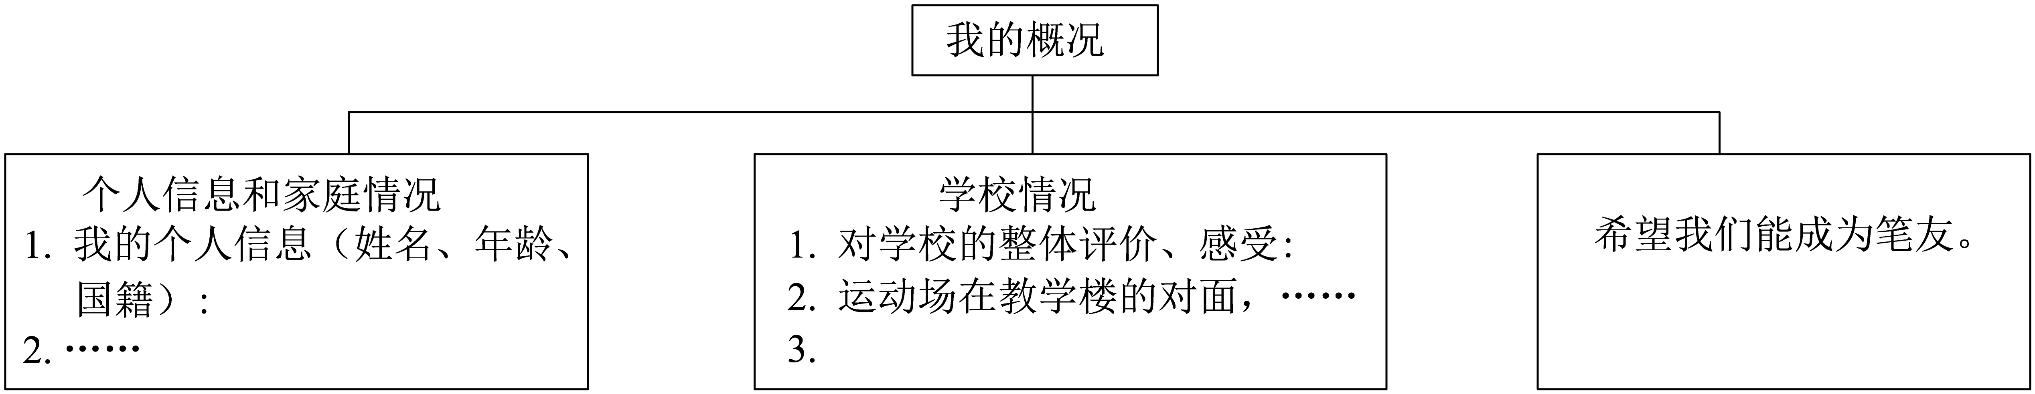
作文要求：
1.不得在作文中出现学校的真实姓名和考生的真实姓名。
2.可在思维导图内容提示的基础上适当拓展信息
3.语句连贯，词数不少于70词。作文开头已给出，不计入总词数。
Dear Peter,
I’m writing to tell you something about myself. _____________________________________________________________________________________________________________________________________________________________________________________________________________________________________________________________________________________________________________________________________________________________________________________________________________________________________________________________________________________
I am looking forward to your reply!
Yours,
Li Hua

【答案】445．He is 12 years old./12 years old. 446．Peter’s sister. 447．Greenway School 448．On the front wall of the classroom. 449．Because he likes reading. 450．例文
Dear Peter,
I’m writing to tell you something about myself. My name is Li Hua. I’m 15 years old and come from China. I’m a sunny boy and I like making friends. There are four people in my family. They are my parents, my sister and I. I study in No.1 Middle School. I think it’s a great school. There are many teaching buildings in our school. Across from the teaching building, there is a big playground. We can play basketball and football there after class. I hope we can become pen-pals.
I am looking forward to your reply!
Yours,
Li Hua
【难度】0.94
【来源】广东省珠海市九洲中学2025-2026学年七年级上学期期中考试英语试卷
【导语】本文主要介绍了皮特的一家人。
【详解】445．根据“I am a 12-year-old boy from England.”可知，皮特是12岁。故填He is 12 years old./12 years old.
446．根据“My sister is 3 years old. She likes drawing.”可知，喜欢在皮特家里画画的是皮特的妹妹。故填Peter’s sister.
447．根据“I am a student in Greenway School.”可知，皮特就读的学校是Greenway School。故填Greenway School.
448．根据“There is a computer on the front wall of the classroom. ”可知，电脑在教室前面的墙上。故填On the front wall of the classroom.
449．根据“There is also a reading corner at the back of our classroom. It is my favourite place because I like reading.”可知，喜欢英语角的原因是皮特喜欢阅读。故填Because he likes reading.
450．[总体分析]
①题材：本文是一篇应用文，为电子邮件；
②时态：时态为“一般现在时”；
③提示：写作要点已给出，考生应注意不要遗漏“信息提示”中的介绍要点，适当增加细节，并突出写作重点。
[写作步骤]
第一步： 表明写作意图。逐步引出重点介绍的内容。
第二步： 具体阐述写作内容，从个人信息和家庭信息展开，并描述学校情况，并且阐述自己对学校的个人感受。
第三步：书写结语，表达期望与对方成为笔友，对收到对方来信的期望。
[亮点词汇]
① make friends交朋友
② younger than sb.比某人更年轻
③ teaching building教学楼
④ across from在……对面
[高分句型]
①There are four people in my family.(There be句型)
②I hope we can become pen-pals.(宾语从句)
A．请阅读下面短文，根据所提供的信息，回答5个小题。
Hello! My name is David. Today is my first day in a new school. I don’t have any friends at the school, so I’m a little afraid of going there.
My mother tells me I’m nice and all of my classmates will love me. I get up early. My mother makes a delicious breakfast for me, and I have it at home. After that, she takes me to school by car. I say goodbye to my mother at the school gate and walk into the school.
Mrs. Green, my Chinese teacher, takes me to the classroom. It’s big and nice. There are some pictures on the walls. There are forty-eight students in my class, twenty-six boys and twenty-two girls. I sit next to a tall boy. He is Sam. He wears glasses. He is kind to me. We become friends. We like playing football and we play it in the playground after school. We have fun.
When I get home, I tell my parents everything at school. I love my new school, and I enjoy my school day.
451．Where does David have breakfast?
________________________
452．Who takes David to school?
________________________
453．What is David’s classroom like?
________________________
454．How many students are there in David’s class?
________________________
455．What do David and Sam do after school?
________________________
B．Writing
456．假设你是李华，刚进入初中校园，在班会上需要做自我介绍。根据以下要点写一篇自我介绍发言稿。
要点：
1 你的基本信息（姓名、年龄、来自哪里）；
2 你的爱好；
3 你喜欢的学科及原因；
4 你对初中生活的期待。
要求：80词左右，开头和结尾已给出，不计入总词数。
________________________________________________________________________________________________________________________________________________________________________________________________________________________________________________________________________________________________________________________________________________________________________________________________________

【答案】451．At home. 452．His mother. 453．It’s big and nice with some pictures on the walls. 454．48. 455．They play football. 456．例文
Hi, everyone! My name is Li Hua, and I’m 12 years old. I come from Beijing.​
I have many hobbies. I like playing basketball because it’s fun and helps me stay strong. I also enjoy reading storybooks, especially adventure ones.​ My favorite subject is English. I think it’s interesting to learn a new language, and I hope to talk with foreigners someday.​
I’m really excited about junior high. I look forward to making new friends and learning more new things here.​
Thank you!
【难度】0.65
【来源】广东省珠海市第十一中学2025-2026学年七年级上学期开学考试英语试卷
【导语】本文讲述了David在新学校的第一天经历，包括他的感受、妈妈的鼓励、课堂环境以及与新朋友Sam的互动。
【详解】451．根据“I have it at home”可知，David在家吃早餐。故填At home.
452．根据“she takes me to school by car”可知，是David的妈妈开车送他去学校。故填His mother.
453．根据“It’s big and nice. There are some pictures on the walls”可知，教室又大又漂亮，墙上有一些画。故填It’s big and nice with some pictures on the walls.
454．根据“There are forty-eight students in my class”可知，班上有48名学生。故填48.
455．根据“We like playing football and we play it in the playground after school”可知，他们放学后喜欢踢足球。故填They play football.
456．[总体分析]
① 题材：本文是一篇发言稿；
② 时态：为“一般现在时”；
③ 提示：根据所给提示完成写作，注意标点符号及大小写等问题，不要犯语法错误。注意上下文之间的逻辑关系，语意连贯。
[写作步骤]
第一步，介绍基本信息（姓名、年龄、来自哪里）；
第二步，阐述自己的爱好；
第三步，说明喜欢的学科及原因；
第四步，表达对初中生活的期待。
[亮点词汇]
① stay strong保持强壮
② especially尤其是
③ look forward to期待
[高分句型]
① I like playing basketball because it’s fun and helps me stay strong（原因状语从句）
② I think it’s interesting to learn a new language, and I hope to talk with foreigners someday.（宾语从句）
请阅读下面短文，根据所提供的信息，回答下面问题。要求所写答案语法正确、信息完整切题。
Hi! My name is Tom. I have two good friends. They are Bob and Dale. Bob is strong and he likes playing the guitar. Dale is tall and he can play the violin very well.
Today, I meet them in the classroom. Bob has a jacket. It is cool. What colour is the jacket? It is purple. Bob says to me, “Can you spell ‘purple’?” I say, “Yes. P-U-R-P-L-E.” Dale has a key and a bag. The key is brown. And the bag is black. The key is in the bag. The bag is on the desk.
Now, let me tell you about my things. I have a pen and two rulers. The pen is blue and yellow. It’s special, because it is a gift from my brother. I love it a lot. And what about my rulers? They’re red! I can spell “red” easily. It’s R-E-D．I love using these rulers and my pen every day for my homework.
457．Who can play the violin very well, Bob or Dale?
____________________________.
458．What does Dale have?
____________________________.
459．Where is the key?
____________________________.
460．How many rulers does Tom have?
____________________________.
461．Why is Tom’s pen special?
____________________________.
462．书面表达
假设你叫李明，在明天的英语课上，老师要求你用英文向同学们介绍一些你书包里的物品。请你根据以下思维导图的提示，用英文写一篇发言稿。
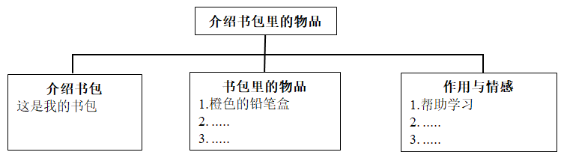
注意：
(1)可在思维导图内容提示的基础上适当拓展信息。
(2)不能照抄原文；不得在作文中出现真实校名和学生的真实姓名。
(3)语句连贯，词数70左右。作文开头已经给出，不计入总词数。
Hello! I am Li Ming. _______________________________________________________________________________________________________________________________________________________________________________________________________________________________________________________________________________________________________________________________________________________________________________________________________________________________________________________________________

【答案】457．Dale./ Dale can play the violin very well. 458．A key and a bag./ He/Dale has a key and a bag. 459．In the bag./ It/The key is in the bag. 460．2/Two./ He/Tom has 2/two rulers. 461．Because it is a gift from his brother. 462．范文：
Hello! I am Li Ming. This is my schoolbag. It’s not big but beautiful. There is a pencil case, some books, a ruler and an eraser in it. Let me show you one by one.
This is my pencil case. It’s orange. There are some pencils and pens in the pencil case. These books are for the classes. And my ruler is white. It helps me draw. And the black eraser can help me with my mistakes.
All these things help me learn at school. They are lovely and I like them very much.
【难度】0.65
【来源】广东省珠海市第十一中学教育集团2024-2025学年七年级上学期期中质量监测英语试题
【导语】本文作者Tom主要介绍了自己的好朋友鲍勃和戴尔，并介绍了自己的个人物品。
【详解】457．根据“Dale is tall and he can play the violin very well.”可知，戴尔小提琴拉得很好。故填Dale./ Dale can play the violin very well.
458．根据“Dale has a key and a bag.”可知，戴尔有钥匙和一个包。故填A key and a bag./ He/Dale has a key and a bag.
459．根据“The key is in the bag.”可知，钥匙在包里。故填In the bag./ It/The key is in the bag.
460．根据“Now, let me tell you about my things. I have a pen and two rulers.”可知，他有两个尺子。故填2/Two./ He/Tom has 2/two rulers.
461．根据“It’s special, because it is a gift from my brother.”可知，因为这是他哥哥送的礼物。故填Because it is a gift from his brother.
462．[总体分析]
①题材：本文是一篇演讲稿；
②时态：时态为一般现在时；
③提示：根据思维导图的提示，介绍一些书包里的物品。
[写作步骤]
第一步，介绍自己的书包；
第二步，介绍书包里的物品；
第三步，书写结语，表达自己对这些物品的喜爱。
[亮点词汇]
①one by one逐一的
②help sb. with sth.在某方面帮助某人
③at school在学校
[高分句型]
There are some pencils and pens in the pencil case. (There be句型)
I’m Mark, a student in New York. Let me introduce our Friday food to you. In America, Friday nights are pizza nights for most families. That’s the last workday before the weekend. Everyone is quite relaxed and wants to enjoy the weekend as early as possible. Parents don’t want to spend (花费) too much time cooking on Friday, so they buy pizzas.
My parents go to Pizza Hut on York Street to buy pizza s every Friday. We kids all love cheese pizzas. Mom and Dad buy two cheese pizzas for us. They don’t like cheese pizzas. Both of them love meat. They often buy chicken pizzas for themselves. Sometimes they’d like to try beef or fish for a change. The next week they go back to chicken.
Every Friday, the kitchen table is full of pizza boxes after dinner. It’s our job to clean the table. We need to put all the boxes in the big bin(垃圾桶) in front of the house. We play “rock, paper, scissors (石头剪刀布游戏)” to see who does the job. I never have good luck. It’s always me.
But when the weekend comes, I become very lucky. I am always the winner of the family activities. I really enjoy my family life.
463．Do all the families in America have pizzas on Friday night?
_____________________________________________________
464．Why do parents buy pizzas on Friday?
_____________________________________________________
465．Where do Mark’s parents buy pizzas?
_____________________________________________________
466．What kind of pizzas does Mark love?
_____________________________________________________
467．Who always puts the boxes in the bin?
_____________________________________________________
468．Mark 非常享受自己的家庭生活, 同时很想了解其他国家孩子的家庭生活。假如你是李华, 请用英文写一封信向 Mark 介绍自己的家庭生活, 内容包括：
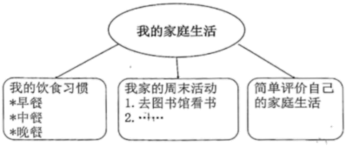
作文要求：
1. 不能照抄原文；
2. 不得在作文中出现学校真实的名称和学生的真实姓名；
3. 语句连贯, 词数60个左右。开头已经给出，不计入总词数。
Dear Mark,
I'm happy to know about your family life. Let me introduce mine to you. _____________________________________________________________________________________________________________________________________________________________________________________________________________________________________________________________________________________________________________________________________________________________________________________________________________________________________________________________________________________________________________________________________________________________________________________________________________________________________________________________________________________________________________________________________________________________________________________________________________________________________________________________________________
Best wishes!
Yours,
Li Hua

【答案】463．No, they don’t. 464．Because they don’t want to spend too much time cooking on Friday. 465．Pizza Hut on York Street. 466．Cheese pizzas. 467．Mark and his parents. 468．例文
Dear Mark,
I’m happy to know about your family life. Let me introduce mine to you. In a typical day, I start off by having a hearty breakfast consisting of milk, eggs, and whole grain bread. Lunchtime finds me indulging in French fries, chicken nuggets, and an apple. Dinner typically consists of fresh fruits, vegetables, and steamed rice along with grilled fish or chicken. I also love ending my day with a scoop of vanilla ice cream as a sweet treat. I often go to the library to read books and go to the park with my parents on weekends. I have a happy family.
Best wishes!
Yours,
Li Hua
【难度】0.65
【来源】广东省珠海市斗门区2023-2024学年七年级上学期期末英语试题
【导语】本文是一篇说明文。文章介绍了披萨的起源，发展和传播，到最后流行全世界，成为全世界最为人喜爱的食物的过程。
【详解】463．根据第一段“ In America, Friday nights are pizza nights for most families.”可知，不是美国所有的家庭星期五晚上都有披萨。故填No, they don’t.
464．根据第一段“Parents don’t want to spend (花费) too much time cooking on Friday, so they buy pizzas.”可知，父母不想在星期五花太多时间做饭，所以他们买了披萨。故填Because they don’t want to spend too much time cooking on Friday.
465．根据第二段“My parents go to Pizza Hut on York Street to buy pizza s every Friday.”可知，Mark的父母每周五都会去约克街的必胜客买披萨。故填Pizza Hut on York Street.
466．根据第二段“We kids all love cheese pizzas.” 可知，Mark喜欢奶酪披萨。故填Cheese pizzas.
467．根据第三段“We need to put all the boxes in the big bin(垃圾桶) in front of the house.”可知，Mark和他的父母需要把所有的箱子都放在房子前面的垃圾桶。故填Mark and his parents.
468．[总体分析]
①题材：本文是一篇书信作文 ；
②时态：本文应使用“一般现在时”为主；
③提示：写作要点已经给出，根据要点，可增加细节，自由发挥。
[写作步骤]
第一步，引起下文，告诉对方来信目的是介绍自己的家庭生活；
第二步，谈谈自己的饮食习惯和家庭周末活动；
第三步，简单评价自己的家庭生活。
[亮点词汇]
①consist of包含
②along with和
[高分句型]
In a typical day, I start off by having a hearty breakfast consisting of milk, eggs, and whole grain bread.(非谓语作后置定语)
请阅读下面短文，根据所提供的信息，回答下面问题，要求所写答案语法正确，语义完整切题，并将答案写在答题卡对应题目的答题位置上。
Gina and Jane are good friends. They are in the same school. They go to school five days a week. They have four classes in the morning and three in the afternoon every day. After school, they often play games. They go home at 6: 00 p. m.
The two girls’ mothers are also good friends. Gina often goes to Jane’s home on Saturday. They read books in the morning, play the piano in the afternoon, and watch TV in the evening.
Jane has a great collection of picture books. Gina likes these books. She can also take some books home.
The two girls also like eating some fruits. They like bananas, strawberries and oranges, but they don’t like eating grapes. Gina’s mother can make great fruit salad. She usually lets Gina take some to Jane. Jane loves the food because it is very delicious. What good friends they are!
469．How many classes do Gina and Jane have every day?
____________________________________
470．What do Gina and Jane often do after school?
____________________________________
471．Where does Gina often go on Saturday?
____________________________________
472．Does Jane have a great collection of picture books?
____________________________________
473．Why does Jane love the food?
____________________________________
474．书面表达
请根据要求完成短文写作，并将写作内容写在答题卡对应题目的答题位置上。
假如你叫李明，你打算向你的英国笔友Tom写一封电子邮件，向他介绍你的朋友Frank。请你根据以下思维导图内容提示用英文写一篇短文。
我的朋友
基本情况1. 姓名  2. 年龄：生日  3. 所在班级（1班）；年级（7年级）  4. …… | 性格特征1. 善良的  2. 乐于助人的 (helpful)  3. …… | 喜欢的事物及其原因1. 喜欢吃蔬菜和水果因为它们很健康  2. 喜欢打排球和篮球因为不想变胖  3. 最喜欢的科目及原因  4. ……
注意：（1）可在思维导图内容提示的基础上适当拓展信息。
（2）不能照抄原文：不得在作文中出现真实校名、地名和考生的真实姓名。
（3）语句连贯，词数80左右。作文的标题和开头已经给出，不计入总词数，也不必抄写在答题卡上。
Dear Tom,
How are you? I’m happy to tell you something about my friend. ___________________________________________________________________________________________________________________________________________________________________________________________________________________________________________________________________________________________________________________________________________________________________________________________________________________________________
Yours,
Li Ming

【答案】469．7/Seven./They have four classes in the morning and three in the afternoon every day. 470．They often play games (after school). 471．Gina often goes to Jane’s home on Saturday./Jane’s home. 472．Yes, she does. 473．Because it is very delicious./Jane/She loves the food because it is very delicious. 474．范文：
Dear Tom,
How are you? I’m happy to tell you something about my friend. His name is Frank. He is twelve years old and his birthday is on August 8th. We are in Class one Grade seven. His telephone number is 232-4672. He is kind and helpful. He likes eating vegetables and fruits because they are very healthy. He also likes playing volleyball and basketball because he doesn’t want to be fat His favorite subject is English because he thinks it’s fun and interesting. This is my friend. Do you like him?
Yours,
Li Ming
【难度】0.65
【来源】广东省珠海市金湾区2023-2024学年七年级上学期期末考试英语试题
【导语】本文主要介绍了两个好朋友吉娜和简的日常生活和兴趣爱好。
469．根据“They have four classes in the morning and three in the afternoon every day.”可知，一天上七节课。故填7/Seven./They have four classes in the morning and three in the afternoon every day.
470．根据“After school, they often play games.”可知，放学后他们玩游戏。故填They often play games (after school).
471．根据“Gina often goes to Jane’s home on Saturday.”可知，吉娜星期六经常去简家。故填Gina often goes to Jane’s home on Saturday./Jane’s home.
472．根据“Jane has a great collection of picture books.”可知，简收藏了很多图画书。故填Yes, she does.
473．根据“Jane loves the food because it is very delicious”可知，因为简认为食物很美味。故填Because it is very delicious./Jane/She loves the food because it is very delicious.
474．[总体分析]
① 题材：本文是一篇电子邮件；
② 时态：时态为“一般现在时”；
③ 提示：写作要点已给出，考生应注意不要遗漏“信息提示”中每一项内容，适当添加细节，并突出写作重点。
[写作步骤]
第一步，介绍朋友的基本情况；
第二步，介绍他的性格特征；
第三步，最后介绍他喜欢的事物及其原因。
[亮点词汇]
①kind and helpful善良而乐于助人
②like doing sth喜欢做某事
③want to be想成为
[高分句型]

He likes eating vegetables and fruits because they are very health.（原因状语从句）
A．回答问题
请阅读下面短文，根据所提供的信息，回答5个问题，要求所写答案语法正确，语义完整切题，并把答案写在答题卡对应题目的答题位置上。
When is your birthday? Our giant panda couple just had their sixteenth birthday. They are Xing Xing and Liang Liang. They live in the Zoo Negara Malaysia. China sent them there in 2014. Let’s have a look at their family members.
Xing Xing, Father Panda, was born on August 23rd, 2006. He likes delicious fruit, such as watermelons, apples and grapes. His favorite vegetable is carrots!
Liang Liang is Xing Xing’s wife. Her birthday is the same as Xing Xing’s. That’s fun, isn’t it? They were both born in China and travelled to Malaysia together on May 21st, 2014.
Nuan Nuan’s birthday is on August 18th. She was born in Malaysia in 2015. She’s the first daughter of Xing Xing and Liang Liang. She came back to China in 2017. She really misses her parents.
Yi Yi is the second daughter of the family. She was born on January 14th, 2018. She still lives with her parents now.
Sheng Yi’s birthday is on May 31st, 2022. She is only one year old. She’s the youngest child of the family. She lives in the zoo with her family and she likes to bring happiness to the local people.

475．How many children do Liang Liang and Xing Xing have?
___________________________________________________________
476．What is Xing Xing’s favorite vegetable?
___________________________________________________________
477．Where does Nuan Nuan live now?
___________________________________________________________
478．When was Yi Yi born?
___________________________________________________________
479．Who is the youngest child of the family?
___________________________________________________________
B．书面表达
480．根据要求完成短文写作，请将作文写在答题卡指定的位置。
假如你叫李明，你的朋友王刚2月3日（周六）生日，你准备在海滨公园为他举办13岁生日派对。请你根据以下思维导图的内容提示用英文写一封邮件，邀请刚来的美国交换生Peter一起参加派对。
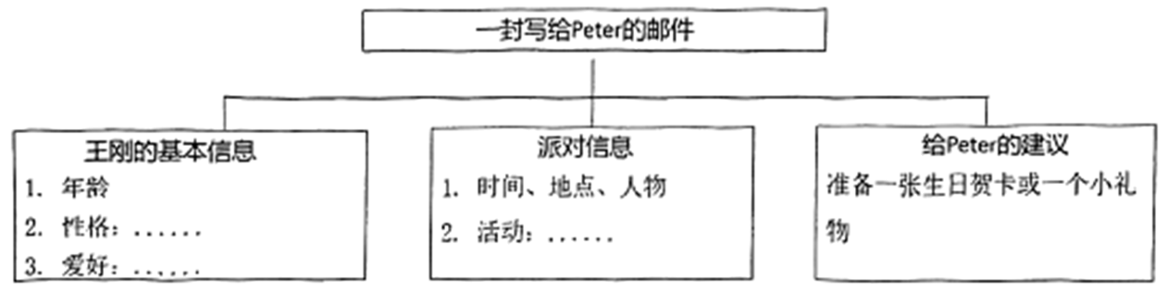
作文要求：
1. 可在思维导图内容提示的基础上适当拓展信息。
2. 不能照抄原文；不得在作文中出现真实校名、地名和考生的真实姓名。
3. 语句连贯，词数80词左右。邮件的开头和结尾已经给出，不计入总词数。
Dear Peter,
I’m writing to ask you to Wang Gang’s birthday party. ___________________________________________________________________________________________________________________________________________________________________________________________________________________________________________________________________________________________________________________________________________________________________________________________________________________________________________________________________________________________
Would you like to come?
Li Ming

【答案】475．Three. 476．Carrots. 477．In China. 478．On January 14, 2018. 479．Sheng Yi. 480．参考范文：
Dear Peter,
I’m writing to ask you to Wang Gang’s birthday party. Wang Gang is my best friend. This is his thirteenth birthday. He is a friendly boy. He likes playing basketball very much. Do you want to make friends with him?
The birthday party is in Haibin Park at 3:00 pm on February 3rd. Our friends and his sister will come. We can play games, fly kites and have a picnic there. It’s a good time for us to have fun together. If you can come, it’s a good idea to bring Wang Gang a birthday card or a small gift. He’ll be happy to meet you. Would you like to come?
Li Ming
【难度】0.65
【来源】广东省珠海市香洲区2023-2024学年七年级上学期期末英语试题
【导语】本文向我们介绍了大熊猫一家。
475．根据“Nuan Nuan, Yi Yi, Sheng Yi”可知，有三个熊猫宝宝，故填Three.
476．根据“His favorite vegetable is carrots!”可知，Xing Xing最喜欢的蔬菜是胡萝卜，故填Carrots.
477．根据“She came back to China in 2017.”可知，Nuan Nuan现在生活在中国，故填In China.
478．根据“Yi Yi is the second daughter of the family. She was born on January 14th, 2018.”可知，Yi Yi出生于2018年1月14日。故填On January 14, 2018.
479．根据“Sheng Yi’s birthday is on May 31st, 2022. She is only one year old. She’s the youngest child of the family.”可知，Sheng Yi是家里最小的孩子。故填Sheng Yi.
480．[总体分析]
①题材：本文是一篇应用文，为电子邮件；
②时态：时态以“一般现在时”为主；
③提示：写作要点已给出，要求根据提示内容邀请Peter参加派对，适当添加细节，并突出写作重点。
[写作步骤]
第一步，表明写作意图，介绍王刚的信息；
第二步，具体介绍派对的信息；
第三步，给Peter一些建议。
[亮点词汇]
①make friends with与……交朋友
②have a picnic去野餐
③have fun玩得开心
[高分句型]
If you can come, it’s a good idea to bring Wang Gang a birthday card or a small gift.（if引导的条件状语从句）
回答问题
请阅读下面短文，根据所提供的信息，回答5个问题，要求所写答案语法正确，语义完整切题，并把答案写在答题卡对应题目的答题位置上。
I’m Alex Dunphy. I’m 26 years old. There are 5 people in my family—my parents, my sister, my brother and I. My father’s name is Phil. He is 54. He likes the color white. He is nice and cool. My mother is Claire. She is 52. She likes the color black. She is strict with (对……严格) us. Haley is my sister. She is 29. She is beautiful. Red is her favorite color. She likes making friends. She has many good friends. My brother Luke is 24. He likes watching TV and playing sports. He often plays ball games with my dad. I like reading books and the color yellow. And I do well at school. Teachers say I am smart (聪明的).
We are a happy family!
481．What color does Alex’s father like?
______________________________________________________________________________________________
482．How is Alex’s mother?
______________________________________________________________________________________________
483．How old is Haley?
______________________________________________________________________________________________
484．Who does Luke often play ball games with?
______________________________________________________________________________________________
485．What does Alex like doing?
______________________________________________________________________________________________
486．书面表达
根据要求完成短文写作，并将作文写在答题卡的指定位置上，假如你是李浩，在班级“最美全家福”征集活动中，你的照片顺利入选，英语老师希望你在课堂上和大家分享这张照片。请你根据下面所给照片，用英语写一篇短文，为这次分享做准备。
作文要求：
1. 不能照抄全文，不得在作文中出现学校的真实名称和学生的真实姓名
2. 语句连贯，词数60左右。作文的开头已经给出，不计入总词数。
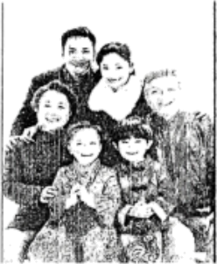
Hello, everyone! I’m Li Hao. _____________________________________________________________________________________________________________________________________________________________________________________________________________________________________________________________________________________________________________________________________________________________________________________________________________________________________________________________________________________________________________________________________________________________________________________________________________________________________________________________________________________________________________________________________________________________________________________________________________________________________________________________________________________________________________________________________________________
I love my family!

【答案】481．White. 482．She is strict. 483．She is 29. 484．His father. 485．Alex likes reading books. 486．例文
Hello, everyone! I’m Li Hao.
Look! This is a photo of my family. There are six people in my family. They are my grandparents, parents, sister and I. My grandfather is 65 years old. My grandmother is 63 years old. My father is a doctor. He likes playing basketball very much. My mother is an English teacher. She is friendly and popular with students. My sister is 12. She and I are both students. We are a big happy family.
I love my family!
【难度】0.65
【来源】广东省珠海市九洲中学2023-2024学年七年级上学期期中英语试题
【导语】本文主要介绍了Alex的家庭信息。
【详解】481．根据“My father’s name is Phil. He is 54. He likes the color white.”可知他喜欢白色。故填White.
482．根据“She is strict with (对……严格) us”可知她很严格。故填She is strict.
483．根据“Haley is my sister. She is 29.”可知她二十九岁了。故填She is 29.
484．根据“He often plays ball games with my dad.”可知Luke经常和爸爸一起打球。故填His father.
485．根据“I like reading books and the color yellow. ”可知喜欢读书，故填Alex likes reading books.
486．[总体分析]
① 题材：本文是一篇记叙文，为看图作文；
② 时态：时态为“一般现在时”
③ 提示：根据所给图片完成写作，可适当发挥，不偏离主题。
[写作步骤]

第一步，整体介绍家里有六口人；
第二步，具体介绍家庭的成员。
[亮点词汇]

①a photo of……的一张照片
②like doing sth喜欢做某事
③be popular with受……欢迎
[高分句型]
There are six people in my family（There be句型）
A）回答问题
阅读以下文章，根据所提供的信息，回答5个问题，要求所写答案语法正确，语义完整切题，并把答案写在答题卡对应题目的答题位置上。
Hi! I’m Li Ming. I want to introduce (介绍) one of my favorite sportsmen to you.

Her name is Quan Hongchan. Quan is a young but famous diver(跳水运动员). She is sixteen years old and she was born in Zhanjiang, Guangdong Province.
When she was seven years old, she began diving. In 2021, She won her first gold medal(金牌) at the Tokyo Olympics. In 2023, Quan won two gold medals in the Hangzhou Asian Games! She is so excellent(优秀的) that many people call her “diving talent”(跳水天才). She has short black hair and there is a mole(痣) on her face. Though she doesn’t look strong, she has great power and strength(力量).
For Quan, hard work is the key to success(成功). Usually, she begins training(训练) at 7 o’clock in the morning, and she goes to bed at around 11 o’clock at night. She knows that “Practice makes perfect.”
After training, she likes playing with dolls of turtle most. She said, “Although turtles are not very beautiful, they are really cute and they always keep walking.” So during the Asian Games, many people gave Quan the lovely turtle dolls because they wanted to show their love and respect to her.
1. Where does Quan come from?
______________________________487______________________________
2. How many gold medals did Quan get according to the text?
______________________________488______________________________
3. What is Quan’s key to success?
______________________________489______________________________
4. When does Quan usually begin to train(训练)?
______________________________490______________________________
5. According to Quan, what’s the meaning of the “turtles”?
______________________________491______________________________
B）书面表达
假如你是Frank，现在你需要向同学介绍你的一位好朋友Tom Smith。请用英语介绍以下内容：
My Best Friend | Name: Tom Smith
My Best Friend | Age: 12
My Best Friend | Nationality (国籍): Canada
My Best Friend | Looks(外貌): 1. tall 2. ……
My Best Friend | Favorite Color: blue
My Best Friend | Hobbies: 1. swimming 2. ……
注意：
（1）不能照抄原文，不能在作文中出现真实校名、地名和学生的真实姓名。
（2）包含思维导图信息，并在该基础上适当拓展信息；
（3）语句连贯，词数60词左右。作文的标题和开头已给出，不计入总词数，也不必抄写在答题卡。
My Best Friend
Hello! I’m Frank. I want to introduce my best friend to you. _________________________________________________________________________________________________________________________________________________________________492_________________________________________________________________________________________________________________________________________________________________

【答案】487．She comes from Zhanjiang, Guangdong Province. 488．Quan got three gold medals. 489．Quan’s key to success is her hard work. 490．She usually begins to train at 7 o’clock in the morning. 491．According to Quan, the meaning of the “turtles” is “keep walking”. 492．例文
My Best Friend
Hello! I’m Frank. I want to introduce my best friend to you.
His name is Tom Smith. He is from Canada. He is twelve and his birthday is on July 22nd. He is tall and very handsome. His favorite color is blue, so some of his clothes like jackets, sweaters, and T-shirts are blue. He likes vegetables and fruit, and he eats them every day. He likes swimming. After school, he often goes to swim with his friends and he can do it very well.
【难度】0.65
【来源】广东省珠海市第十一中学2023-2024学年七年级上学期期中检测英语试题
【导语】本文主要介绍了作者最喜欢的运动员——全红婵的情况。
【详解】487．根据第一段第二句“she was born in Zhanjiang, Guangdong Province.”可知，她来自广东省浙江，故填She comes from Zhanjiang, Guangdong Province.
488．根据“In 2021, She won her first gold medal at the Tokyo Olympics. In 2023, Quan won two gold medals in the Hangzhou Asian Games! ”可知，2021年获得1枚金牌，2023年获得2枚金牌，故填Quan got three gold medals.
489．根据“For Quan, hard work is the key to success.”可知努力训练是她成功的关键，故填Quan’s key to success is her hard work.
490．根据“Usually, she begins training at 7 o’clock in the morning…”可知她通常早晨7点开始训练，故填She usually begins to train at 7 o’clock in the morning.
491．根据“Although turtles are not very beautiful, they are really cute and they always keep walking.可知她认为虽然乌龟不是很漂亮，但是它们总是不停地走。故填According to Quan, the meaning of the “turtles” is “keep walking”.
492．[总体分析]
①题材：本文是一篇记叙文，为材料作文；
②时态：时态为“一般现在时”；
③提示：写作要点已给出，考生应注意不要遗漏，适当增加细节完整表述内容。
[写作步骤]
第一步，介绍自己的好朋友是谁；
第二步，从他的年龄，生日，喜欢的颜色，饮食习惯，爱好等方面来介绍这位朋友。
[亮点词汇]
①every day每天
②after school放学后
③like doing sth.喜欢做某事
[高分句型]
①After school, he often goes to swim with his friends and he can do it very well.（and连接并列句）
阅读下面的短文，根据短文大意回答问题。
Look! This is our classroom. It is very big and clean. It has four big windows. We’re having an English class. There are 22 girls and 28 boys in our class. Everyone has a desk and a chair. They are all new. We look after them very well. In our classroom there are two blackboards. One is for the teacher and the other is for students. We can see some pictures on the board. The walls look very white. On them we can see two maps, the map of China and the map of the world(世界).
In the morning the students come to school very early, and the teachers come to school early, too. We have four lessons in the morning and two in the afternoon. We like our lessons very much. We like our class and our classroom. We also love our teachers.
根据材料内容回答下列问题。
493．How many students are there in the class?
_________________________________________
494．What color are the walls?
_________________________________________
495．What are those on the board?
_________________________________________
496．Can we see the map on the wall?
_________________________________________
497．Who go to school early in the morning?
_________________________________________
498．书面表达。
假设你是 Gina，请根据所给信息，以“My Family”为题，写一篇60词左右的英语短文，在英语课上介绍你的家庭情况。
姓名 Gina
年龄 12
班级年级 七年二班
电话号码 427-0635
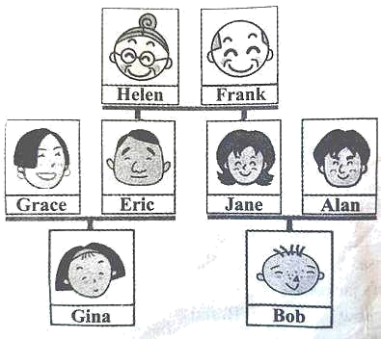
写作要求：
1）包含图片和表格信息，可适当发挥；
2）内容连贯，逻辑通顺，表达清晰；
3）书写工整。
My Family_________________________________________________________________________________________________________________________________________________________________________________________________________________________________________________________________________________________________________________________________________________________________________________________________________________________________________________________________________________________________________________________________________________________________________________________________________________________________________________________________________________________________________________________________________________________________________________________________________________________________________________________________________________________________________________________________________________________________________________________________________________________________________________________________________________________________________

【答案】493．There are 50 students in the class. 494．The walls are white. 495．They are some pictures. 496．Yes, we can. 497．The students and the teachers go to school early. 498．例文
My name’s Gina. I’m 12. I’m in Class Two Grade Seven. My phone number is 427-0635. Here is my family tree. You can see eight people in it. Helen and Frank are my grandparents. They have a son and a daughter. They are Eric and Jane. Eric is my father and Grace is my mother. I have no brothers and no sisters. Jane is my aunt and Alan is my uncle. My cousin’s name is Bob. I love my family.
【难度】0.65
【来源】广东省珠海市珠峰实验学校、梅华中学2023-2024学年七年级上学期期中考试英语试题
【导语】本文主要介绍了作者教室里的物品设施。
【详解】493．根据“There are 22 girls and 28 boys in our class.”可知班级里有50名学生。故填There are 50 students in the class.
494．根据根据“The walls look very white. ”可知墙是白色的。故填The walls are white.
495．根据“We can see some pictures on the board.”可知黑板上有一些图片。故填They are some pictures.
496．根据“On them we can see two maps, the map of China and the map of the world(世界).”可知我们可以看到地图。故填Yes, we can.
497．根据“In the morning the students come to school very early, and the teachers come to school early, too. ”可知早上学生和老师去学校都很早。故填The students and the teachers go to school early.
498．[总体分析]
① 题材：本文是一篇记叙文，为材料作文；
② 时态：时态为“一般现在时”；
③ 提示：写作要点已给出，注意不要遗漏提示信息，适当添加细节，并突出写作重点。

[写作步骤]
第一步，介绍Gina的个人信息；
第二步，介绍家庭树。
[亮点词汇]

①phone number电话号码
②family tree家庭树
[高分句型]

①Here is my family tree. （Here be句型）
②Eric is my father and Grace is my mother. （and并列句）

