OpenCV4.0安装记录:

系统 : Ubuntu18.04.02

安装方法 : 编译安装

教程链接 : https://www.learnopencv.com/install-opencv-4-on-ubuntu-18-04/
该教程将提供一个bash脚本,用于安装OpenCV4.0,同时将安装C++和Python3.6. 注意,本教程 采用的脚本将OpenCV安装在本地目录,而非整个系统.

1.安装OpenCV4.0

打开Ubuntu终端,选择一个你想安装OpenCV的目录,进入目录,开始运行以下教程及代码.本样例,将OpenCV安装在 /home/name/ 目录下

步骤0：选择要安装的OpenCV版本
1  2  3 | echo "OpenCV installation by learnOpenCV.com"  #定义要安装的OpenCV版本 (选择要安装的OpenCV版本,OpenCV4.0代号为”master”)  cvVersion="master"

我们还将清理build目录并创建installation目录。
# 清理build目录
rm -rf opencv/build
rm -rf opencv_contrib/build
# 创建安装目录
mkdir installation
mkdir installation/OpenCV-"$cvVersion"

最后，我们将当前工作目录存储在cwd变量中。我们还将在此博客中将此目录称为OpenCV_Home_Dir,即安装的文件夹.
# 保存当前的工作目录
cwd=$(pwd)

第1步：更新包
sudo apt -y update
sudo apt -y upgr ade

第2步: 安装OS库
sudo apt -y remove x264 libx264-dev
## 安装依赖项
sudo apt -y install build-essential checkinstall cmake pkg-config yasm
sudo apt -y install git gfortran
sudo apt -y install libjpeg8-dev libpng-dev

sudo apt -y install software-properties-common
sudo add-apt-repository "deb http://security.ubuntu.com/ubuntu xenial-security main"
sudo apt -y update

sudo apt -y install libjasper1
sudo apt -y install libtiff-dev

sudo apt -y install libavcodec-dev libavformat-dev libswscale-dev libdc1394-22-dev
sudo apt -y install libxine2-dev libv4l-dev
cd /usr/include/linux
sudo ln -s -f ../libv4l1-videodev.h videodev.h
cd "$cwd"

sudo apt -y install libgstreamer1.0-dev libgstreamer-plugins-base1.0-dev
sudo apt -y install libgtk2.0-dev libtbb-dev qt5-default
sudo apt -y install libatlas-base-dev
sudo apt -y install libfaac-dev libmp3lame-dev libtheora-dev
sudo apt -y install libvorbis-dev libxvidcore-dev
sudo apt -y install libopencore-amrnb-dev libopencore-amrwb-dev
sudo apt -y install libavresample-dev
sudo apt -y install x264 v4l-utils

# 可选的依赖项
sudo apt -y install libprotobuf-dev protobuf-compiler
sudo apt -y install libgoogle-glog-dev libgflags-dev
sudo apt -y install libgphoto2-dev libeigen3-dev libhdf5-dev doxygen

第3步: 安装Python库
sudo apt -y install python3-dev python3-pip
sudo -H pip3 install -U pip numpy
sudo apt -y install python3-testresources

我们还将安装virtualenv和virtualenvwrapper模块来创建Python虚拟环境
cd $cwd
############ For Python 3 ############
# 创建虚拟环境
python3 -m venv OpenCV-"$cvVersion"-py3
echo "# Virtual Environment Wrapper" >> ~/.bashrc
echo "alias workoncv-$cvVersion=\"source $cwd/OpenCV-$cvVersion-py3/bin/activate\"" >> ~/.bashrc
source "$cwd"/OpenCV-"$cvVersion"-py3/bin/activate

# 现在在这个虚拟环境中安装python库
pip install wheel numpy scipy matplotlib scikit-image scikit-learn ipython dlib

# 退出虚拟环境
deactivate

第4步: 下载opencv和opencv_contrib
git clone https://github.com/opencv/opencv.git
cd opencv
git checkout $cvVersion
cd ..

git clone https://github.com/opencv/opencv_contrib.git
cd opencv_contrib
git checkout $cvVersion
cd ..
(注:该下载会从github下载,若网络无法连接,可采用如下方式:
百度云链接 提取码：ad4p
将两个zip解压并重命名：
unzip opencv.zip
unzip opencv_contrib.zip
mv opencv-4.0.0 opencv
mv opencv_contrib-4.0.0 opencv_contrib
这里建议将opencv与opencv_contrib放到同一文件夹中，之前看相关博客说这需要在同一级文件夹中Cmake编译才能找到opencv_contrib。
)
步骤5：使用contrib模块编译并安装OpenCV
cd opencv
mkdir build
cd build
接下来，我们开始编译和安装过程

cmake -D CMAKE_BUILD_TYPE=RELEASE \
-D CMAKE_INSTALL_PREFIX=$cwd/installation/OpenCV-"$cvVersion" \
-D INSTALL_C_EXAMPLES=ON \
-D INSTALL_PYTHON_EXAMPLES=ON \
-D WITH_TBB=ON \
-D WITH_V4L=ON \
-DOPENCV_PYTHON3_INSTALL_PATH=$cwd/OpenCV-$cvVersion-py3/lib/python3.6/site-packages \
-D WITH_QT=ON \
-D WITH_OPENGL=ON \
-D OPENCV_EXTRA_MODULES_PATH=../../opencv_contrib/modules \
-D BUILD_EXAMPLES=ON ..
编译安装
make -j4
make install
注:安装过程中可能会提示错误:
错误一: 提示某个目录或文件无法找到,此时,打开文件/build/CMakeDownloadLog.txt,
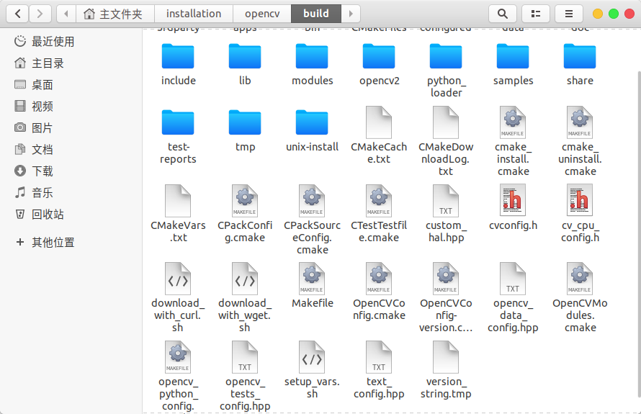

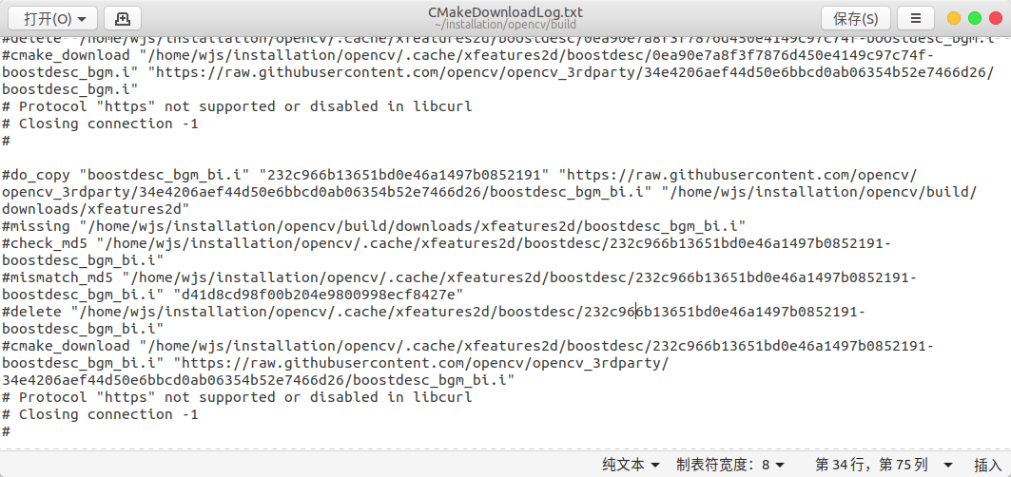
找到命令行提示中无法找到的文件对应的log,打开对应的链接,手动进行下载,手动将文件导入到目录/opencv_contrib/modules/features2d/src.

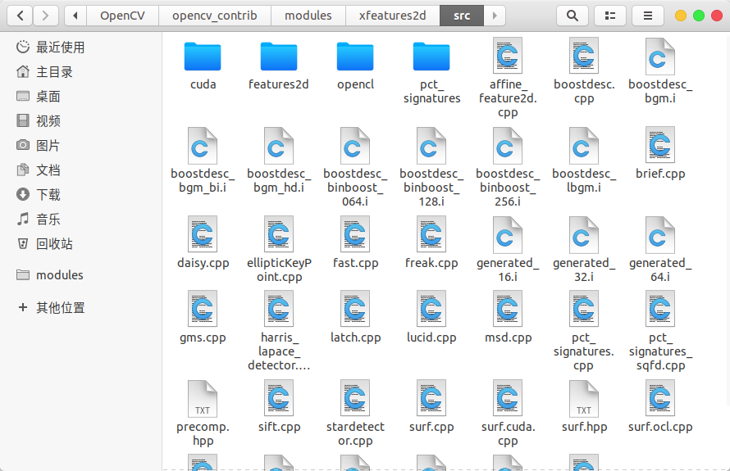
注:缺少的文件的百度云链接:
百度云链接 提取密码: cbc8
将压缩包下载下来,并解压到/opencv_contrib/modules/xfeatures2d/src文件中,不需要进行其他操作,再次编译.

