AUTONOMOUS LINE FOLLOWING AND OBSTACLE AVOIDANCE CAR
Mini Project
Group Members
Registration Number | Programme / Specialization | Section
RA2611067010041 | B.Tech EEE - VLSI Design and Technology | M1
RA2611067010083 | B.Tech EEE - VLSI Design and Technology | M1
RA2611067010084 | B.Tech EEE - VLSI Design and Technology | M1
RA2611067010098 | B.Tech EEE - VLSI Design and Technology | M1
RA2611067010040 | B.Tech EEE - VLSI Design and Technology | M1
RA2611067010096 | B.Tech EEE - VLSI Design and Technology | M1
College of Engineering & Technology
SRM Institute of Science and Technology, Kattankulathur, Chengalpattu District, Tamil Nadu
Faculty In-Charge
Radhamani A V
Department of Physics and Nanotechnology
College of Engineering & Technology, SRM Institute of Science and Technology
Summary: This mini project presents a low-cost autonomous car that follows a marked path and responds to obstacles on its route. An infrared sensor array detects the line and helps the controller correct the car direction. An ultrasonic sensor measures the distance to objects ahead. When it detects an obstacle, the car stops, scans for a clear direction, turns, and searches for the line again. A microcontroller processes sensor readings and controls the two geared motors through a dual motor driver. The project demonstrates embedded programming, sensor interfacing, motor control, and basic autonomous navigation on a controlled indoor course.
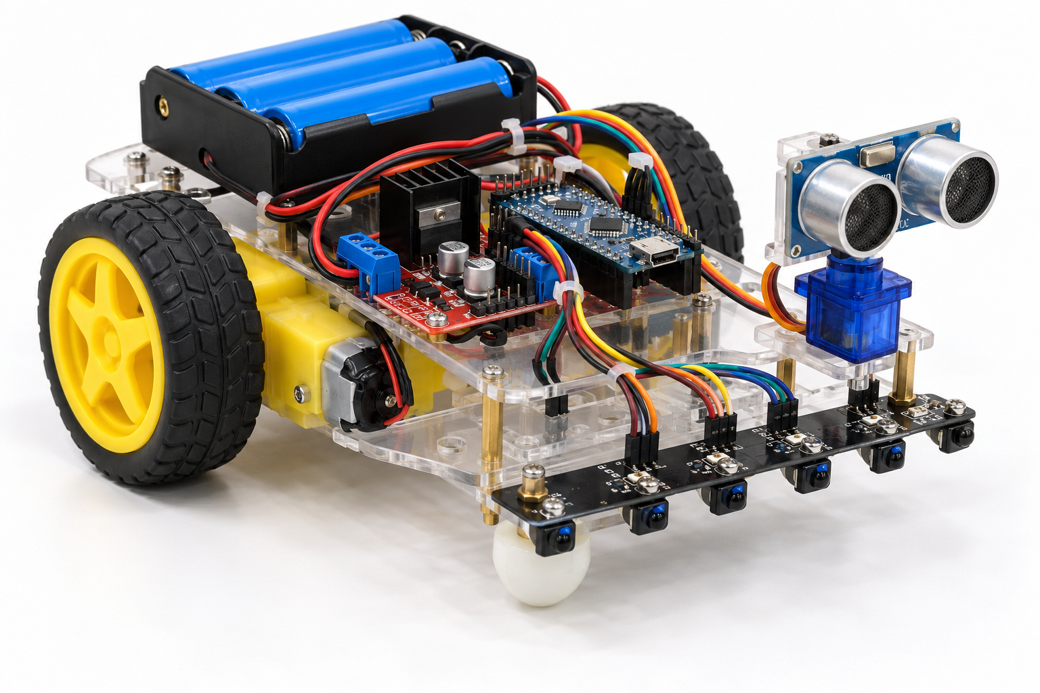
Figure. Concept image of the autonomous car with line-following and obstacle-detection sensors.

