Localizatron Documentation
Thank you for purchasing Localizatron for Unity3D!

1. Installation
All you need to do to install Localizatron is to import Localizatron package in your project.
That's it? Sorry to disappoint you... :)

2. Editor integration
Localizatron comes with Unity3D Editor integration. When you install this package, a menu item called “Localizatron” appears on toolbar:
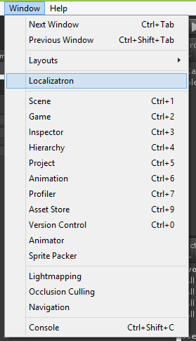
If you click on “Open Localizatron” item, localization management window will open up.
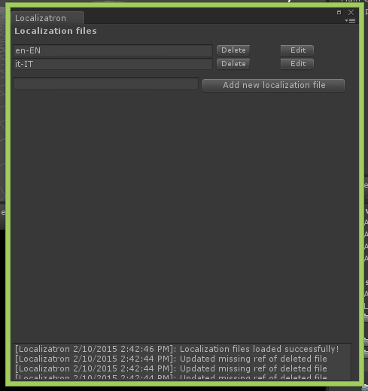
In this window you will find all localization files in your project (in Localizatron's locale folder).
With buttons you can easily delete (“Delete”), add (“Add new localization file”) and edit (“Edit”) your localization strings.
Each action is logged in bottom log area. So you can see what type of actions Localizatron is performing. If you want to deactivate this feature, you can set on false IS_DEBUG in LocalizatronEditor.cs script.

If you click on Edit button, this window will appears:
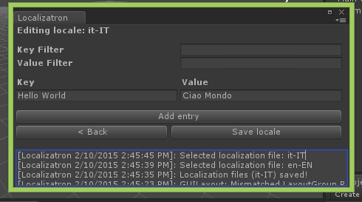

In this window you can easily manage your localization strings.
To add an entry, you can click on “Add entry” button.
To edit an entry, you simply have to change text in textboxes (this is valid for keys and for values).
To delete an entry, you simply have to delete key text.
You can save you changes with “Save locale” button.

3. In-game usage
When Localizatron is setted, you can use it in-game scenes. In your classes/methods you can use a single function to translate your text:
public string Translate(string key)
This function allows you to perform translation from your localization files and, if there is no keys in it, this function returns the input string. So, you can use this function in any string in your game, even there is no translations. Easy, isn't it? :)
Example:
GUI.Label(new Rect(50f, 11f, 100f, 22f), Localizatron.Instance.Translate("Hello World"));
This statement makes a Label with “Hello World” translation text, if there is one. :)
Now you can ask: “Ok, you are able to translate words, but how can we set or change current language?”. The answer is: “With following function!”
public bool SetLanguage(string language)
With this function you are able to change current language. You need to pass as parameter the name of localization file that you can find in localization management window.
Example:
if(GUI.Button(new Rect(10f, 10f, 50f, 22f), "IT")) {
Localizatron.Instance.SetLanguage("it-IT");
}
P.S.: default language is setted on “en-EN” file in Settings class.
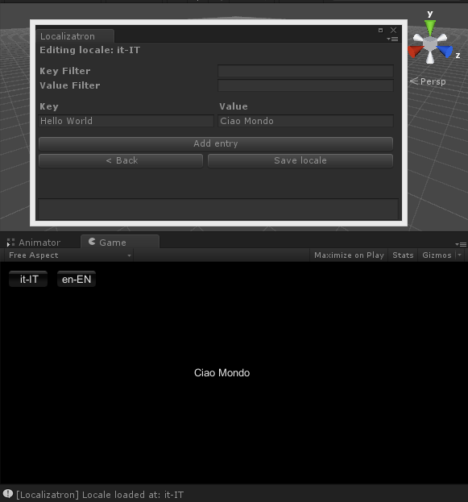
You can find this example scene in this package.
For any issue, you can contact me on: m4nu.91@gmail.com
Or Twitter: @MHLabSoftware

Thank you again! :)

