

Microelectronics Systems
Lab Manual

Student’s Chinese Name | 李宸羽
Student’s English Name | Chenyu Li
Student’s UESTC ID# | 2024190905037
Student’s UoG ID# | 3073568

General Instructions

Here are some general instructions for Microelectronics Systems lab:
- All students are advised to bring their lab manuals with them for each lab session. The lab manuals are supposed to be hard bound.
- Students are required to complete the questionnaires at the end of each lab exercise.
- A minimum of 7 out of 9 lab exercises must be completed to avoid CW.
- The lab manuals must be submitted in the week following the third lab session.
- All students must complete and sign the Declaration of Originality Form before submission of the lab manual.



Declaration of Originality Form
This form must be completed and signed and submitted with all assignments.
Please complete the information below (using BLOCK CAPITALS).
Name LI CHENYU
Student Number 2024190905037
Course Name MICROELECTRONIC SYSTEM
Assignment Number/Name MS LAB MANUAL
An extract from the University’s Statement on Plagiarism is provided overleaf. Please read carefully THEN read and sign the declaration below.
I confirm that this assignment is my own work and that I have:
Read and understood the guidance on plagiarism in the Student Handbook, including the University of Glasgow Statement on Plagiarism
Clearly referenced, in both the text and the bibliography or references, all sources used in the work
Fully referenced (including page numbers) and used inverted commas for all text quoted from books, journals, web etc. (Please check with the Department which referencing style is to be used)
Provided the sources for all tables, figures, data etc. that are not my own work
Not made use of the work of any other student(s) past or present without acknowledgement. This includes any of my own work, that has been previously, or concurrently, submitted for assessment, either at this or any other educational institution, including school (see overleaf at 31.2)
Not sought or used the services of any professional agencies to produce this work
In addition, I understand that any false claim in respect of this work will result in disciplinary action in accordance with University regulations
DECLARATION:
I am aware of and understand the University’s policy on plagiarism and I certify that this assignment is my own work, except where indicated by referencing, and that I have followed the good academic practices noted above
Signed 李宸羽

The University of Glasgow Plagiarism Statement
The following is an extract from the University of Glasgow Plagiarism Statement. The full statement can be found in the University Calendar at http://www.gla.ac.uk/media/media_413985_en.pdf#page=53&view=fitH,225. This should be read in conjunction with the discipline specific guidance provided by the School.
31.1 The University's degrees and other academic awards are given in recognition of a student's personal achievement. All work submitted by students for assessment is accepted on the understanding that it is the student's own effort.
31.2 Plagiarism is defined as the submission or presentation of work, in any form, which is not one's own, without acknowledgement of the sources. Plagiarism includes inappropriate collaboration with others. Special cases of plagiarism can arise from a student using his or her own previous work (termed auto-plagiarism or self-plagiarism). Auto-plagiarism includes using work that has already been submitted for assessment at this University or for any other academic award.
31.3 The incorporation of material without formal and proper acknowledgement (even with no deliberate intent to cheat) can constitute plagiarism.
Work may be considered to be plagiarised if it consists of:
- a direct quotation;
- a close paraphrase;
- an unacknowledged summary of a source;
- direct copying or transcription.
With regard to essays, reports and dissertations, the rule is: if information or ideas are obtained from any source, that source must be acknowledged according to the appropriate convention in that discipline; and any direct quotation must be placed in quotation marks and the source cited immediately. Any failure to acknowledge adequately or to cite properly other sources in submitted work is plagiarism. Under examination conditions, material learnt by rote or close paraphrase will be expected to follow the usual rules of reference citation otherwise it will be considered as plagiarism. Departments should provide guidance on other appropriate use of references in examination conditions.
31.4 Plagiarism is considered to be an act of fraudulence and an offence against University discipline. Alleged plagiarism, at whatever stage of a student's studies, whether before or after graduation, will be investigated and dealt with appropriately by the University.
31.5 The University reserves the right to use plagiarism detection systems, which may be externally based, in the interests of improving academic standards when assessing student work.
If you are still unsure or unclear about what plagiarism is or need advice on how to avoid it,
SEEK HELP NOW! You can contact any one of the following for assistance:
Lecturer
Course Leader
Dissertation Supervisor
Adviser of Studies
Student Learning Service

Introduction to the Microcontroller

Objectives
After completing these laboratories, you should be able to programme an embedded microcontroller to:
- generate digital output signals
- receive and process digital input signals
- generate analogue output signals
- receive and process analogue input signals
- generate pulse width modulated signals
This set of experiments will be assessed by milestones. You need to get through all the milestones, as the project in this course requires you to be proficient in getting analogue and digital signals into and out of the microcontroller.

Overview - the microcontroller
The set of experiments is based around the mbed microcontroller development board. Each student will be given an mbed, which hopefully you will come to cherish and use widely throughout your years of study at GC-UESTC. This means that you need to keep your mbed for several courses so treat it well and protect it. You will also be given a small breadboard to enable you to easily connect components to your beloved mbed.
The mbed microcontroller development board is shown in Figure 1 below.
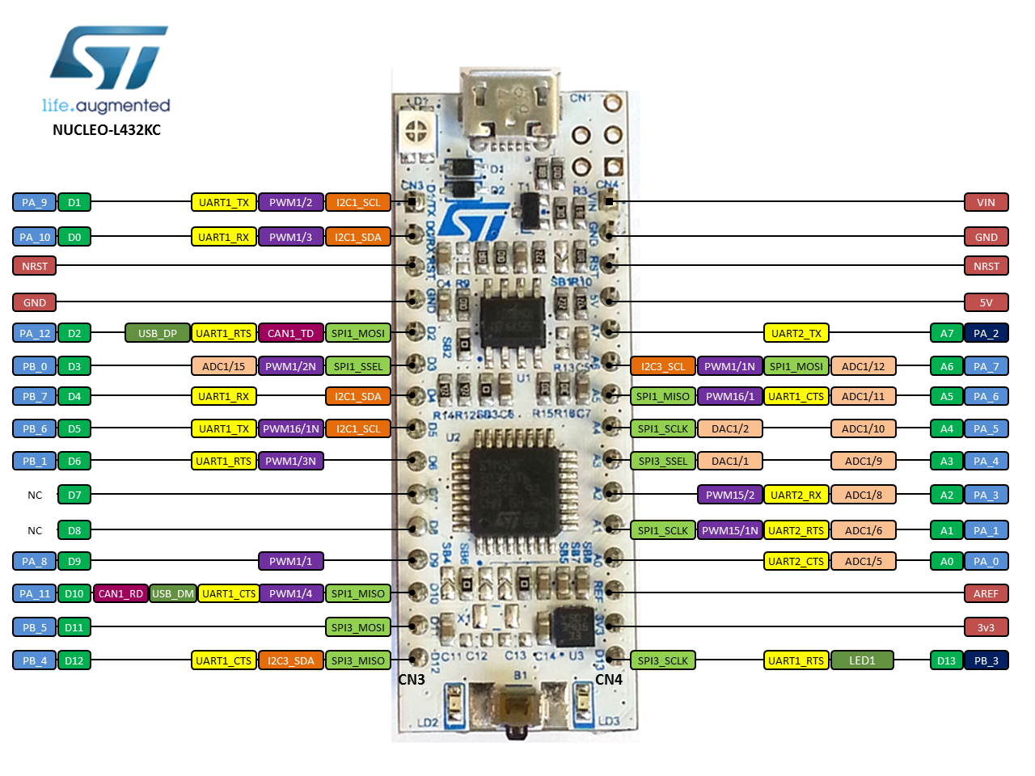
Figure 1 - Nucleo microcontroller development board and some details of the pins on the board

The development board is based on the Nucleo L432KC microcontroller, with a 32-bit ARM Cortex-M4 core running at 80 MHz (ARM processors are used in many contemporary products including iphones for example). The development board has many interfaces which are shown in Figure 2:
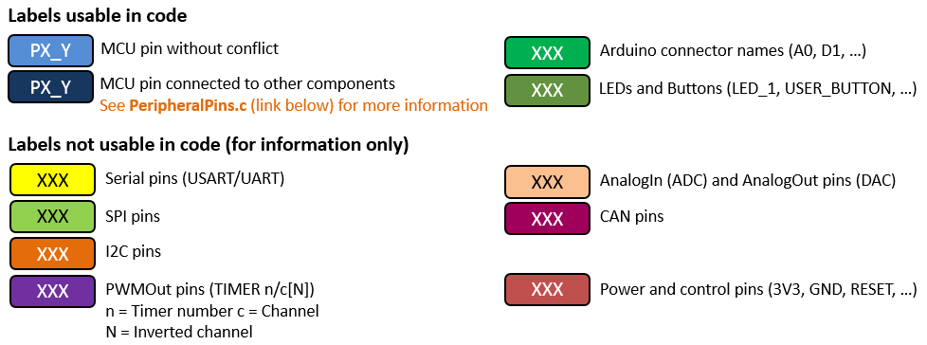
Figure 2 - Pins Legend

The real beauty of the mbed development board is the simplicity with which the microcontroller can be programmed. It comes with an extensive application programming interface (API), which is a large set of building blocks (libraries) that are effectively C++ utilities. The API allows programs to be easily and quickly developed.
Code can be generated using a web-based complier; this means you can develop programs whenever you have internet access. Once compiled, programs are easily downloaded to the mbed via a USB connector, which is also used to power the mbed.
The connections from the board that you will use are power (3v3 and GND) and pins labelled as D or A. For example, the development board has many interfaces:
pins D0 to D6, D9 to D13 and A0 to A3 and A6 to A7 can be used as digital in and digital out.
pins A0 to A6 and D3 can also be configured for analogue input.
pins A3 and A4 can be configured for analogue output.
pins D0, D1, D9, D10, A2, A5 can also be configured for pulse width modulated output. Various other pins can be configured for serial communication such as CAN, SPI, I2C and UART connection.
Potential irregularities:
Pins A4 and A5 are only ADC input
Pins D7 and D8 are not used.
The pins marked PWMx/yN are inverted waveforms of the PWMx/y outputs.
For PWM, the x represents a timer and y is channel, so if you want a different frequency, you must use a different timer, i.e., PWM1 and PWM16. If you are happy with the same frequency but want different duty cycles, you can use PWM1/1, PWM1/2 etc.
There are 3 LEDs on the board, one for ‘power on’ (red LD2 next to pin D12), a tricolour LED, LD1 (red/green/orange) for status, and a green LD3 that is connected to pin D13 digital output. LD3 can be driven to test basic functions without the need for any external component connection. LD3 will be called LED1 in the programs. However just using a microcontroller for one LED would be pretty boring, so we will want to attach other stuff.
To connect external components to the microcontroller, you will need to plug the Nucleo board into a breadboard. You should consider which way round it should go and make sure the USB lead does not take valuable space.
It is useful first step to connect GND and the 3V3 to the power rails of the breadboard since they are used a lot in circuits.
You should be aware that various input and output pins have maximum voltage and current limits, which should not be exceeded, otherwise your cherished microcontroller will be terminally damaged. Microcontroller input pins should not see voltages in excess of 5V.
As you can see from Figure 1, the mbed has a number of voltage pins, including:
GND : the reference potential = 0V. This should always be used as the ground for your logic circuits.
VIN : 7V - 12V input if running on a battery rather than the USB
5V : 5.0 V USB output that comes directly from your USB
3V3 : 3.3 V regulated output from the on board regulator – this is the voltage referred to as VDD in the course notes, and should always be used as the +ve for your logic circuits.

Getting Started
- mbed Account
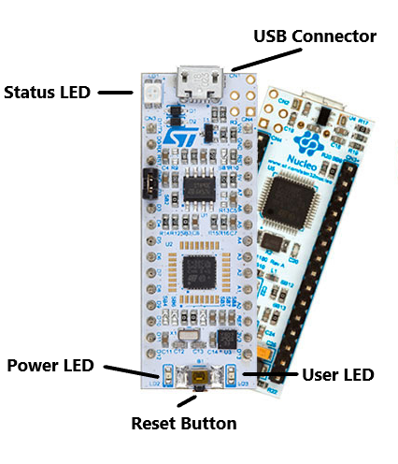
Figure 3. Top-view of the mbed
First, you need to make an mbed account. Go to the mbed website, www.mbed.org, and follow the instructions on getting started (http://mbed.org/handbook/Setup-guide). While you make an account, you need to have your mbed connected to your computer via a USB cable.
- Download a Program
Once you have created your mbed account, you can download your first program from the Getting Started web page - the usual starting place is the "Hello World" program. Save the program on your computer - perhaps create an mbed directory in your mapped drive, then copy the program to the mbed. This is where the mbed is really neat, as it just appears as a USB drive on your computer.
While the program is downloading to the mbed, the status LED (see Figure 3) on the mbed should flash. You may have to press the reset button on the mbed to get the program to run, but otherwise, one of the LEDs on the mbed should start to flash.
- Chose the chip type, Create and Run a New Program
The default chip type may not be the same as the one we used in these exercises, so we should choose the right one for preparation. Firstly, click and open the device selecting page like Figure 4:
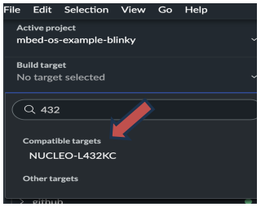
Figure 4 – Device selecting page
Then click the “Add Board” button and choose NUCLEO-L432KC as the platform used in compiler in STMicroelectronic label.
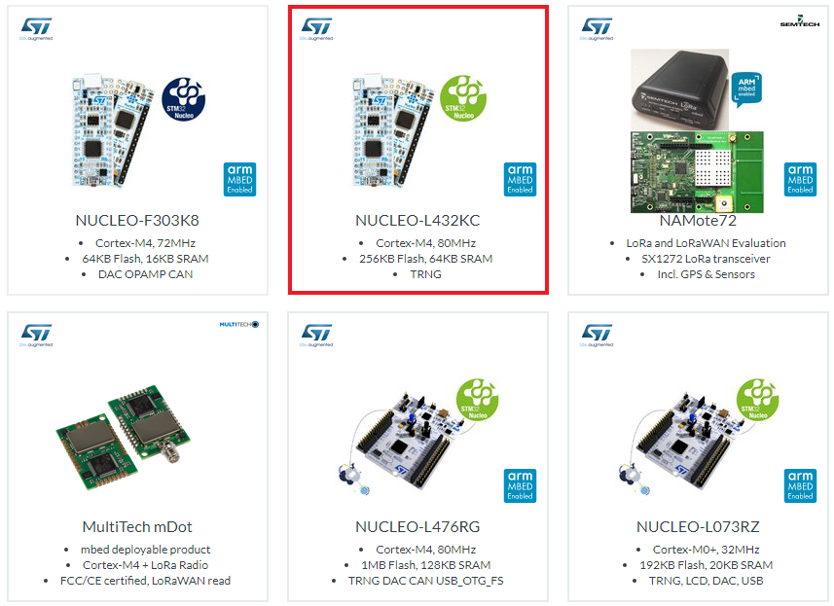
Figure 5 – Select L432KC in STMicroelectronic label

You use the web based compiler to create a program, simplest way will be to follow the instructions to Create A Program from the Getting Started web page of the mbed site. The compiler screen looks like:
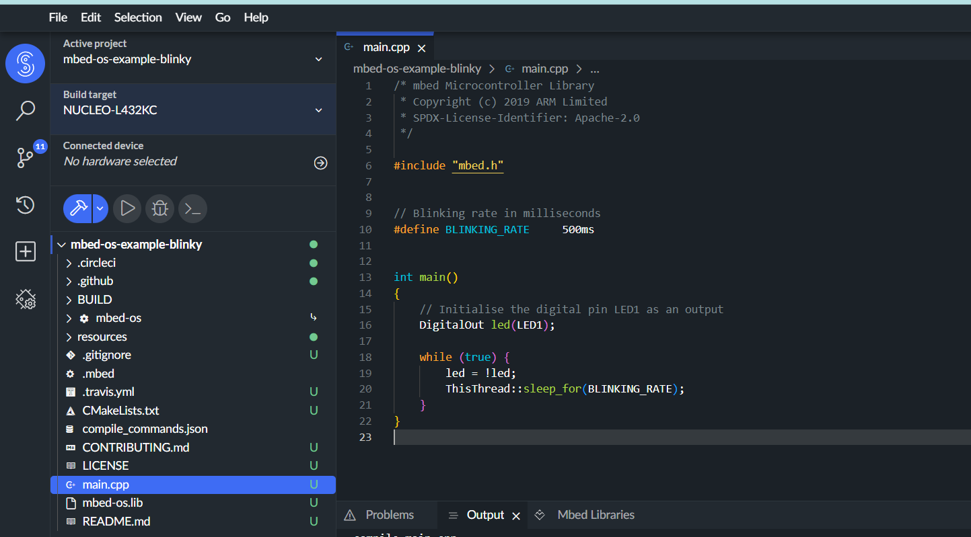
Figure 6 - Screenshot of mbed compiler environment
Click New to create a new program, and enter a filename. Your newly created program will appear in the Program Workspace on the left of the screen. If you expand the program by clicking on the +, you will see something called main.cpp - double click on this, it will open your program in the compiler environment. As you can see, any new program already has some lines of code, shown in Figure 7.
To get the program onto the mbed, you first have to compile it, by clicking the "Compile" button in the toolbar. This will create the binary code, which will ultimately be downloaded to the mbed. If the compiling goes well, you will get a "Success!" message in the compiler output, and a popup will prompt you to download the compiled .bin file to the mbed, as described below.
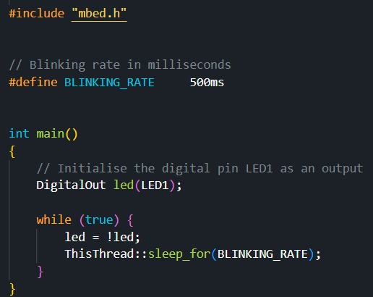
Figure 7 –The default code included in any new mbed program
Whilst the program is downloading, the status LED on the mbed will flash. Once this has stopped, press the Reset Button on the mbed to start your program running. You should see User LED flashing on and off every 0.2 seconds.
- The DigitalOut Component
As you can see, it is very easy to program the mbed. This is because of the Application Programming Interface (API) that was mentioned previously. Basically, this is a set of programming building blocks, which are C++ utilities, which allow rapid code development. You can find links to the various library blocks from the mbed website handbook page
http://mbed.org/handbook/Homepage.
You can follow links for each library function that describes the programming syntax as well as giving some examples to make things more obvious.
Based on this, we can explore each line of code in Figure 7.
Please pay attention to the input method. You should use “” not “”, ; not ；, () not （）.
#include "mbed.h" | This is a header that needs to be at the start of each mbed.
DigitalOut myled(LED1); | Essentially, what you are doing here is using the DigitalOut component to set LED1 (LD3 on board) as a digital output, and to give that "port" a name, myled. You can do something similar for each of other Digital IO pins, using the format:  DigitalOut variablename (pin number)  For example,  DigitalOut greenled (D5)  would set digital-pin 5 as a digital output, with the name ‘greenled’.
int main() { | The action of any C++ program is contained within its main() function. The function definition, what goes on inside the function, is contained within the curly brackets, starting immediately after main(), and continuing until the last closing curly bracket.
while(1) { | Many embedded systems programs contain endless infinite loop, a section of the program that just goes on repeating forever. In other branches of programming, this is bad practice, but for embedded systems, this is quite standard. The endless loop is created using the while keyword; this controls the code within the curly brackets, which follow. Normally, while is used to set up a loop, which repeats if a certain condition is satisfied, but if we write while(1), this will make the loop repeat endlessly.

The part of the program that actually causes the LED to switch on and off is contained in the 4 lines within the while loop. There are two calls to the library function ThisThread::sleep_for(), and two statements in which the value of myled is changed.
myled=1; | means that the variable myled is set to the value 1, no matter what its previous value was.  In C++, this is different to "equals", which is represented by "= =". "=" has the meaning "is set to". This sets a logic 1, or voltage of 3.3V on the pin to which LED1 is connected. This will case the LED to light up.
ThisThread::sleep_for(200ms); | function is from the mbed library - you can find out more about it on the mbed website. The 200 parameter is in milliseconds, and defines the delay length caused by this function. So, the LED will be lit for 200ms
myled=0; | means that the variable myled is set to the value 0, whatever its previous value was. This sets a logic 0, or voltage of 0 V on the pin to which LED1 is connected. This will cause the LED to switch off. Note that this will not always turn an LED off; it depends on how the LED is wired in the circuit.
ThisThread::sleep_for(200ms); | the LED will be switched off for 200ms

The program will then loop back to the while(1) statement and the LED flashing will continue forever.
- The DigitalIn Component
The mbed API has a DigitalIn function with a format identical to that of DigitalOut. Refer to the DigitalIn section of the mbed handbook for further details.
The syntax is DigitalIn variablename (pinnumber);
For example Digitalin switchinput(D5); would set digital-pin 5 as a digital input, with the variable name switchinput.
- Modifying the Program Code
In the main.cpp file, change the value within the ThisThread::sleep_for(); command. Now compile and download the modified code to the mbed, you should now see LED1 (LD3) flashing with a different frequency.
- Mbed Libraries
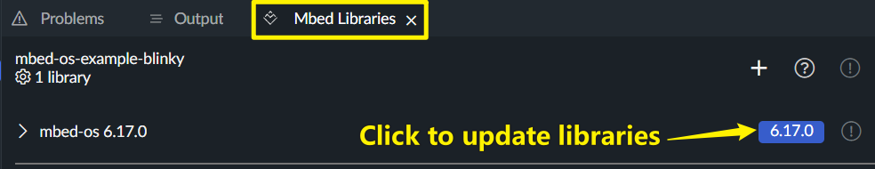
You can explore the syntax for many of the mbed libraries by following links from the mbed handbook homepage. http://mbed.org/handbook/Homepage
In this manual, mbed-os 6.17.0 is chosen as the Mbed library and you can click the blue button to select different libraries. Libraries newer than mbed-os 6.15.0 are suggested.

2. Lab Exercises

Exercise 1 - Switching on and off a pair of LEDs
- Select two LEDs from the parts available in the lab – one should be a red LED and the other should be a green LED.
- Use the breadboard to connect the mbed and the LEDs. Connect the anode of the red LED to digital-pin 5 (D5) on the mbed and the cathode to ground. The anode of the LED has the longer leg while the cathode has the shorter leg. Connect the anode of the green LED to digital-pin 6 of the mbed board and the cathode to ground.
- Based on what you have learned above, and with reference to the DigitalOut page on the mbed website, generate code that will cause the LEDs to switch on and off, where the red LED is ON while the green LED is off and visa versa. The duration of illumination of each LED should be 1 second.
- Switch the cathode of the green LED to digital-pin 6 and the anode to ground. Run the program. What is changed?
- Switch the anode of the green LED back to digital-pin 6. Connect the cathode to digital-pin 9.
- Modify the program so that digital-pin 9 is set to level of 0. Run your program. While the program is running, measure the voltage at digital-pin 9. Has the sequence of turning ON and OFF the two LEDs changed from step c?
- Modify the program so that digital-pin 9 is set to level of 1. Run your program. While the program is running, measure the voltage at digital-pin 9. Has the sequence of turning on and off the two LEDs changed from step c?

Milestone 1: Show your code and the LEDs switching ON and OFF to a demonstrator.
Procedure: Please briefly describe the exercise procedure. Also provide schematic diagram, output, figure and/or table, if any.
1.Select a red LED and a green LED from lab parts.
2.Connect the anode of the red LED to D5 on mbed and its cathode to ground, and the anode of the green LED to D6 on mbed and its cathode to ground using a breadboard.
3.Write code to make the red LED on while the green LED off and vice versa, with each LED's illumination duration of 1 second.
4.Switch the cathode of the green LED to D6 and the anode to ground, then run the program and observe changes.
5.Switch the anode of the green LED back to D6 and connect the cathode to D9. Modify the program to set D9 to level 0 or 1 respectively, run the program, measure the voltage at D9, and observe if the LED on - off sequence changes compared to step 3.

Please write your code here. Do not forget to include comments.
#include "mbed.h"
// Initialize a digital output for the red LED on pin D5
DigitalOut redLED(D5);
// Initialize a digital output for the green LED on pin D6
DigitalOut greenLED(D6);
int main() {
while (1) {
// Turn on the red LED and turn off the green LED
redLED = 1;greenLED = 0;
ThisThread::sleep_for(1s);
// Turn off the red LED and turn on the green LED
redLED = 0;greenLED = 1;
ThisThread::sleep_for(1s);
}
}
Please write your main finding. Also, if there are any questions asked in this milestone, include the response to these questions.
1.In step 3, the code can make the two LEDs turn on and off alternately as expected.
2.In step 4, the green LED doesn't light up as the connection change reverses the current direction, and only the red LED works properly.
3.In step 5, when D9 is set to 0, its voltage is close to 0V, and the LED on - off sequence remains the same as in step 3.
4.In step 5, when D9 is set to 1, its voltage is close to 3.3V, and the LED on - off sequence still doesn't change compared to step 3

Exercise 2 – Controllable switching of LEDs / Generating a square wave and observing it on an oscilloscope
Below is some code that flashes one of two LEDs, depending on the state of a 2-way switch. It gives the opportunity to introduce some additional syntax.
/*Program to flash 1 of 2 LEDS, depending on the state of a 2 way switch
of
a
2
way
*/
#include "mbed.h"
DigitalOut redled(D3);
DigitalOut greenled(D4);
DigitalIn switchinput(D5);
int main() {
while(1) {
if(switchinput==1) { //test value of switch input
//execute following block of code if switch input is 1
greenled = 0; //green LED is off
redled = 1; //flash red LED
ThisThread::sleep_for(1s); //sleep 1s
redled = 0;
ThisThread::sleep_for(1s);
} //end of if
else {
//execute this block of code if switchinput is 0
redled = 0; //redled is off
greenled = 1; //flash green LED
ThisThread::sleep_for(1s);
greenled = 0;
ThisThread::sleep_for(1s);
} //end of else
} //end of while(1)
} //end of main

Comments have been added at the beginning of the code using the /* comments */ syntax, which allows comments to span more than one line. The comments are placed between the /* and */ . Shorter inline comments can be added by first inserting // then placing comment after
DigitalIn switchinput(D5); | Sets digital-pin 5 as a digital input and assigns variable switchinput to that pin
The code also introduces the if and else keywords and the equal operator ==. This causes the block of code that follows the if and else keywords to be executed if the specific condition is met. In the case of the code above, the condition is that the variable switchinput is equal to 1. If this condition is satisfied (i.e., digital-pin 5 is connected to a logic 1), then the block of code immediately following the if statement is executed. In this case, the green LED connected to digital-pin 4 would be switched off and the red LED connected to digital-pin 3 would flash on and off. If the condition is not satisfied, then the block of code following the else statement would be executed, in this case the red LED connected to digital-pin 3 would be switched off and the green LED connected to digital-pin 4 would flash on and off.

Write a program to generate a 1 kHz square wave, and observe it on an oscilloscope. You can choose whichever output pin you wish as the source of the square wave.

Milestone 2: Show your code and the output waveform to a demonstrator.
Procedure: Please briefly describe the exercise procedure. Also provide schematic diagram, output, figure and/or table, if any.
1.First, I learned how DigitalOut, DigitalIn, if - else and pwm.period() work.
2.Then, I chose D4 as the output pin to generate the 1 kHz square wave because it's a digital output pin and easy to use.
3.Since the frequency of the square wave is 1 kHz, I calculated that the period is 1 ms. So, each high and low state of the square wave should last 1 ms.
4.I used DigitalOut in the mbed IDE to set D4 as an output. In a while(ture) loop, I toggled the pin's state. I set it high, waited for 1 ms, then set it low and waited for another 1 ms to make the square wave.
5.Finally, I connected D4 to the oscilloscope. I set an appropriate voltage range to see the square wave clearly.

Please write your code here. Do not forget to include comments.
#include "mbed.h"
// Define a digital output pin for square wave output, connected to D4
DigitalOut squareWavePin(D4);
// Create a PWM output object, also using D4 pin to generate PWM signal
PwmOut pwm(D4);
int main() {
// Set the period of the PWM signal to 0.001 seconds, corresponding to a frequency of 1kHz
pwm.period(0.001);
while (true)
{
// Set the duty cycle of the PWM signal to 50% to generate a square wave
pwm.write(0.5);
}
}
Please write your main finding. Also, if there are any questions asked in this milestone, include the response to these questions.
1.The code worked well and I could see a clear 1 kHz square wave on the oscilloscope. The high level was about 3.3V and the low level was 0V, just like I expected.
2.Setting the right time scale and voltage range on the oscilloscope was very important. If the time scale was too big, I couldn't see the high and low parts clearly. If the voltage range was wrong, the wave might not show up or look wrong.
3.The pwm.period() function helped control the time well. But there might be a little difference between the real frequency and 1 kHz because of the function's extra work and the mbed's internal processing. Still, it was close enough for what I needed.

Exercise 3 - Create a square wave whose frequency depends on the position of a switch
Switches are used in many applications. One important application is internal to the microcontroller. There are switches at every pin, which are activated to enable signals to be outputted or to allow input signals to be collected. Another application is to permit a microcontroller to connect and disconnect a high voltage/high current source to another circuit. The microcontroller itself can’t supply sufficient voltage or current to the circuit but can output sufficient voltage and current to control the switch.
Before you can complete the milestone associated with this program, let’s understand the working of a single pole single throw (SPST) switch that will be used in this exercise. Below is the diagrams and truth table for the SPST switch, 74HC4066, that we will be using here.
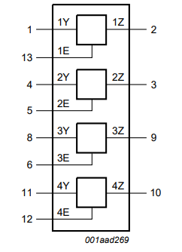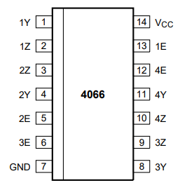
74HC4066 Logic Symbol 74HC4066 Pin configuration
Input |  |  | Output
V_{cc} | E | Y | Z
0 | x | x | 0
1 | 0 | x | 0
1 | 1 | 0 | 0
1 | 1 | 1 | 1
Truth Table for 74HC4066 operations
The 74HC4066 is a quad (4) SPST analog switch. Each switch features input pin (Y) and output pin (Z) and an active HIGH enable input (E). For instance, for switch 1, input pin is labelled as 1Y, output pin is labelled as 1Z and the enable pin is labelled as 1E. After connecting V_{cc} and GND to the power supply, when enable pin E is LOW, the analog switch is turned off. By contrast, when enable pin E is HIGH, the analog switch works as a normal switch. Please refer to the truth table above for all the possible configurations.
Modify Program 2 above so that it will output one of two possible frequencies, 200 Hz and 500 Hz depending on the position of a switch (ON or OFF), which you will wire to one of the input pins on your mbed.

Milestone 3: Show your code and that you can change the square wave frequency by using a switch to a demonstrator.

Procedure: Please briefly describe the exercise procedure. Also provide schematic diagram, output, figure and/or table, if any.
1.Understand the 74HC4066 Switch: Learn how the 74HC4066 SPST analog switch works. It has an enable pin (E) that controls whether the switch is ON (HIGH) or OFF (LOW).
2.Connect Hardware:
Connect the switch’s Vcc to 3.3V and GND to ground.
Link the switch’s enable pin (E) to an mbed input pi.
Connect the mbed’s PWM output to the circuit.
3.Modify Code: Write a program to read the switch state and change the PWM frequency:
500 Hz when the switch is ON (HIGH).
    - when the switch is OFF (LOW).
4.Test: Run the code and use an oscilloscope to verify the frequency changes with the switch.

Please write your code here. Do not forget to include comments.
#include "mbed.h"
PwmOut pwm(D3);
DigitalOut pin1(D5);
DigitalOut pin13(D6);
DigitalIn pin2(D7);

// main() runs in its own thread in the OS
int main()
{
// Modify the high and low levels here to control the switch opening and closing
pin1 = 1; pin13 = 1;

// The switch is closed when the input is high level
if(pin2 == 1)
{
pwm.period(0.002);
while (true)
{
pwm.write(0.5);
}
}

// The switch is open when the input is low level
else
{
pwm.period(0.005);
while (true)
{
pwm.write(0.5);
}
}
}
Please write your main finding. Also, if there are any questions asked in this milestone, include the response to these questions.
1.Switch Control: The code successfully changes the square wave frequency based on the switch position: ON (HIGH): 500 Hz OFF (LOW): 200 Hz.
2. By using the PwmOut class with a duty cycle of 0.5 (pwm.write(0.5)), a stable square wave was generated. The high - level voltage of the square wave was approximately 3.3 V, and the low - level voltage was close to 0 V, which was consistent with the expected output characteristics of the mbed's digital output pins. This demonstrated the proper functioning of the PWM generation mechanism on the mbed board.

Exercise 4 – Multiplexing/Demultiplexing
There are times when more pins are needed to perform tasks than there are pins available. One way to overcome this problem is to use a multiplexer or demultiplexer. Multiplexers are commonly used as a way to combine many signals into one or a few signals that are then read by the microcontroller. Demultiplexers allow the microcontroller to send a few signals out to control many circuits.

  - Connect the anodes of 4 LEDs to the outputs of the 2 x 4 demultiplexer.
  - Connect the cathodes of the LEDs to ground.
  - Connect the power and ground to the demultiplexer.
  - Write a program to use the output from 2 pins on the microcontroller to turn ON and OFF the LEDs in a sequence.
  - Consider what would happen if the anodes of the LEDs had been connected to 3.3 V and the cathodes of the LEDs were connected to the output of the multiplexer instead.

Milestone 4: Show your code and explain how to select a specific LED to turn to a demonstrator.

Procedure: Please briefly describe the exercise procedure. Also provide schematic diagram, output, figure and/or table, if any.
1.Check the data sheet to find appropriate pins which can be used to generate different voltages. Then I chose D5 and D6.
2.According to the working principle of multiplexer, different combination of inputs to the device can produce certain out puts, we use this property to light up LEDs in sequence. If LEDs' anodes are connected to 3.3V and cathodes to the demultiplexer outputs, the demultiplexer must output low voltage (0V) to turn an LED on.
3.However, results are totally opposite from my expectation, four lights were lit up and one of them extinguished each time. So I changed the anodes and cathodes to the opposite direction

Please write your code here. Do not forget to include comments.
#include "mbed.h"

// address controller pins
DigitalOut A(D5);
DigitalOut B(D6);

int main() {
while (true) {
// change the cannels in sequence
A = 0, B = 0; ThisThread::sleep_for(1s); // channel 0（LED1）
A = 0, B = 1; ThisThread::sleep_for(1s); // channel 1（LED2）
A = 1, B = 0; ThisThread::sleep_for(1s); // channel 2（LED3）
A = 1, B = 1; ThisThread::sleep_for(1s); // channel 3（LED4）
}
}
Please write your main finding. Also, if there are any questions asked in this milestone, include the response to these questions.
1.Sequential LED Control: By varying the selection pins, each LED is turned on sequentially. The demultiplexer routes the output to the selected LED based on the binary input.
2.Active-High vs. Active-Low Logic: In the original setup (anode to demultiplexer, cathode to GND), the demultiplexer outputs high voltage to turn the LED on. If anodes are connected to 3.3V and cathodes to the demultiplexer, the demultiplexer must output low voltage to turn the LED on. This requires modifying the code to use active-low logic.
3.Multiplexing Advantage: Using a demultiplexer reduces the number of required microcontroller pins (2 pins for 4 LEDs, instead of 4 separate pins), efficient for systems with limited I/O.
4.Answer to question e: Four lights were lit up and one of them extinguished each time.

Exercise 5 - Drive a seven-segment display to display 0-9 and a word H E L P repeatedly
In program 1 you switched ON and OFF a pair of LEDs. LEDs are often packaged together to form patterns, digits, alphanumeric characters etc. A number of standard groupings of LEDs are available including a seven-segment display, which is is composed of seven individual LEDs that can be used to display all numerical digits along with quite a few letters from the English alphabet by lighting different combinations of the seven LED segments.
Figure 8a shows the 7 segments labelled A-G. A decimal point (DP) is usually included in the display. The 7 segments display we will use has 10 pins, which are connected as shown in Figure 8b and in datasheet that is on the course website. The LEDs have a common cathode terminal, pins 3 and 8 on the package; the other pins connect to individual segments. Segment A is connected to pin 7, segment E is connected to pin 1, DP is connected to pin 5, etc. The cathode will be connected to GND, ground of the mbed. By applying a sufficiently large positive voltage to the LED, as can be achieved with an mbed DigitalOut command, a given LED can be illuminated.
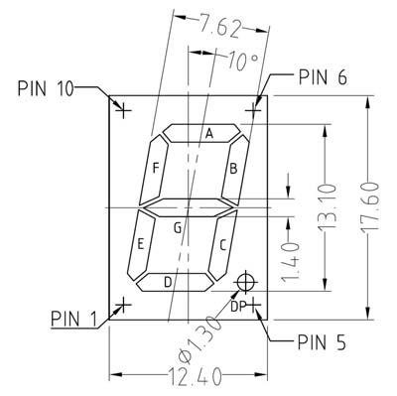

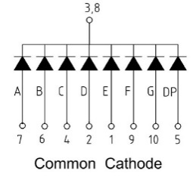
Figure 8a - Labelling of the 7 segments in a seven-segment display
Figure 8b - the pin allocation of the Avago segment display

All the segments can be written in a single byte (8 bits), for example in the sequence
(MSB) DP G F E D C B A (LSB)
If you want to represent the digit "0", it would be necessary to illuminate segments A, B, C, D, E, F. Using the above approach, a "0" would be represented by the byte 00111111 (DP and G not lit, the other segments are illuminated). This is represented in hexadecimal notation as 0x3F, where 0x tells us that it is a hexademical notation and 3F is the hex representation for 0011 1111.
The advantage of this approach is that we can connect the 7 segment display to 7 digital output pins of the mbed, using a new mbed API class BusOut, which allows you to group a set of digital outputs together and to write 2 hexadecimal nibbles directly to it. To demonstrate this, tie the breadboard connect pin 3 or 8 of the seven segment display to the Gnd connection of the mbed and the other pins of the seven segment display to mbed pins that can be configured as digital outputs. Do this in a reasonably logical way, such as that outlined in the table below.2 Please note that you will need to remove the short circuit between D2 and GND, or D2 cannot output a proper voltage.
mbed  pin | GND | D2 | D3 | D4 | D5 | D6 | D9 | D10 | D11
Display pin | 3 or 8 | 7 | 6 | 4 | 2 | 1 | 9 | 10 | 5
Display segment | - | A | B | C | D | E | F | G | DP

- Produce a table in your lab book like that below that shows the hexadecimal number you will write to the 8 mbed pins to generate the display values 0-9. 0 and 1 are provided to get you started.
Display Value | 0 | 1 | 2 | 3 | 4 | 5 | 6 | 7 | 8 | 9
Segment drive in  digital | 0011  1111 | 00001100 | 0101  1011 | 0100  1111 | 0110  0110 | 0110  1101 | 0111  1101 | 0000  0111 | 0111  1111 | 0110  1111
Segment  drive in hex | 0x3F | 0x06 | 0x5B | 0x4F | 0x66 | 0x6D | 0x7D | 0x07 | 0x7F | 0x6F
Having worked out which values to write to the mbed pins, the issue of coding this can be considered with reference to the program below.
/* Program to demonstrate driving 7 segment display. This example shows how to display digits 0,1,2,3 in turn
*/
#include "mbed.h"
BusOut display(D2,D3,D4,D5,D6,D9,D10,D11); //segments A,B,C,D,E,F,G,DP int main () {
while(1) {
for (int i=0; i<4;i++){
switch(i){
case 0: display = 0x3F; break; //display 0 case 1: display = 0x06; break; //display 1
case 2: display = 0x5B; break; //display 2 case 3: display = 0x4F; break; //display 3
} //end of switch
ThisThread::sleep_for(500ms); //display value for 0.5s
 |  | } | //end | of | for
 | } |  | //end | of | while
} |  |  | //end | of | main

The new commands in the above program are:
BusOut | needs to have a name specified - in this case display, and then lists in brackets the pins which will be members of that bus.
for | This is just a loop. In this example, variable i (an integer (int) in this case) is initially set to 0 (i=0), and on each iteration of the loop it is incremented by 1 (i++), so long as (in this case) i<4 the loop will repeat. When it reaches 4, the loop terminates.
switch, case, break | Used together, these words provide a mechanism to permit one item to be chosen from a list. In this case, as the variable i is incremented, its value is used to select the word that is sent to the display so that the correct digit can be illuminated.

We now have quite a few nested blocks of code. The switch block lies within the for block, which lies inside the while block, which lies inside the main block. To clarify which curly bracket terminates each block, these have been commented in the code section above.
- Based on your table to determine the hexadecimal values required to produce the digital 0-9 on the seven segment display, modify the code above to count from 0-9.
- What happens if the time each number is displayed is reduced by a factor of 50 to 0.01s?
The mbed has an internal clock. The clock can be used with the while statement to begin or end an operation.
d. Modify your code from part (b) to have the seven-segment display flash the letters H E L P in sequence,
  - where each letter is displayed in sequence for 0.2 s.
  - then there is no display for 0.2 s
  - step (i) and (ii) are repeated 5 times and then the program stops

Milestone 5: Show your code and the working display to a demonstrator.
Procedure: Please briefly describe the exercise procedure. Also provide schematic diagram, output, figure and/or table, if any.
1.Convert binary to hexadecimal.
2.Connect the pins of the seven - segment display to the breadboard according to the corresponding relationship. Connect the common cathode (pin 3 or 8) of the display to the ground (GND), and connect the other pins A - G and DP of the display to the D2 - D11 pins of the MCU respectively, referring to the table in the document.
3. Pay attention to removing the short - circuit between D2 and GND to ensure that D2 can output a proper voltage. Based on the table of hexadecimal values for displaying 0 - 9 on the seven - segment display generated before, modify the sample code. Traverse 0 - 9 in a loop, and use the switch statement to set the value of display to show different numbers, with each number displayed for 0.5 seconds. Then I do the same to generate “HELP”.

Please write your code here. Do not forget to include comments.
#include "mbed.h"

BusOut display(D2,D3,D4,D5,D6,D9,D10,D11);

// display 0 - 9
void displayNumbers() {
for(int i = 0; i < 10; i++) {
switch(i) {
case 0: display = 0x3F; break;
case 1: display = 0x06; break;
case 2: display = 0x5B; break;
case 3: display = 0x4F; break;
case 4: display = 0x66; break;
case 5: display = 0x6D; break;
case 6: display = 0x7D; break;
case 7: display = 0x07; break;
case 8: display = 0x7F; break;
case 9: display = 0x6F; break;
}
ThisThread::sleep_for(500ms); // display each letter for 0.5s
}
}
// display letter H、E、L、P
void displayHELP() {
for(int j = 0; j < 5; j++) { // repeat for 5 timed
for(int n = 0; n < 4; n++) {
switch(n) {
case 0: display = 0x76; break; // H
case 1: display = 0x79; break; // E
case 2: display = 0x38; break; // L
case 3: display = 0x73; break; // P
}
ThisThread::sleep_for(200ms); // display each letter for 0.2s
display = 0x00; // display 0.2s，distinguish the seven - segment display
ThisThread::sleep_for(200ms);
}
}
}

int main() {
while (true) {
displayNumbers(); // display 0 - 9
displayHELP(); // display H、E、L、P
}
}

Please write your main finding. Also, if there are any questions asked in this milestone, include the response to these questions.
1.The modified code can make the seven - segment display show 0 - 9 in sequence. Each number is stably displayed for 0.5 seconds, which meets the expectation. The display and extinction time of each letter is accurate, and the program stops after repeating 5 times.
2.This verifies the correctness of the code logic and the setting of the delay time, and also demonstrates the ability to display complex characters by controlling the output of different hexadecimal values on the pins of the seven - segment display
3.Answer to question: Since the numbers flashes too fast, human eyes cannot recognize them separately.

Exercise 6 - Creating constant output voltages
As you can see from Figure 1, the mbed has can be configured to generate a number of outputs, including an analogue output on analog-pin 4 (A4). The API command for configuring analogue-pin 4 as an analogue output is AnalogOut name (A4), where name is a variable.
We can then assign a value to the variable, Aout=0.25; for example. The value assigned to the variable can be a floating point number between 0.0 and 1.0 which is outputted to analogue-pin 4. The actual output voltage on analogue-pin 4 is between 0 V and 3.3 V so the floating point number between 0.0 and 1.0 is scaled to this range (0.0 will output 0 V, 0.5 will output 1.65 V, 1.0 will output 3.3 V etc).
The code below outputs 2 values of voltage to analogue-pin 4.
/*Program to output 2 voltage levels to analogue-pin 4 Read the output on a multimeter
*/
#include "mbed.h"
AnalogOut Aout(A4); //create an analogue output on analogue-pin 4
int main() {
while (1) {
Aout=0.33;
ThisThread::sleep_for(2s);
Aout=0.66;
ThisThread::sleep_for(2s);
}
}
- Given the description of the range of analogue voltages that the mbed can output, what are the two output voltages that should appear on pin A4?

- Confirm the two output voltages in the code shown above are as you expect.

- Modify the code to output constant voltages of 0.5 V, 1.0 V, 2.0 V and 2.5 V.

Milestone 6: Show your code and the output voltages to a demonstrator.
Procedure: Please briefly describe the exercise procedure. Also provide schematic diagram, output, figure and/or table, if any.
1.The MCU’s analogue output generates voltages between 0 V and 3.3 V. Values between 0.0 and 1.0 map to proportional voltages in this range. The given code alternates between 0.33 and 0.66 for the analogue output. These values should produce voltages close to 1.1 V (0.33 of 3.3 V) and 2.2 V (0.66 of 3.3 V). Use a multimeter to confirm these voltages appear on pin A4.
2.To output specific voltages, assign values between 0.0 and 1.0 that correspond to these voltages relative to the 3.3 V maximum:
0.5 V ≈ 0.1515 (since 0.5 V is about 15.15% of 3.3 V) 1.0 V ≈ 0.3030 (30.30% of 3.3 V) 2.0 V ≈ 0.6060 (60.60% of 3.3 V) 2.5 V ≈ 0.7576 (75.76% of 3.3 V)
3.Update the code to cycle through these values, with 2-second delays between each.

Please write your code here. Do not forget to include comments.
#include "mbed.h"
AnalogOut Aout(A4);
//create an analogue output on analogue-pin 4
int main()
{
while (1)
{
Aout=0.1515;
ThisThread::sleep_for(2s);
Aout=0.3030;
ThisThread::sleep_for(2s);
Aout=0.6060;
ThisThread::sleep_for(2s);
Aout=0.7576;
ThisThread::sleep_for(2s);
}
}
Please write your main finding. Also, if there are any questions asked in this milestone, include the response to these questions.
- Voltage Generation:
The MCU successfully outputs the target voltages by assigning appropriate values (0.0–1.0) to the AnalogOut variable. Measured voltages on pin A4 match the expected values within the precision of the microcontroller’s digital-to-analog converter (DAC).
- Code Functionality:
The modified code cycles through the specified voltages, each displayed for 2 seconds.The key takeaway is that the MCU’s analogue output allows precise voltage control by scaling values between 0 and 1 to the 0–3.3 V range. This is useful for applications requiring adjustable voltages, such as driving sensors or LEDs with varying brightness.

Exercise 7 - Creating a sawtooth waveform
- Using a for loop, generate a 100 Hz sawtooth waveform with minimum and maximum voltages of 0 V and 3 V, respectively. You will have to work out how many "steps" to have in your sawtooth and then calculate their duration so that the frequency is correct.
- Measure the output signal using an oscilloscope. Determine the frequency of the sawtooth waveform.
- Change the time scale on the oscilloscope so that you can see the individual steps that form the sawtooth. Are the steps in voltage of uniform magnitude? Is the increment equal to the step size that you calculated in part a?
Hint: Read the mbed datasheet to determine the number of bits that the digital-to-analog converter (DAC) has.
Note: Not all components in a microcontroller (microprocessor) are composed of digital logic gates. A DAC and its complement, an analogue-to-digital converter (ADC) contain analogue circuits.

Milestone 7: Show your code and the resulting waveform on an oscilloscope to a demonstrator.
Procedure: Please briefly describe the exercise procedure. Also provide schematic diagram, output, figure and/or table, if any.
1.Use a for loop to increment an analog output voltage from 0 V to 3 V in small steps. The total period of the sawtooth wave should be 10 ms .
2.Divide the period into small time steps to create a smooth sawtooth shape. Connect the analog output pin to an oscilloscope. Observe the waveform to confirm it is a sawtooth shape and measure its frequency.
3.Check if the voltage steps are uniform. The MCU’s DAC (Digital-to-Analog Converter) has 12 bits, so there are 4096 possible steps between 0 V and 3.3 V.
Please write your code here. Do not forget to include comments.
#include "mbed.h"

// The DAC is 12-bit
int bits = 12;
// Calculate the number of quantization levels, which is 2 to the power of bits
int steps = 1 << bits;

float min_v = 0;
float max_v = 3;
float frequency = 100;
float period = 1 / frequency;

float step_v = (max_v - min_v) / steps;
float step_t = period / steps;

AnalogOut sawtooth_out(A4);

// main() runs in its own thread in the OS
int main()
{
while (true)
{
for (int i = 0; i < steps; ++i) {
float voltage = min_v + i * step_v;
// Convert the voltage value to a ratio between 0 and 1 and output it to the analog output pin
sawtooth_out = voltage / max_v;
// Put the thread to sleep for the duration of each step
ThisThread::sleep_for(step_t);
}
}
}
Please write your main finding. Also, if there are any questions asked in this milestone, include the response to these questions.
1.The code successfully generates a 100 Hz sawtooth waveform with a voltage range of 0 V to 3 V. The oscilloscope confirms the waveform shape and frequency.
2.The voltage steps are nearly uniform due to the MCU’s 12-bit DAC, which provides high precision. Each step corresponds to a small, consistent voltage increment, visible as distinct levels on the oscilloscope when the time scale is adjusted.
3.Measured frequency on the oscilloscope matches the target 100 Hz, validating the timing logic in the for loop and delay functions. The 12-bit resolution ensures smooth transitions between steps, with minimal visible distortion in the sawtooth wave. Reducing the number of steps would create a waveform, highlighting the importance of DAC resolution in analog signal generation.

Exercise 8 – Illuminating LEDs depending on analogue input voltage
The real world is analogue, and many sensors have analogue outputs, yet it is essential that a microcontroller have these signals available in a digital form. As shown in Figure 9, the ability to convert from analogue inputs to digital signals is so important that the mbed can handle up to seven analogue inputs at any given time, on analogue-pins A0-A6. The Application Programming Interface for handling analogue input signals is similar in format to many of those we have looked at already in this introduction to the mbed.
A simple way to observe the operation of the analogue input is to use a potentiometer to vary the drive voltage being applied to an LED. Figure 9 shows a 10 kΩ potentiometer connected to an analogue input of the mbed (A6). The analogue input voltage can be used to directly drive the drive analogue output voltage of A4, which is connected to an LED. The potentiometer is just acting as a voltage divider – the resulting voltage will change the brightness of the LED.
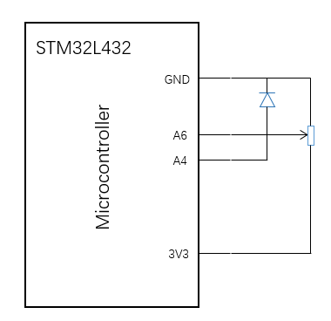
Figure 9 – Connection of 10 kΩ potentiometer and LED to demonstrate operation of analogue in and analogue out functions
/* Program to use analogue output on analogue-pin 4(A4) to control LED brightness via analogue input on analogue-pin 6(A6)
*/
#include "mbed.h"
AnalogOut Aout(A4); //defines analog output on A4
AnalogIn Ain(A6); //define analog input on A6
int main() {
while(1) {
Aout=Ain; //transfer analog in signal to analog out
}
}
- Construct the circuit of Figure 9.
- Implement the code above to vary the brightness of the LED.
- Confirm that you can vary the intensity of the LED using the potentiometer.
- Determine the smallest variation in the trim pot resistance that will cause a change in the intensity of the LED.
Hint: Read the mbed datasheet to determine the number of bits that the analogue-to-digital (or analog-to-digital) converter (ADC) has.
- What would happen if the trim pot was connected to +1V instead of Vout? What circuit from Analogue Electronics would you place between the +1V and the trim pot to make the LED intensity per step the same as in step c?
- Connect 4 separate LEDs at 4 digital output pins of the mbed. Write a program that will illuminate the 4 LEDs depending on the value of input voltage that is produced using a potentiometer to divide the output voltage on the Vout pin of the mbed. The LED illumination in response to the input voltage should meet the requirements in the table below.

Voltage | LED1 | LED2 | LED3 | LED4
0 V< Vin <0.6 V | 0 | 0 | 0 | 0
0.6 V< Vin <1.2 V | 1 | 0 | 0 | 0
1.2 V< Vin <1.8 V | 1 | 1 | 0 | 0
1.8 V< Vin <2.4 V | 1 | 1 | 1 | 0
Vin >2.4V | 1 | 1 | 1 | 1

- Using a multimeter, confirm that the appropriate LEDs illuminate for the given input voltages.

Milestone 8: Show your code to a demonstrator and demonstrate that the LED pattern is correct for the input voltages.
Procedure: Please briefly describe the exercise procedure. Also provide schematic diagram, output, figure and/or table, if any.
1.Connect a potentiometer as a voltage divider: one end to 3.3V, the other to GND, and the wiper to MCU’s analog input pin A6.
2.LED Connections: Connect four LEDs (LED1-LED4) to digital output pins. Each LED’s anode connects to the digital pin, and the cathode connects to GND through a LED as a current-limiting resistor. Use AnalogIn to read the voltage from A6 and convert it to a real voltage value (0–3.3V).
3.Use a multimeter to measure the input voltage and confirm the corresponding LEDs light up as expected for each range.

Please write your code here. Do not forget to include comments.
#include "mbed.h"

// Define an analog output pin connected to A4
AnalogOut Aout(A4);
// Define an analog input pin connected to A6
AnalogIn Ain(A6);
// Define a digital output pin for LED connected to D5
DigitalOut LED(D5);
// Define a digital output pin for LED2 connected to D6
DigitalOut LED2(D6);
// Define a digital output pin for LED3 connected to D9
DigitalOut LED3(D9);
// Define a digital output pin for LED4 connected to D10
DigitalOut LED4(D10);

int main() {
while (true) {
// Read the voltage in real - time and convert it to the actual voltage value
float voltage = Ain.read() * 3.3;
// Output the analog signal to pin A4
Aout = Ain;

// Control the LEDs according to the voltage
if (voltage < 0.6) {
// Turn off all LEDs
LED = LED2 = LED3 = LED4 = 0;
} else if (voltage < 1.2) {
// Turn on LED and turn off the other LEDs
LED = 1;
LED2 = LED3 = LED4 = 0;
} else if (voltage < 1.8) {
// Turn on LED and LED2, turn off the other LEDs
LED = LED2 = 1;
LED3 = LED4 = 0;
} else if (voltage < 2.4) {
// Turn on LED, LED2, and LED3, turn off LED4
LED = LED2 = LED3 = 1;
LED4 = 0;
} else {
// Turn on all LEDs
LED = LED2 = LED3 = LED4 = 1;
}

// Add a delay
ThisThread::sleep_for(100ms);
}
}
Please write your main finding. Also, if there are any questions asked in this milestone, include the response to these questions.
1.Voltage-to-LED Mapping: The code correctly maps input voltage ranges to LED states. For example, when the potentiometer sets, the first two LEDs (LED1, LED2) light up, matching the specified logic.
2.ADC Resolution Impact: The MCU’s ADC has 12-bit resolution, meaning it can detect voltage changes that is very small . However, the visible minimum voltage change that triggers an LED state change is determined by the code’s defined ranges (e.g., 0.6V steps), which are much larger than the ADC’s precision.
3.Answer to the question: This reduces the input voltage range from 0–3.3V to 0–1V, meaning the analog input can no longer reach the higher voltage thresholds specified in the LED activation table. As a result:LEDs that require higher voltages would never turn on.

Exercise 9 – Communication between MCU boards via SPI link
Communications systems are important for exchanging information. On the MCU board, there are various means of communication. Here we will investigate the SPI communication between two MCU boards: one MCU is set as ‘master’ (the controller issuing commands), and the other is set as the ‘slave’ (following commends). You will work in teams so you could use two MCU boards.
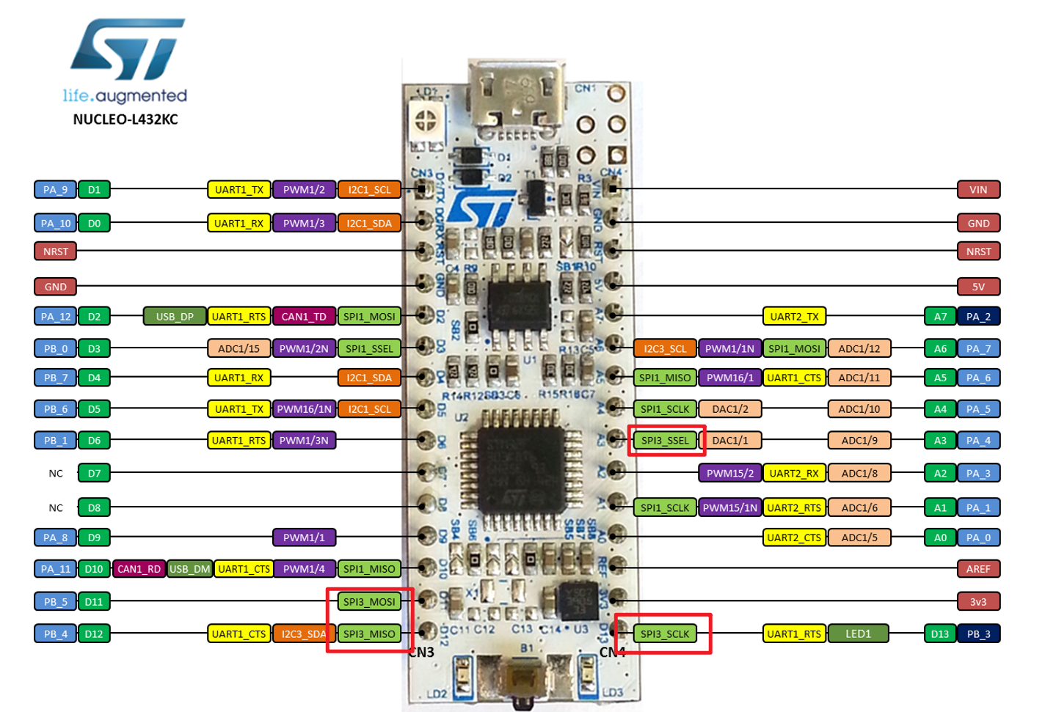
SPI3 Configuration on L432KC (circled by red)
We use the SPI3 configuration output/input on pins D11 D12 and D13. In addition, we need a digital line to select the slave that we wish to talk to, using pin A3. Connect each of these pins directly from one MCU to the same pin on the other. There should be 4 signal wires and a ground connection between the two breadboards. Note that there is also an SPI1 configuration on the L432KC, but not every combination works fine. The test results are shown in the table below, and SPI3 configuration is suggested as it does not lead to confusion.
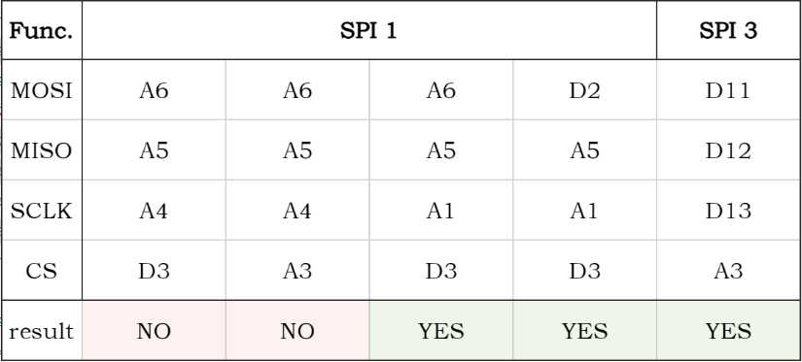
SPI Configurations test result
Each MCU needs two switches and two LEDs, connected to the appropriate digital I/O pins. The switches from the master are used to control the LEDs on the slave and vice versa.
The following program should be used on the MCU that you have selected to be the master. Please note you need to fill in (?), depending on the pins you use to connect the switches and LEDs.

// Sets the MCU up as Master, and exchanges data with a slave, sending its own switch positions, and displaying those of the slave.
#include "mbed.h"
SPI ser_port(D11, D12, D13); // mosi, miso, sclk
DigitalOut red_led(?); //red led
DigitalOut green_led(?); //green led
DigitalOut cs(A3); //this acts as “slave select”
DigitalIn switch_ip1(?);
DigitalIn switch_ip2(?);
char switch_word; //word we will send
char recd_val; //value return from slave

int main() {
while (1){
//Default settings for SPI Master chosen, no need for further configuration
//Set up the word to be sent, by testing switch inputs
switch_word=0xA0; //set up a recognisable output pattern
if (switch_ip1==1)
switch_word=switch_word|0x01; //OR in lsb
if (switch_ip2==1)
switch_word=switch_word|0x02; //OR in next lsb
cs = 0; //select slave
recd_val=ser_port.write(switch_word); //send switch_word and receive data
cs = 1;
ThisThread::sleep_for(10ms);
//set leds according to incoming word from slave
red_led=0; //preset both to 0
green_led=0;
recd_val=recd_val&0x03; //AND out unwanted bits
if(recd_val==1)
red_led=1;
if(recd_val==2)
green_led=1;
if(recd_val==3){
red_led=1;
green_led=1; }
}
}
The following program should be used on the MCU that you have selected to be the slave. Please note you need to fill in (?), depending on the pins you use to connect the switches and LEDs.
// Sets the MCU up as Slave, and exchanges data with the master, sending its own switch positions, and displaying those of the slave.
#include "mbed.h"
SPISlave ser_port(D11, D12, D13, A3); // mosi, miso, sclk, ssel
DigitalOut red_led(?); //red led
DigitalOut green_led(?); //green led
DigitalIn switch_ip1(?);
DigitalIn switch_ip2(?);
char switch_word ; //word we will send
char recd_val; //value from master

int main() {
while (1){
//Set up the word to be sent, by testing switch inputs
switch_word=0xA0; //set up a recognisable output pattern
if(switch_ip1==1)
switch_word=switch_word|0x01; //OR in lsb
if(switch_ip2==1)
switch_word=switch_word|0x02; //OR in next lsb

if(ser_port.receive()) { //test if data has been transmitted
recd_val = ser_port.read(); //read byte from master ser_port.reply(switch_word); //make this the next reply
}

//set leds according to incoming word from slave
red_led=0; //preset both to 0
green_led=0;
recd_val=recd_val&0x03; //AND out unwanted bits
if(recd_val==1)
red_led=1;
if(recd_val==2)
green_led=1;
if (recd_val==3){
red_led=1;
green_led=1; }
}
}

- Finish the two programs
- Download the programs on the appropriate boards
- Set up the boards, switches and LEDs
- Run the programs and have a look at the data and clock signals on the oscilloscope.
Note: For this exercise 1) Do not use wait() and wait_ms() any more, please use ThisThread::sleep_for(), wait_us(), or wait_ns() instead; 2) Connect the GND of two boards together; 3) You may find that LEDs are flickering, while they should be OFF. It may be caused due to various reasons. If you connect the switch input port (on the other board) directly to GND, the LEDs will be OFF; or you connect the switch input port directly to VCC, and the LEDs will be ON.

Milestone 9: Show your working SPI link to a demonstrator and explain the data and clock signals on the oscilloscope.
Procedure: Please briefly describe the exercise procedure. Also provide schematic diagram, output, figure and/or table, if any.
1.Prepare Hardware: Get two Nucleo L432KC boards (one master, one slave), four switches, four LEDs, a breadboard, and Dupont wires.
2.Connect Hardware: Link master's D11, D12, D13, A3 to slave's corresponding pins, and connect both GNDs. Connect switches to A1/A2 and LEDs to D5/D6 on each board.
3.Code and Download: Write master and slave codes using mbed compiler. The master reads and sends switch states, and controls LEDs by received data. The slave does the same. Compile and download the codes.
4.Run and Observe: TEST AND RUN.

Please write your code here. Do not forget to include comments.
#include "mbed.h"

// SPI configuration: MOSI=D11, MISO=D12, SCLK=D13, SSEL=A3 (Slave Select)
SPISlave ser_port(D11, D12, D13, A3); // MOSI, MISO, SCLK, SSEL (slave select)

// Slave's LEDs (connected to D9 and D10, mirroring master's LED pins)
DigitalOut red_led(D5);
DigitalOut green_led(D6);

// Slave's switches (connected to D5 and D6, mirroring master's switch pins)
DigitalIn switch_ip1(A1); // Switch 1 (e.g., connected to 3V3/GND)
DigitalIn switch_ip2(A2); // Switch 2 (e.g., connected to 3V3/GND)

char switch_word; // Data to reply (8 bits, lower 2 bits for switch states)
char recd_val; // Data received from master

int main() {
while (1) {
// Pack switch states into switch_word (LSB: switch_ip1=bit0, switch_ip2=bit1)
switch_word = 0xA0; // Base value (upper 6 bits can be arbitrary)
if (switch_ip1 == 1) switch_word |= 0x01; // Set bit 0 if switch 1 is ON
if (switch_ip2 == 1) switch_word |= 0x02; // Set bit 1 if switch 2 is ON

// Check if master is sending data
if (ser_port.receive()) {
recd_val = ser_port.read(); // Read data from master
ser_port.reply(switch_word); // Reply with slave's switch state
}

// Control LEDs based on received data (only use lower 2 bits)
red_led = 0;
green_led = 0;
recd_val &= 0x03; // Mask to keep only bits 0 and 1

if (recd_val & 0x01) red_led = 1; // Bit 0 controls red_led
if (recd_val & 0x02) green_led = 1; // Bit 1 controls green_led
}
}
#include "mbed.h"

// SPI configuration: MOSI=D11, MISO=D12, SCLK=D13, SSEL=A3 (Slave Select)
SPISlave ser_port(D11, D12, D13, A3); // MOSI, MISO, SCLK, SSEL (slave select)

// Slave's LEDs (connected to D9 and D10, mirroring master's LED pins)
DigitalOut red_led(D5);
DigitalOut green_led(D6);

// Slave's switches (connected to D5 and D6, mirroring master's switch pins)
DigitalIn switch_ip1(A1); // Switch 1 (e.g., connected to 3V3/GND)
DigitalIn switch_ip2(A2); // Switch 2 (e.g., connected to 3V3/GND)

char switch_word; // Data to reply (8 bits, lower 2 bits for switch states)
char recd_val; // Data received from master

int main() {
while (1) {
// Pack switch states into switch_word (LSB: switch_ip1=bit0, switch_ip2=bit1)
switch_word = 0xA0; // Base value (upper 6 bits can be arbitrary)
if (switch_ip1 == 1) switch_word |= 0x01; // Set bit 0 if switch 1 is ON
if (switch_ip2 == 1) switch_word |= 0x02; // Set bit 1 if switch 2 is ON

// Check if master is sending data
if (ser_port.receive()) {
recd_val = ser_port.read(); // Read data from master
ser_port.reply(switch_word); // Reply with slave's switch state
}

// Control LEDs based on received data (only use lower 2 bits)
red_led = 0;
green_led = 0;
recd_val &= 0x03; // Mask to keep only bits 0 and 1

if (recd_val & 0x01) red_led = 1; // Bit 0 controls red_led
if (recd_val & 0x02) green_led = 1; // Bit 1 controls green_led
}
}
Please write your main finding. Also, if there are any questions asked in this milestone, include the response to these questions.
1.Main Findings: SPI communication between the two boards was successful. The master and slave exchanged switch - state data correctly and controlled LEDs as expected.
2.Question Responses: For LED flickering, check switch input connections. Connecting to GND or VCC stabilized the LEDs, suggesting unstable switch signals were the cause.

