# **UnityFbs: QuickStart guide**

1. First of all, you need to get a flatc-compiler. Due to Unity AssetStore restrictions I have to remove prepared binaries from package. But you can get flatc-compiler in two ways:
   1. Download a prepared flatc-compiler for your platform form github of this plugin: <https://github.com/Wunder9l/UnityFbs/tree/master/Assets/UnityFbs/Plugins/FlatBuffers/FlatcCompillersForPlatforms>
   2. Build by yourself according to documentation on <https://google.github.io/flatbuffers/flatbuffers_guide_building.html>
2. Set flatc-compiler path: right click on flatc-compiler file in the Editor -> Set as flatc-compiler file:

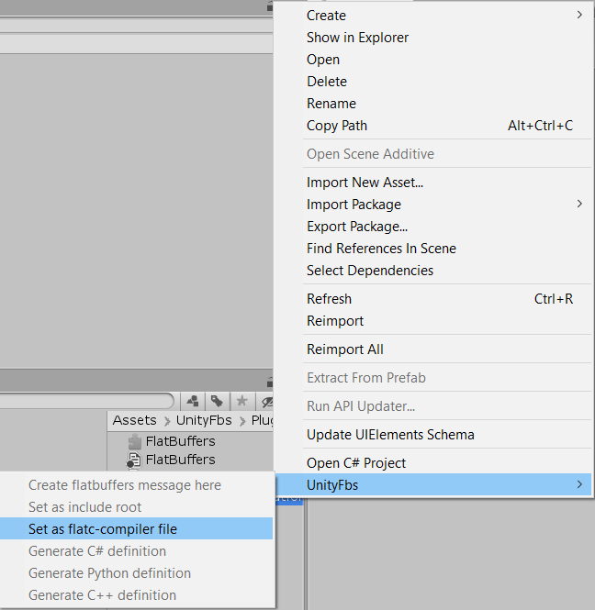

1. Now you can use UnityFbs:
   1. Create new .fbs-message:

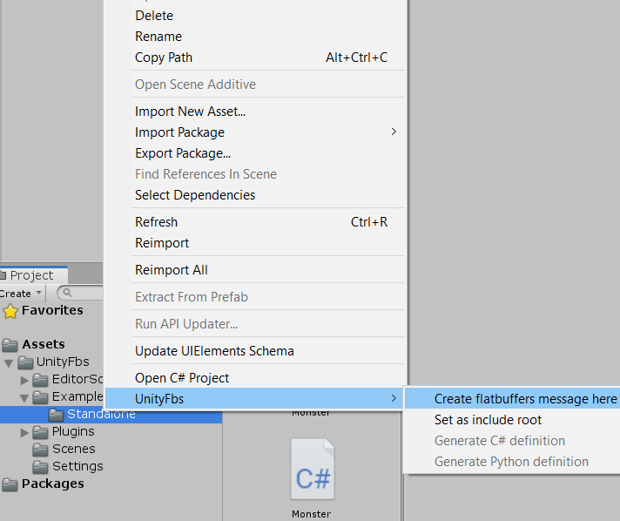

* 1. Compile it

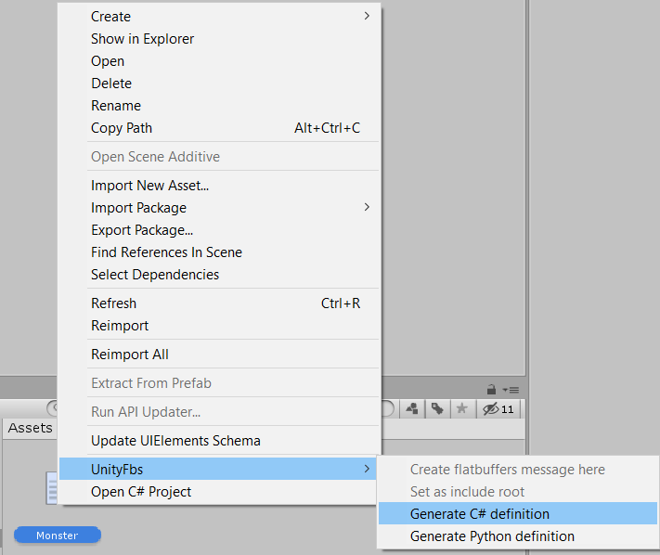

## Extra

1. You can check and set setting of UnityFbs at Edit->Project Settings->UnityFbs

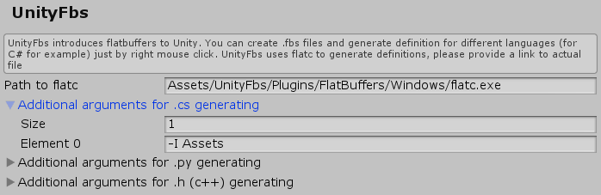

1. If you use hierarchical structure of .fbs-messages and include one into another you probably need to set an include root directory:

