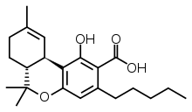

THC-A Precursor (FRESH cannabis) before heating

Phase I: Oxidation

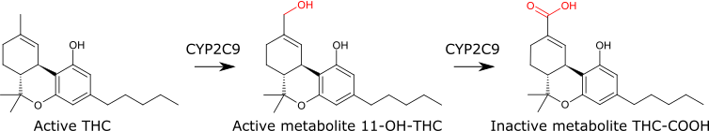

Phase II: Glucuronidation

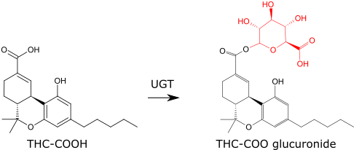

NOTES – wdg public health canna site

Add information about metabolism of THC to 11-OH-THC

