# Connection Utility

## Overview

The Connection Utility can help you reduce repetitive connection tasks when constructing a model in CyPhyML. Based on your current context, it will try to guess connections and port-extension operations that need to be performed and perform them for you.

## Supported Contexts

### Test Bench models

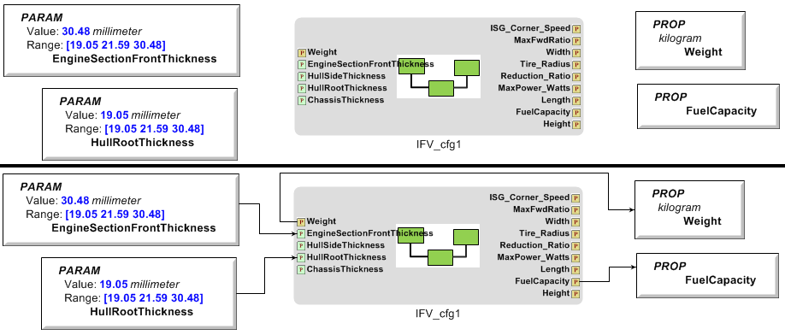The connection utility will find all of the Parameters and Properties of the Test Bench. If a Parameter or Property with the same name exists within the Top Level System Under Test, then a ValueFlow connection will be made between them. Parameters flow into the system under test, while Properties flow out of the system under test.

### Design Space models

#### Design Container: Compound

Figure 1: Before and after within a simple Test Bench

In a compound container, you usually want to sum up any values that all of your child containers have in common.

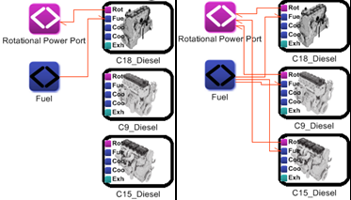For each common Property, a copy of that Property is created at the current level, along with a SimpleFormula addition block, and is fed by ValueFlow connections from the corresponding Properties in the child containers. If a Property block by that name already exists, then the utility will connect to the existing block.

#### Design Container: Alternative

In an alternative container, all of your child objects usually have the same ports, and need to be connected the same way inside the block. For Parameters and Properties the children have in common, the utility will create a copy (or use an existing one) at the container level and connect all of the ports from the child objects.

For each other kind of port, select one component and "extend" all of its ports. For these kinds of ports, the utility looks for an "exemplar," one component that has a connection established using this port. Then it will mirror that connection for each matching port in the other child containers. Match is defined as same name and type.

Figure 2: Before and after within an Alternative Design Container