# CyPhyCAExporter: Generate ComponentAssembly from Desert



## Overview

The DESERT process exports "configurations," each one a set of decisions that represents a feasible design point. These configurations only contain references to the design elements that were selected during the DESERT process without any connections or assembly hierarchy. This tool converts those configurations into fully-elaborated CyPhyML design models. These elaborated models include all connections between components and subsystems and can preserve the hierarchy of the design space.

## Supported Context

Configurations exported from the DESERT process are stored in a "Configurations" model within the top design container. Each exported configuration is represented as a "CWC" model within this container. Select the CWCs that you want to have elaborated, and run the component. The figure below shows a group of exported CWC models for a design space.

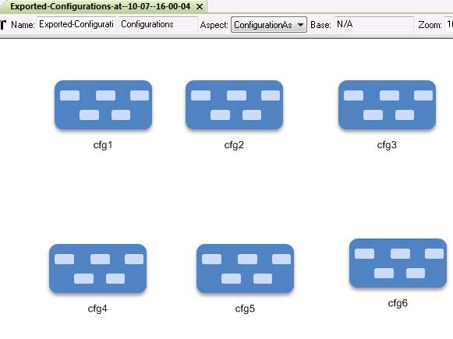

*Figure 1: Exported configurations for a design space (named ‘design_v3’)*

## Component Assembly Export

Once a group of configurations are selected and CyPhyCAExporter is run, it creates fully-specified component assembly models for the chosen configurations. The fully-specified component assembly includes the full hierarchy of the models as well as all connnections. The tool also creates references of these generated component assembly models and places them next to the CWC models that were used for generating them and connects them so that user can easily navigate to the generated component assembly from the configuration for which it was generated. The figure below shows the updated “Configurations” model:

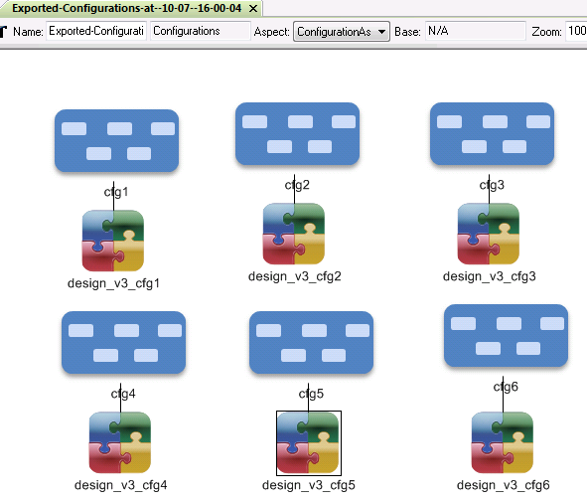

*Figure 2: Configurations converted to component assemblies*