# CyPhyCriticalityMeter: Design Space Criticality/Complexity Meter Tool.

## Overview

This tool plays a very important role in allowing the design space refinement process to work. Therefore, the reader is requested to first read and understand the documentation for both CyPhyDSRefiner and CyPhyDSEConverter tools.

Basically, during the design space refinement process, user selects a set of configurations based on the outcome of static and dynamic analysis of all configurations for further refinement. This is done using CyPhy’s CyPhyDSRefiner tool. CyPhyDSRefiner tool converts the selected configurations into a newly created refined design space. This new refined design space is leaner and a direct representation of the originally selected design configurations with all connections, ports, and properties preserved. The newly created refined design space can be freely refined and expanded for further design space exploration and refinement.

In CyPhyDSEConverter documentation, we looked at how that tool can be used to convert existing components, component assemblies, or design containers into a new design container that can now include new parts in it. At this stage, we envision a new tool to further help the user in determining the usefulness of refining a particular component, component assembly, or a design container. The Design Space Criticality/Complexity Meter Tool will serve this purpose.

One example of the key criticality metrics that is of immediate help to the designer is the number of configurations a particular component, component assembly, or a design container appears in. Depending on the design space, user may choose to refine a design element that is included in all or some reasonable number of configurations. It is worth noticing at this point that at this stage there won’t be any design element in the refined design space that appears in none of the configurations. This is a direct result of the design refinement process in CyPhy – which eliminates all design elements from the refined design space that are not part of the selected configurations for design refinement. However, if the refined design space is further elaborated/refined (or the tool is run for the original/unrefined design space), some components may not appear in the any of the new configurations that will be generated for the refined design space.

Another good example of key metrics that can be computed and shown to the designer at all times is the complexity metrics based using a variety of algorithms. At present, the tool only shows the number of configurations for all components, component assemblies, and design containers. This is shown as an attribute of design elements called “NumAssociatedConfigs”. This is illustrated in figure 1 below. It shows that ISG-1 wasn’t selected in any design configurations, whereas ISG-2 was selected in 3 of 5 design configurations. This example is for original IFV drivetrain design space.

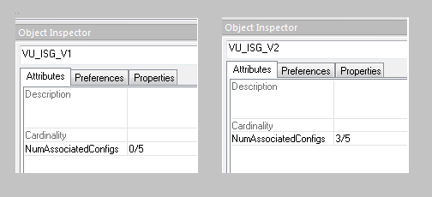

*Figure 2: NumAssociatedConfigs value for ISG-1 and ISG-2*

Also, when invoked, the tool calculates these numbers for all design spaces that are in the GME model. The tool internally runs the Design Space Helper tool and applies ALL constraints of design space and updates the NumAssociatedConfigs attribute for all of the design elements in the design space. The tool runs in batch mode such that NO user selection dialogs are presented (e.g. to select only a few constraints in a design space).