# CyPhyDSRefiner: Design Space Refinement Tool

## Overview

One of the critical requirements of Design Space exploration and configuration generation is the capability to perform coarse-grained exploration and constraint satisfaction on some parts of the design space and when satisfactory configurations have been generated, do deeper refinement of those parts on the selected results. Such a capability is provided by CyPhy’s design refinement tool.

If a user endeavors to completely specify the entire design space down to individual nuts and bolts, not only the design space becomes unmanageable, the analysis tools of varying capabilities are difficult, cumbersome, and time-consuming to apply. It is even possible that the design space becomes so huge that it allows for generation of billions of configurations some of which only differ in a very small way such as color of the dashboard meter! Even if the user manages to reduce the number of configurations by using an appropriately chosen set of design constraints, using all the analysis tools (for all domains we need to analyze such as CAD, Thermal, Electrical, etc.) at such a detailed level becomes highly arduous and time-consuming.

As such, we need to be able to specify design space at a level of detail that we are comfortable reasoning with. As there are constraints that are applicable at this level itself, it is desirable to make use of them and eliminate huge chunks of design space that are clearly infeasible. User then proceeds with generation of constraints at this coarser-level of design space. It is important to note that it is not necessary to specify all parts of the design space at the coarser level and it all depends on the level of detail for each part of the design space that user is comfortable reasoning with and have analysis tools available for. The next step is, of course, to use the generated configurations and run various static and dynamics analysis. Once the analysis is over, a few configurations are down-selected that satisfy all static and dynamics design constraints.

This is the point where CyPhyDSRefiner tool can be invoked on a set of selected design configurations (CWC models generated by the DesignSpaceHelper tool). The design refinement tool will take these selected design configurations and convert them into a refined design space that can be reasoned with in the same way as the original design space. Even the generated refined design space looks very much like the original design space. However, the key difference is that any component, component assembly, or design container that is not part of any of the selected design configurations is not included in the refined design space. Secondly, the original static constraints are removed and a new visual constraint is added that directly encodes the configurations that were selected for design refinement. The reason for this is that the initial configurations were selected only after a detailed constraint satisfaction and dynamics analysis of the original coarse-level design space and there is no need for re-doing that work.

Note that for all components which are still part of the refined design space, all of their connections, ports, and properties are preserved in the generated refined design space. In fact, if Design Space Helper tool is invoked again on the refined design space, the configurations generated are exactly the same as those that were selected for refinement from original design space – with same look and behavior!

## Example

The new refined design space is leaner and a direct representation of the originally selected design configurations. However, as it is still a design space, the user can freely refine and expand this design space as different parts of the design space are now included or some parts of the design space are further elaborated into greater detail.

The CyPhy tool called CyPhyDSEConverter is very useful here to convert existing components, component assemblies, or design containers into a new design container that can now include new parts in it. See the document on CyPhyDSEConverter document for more on that.

Below we provide an example to illustrate the design space refinement process. Figure 1 below shows the top-level view of a sample IFV drivetrain design space.

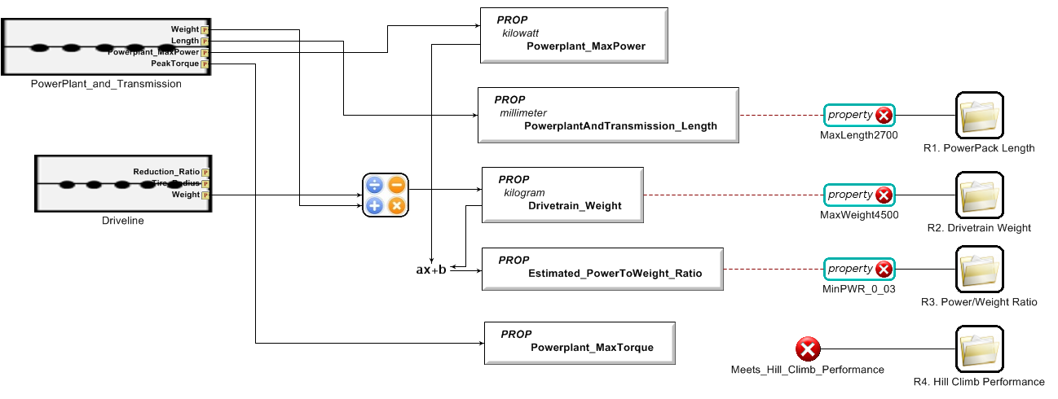

*Figure 1: Top-level view of the IFV drive train design space*

When Design Space Helper tool is invoked on this design space, the tree viewer of the configurations shows that there are a total five configurations that satisfy all of the design constraints that were specified in the design space. Figure 2 below shows the tree viewer of the tool. It can be seen in Figure 2 that both VU_ISG_V2 and VU_ISG_V3 are used in some of these five configurations. Also, both transfer cases are used, viz. 455 and 484.

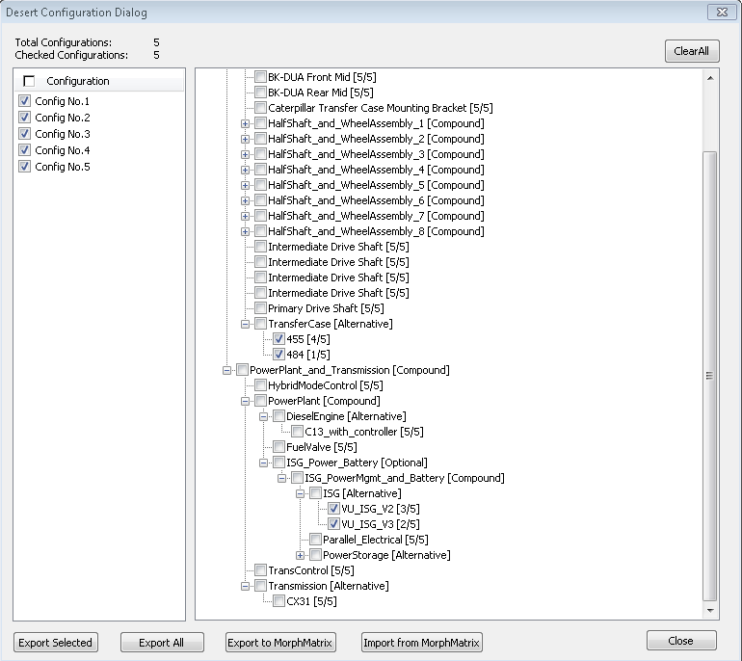

*Figure 2: Design configurations tree-viewer*

When all of the five configurations are exported, each of them is then elaborated from CWC models (containing only design element references with no connections or hierarchy) to fully-specified component assemblies with hierarchy and connections. Figure 3 below shows the five generated configuration models and a fully-specified component assembly corresponding to configuration #3.

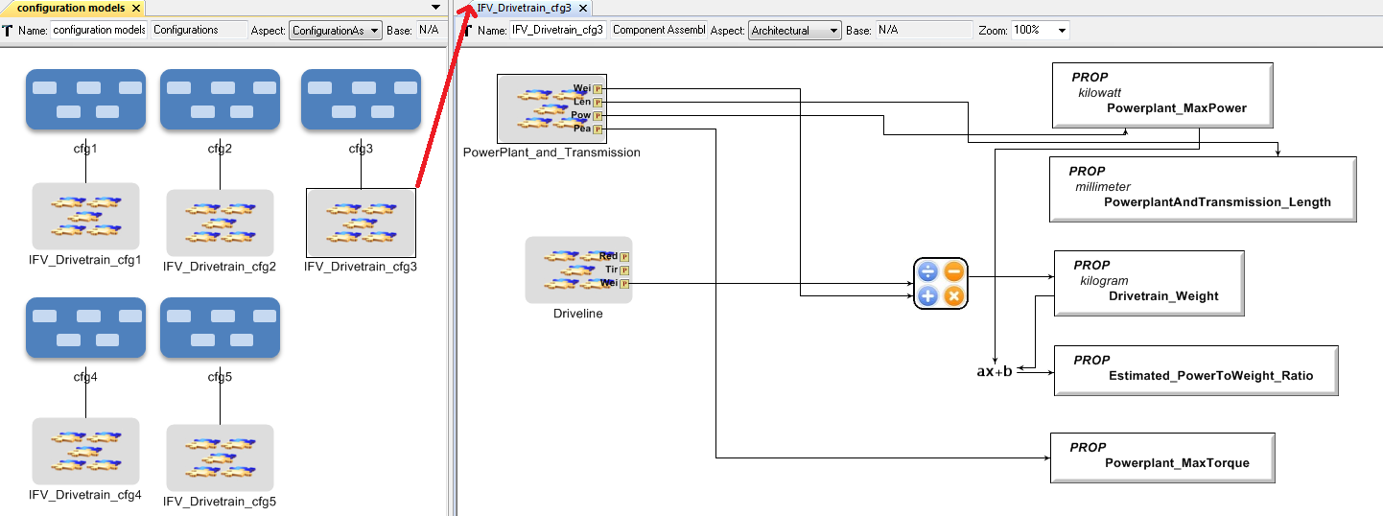

*Figure 3: Generated configurations (CWC models) and a fully-specified component assembly*

Next the detailed analysis is performed for these fully-specified component assemblies. Let’s assume that after analysis, configurations #2 and #3 were selected finally. Next, we select the cfg2 and cfg3 CWC configuration models in GME and invoke the CyPhyDSRefiner tool to generate a new refined design space that includes only these two design configurations. Figure 4 below shows the top-level view of the refined design space. Notice that this looks exactly like the original design space, except that a new reference to the original design space and a new visual constraint is added to the refined design space.

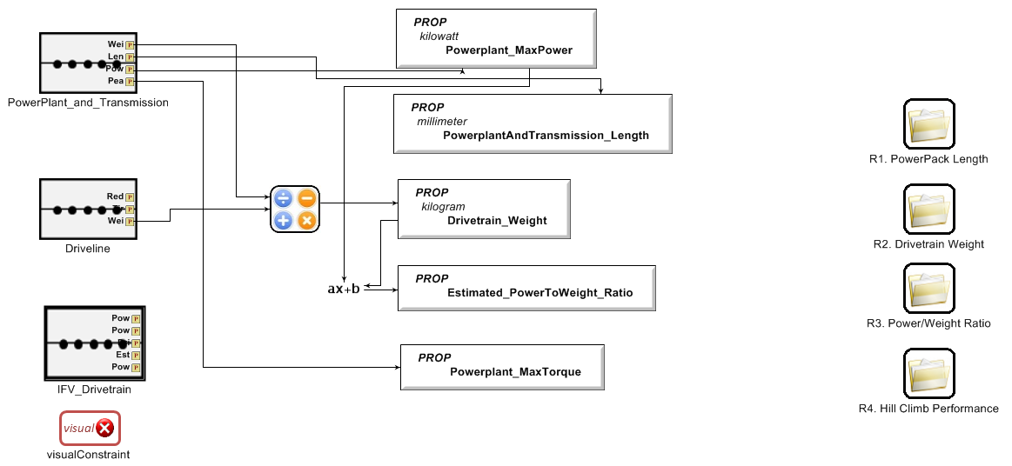

*Figure 4: IFV drivetrain refined design space using configurations 2 and 3*

However, when we look deeper into the ISG design alternatives in the refined design space (see Figure 5 below), we can see that now it contains only VU_ISG_V3 ISG (and only 455 transfer case) as the constituent component. The detailed path to ISG container can be seen in the title of the GME window in the figure.

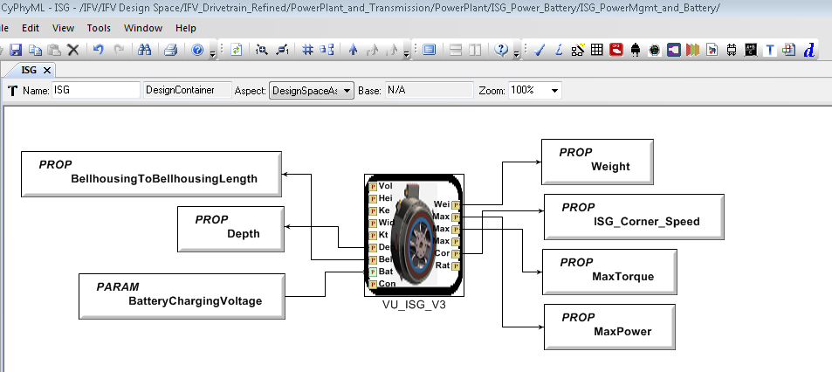

*Figure 5: Looking deeper into ISG alternatives in refined design space*

At this point, user can safely edit the refined design space for further elaboration or refinement as is normally done during design space modeling. Newer design constraints can also be added along with this refinement.

Moreover, if more alternatives need to be added at the same level as an existing design element (i.e., a component, a component assembly, or a design container), then CyPhy’s Design Element to Container Converter Tool called, CyPhyDSEConverter can be used.