# CyPhyDynamics

## Overview

The CyPhyDynamics interpreter creates a Simulink simulation from bond graph models representing the physical dynamics of system components. Model parameters in CyPhyML are translated to constants and workspace variables in the generated Simulink model. Controller components that are specified as alternative models in CyPhyML can be generated directly as Simulink blocks or as a platform-included TrueTime Simulink model using the ESMoL tools. The interpreter also integrates Simulink blocks specified by test components such as test drivers and evaluation blocks in the test bench.

## Supported Context

**TestBench models**

Invoking the CyPhyDynamics interpreter on a test bench creates a Simulink model including test drivers, dynamic simulations for the included components, and evaluation blocks. In the test bench, driver and evaluation components refer to Simulink blocks defined previously and placed in the Include directory.

## Options

### Use ESMoL Implementation:

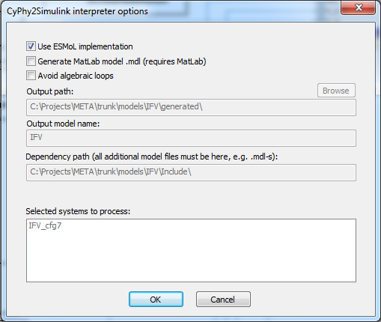Create a detailed ESMoL software implementation model for controller blocks.

Figure Dialog Box Displaying options

### Generate MatLab model .mdl (requires MatLab):

The interpreter generates a script that creates the full Simulink model. When this box is checked, the interpreter will also run the script (does not work with the ESMoL option).

### Avoid algebraic loop:

Insert delays to avoid algebraic loops in the simulation.

### Output path (read-only):

In Matlab, run ‘IFV_buildscript’ from this location to create the dynamics simulation model.

### Output model name (read-only):

Filename string – the generator appends .mdl.

### Dependency path (all additional model files must be here, e.g. .mdl-s):

Library file locations (for driver and evaluator blocks).

### Selected systems to process:

Name of the design instance model which will be simulated.