# Master Interpreter

## Overview

The Master Interpreter is primarily used to execute Test Bench models. It can guide the sequential execution of multiple interpreters as part of a workflow.

For Test Bench models that include references to a Design Space model as the System Under Test, the Master Interpreter can iterate over any number of configurations that were generated from that Design Space.

## Supported Contexts

### Component Assembly

*not yet documented*

Figure 1: The Master Interpreter GUI

### Design Space (Design Container)

*not yet documented*

### Test Bench

ringthen MIit*d*

IfTBand no (Figure 2),tconfiguration, a(Dashboard.xml)

If the System Under Test in the Test Bench is a Component Assembly, then the interpreters in the workflow are executed sequentially on the Test Bench. All outputs are gathered in the output directory.

If the System Under Test in the Test Bench is a Design Space model, then it is treated as a “template.” The component generates separate test benches for each selected configuration based on the provided template. The design space reference will be replaced by generated references to each configuration. In the output directory, each configuration will have its own subdirectory, and each interpreter will have its own subdirectory within that.

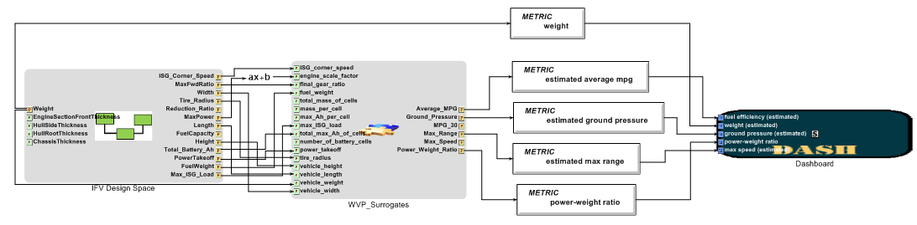

Figure 2: Test Bench model driving dashboard visualization

### Multi-Experiment (without Design Space reference)

*not yet documented*

### Multi-Experiment (with Design Space reference)

*not yet documented*