**RLC circuit**

1 Mar 2011

Figure 1. Circuit Schematic

R: 2 Ω 15W ±1%

L: 1 mH 1.8A ±15%

C: 680 µF 16v ±20%

Vin: 5vrms, variable waveform

Components mounted to 30mm circular perforated board (see Fig 2). Board secured inside of 30mm ID pvc tube, open on ends, positioned vertically

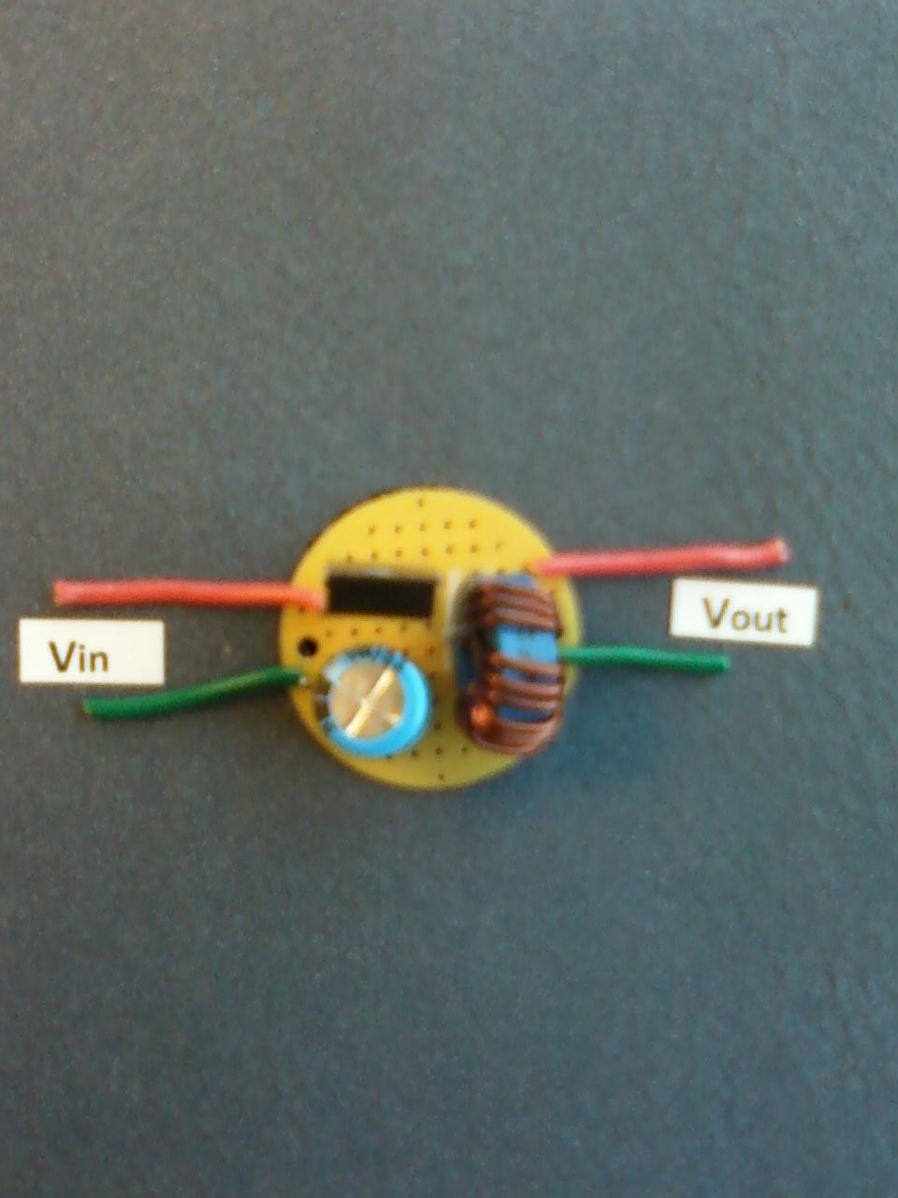

Figure 2. Example Layout