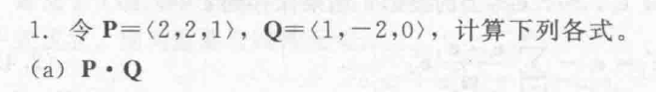
2 * 1 + 2 * (-2) + 1 * 0 = -2
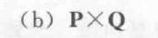
((2 * 0 – 1 * (-2)),(1 * 1 – 2 * 0),(2 * (-2) – 2 * 1)) =
(2,1,-6)
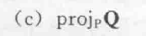
-2/9 * (2,2,1) = (-4/9,-4/9,-2/9)
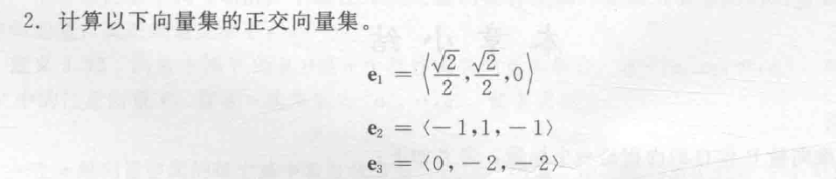
如果输入向量v0、v1和v2，则Gram-Schmidt正交向量产生矢量u0、u1和u2如下，
u0 = v0 / |v0|
u1 = (v1 - (u0 * v1)u0) / |v1 - (u0 * v1)u0|
u2 = (v2 - (u0 * v2)u0 - (u1 * v2)u1) / |v2 - (u0 * v2)u0 - (u1 * v2)u1|

其中|A|表示向量A的长度和A * B表示向量A和B的点积

e1’ = e1
e2’
= (e2 - (e1’ * e2) e1)
=(e2 - (e1’ * e2) e1)
= e2

e3’
= (e3 - (e1 * e3) e1 - (e2 * e3) e2)
=((0,-2,-2) – (-1,-1,0) - 0)
= (1,-1,-2)

V2 – V1 = (-3,0,1)
V3 – V1 = (6,-10,3)
(V2 – V1) X (V3 – V1)
= (0 * 3 – 1 * (-10)),(1 * 6 – (-3) * 3),((-3) * (-10) – 0 * 6)
=(10,15,30)
||(V2 – V1) X (V3 – V1)|| = √(100 + 225 + 900) = √1225 = 35
35 * (1 / 2) = 17.5
(V · W)²+ ||V X W||²
= (||V|| ||W|| cosα) ²+ ||||V|| ||W|| sinα ||²
= V ² W²(cosα² + sinα²)
= V ² W²
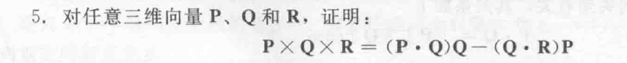
P X Q X R
= (PyQz – PzQy,PzQx – PxQz,PxQy – PyQx ) X R
= (PzQx – PxQz) * Rz – (PxQy – PyQx) * Ry,
(PxQy – PyQx) * Rx - (PyQz – PzQy) * Rz,
(PyQz – PzQy) * Ry – (PzQx – PxQz) * Rx
= (PzQxRz – PxQzRz) - (PxQyRy – PyQxRy),
(PxQyRx – PyQxRx) - (PyQzRz – PzQyRz),
(PyQzRy – PzQyRy) – (PzQxRx – PxQzRx)
= (PzQxRz + PyQxRy – PxQzRz - PxQyRy),
(PxQyRx + PzQyRz– PyQxRx - PyQzRz),
(PyQzRy + PxQzRx – PzQyRy – PzQxRx)
(P·R)Q – (Q ·R) P (题目出错，正确是这样，参照第一版)
=(PxRx + PyRy + PzRz)Q – (QxRx + QyRy + QzRz)P
= (PxRxQx + PyRyQx + PzRzQx) - (QxRxPx + QyRyPx + QzRzPx),
(PxRxQy + PyRyQy + PzRzQy) - (QxRxPy + QyRyPy + QzRzPy),
(PxRxQz + PyRyQz + PzRzQz) - (QxRxPz + QyRyPz + QzRzPz),
=(PyQxRy + PzQxRz - PxQyRy - PxQzRz),
(PxQyRx + PzQyRz - PyQxRx - PyQzRz),
(PxQzRx + PyQzRy - PzQxRx - PzQyRy),
两边相等。
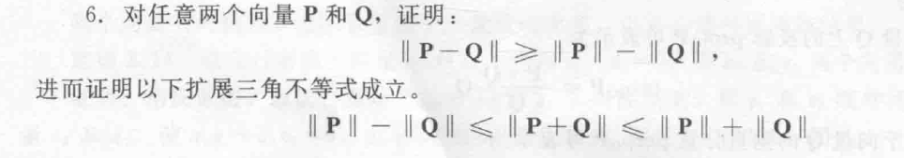
|| P - Q||²
= (P - Q) ·(P - Q)
= P² + Q² - 2 P·Q
≥ P² + Q² - 2 ||P||||Q||
= (|| P|| - || Q||)²

(|| P|| - || Q||) ²
≤P² + Q² - 2 ||P||||Q||
≤P² + Q² + 2 ||P||||Q||
≤|| P + Q||²
≤(|| P|| + ||Q||)²

