NAMIBIA UNIVERSITY OF SCIENCE AND TECHNOLOGY
Faculty of Computing and Informatics

STEMMate Namibia
Final Consultancy Report
Architecture, vertical slice, tests, evaluation and redesign
Student number | Name | Practical group | Primary role
225009145 | Nangolo Nombili | 02 | Project manager and report
225121506 | Lydia Amutenya | 02 | Requirements
225050579 | Dinilson Nathinge | 02 | Architecture
223124680 | Naobeb DB | 02 | Development (backend and data)
225068125 | Alfons Beukes | 02 | Development (interface) and testing
223128503 | Mouton JM | 02 | Evaluation and redesign

Team | Group 06
Team representative | Nangolo Nombili
Course | Software Design (SDN621S), Semester 2, 2026
Assessment | A4 (25% of the course mark)
Submission date | 6 November 2026
Repository | https://github.com/Wxanted/STEMMATE_Assignment_4

1. Executive summary
STEMMate Namibia is a web app for volunteers who run STEM clubs in schools with little or no internet. The client context is the Namibian Sustainable Software Design Laboratory (NSSDL). This report is our final consultancy report for Assessment 4. It explains what we designed, what we built, how we tested it, what we learned from real users, and what we advise the client to do next.
What we built. One complete working path, called a vertical slice: a facilitator logs in, filters a catalogue of 31 STEM activities, opens one, saves it on the phone, and opens it again with no internet. The path has a screen layer, input checks, filter logic, saved data and a visible result. All data is made up.
What we did not build. Our requirements plan said the slice would be "planning a session offline": creating a session plan, saving it, and syncing it to a server. We did not build that. The plan editor, the sync queue, the server and the Synced, Pending and Failed status are designed in this report but they are not code. We say this early because the traceability matrix shows it: of 16 requirements, 2 are Passed, 11 are Partial, 1 is Not implemented and 2 are Deferred.
Evidence. We have 37 documented tests. 32 are automated and all 32 pass in the final run (15 unit tests and 17 browser tests). The first browser run had 2 failures, and we kept them as evidence. 5 manual tests, including a screen reader test and a test on a real phone, were not run. Five people did a task-based usability test on 2 November 2026. All five saved an activity and opened it with no internet, without help. Logging in was the weakest task: 3 people did it alone, 1 needed help and 1 could not do it.
Redesign. We record five before and after changes. Two are built (touch-size buttons and a build step that makes the app open from a file). Three come from the usability test (a simpler no-results screen, a stronger Online sign, and filters that switch off dead-end choices). Those three are designed but not built. One major problem, a login screen that is hard to see, has no fix yet.
Recommendation. Treat this work as a proof of the offline find-and-save path, not as a product. Before any school use: fix the login screen, replace the placeholder login, encrypt saved data, run the five manual tests on a real low-cost Android phone, then build the plan editor and sync in that order. Section 12 gives the steps.
How to read the evidence. Every claim in this report points to a test ID, a file in the repository or the usability record sheet. Where something is a plan and not a fact, the text says "planned", "designed" or "proposed".

2. Context and problem

2.1 Who the users are and where they work
The users are STEM club facilitators. They are often volunteers or teachers, not software experts. They work in low-resource schools. We use these working assumptions, which come from the A3 baseline and the brief:
- The device is a low-specification Android phone, often shared by several facilitators.
- Internet is slow, costs money, or is missing. The app must work with no connection after the first visit.
- A facilitator needs to find a suitable activity quickly. Requirement QR-01 sets a target of about two minutes.
- No pupil names, photos, recordings or school records may be collected or stored (QR-05).
These are assumptions. We did not interview facilitators, because the brief forbids unapproved external contact. Our test users were adults from our own circle (Section 8), so they do not prove how real facilitators behave.

2.2 The problem we chose
A facilitator with no internet cannot look up a science activity, so the session depends on what the facilitator remembers or has on paper. STEMMate lets them keep a library of activities on the phone. The A4 task was to show, through one thin but complete path, that this can work on a weak device with no connection, and to describe the larger design around it.

2.3 Scope: what is in and what is out
Area | Position
Built and tested | Login (demo accounts), filter by level, topic, time and materials, view an activity, save it on the device, open it with no internet, separate saved lists for each user, error screen when the device storage is full.
Designed, not built | Session plan editor with autosave (FR-03, QR-02), sync queue and server (FR-04), Synced, Pending and Failed status (FR-A4-02), conflict choices, backup and restore.
Deferred by decision | Equipment and materials record (FR-05) and reuse of old plans (FR-06). The requirements register marks them as outside the A4 slice.
Excluded on purpose | Attendance recording. It would store learner-related data, which conflicts with QR-05 (Section 6.6).

2.4 How the team worked
Six members, each with a primary role (cover page). The repository on GitHub holds the requirements, the traceability matrix, the architecture diagrams, the code, the tests and the test results. Commits are dated and show who did what. Each member also submits an individual evidence file.
Member | Role | Main work in the repository
Nangolo Nombili | Project manager and report | Created and organised the repository, merged pull request #1, wrote the README, demo script, evaluation report and this report.
Lydia Amutenya | Requirements | Requirements register and traceability matrix (dated 20 October 2026, updated 5 November 2026).
Dinilson Nathinge | Architecture | Architecture diagrams (8 pages) and the four decision records.
Naobeb DB | Development (backend and data) | Back-end and data prototype and its guide (not part of the verified slice, Section 6.6).
Alfons Beukes | Development (interface) and testing | Interface slice, unit and browser tests, test register (pull request #1, branch Alfons-interface).
Mouton JM | Evaluation and redesign | Usability test record sheet results and the before and after changes file (2 November 2026).
Roles and main work. This is a summary from the repository and the shared files. Each member's own evidence file gives the detail.

3. Updated requirements

3.1 The register and the status of each requirement
We kept the A1 and A2 requirement IDs (FR-01 to FR-06 and QR-01 to QR-06) so that all documents trace to each other. We added four requirements for A4. They use the prefix A4: FR-A4-01, FR-A4-02, QR-A4-01 and QR-A4-02. Table 1 gives the status of each, as set in the traceability matrix of 5 November 2026. The full matrix is Appendix A.
ID | Requirement (short) | Status | Tests
FR-01 | Browse and filter stored STEM activities by level, duration, topic and available materials. | Passed | U01–U04, E01, E16
FR-02 | Save a selected activity on the device for offline use. | Passed | U05, E01, E04
FR-03 | Create and edit a session plan containing steps, timing, materials, safety notes and inclusion prompts. | Not implemented | none
FR-04 | Synchronise a completed local plan when internet connectivity returns without losing content. | Partial | none
FR-05 | Record equipment/materials use, including session date, responsible person and equipment return status. | Deferred | none
FR-06 | Reuse or copy a previous session plan. | Deferred | none
FR-A4-01 | Require a facilitator to sign into a private workspace before viewing or editing plans. | Partial | E02, E03, E11, E12
FR-A4-02 | Display Synced, Pending or Failed sync status using text or an icon as well as colour, while preserving the local plan after sync failure. | Partial | none
QR-01 | Allow a facilitator to find and select a suitable stored activity within approximately two minutes offline. | Partial | U01–U04, E01, E04, E14, M03
QR-02 | Automatically save an unfinished plan and preserve it after connection loss, app closure or device restart. | Partial | none
QR-03 | Support use on a shared, low-spec device while avoiding unnecessary large downloads. | Partial | U06, E14, M02
QR-04 | Support keyboard access, readable contrast, visible focus, labelled controls and messages that do not rely on colour alone. | Partial | E06–E10, E13, E15, M01, M04, M05
QR-05 | Do not collect, store or synchronise pupil names, photos, recordings, school records or other pupil-identifying information. | Partial | none
QR-06 | Keep drafts separate and protected on a shared device so a second workspace cannot open, change or delete another workspace's unfinished draft. | Partial | U12, E11, E12
QR-A4-01 | Provide understandable error messages that indicate whether an operation succeeded, failed or requires recovery. | Partial | E02, E03, E05
QR-A4-02 | Preserve the integrity of saved plans and provide a way to verify that they were stored successfully locally and after synchronisation. | Partial | none
Table 1: Requirements and verification status. "Passed" means verified with recorded evidence. "Partial" means some of the requirement is shown but not all of it.

3.2 What changed from the baseline
- Added: FR-A4-01 (private sign-in), FR-A4-02 (sync status shown in text as well as colour), QR-A4-01 (clear success and error messages), QR-A4-02 (a way to verify that a plan was stored).
- Changed in meaning: FR-01 and FR-02 now refer to activities in the built slice. FR-03 and FR-04 refer to session plans, which are not built.
- Deferred: FR-05 and FR-06, as stated in the register.

3.3 Problems we found in our own requirements work
- The test register and the architecture diagrams were written with the A3 identifiers (PR-01, SR-01, AR-01 and FR-05 for sync). The A4 register uses different numbers (for example QR-05 for privacy, QR-06 and FR-A4-01 for access, QR-04 for accessibility, FR-04 for sync). The matrix links tests to the A4 IDs by hand. A future version should rename the tests and diagrams to one set of IDs. Table 2 shows the mapping we used when reading the older files.
A3 ID (old files) | Meaning | A4 requirement used in the matrix
PR-01 | No pupil data | QR-05
SR-01 | Sign-in, separate profiles | FR-A4-01, QR-06
AR-01 | Accessibility | QR-04
FR-05 (A3) | Sync a saved plan | FR-04 and FR-A4-02
FR-04 (A3) | Autosave a plan | QR-02
FR-03 (A3) | Save an activity offline | FR-02
Table 2: Identifier mapping between the architecture and test files (A3 IDs) and the A4 register. This mapping was worked out by the report author from the files. The requirements owner should confirm it.
- Four statuses (FR-04, FR-A4-02, QR-02, QR-A4-02) rely partly on results reported by a peer about the sync queue. The matrix says the logs were not independently reviewed. We do not use those reports as proof in this report. The code we could run and test has no sync queue.
- The attendance prototype in the repository (Section 6.6) is not in the register and conflicts with QR-05, so we did not count it.

4. Design argument
Our argument has four steps. Each step starts from a fact about the context and ends in a design choice.
Fact about the context | What it means for the design | Design choice
Internet is missing or costs money. | The app cannot depend on a server to be useful. | Offline first. The app and the saved activities live on the phone. A server is only for backup and sync.
Devices are weak and shared. | Big downloads and heavy frameworks are a risk. Two people may use one phone. | A small web app with no framework (about 33 KB). Saved data is kept separately for each signed-in user.
Users are not experts and have little time. | Mistakes must be easy to recover from. | Clear messages, a Save failed screen with three ways out, a Clear filters button, and large touch targets.
Pupils are children. | Collecting their data creates risk and is outside the brief. | The data model has no pupil fields. Attendance recording was left out.
Money and skills for support are limited. | A complex stack would be abandoned. | Plain HTML, CSS and JavaScript. One build command. A small school PC as the only server (proposed).
Table 3: From context to design choice.

4.1 Why a Progressive Web App
A web app that installs from a link works on any Android phone with a recent browser. There is no app store, no download of a large package and no separate version for each device. A service worker keeps a copy of the app files so the app opens with no connection (Mozilla Developer Network, 2024). We decided this in ADR-01 (Section 5.8).

4.2 Why local first
If every save went straight to a server, a lost connection would lose the facilitator's work. In a local-first design the phone is the main copy. The server gets a copy later. This matches the offline cookbook patterns described by Archibald (2014). The built slice follows this idea for saved activities. The planned sync follows it for session plans (ADR-02).

4.3 The trade-offs we accept
- Weaker security for simpler code. Saved data is stored as plain text in the browser and the login is a placeholder. Real facilitators need encryption and a real login before use (ISS-03, ISS-04).
- Fewer features for a more reliable path. We built one path and tested it well instead of building a plan editor that we could not test.
- Browser storage limits. Browser storage is small and can be cleared by the user or the phone. Backup to the server is therefore part of the design, not an extra.

5. Architecture
Each view has one purpose. The diagrams are redrawn from the team's architecture file (docs/architecture/STEMMate_A4_Architecture.drawio, 8 pages). We marked each part as BUILT or NOT BUILT so that the diagrams do not claim more than the code does. In every diagram a solid line is local or offline and a dotted line needs a connection.

5.1 System context
Purpose: show the boundary of the system and who or what it talks to. It serves FR-01, FR-02 and FR-04, and QR-05.
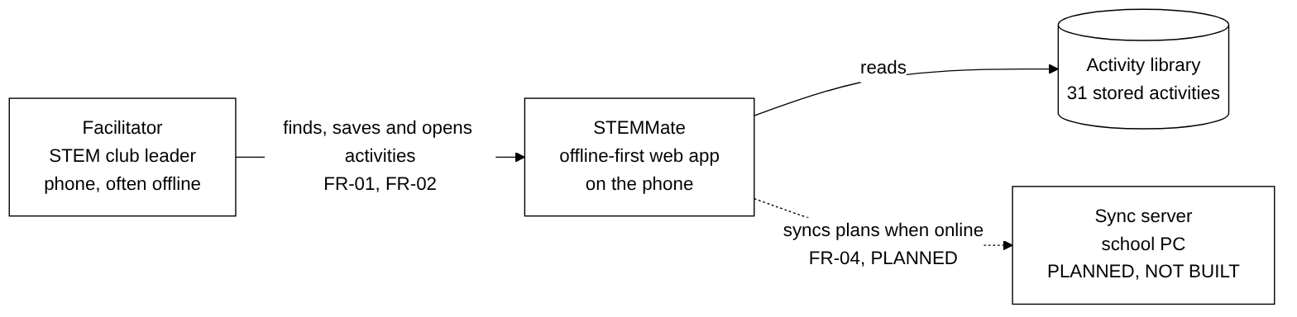
Figure 1: System context. The sync server is planned and not built.
Only one kind of user exists in the design: the facilitator. No pupil is a user, and the system holds no pupil identity.

5.2 Containers: what runs where
Purpose: show the deployable parts and the order of a save. It serves FR-02 to FR-04, QR-01, QR-02 and QR-06.
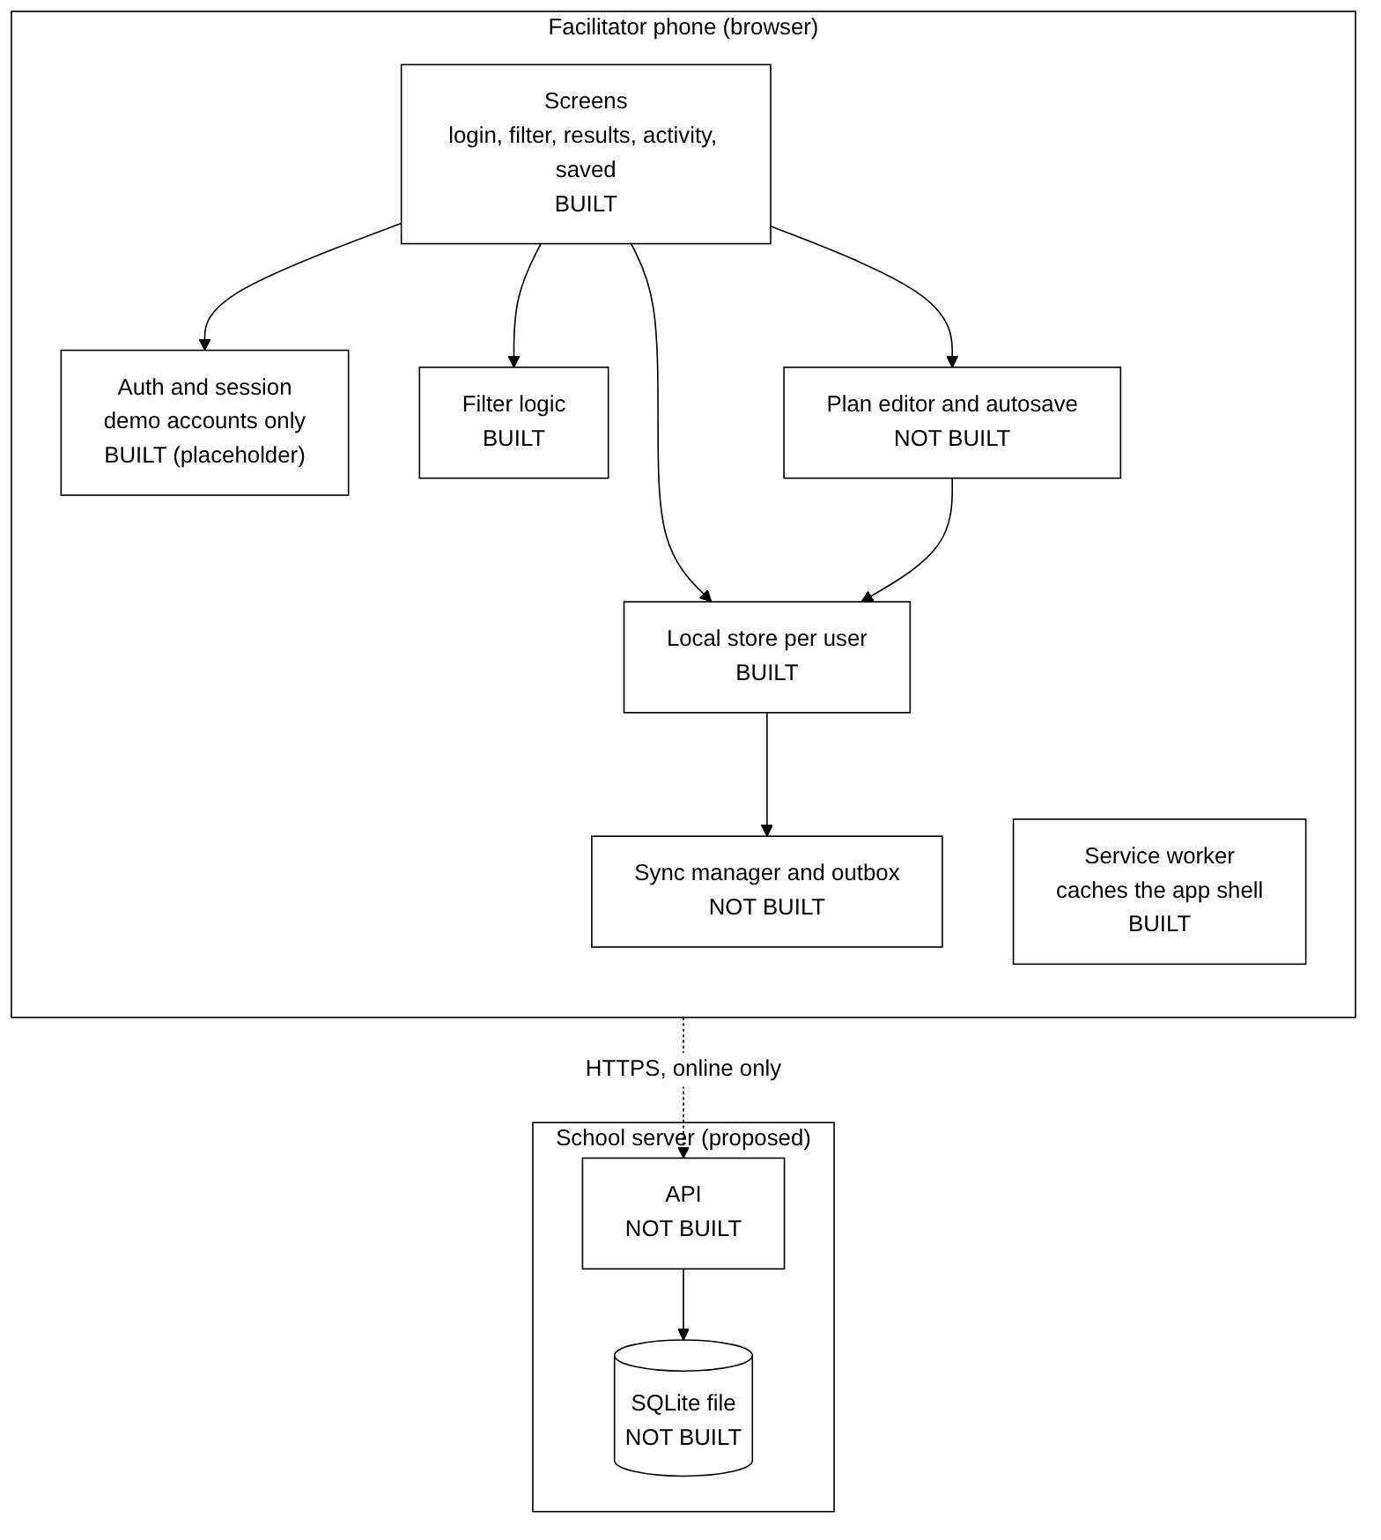
Figure 2: Containers. Built parts are labelled BUILT.
In the code, the container "Screens" is js/app.js, "Filter logic" and validation are js/logic.js, "Auth and session" is js/auth.js, and "Local store" is js/storage.js. The service worker is sw.js. The build step joins the modules into one file, js/app.bundle.js.

5.3 Deployment
Purpose: show where the parts would run in a school. It is a proposal. We did not deploy it, and we did not test backup and restore.
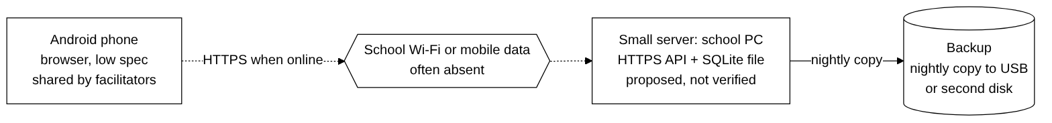
Figure 3: Proposed deployment (not verified).

5.4 Logical data model
Purpose: list the stored data and show that no pupil data exists. Table 4 gives the entities. In the built slice only Activity (the catalogue in js/data.js), Facilitator (demo accounts) and Saved activity (per user in local storage) exist. The other entities are designed.
Entity | Fields | Notes
Facilitator | id (key), displayName, credentialHash | Built as demo accounts. The planned design stores a hash, not a password.
Activity | id (key), title, level, ages, topic, minutes, materials, costNAD, safety, steps | Built. 31 records. The largest record is 441 bytes.
Saved activity | facilitatorId (FK), activityId (FK), savedAt | Built. One list per user.
Session plan | planId (key, made on the phone), facilitatorId (FK), activityId (FK), title, safetyNotes, inclusionPrompts, updatedAt | Designed. The phone makes the ID so a retry cannot create a second copy.
Plan step | planId (FK), position, description, minutes, materials | Designed.
Sync queue item (phone only) | planId (FK), state (Pending, Failed, Synced), retryCount, lastError | Designed.
Table 4: Logical data model. FK means foreign key. There is no Learner or Pupil entity and no pupil field anywhere (QR-05).
Relationships: a facilitator saves many activities and owns many plans. A plan is based on one activity, contains one or more steps, and has at most one queue item.

5.5 Roles and access rules
Purpose: show who may do what on a shared phone. It serves QR-06 and FR-A4-01.
Action | Owner | Other facilitator | Not signed in
Sign in to own workspace | Yes | Own only | No
Save activities for offline use | Yes | Own only | No
Create, edit, delete own plan | Yes | No | No
Open another facilitator's draft | No | No | No
Sync own plans | Yes | Own only | No
Table 5: Access rules. What the built slice enforces: protected screens redirect to login (test E11) and one user's saved list is invisible to another user (tests U12, E12). What it does not enforce: real authentication and encryption (ISS-03, ISS-04).

5.6 Sequence and states for saving and syncing a plan (planned)
Purpose: show the intended order of a plan save with its failure branches. This is the design of the part we did not build. It serves FR-03, FR-04, FR-A4-02, QR-02 and QR-A4-01.
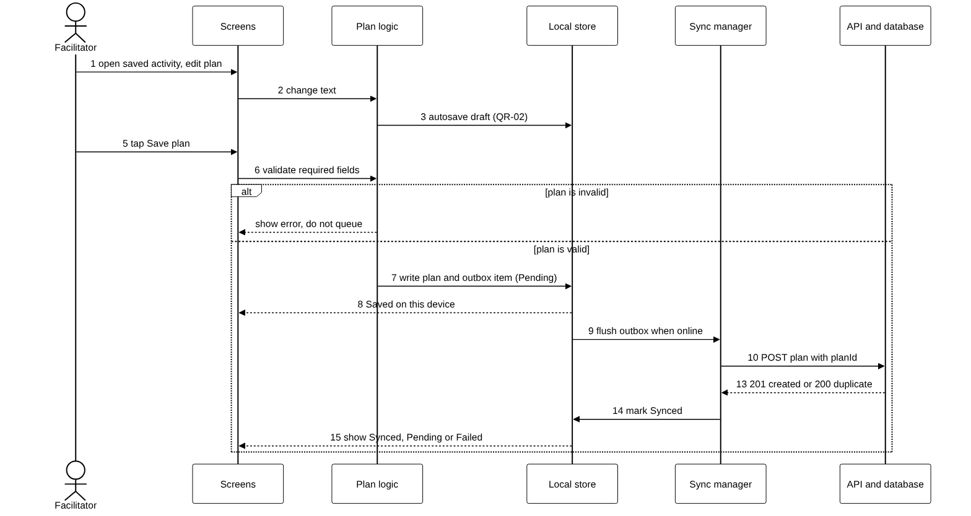
Figure 4: Create, autosave and sync a plan (UML sequence, planned).
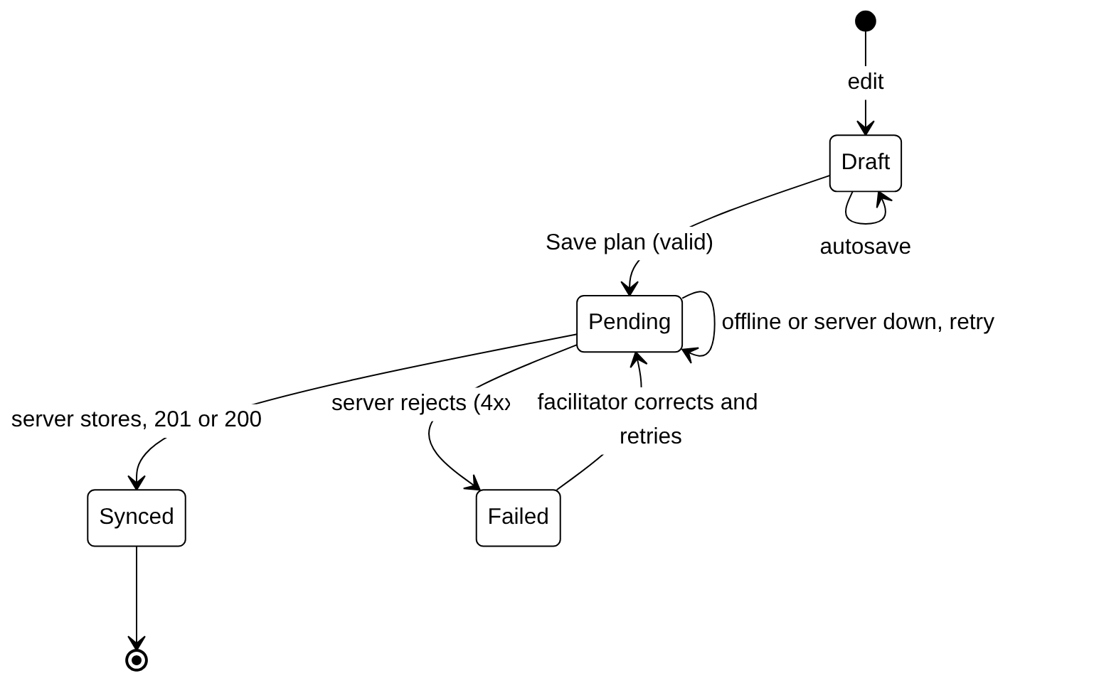
Figure 5: Sync states of a plan (planned).
The key idea is the order: write on the phone first, then queue, then send, then mark. Because the phone creates the plan ID, a retry after a lost reply is recognised by the server as a duplicate (reply 200) and no second copy is stored.

5.7 Offline and failure strategy
Situation | What should happen | Status
No internet when opening the app | The service worker serves the saved app files. A text badge says Offline. | Built, tested (E04, E09)
Device storage full when saving | A Save failed screen shows the cause and three choices: Try again, Free up space, Back. Earlier saves stay intact. | Built, tested (U11, E05)
Saved data is damaged | The damaged data is set aside, the app does not crash, and saving works again. | Built, tested (U13)
Second facilitator on the same phone | Only the signed-in user's saved list is visible. | Built, tested (U12, E12)
No internet when saving a plan | Plan saved on the phone as Pending, sent later. | Designed
Reply lost after the server saved | The retry reuses the plan ID and the server answers duplicate. | Designed
Server rejects the data | Plan shown as Failed with the reason. Local copy kept. | Designed
Two devices edit one plan | Show a comparison. The facilitator chooses Keep Local, Keep Remote or Merge. The local draft is never silently overwritten. | Designed
App closed or battery dies mid-edit | Restore the last autosaved draft. | Designed
Server disk fails | Restore from the last backup. Unsent plans stay queued on the phones. | Designed, never tested
Table 6: Offline and failure strategy.

5.8 Architecture decision records
The architecture file holds four decision records, all owned by Dinilson Nathinge. For each one the file lists the context, the options and the decision. In the file, the approval of every record by the team is marked "not confirmed". We add the trade-offs below, written by the report author from the options in the file. The owner has to confirm that this wording is what the team decided.

ADR-01: Platform is an offline-first Progressive Web App
Context | Shared, low-specification Android phones. Offline use is required.
Options | (a) Online-only web app. (b) Native Android app. (c) Offline-first PWA.
Decision | (c) Offline-first PWA.
Why | (a) fails the offline need. (b) needs separate builds, an app store or file transfer, and a large install. (c) works from a link, updates itself, and runs on the browser the phones already have.
Trade-offs | Gains: small download, one code base, easy updates. Costs: browser storage is limited and can be cleared, some features of native apps are not available, and the behaviour depends on the browser version.
Evidence | Tests E04 and E17 show the app opens offline and from a file. Not yet tested on a real low-cost phone (M02).
Team approval | Not confirmed.

ADR-02: Synchronisation is local first with a queue
Context | Plans must stay available offline and be sent when the connection returns (FR-04).
Options | (a) Send each save immediately. (b) Save on the phone, queue it, and send when online.
Decision | (b) Local first, then queued sync.
Why | (a) loses work when the connection drops. (b) keeps the plan safe on the phone and makes the sync a background job that can retry.
Trade-offs | Gains: no lost work, works on weak connections. Costs: more code (queue, retry count, status), a need to prevent duplicates (stable plan ID) and a need to handle conflicts.
Evidence | Designed only. The built slice applies the local-first idea to saved activities. No sync code exists in the tested app.
Team approval | Not confirmed.

ADR-03: Conflicts are resolved by the facilitator
Context | The same plan may be edited on two devices.
Options | (a) Newest edit wins. (b) Show both and let the facilitator choose Keep Local, Keep Remote or Merge.
Decision | (b) The facilitator chooses.
Why | (a) can silently delete a facilitator's work, which is the worst result in a setting where work cannot be redone easily. (b) puts the choice with the person who knows the content.
Trade-offs | Gains: no silent data loss. Costs: an extra screen, and a facilitator with little time may find the choice confusing.
Evidence | Designed only. Needs a usability test before it is built.
Team approval | Not confirmed. The reason written in the architecture file for this record is "Authentication and Authorization". That does not match the decision, so the owner should replace it.

ADR-04: Server storage is a SQLite file
Context | Synchronised plans need persistent storage on a small school server.
Options | (a) A hosted database. (b) A PostgreSQL server. (c) A SQLite file on the school PC.
Decision | (c) SQLite. The file location is still to be agreed.
Why | (a) needs internet and a monthly fee. (b) needs more memory and a person who can run a database server. (c) is one file, needs no separate service, and a backup is a file copy (SQLite Consortium, 2024).
Trade-offs | Gains: low cost, low upkeep, easy backup. Costs: limits for many writers at once, and the backup and restore must be tested before anyone relies on it.
Evidence | Designed only. No server or database exists in the tested app.
Team approval | Not confirmed. The reason in the architecture file is "Preserve consistency". The owner should confirm the wording.

5.9 Rejected options
The options above that were not chosen are: online-only web, native Android, immediate send, newest edit wins, hosted database, PostgreSQL. We also rejected a plain login against a server for the A4 slice, because no server exists, and we rejected the attendance feature because of QR-05.

6. Implementation slice

6.1 The path
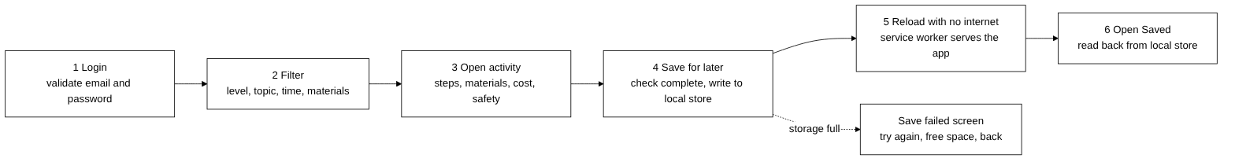
Figure 6: The built vertical slice.
The slice goes through all layers. Table 7 shows where each layer lives.
Layer | File | What it does
Interface | index.html, css/style.css, js/app.js | Eight screens, a text Online or Offline badge, labelled fields, focus control, 44 by 44 pixel buttons.
Validation | js/logic.js, js/auth.js | Checks the email and password format. Refuses an activity with a missing field (for example no safety notes).
Logic | js/logic.js | Filters by level, topic, time bucket and materials. Handles no matches.
Data | js/data.js | 31 made-up activities and 2 demo accounts.
Persistence | js/storage.js | Saves per user in the browser. Raises a clear error when storage is full. Sets aside damaged data.
Offline | sw.js | Caches index.html, the style file and the script, so the app opens with no connection.
Output | js/app.js | The activity page with steps, materials, cost and safety notes, and a confirmation or error message.
Table 7: Layers of the slice. The source files together are small: the app shell (index.html, the style file and the bundled script) is about 33 KB.

6.2 Error handling and recovery
- Wrong password: a clear message, and the user stays on the login page (E02).
- Empty login form: both fields are marked and the cursor moves to the first one (E03).
- Storage full: a Save failed screen with Try again, Free up space and Back. Earlier saves are not harmed (U11, E05).
- Damaged saved data: set aside, no crash, saving works again (U13).
- A filter with no results: a message and a Clear filters button (U04, E16).

6.3 Accessibility features in the code
- Every field and button has an accessible name (E08). One main heading and landmarks on each page (E13).
- Keyboard-only login works and focus moves to a sensible place after each step (E10).
- The Online or Offline status uses a word, not only a colour (E09).
- No sideways scrolling at 360 by 720 pixels on all eight screens (E06). Touch targets are at least 44 by 44 pixels (E07).
- Text contrast meets WCAG 2.2 level AA in a script check on five screens (E15; W3C, 2023). The script is an approximation, not a full audit.

6.4 Synthetic data and privacy
The 31 activities and the 2 demo accounts are made up. There are no pupil fields (QR-05). Our review of the files found no other personal data stored by the app. The matrix still marks QR-05 as Partial, because nobody has reviewed every storage location and every network request. We found no request in the code to any server other than the one that loads the app files.

6.5 How to run it
The root README gives the full steps. In short: download the repository, open a terminal in the src folder, run py -m http.server 8080 (Windows) or python3 -m http.server 8080 (macOS and Linux), and open http://localhost:8080 in Chrome or Edge. Demo login: facilitator1@example.org with the password Demo-Pass-1. To test the offline use, save an activity, set the Network tab of the browser tools to Offline, reload, and open Saved. The offline cache works only on localhost or HTTPS, not when a file is double-clicked, but the app itself still opens (E17).

6.6 Work in the repository that is not part of the slice
The src folder also holds a back-end and data prototype (a page with no file extension, and a Word guide). It simulates sync with a browser database and records pupil attendance. It is not connected to the app, it was not tested by us, and its attendance roster conflicts with QR-05. We did not count it in the slice. Its sign-in accepts one test account with any code of four or more characters, so it is not a security control. If the team wants to use it, the attendance part must be removed or a privacy-safe design agreed and recorded as a new requirement. The setup steps in the Word guide (npm install, a server on port 3000) do not match this repository, so a new person following it would fail.

6.7 Known limits of the slice
- Login is a placeholder. Saved data is not encrypted.
- There is no plan editor, no sync and no server.
- The catalogue has 31 activities. Some filter combinations have no match, which led to a usability problem (I-03).
- Speed was measured on a desktop with the processor slowed 6 times. The filter took 361 ms. This is not a measurement on a real 2 GB phone.

7. Tests and quality evidence

7.1 Test strategy
We test at three levels. Unit and integration tests check the logic and the storage. Browser tests drive the real app in Chromium and check the whole path, accessibility, layout and failure behaviour. Manual tests need a person or a real device. We use the Node.js test runner (Node.js, 2024) and Playwright (Microsoft, 2024). Each test has an ID and a requirement. The full list is Appendix B.
Type | Number | Result
Unit and integration tests (U01 to U15) | 15 | 15 passed
Browser tests (E01 to E17) | 17 | 17 passed in run 3
Manual tests (M01 to M05) | 5 | Not run
Total documented | 37 | 32 automated, all passing. 5 manual, not run.
Table 8: Test counts. The brief asks for at least 12 documented tests and at least 4 automated.

7.2 Honest failures
We kept the failing runs. Run 1 of the browser tests gave 14 of 16. The two failures led to changes:
- E07 (touch size) failed. Three text links were only 20 pixels tall (ISS-01). We changed them into full-width buttons. E07 passed in run 2.
- E04 (offline reload) failed. We found, by repeating the steps by hand, that the fault was in the test: it read the page before the page finished loading (ISS-02). The app was right. We fixed the test.
- E17 was added after a real problem. A teammate found that double-clicking index.html showed a blank page, because browsers block module scripts on file addresses (ISS-07). Our tests used a web server and missed it. We added a build step that joins the modules into one script, and we added test E17. Run 3 is 17 of 17.
The result files are in src/docs: e2e-results-run1.json, run2 and run3, and unit-results-run2.tap.

7.3 How the tests trace to requirements
Table 9 shows, for each requirement, the tests that support it and the matrix status. A requirement is "Passed" only if its tests cover the whole requirement.
Requirement | Tests | Status | What is missing
FR-01 | U01 to U04, E01, E16 | Passed | Nothing
FR-02 | U05, E01, E04 | Passed | For activities, not for plans
FR-03 | none | Not implemented | No plan editor
FR-04, FR-A4-02 | none we ran | Partial | No sync queue or status in the app
FR-A4-01 | E02, E03, E11, E12 | Partial | Real authentication
QR-01 | U01 to U04, E01, E04, E14 | Partial | M03 (first-time user) not run
QR-02, QR-A4-02 | none we ran | Partial | No plan autosave or integrity check after sync
QR-03 | U06, E14 | Partial | M02 (real phone) not run
QR-04 | E06 to E10, E13, E15 | Partial | M01, M04, M05 not run
QR-05 | data.js review | Partial | Full storage and network review
QR-06 | U12, E11, E12 | Partial | Drafts and encryption
QR-A4-01 | E02, E03, E05 | Partial | Errors for planning and sync
Table 9: Requirement to test trace. FR-05 and FR-06 are Deferred and have no tests.

7.4 Limits of the test evidence
- E14 (speed) and E15 (contrast) are script approximations. They do not replace a real phone or an independent audit.
- The project manager re-ran the unit tests (15 of 15) and the browser tests (17 of 17) on his own computer after the interface slice was added. We have no record that anyone outside the team reviewed the tests. The five manual tests remain open.
- There are no tests for the plan editor, the sync queue or the server because they do not exist.
- The dates in the result files come from the clock of the machine that ran them. The register gives 20 October 2026 for runs 1 and 2.

8. Evaluation

8.1 Method
Five people did a task-based usability test on 2 November 2026. They used one HP laptop with Chrome. Their labels are P1 to P5. No names were written down. Each person did five tasks: T1 log in, T2 find an activity with filters, T3 save it, T4 open it with no internet, T5 get back after a search with no results. For each task the tester wrote Y (did it alone), H (needed help) or N (could not do it), and the time. Each problem got a severity from 1 (cosmetic) to 4 (critical), using the scale in the usual usability practice (Nielsen Norman Group, 2012).
The five people were classmates and family members. The record sheet does not say which person was which. The brief allows only consenting adult classmates or simulated stakeholders. We therefore flag this as a compliance risk (Section 11). If any participant was a family member who is not a classmate, the team should ask the lecturer whether the evidence is accepted.
The app files have not changed since 22 October 2026. The testers used the same version as the automated tests.

8.2 Results
 | T1 Log in | T2 Filter | T3 Save | T4 Offline | T5 No results | Comment
P1 | Y 00:36 | Y 01:37 | Y 00:11 | Y 00:28 | Y 00:23 | Layout too plain.
P2 | H 02:40 | Y 02:17 | Y 00:15 | Y 00:23 | H 00:56 | Stuck when no activity matched.
P3 | Y 01:10 | Y 02:05 | Y 00:27 | Y 00:25 | Y 00:59 | Wanted a green sign for Online.
P4 | N 03:02 | H 01:22 | Y 00:20 | Y 00:47 | Y 00:35 | Filter options were missing.
P5 | Y 00:45 | Y 01:30 | Y 00:35 | Y 00:52 | H 01:45 | Fast. Liked the layout.
Table 10: Results for each person. Times are minutes and seconds.
Task | Did it alone | Needed help | Could not | Success without help
T1 Log in | 3 | 1 | 1 | 60%
T2 Filter | 4 | 1 | 0 | 80%
T3 Save | 5 | 0 | 0 | 100%
T4 Open with no internet | 5 | 0 | 0 | 100%
T5 Recover after no results | 3 | 2 | 0 | 60%
Table 11: Summary for each task (5 people). The original record sheet counts 0 people who could not do T1. The rows for each person show that P4 could not, so we use 1.
With five people, one person is 20 percent, so the percentages show a pattern, not a measurement. The main goal works: saving and offline opening worked for everyone, without help, in under a minute each. QR-01 sets a target of about two minutes. Three of the five finished the filter task inside two minutes. P2 (2:17) and P3 (2:05) were slightly over. We do not claim QR-01 as passed, because the whole offline task was not timed from a cold start.

8.3 Problems found and how serious they are
ID | What happened | Who | Severity | Requirement | Change suggested
I-01 | People reached a dead end after a search with no results. | P2, P5 | 2 Minor | QR-A4-01 | One clear way back.
I-02 | The Online sign looks like a plain label, not a status. | P3 | 1 Cosmetic | QR-04 | Add a green dot next to the word.
I-03 | Some filter options are missing or lead to no results. | P4 | 3 Major | FR-01 | Switch off choices with no match.
I-04 | The login fields are hard to see: little contrast and no clear order. | P1, P4 | 3 Major | FR-A4-01 | Bolder labels and stronger marks.
Table 12: Issue log from the usability test. P2 also needed help to log in, but the original issue log does not list P2 under I-04.

8.4 Limits
- Five people, one laptop, one day. Not real facilitators. Not on a phone.
- The tasks were set by us. The test shows how people do set tasks, not how a club would use the app.
- We could not test with children, schools or teachers, as the brief forbids it.

9. Evidence-led redesign
Table 13 lists five changes. Each one is linked to a test or an evaluation finding. We list the status in the last column, so that nothing is claimed as built when it is only designed.
No. | Evidence | Before | After | Status
1 | ISS-01, test E07 (run 1) | Three text links 20 pixels tall. | Full-width buttons, at least 44 by 44 pixels. | Built. E07 passes in run 2.
2 | ISS-07, test E17 | index.html opened from a file showed a blank page. | The modules are joined into one script by the build step. | Built. E17 passes in run 3.
3 | I-01 (P2, P5) | Two buttons, Clear filters and Change filters, look equally important on the no-results screen. | Keep one clear button: Clear filters and Restart. | Designed, not built
4 | I-02 (P3) | The Online sign is a plain round label. | Add a small green dot next to the word. The word stays, so meaning does not depend on colour. | Designed, not built
5 | I-03 (P4), I-01 | All filter choices can be clicked, including mixes that match none of the 31 activities. | Switch off the choices that have no matching activity. | Designed, not built
Table 13: Before and after changes.

9.1 What we updated because of the evidence
- Test register: new issues ISS-01, ISS-02 and ISS-07, and new tests E17.
- Code: changes 1 and 2 are in the repository. Changes 3 to 5 are not.

9.2 Options we considered and did not choose
- Remove all filters except level. Rejected: it would remove the control that makes the activity library useful (FR-01).
- Make the catalogue bigger so every filter combination matches. Not rejected, but not done: it needs new activity content, and the content needs checking for safety.
- Clear filters by itself after a search with no results (P2's idea). Not chosen yet: it could hide what the user searched for. It is worth testing.

9.3 Unresolved
I-04 (login screen hard to see, severity 3) has no fix in the table above. It is the first job for the next round. Several of the ideas from the testers (stronger contrast, cards that make the key action stand out) apply to it.

10. Sustainability and handover plan
This section covers what the brief asks: affordability, bandwidth and energy, maintainability, local administration, privacy, backup and export, support, deployment and decommissioning. For each topic we say what the evidence supports and what is only a proposal. We have not priced anything, because we have no quotes. Money figures would be guesses.

10.1 Affordability, bandwidth and energy
- Measured: the app shell is about 33 KB, made of index.html, the style file and the bundled script. The whole catalogue of 31 activities is about 11 KB (the largest record is 441 bytes). After the first visit nothing needs to be downloaded again for the saved activities (tests E04, E17).
- Meaning: one visit costs very little mobile data. No images or videos are loaded. There is no background polling and no animation, so we expect low battery use, but we did not measure energy.
- Assumption: a school PC that already exists can host the server (ADR-04). Then the main cost is people's time, not hardware or hosting fees. The client must confirm this.
- Risk: the activity content will grow. Large images would break the data budget. A rule is needed: keep each activity payload at or below 1 MB (checked by test U06) and prefer text and simple line drawings.

10.2 Maintainability and local ownership
- The code uses plain HTML, CSS and JavaScript with no framework. There are five small module files, a service worker and a build script. The only tool needed to build is Node.js, and one command (node build.mjs) joins the modules.
- Tests can be re-run with one command each (node --test and the Playwright script). A maintainer can check that a change did not break the path.
- Risk: the bundle must be rebuilt after each change to the source files. If a maintainer forgets, the app and the source differ. We checked by rebuilding that the bundle matched the source when this report was prepared. An automatic check would be better.
- Local ownership: the repository holds the requirements, diagrams, code and tests, so the client or a local student team can continue. The licence of the repository is not yet set. The client should decide it.

10.3 Privacy and data protection
- No pupil data is collected or stored (QR-05). Facilitators' own data is limited to an email, a name and their saved activities.
- Before any real use: replace the placeholder login, hash credentials on the server, encrypt saved data on the phone and in transit (HTTPS), and write a plain privacy notice. Today saved data is plain text in browser storage (ISS-03).
- We did not research Namibian data protection law for this report. The client should obtain legal advice before real use.

10.4 Backup, export and support (proposed)
Topic | Proposal
Backup | Nightly copy of the SQLite file to a USB drive or a second disk. A person at the school is named as responsible. Never tested; a restore test is needed before anyone relies on it.
Export | A facilitator can export their own plans as a file (for example text or PDF). Not built.
Support | A named local support person (for example a teacher or a student volunteer). A one-page guide: how to start the server, how to restore a backup, how to reset a facilitator's access.
Updates | The service worker has a cache version name (stemmate-shell-v3). Changing it makes phones fetch new files on the next visit.
Shared devices | Sign out locks the workspace. Each facilitator has a separate saved list.
Table 14: Backup, export and support.

10.5 Deployment and decommissioning (proposed)
- Deployment: put the src folder on any static web server with HTTPS. The service worker needs HTTPS or localhost. Until a server exists, the app can be shown from localhost.
- Decommissioning: (1) tell facilitators a date and how to export their plans, (2) stop sync, (3) copy the database file to the owner, (4) delete the server copy and the backups on request, (5) remove the app from the phones by clearing site data, (6) hand over the repository and this report.

10.6 Handover package
Item | Where
Source code and tests | Repository, folder src and src/tests
Run and test instructions | Root README.md
Requirements and traceability | Folder docs
Architecture diagrams (8 pages) | docs/architecture/STEMMate_A4_Architecture.drawio
Test register and result files | src/docs
Evaluation and redesign report | docs/STEMMate_A4_Evaluation_and_Redesign_Report.docx
Briefing and demonstration | Video of 6 to 8 minutes, from the demo script
Table 15: Handover package.

11. Risks
A residual risk is a known problem that remains after reasonable action. Table 16 lists ours, ordered by how much they matter to the client. Likelihood and impact are the team's judgement, not measurements.
ID | Risk | Chance | Impact | What to do
R1 | Login screen hard to use (I-04). Users cannot get in. | High | High | Redesign the login and test again.
R2 | Saved data is not encrypted and login is a placeholder (ISS-03, ISS-04). | High | High | Do not use with real facilitators until fixed.
R3 | The slice does not include plan editing or sync, so FR-03 and FR-04 are not delivered. | Certain | High | Build the plan editor, then sync.
R4 | Never tested on a real low-cost phone (ISS-05, M02). | Medium | High | Run M02 on a real 2 GB Android phone.
R5 | Screen reader, zoom and independent accessibility checks not run (M01, M04, M05). | Medium | High | Run them. Fix what they find.
R6 | The usability group is small and may not meet the brief's rule on participants. | Medium | Medium | Ask the lecturer. Re-test with classmates if needed.
R7 | Filters lead to dead ends (I-03). | High | Medium | Switch off choices with no match.
R8 | Backup and restore never tested; server never built. | Certain | Medium | Test before any promise of reliability.
R9 | Browser storage may be cleared by the phone or user. | Medium | Medium | Backup through sync; tell users.
R10 | Unmerged back-end prototype stores attendance and conflicts with QR-05. | Medium | Medium | Remove attendance or write a privacy-safe requirement.
R11 | Architecture ADR reasons and approvals are not confirmed for ADR-03 and ADR-04. | Medium | Low | Owner confirms the wording and the team approves.
Table 16: Residual risks.

12. Recommendation
We advise NSSDL to continue the project, with these conditions.
What the evidence supports. The offline find-and-save path works for five test users, passes 32 automated tests, and uses very little data. A local-first PWA is a sound base for this context.
What it does not support. The evidence does not show that facilitators can plan a session, that sync works, that the app is secure, or that it runs well on a real low-cost phone.
Next steps, in this order:
- Fix the login screen (I-04) and build the three designed changes (changes 3 to 5). Test again with new people.
- Run the five manual tests, above all the screen reader test and the real phone test.
- Replace the placeholder login and encrypt saved data. Do this before any real facilitator uses the app.
- Build the plan editor with autosave (FR-03, QR-02), then the sync queue and the server (FR-04, FR-A4-02), following ADR-02 to ADR-04 once the team has approved them.
- Test backup and restore, name a local support person and write the one-page guide.
- Get lecturer approval and, if needed, ethics clearance before any test with real facilitators or schools.
We do not recommend any school deployment until steps 1 to 3 are done and step 6 is approved.

References
Microsoft (2024) Playwright documentation. Available at: https://playwright.dev/
NUST (2026) SDN621S Assessment 4 brief: Architecture, vertical slice, tests, evaluation and redesign. Windhoek: Namibia University of Science and Technology.
Group 06 (2026) STEMMate Namibia repository. Available at: https://github.com/Wxanted/STEMMATE_Assignment_4

Appendix A: Requirements traceability matrix
Source: docs/STEMMate_A4_Traceability_Matrix.docx (Lydia Amutenya, updated 5 November 2026). Component and test case IDs are from that file. The Tests column lists the test IDs named in the matrix evidence. Where it says "none", the matrix relies on reported peer evidence or gives no test.
ID | Requirement | Component | TC | Tests | Status
FR-01 | Browse and filter stored STEM activities by level, duration, topic and available materials. | Activity library; STEMMate web app | TC-01 | U01–U04, E01, E16 | Passed
FR-02 | Save a selected activity on the device for offline use. | Activity library; local device storage; service worker | TC-02 | U05, E01, E04 | Passed
FR-03 | Create and edit a session plan containing steps, timing, materials, safety notes and inclusion prompts. | STEMMate web app; session planner | TC-03 | none | Not implemented
FR-04 | Synchronise a completed local plan when internet connectivity returns without losing content. | STEMMate web app; sync server; local storage | TC-04 | none | Partial
FR-05 | Record equipment/materials use, including session date, responsible person and equipment return status. | Design component to be confirmed | TC-05 | none | Deferred
FR-06 | Reuse or copy a previous session plan. | Design component to be confirmed | TC-06 | none | Deferred
FR-A4-01 | Require a facilitator to sign into a private workspace before viewing or editing plans. | Authentication and workspace control | TC-07 | E02, E03, E11, E12 | Partial
FR-A4-02 | Display Synced, Pending or Failed sync status using text or an icon as well as colour, while preserving the local plan after sync failure. | STEMMate web app; sync server; local storage | TC-08 | none | Partial
QR-01 | Allow a facilitator to find and select a suitable stored activity within approximately two minutes offline. | Activity library; STEMMate web app | TC-09 | U01–U04, E01, E04, E14, M03 | Partial
QR-02 | Automatically save an unfinished plan and preserve it after connection loss, app closure or device restart. | Session planner; local persistence | TC-10 | none | Partial
QR-03 | Support use on a shared, low-spec device while avoiding unnecessary large downloads. | STEMMate web app; local device | TC-11 | U06, E14, M02 | Partial
QR-04 | Support keyboard access, readable contrast, visible focus, labelled controls and messages that do not rely on colour alone. | STEMMate web app; user interface | TC-12 | E06–E10, E13, E15, M01, M04, M05 | Partial
QR-05 | Do not collect, store or synchronise pupil names, photos, recordings, school records or other pupil-identifying information. | Data model; local storage; network and sync components | TC-13 | none | Partial
QR-06 | Keep drafts separate and protected on a shared device so a second workspace cannot open, change or delete another workspace's unfinished draft. | Authentication and workspace control; draft storage | TC-14 | U12, E11, E12 | Partial
QR-A4-01 | Provide understandable error messages that indicate whether an operation succeeded, failed or requires recovery. | STEMMate web app; error feedback | TC-15 | E02, E03, E05 | Partial
QR-A4-02 | Preserve the integrity of saved plans and provide a way to verify that they were stored successfully locally and after synchronisation. | Session planner; local persistence; sync server | TC-16 | none | Partial
Table A1: Matrix. For FR-04, FR-A4-02, QR-02 and QR-A4-02 the matrix cites reported peer-evaluation results whose logs were not reviewed.

Appendix B: Test register
Source: src/docs/TEST_REGISTER.md. The requirement IDs in this table are the A3 IDs used when the tests were written (see Table 2). Results are from the final runs.
ID | Requirement (A3) | What it checks | Type | Result
E01 | FR-01, FR-02, FR-03, QR-01 | End-to-end: login, filter, view, save, see in Saved | Auto | PASS
E02 | SR-01 | Wrong password shows error and stays on login | Auto | PASS
E03 | SR-01, AR-01 | Empty login flags both fields and moves focus | Auto | PASS
E04 | FR-03 | Airplane mode: saved activity opens fully after reload | Auto | PASS on run 2
E05 | FR-03 (failure) | Storage full shows Save Failed with recovery; retry works | Auto | PASS
E06 | QR-02, AR-01 | No horizontal scroll at 360x720 on all screens | Auto | PASS
E07 | AR-01 | Touch targets >= 44x44 px on all screens | Auto | PASS on run 2
E08 | AR-01 | All form controls and buttons have accessible names | Auto | PASS
E09 | AR-01, FR-03 | Connectivity badge uses text for Online/Offline | Auto | PASS
E10 | AR-01 | Keyboard-only login and focus management | Auto | PASS
E11 | SR-01 | Protected screen redirects when not signed in | Auto | PASS
E12 | SR-01 | Second user cannot see first user's saved activities | Auto | PASS
E13 | AR-01 | Page language, landmarks, one h1, titles | Auto | PASS
E14 | QR-02 | Filter response <= 2 s under 6x CPU throttle | Auto | PASS
E15 | AR-01 | Text colour contrast meets WCAG AA (script check) | Auto | PASS
E16 | FR-01 | No-match filter shows message and Clear filters | Auto | PASS
E17 | FR-03, QR-01 | Works when index.html is double-clicked (no server) | Auto | PASS
M01 | AR-01 | Screen reader (TalkBack on Android): log in, filter, save an activity using speech only | Manual | NOT RUN
M02 | QR-02 | Real 2 GB RAM / 720p Android device: filter and open saved activity within the time target | Manual | NOT RUN
M03 | QR-01 | First-time user completes login > filter > save unaided (done by the evaluation lead with classmates) | Manual | NOT RUN
M04 | AR-01 | Browser zoom / text size at 200%: no loss of content or function | Manual | NOT RUN
M05 | AR-01 | Independent contrast and accessibility audit tool run (e.g. Lighthouse / WAVE) on all screens | Manual | NOT RUN
U01 | FR-01 | FR-01: filter by level returns only that level | Auto | PASS
U02 | FR-01 | FR-01: combined level+topic+duration+materials filter returns only matching records | Auto | PASS
U03 | FR-01 | FR-01: duration bucket boundaries (30, 31, 45, 46, 60, 61) | Auto | PASS
U04 | FR-01 | FR-01: a filter with no matches returns an empty list (no crash) | Auto | PASS
U05 | FR-02 | FR-02 / A3 check: catalogue has >=30 activities and every one has all required fields | Auto | PASS
U06 | QR-02 / FR-03 | QR-02 / A3 check: every activity payload is <= 1 MB | Auto | PASS
U07 | SR-01 | SR-01: login validation rejects bad email, empty and short passwords | Auto | PASS
U08 | SR-01 | SR-01: wrong password is rejected, right password creates a session, logout clears it | Auto | PASS
U09 | FR-03 | FR-03: saved activity persists (a NEW store over the same storage still reads it) | Auto | PASS
U10 | FR-03 | FR-03: saving the same activity twice does not duplicate it | Auto | PASS
U11 | FR-03 (failure) | FR-03 failure: storage full raises StorageFullError and earlier saves stay intact | Auto | PASS
U12 | SR-01 | SR-01: one user's saved activities are not visible to another profile | Auto | PASS
U13 | FR-03 (recovery) | recovery: corrupted saved data does not crash, is set aside, and saving works again | Auto | PASS
U14 | FR-02 | FR-02: an incomplete activity (no safety notes) is refused and not stored | Auto | PASS
U15 | FR-03 | FR-03: remove deletes only the chosen activity | Auto | PASS
Table B1: All 37 tests. E04 and E07 failed in run 1 and passed in run 2. E17 was added after ISS-07. M01 to M05 were not run.

Appendix C: Issue log
ID | Description | Status
ISS-01 | Three text links 20 px tall, below the 44 by 44 px target. | Fixed (E07 passes in run 2)
ISS-02 | A test read the page before it loaded. A fault in the test. | Fixed in the test
ISS-03 | Saved data is not encrypted. Users are kept apart by user ID only. | Open
ISS-04 | Login is a placeholder with demo accounts. | Open
ISS-05 | Speed was only measured on a desktop with a slowed processor. | Open until M02 is run
ISS-06 | Sign-up, session planning, sync, booking and school management are not in this slice. | Open, by design
ISS-07 | index.html opened from a file showed a blank page. | Fixed (E17 passes)
I-01 | Dead end after a search with no results (P2, P5), severity 2. | Designed, not built
I-02 | Online sign looks like a plain label (P3), severity 1. | Designed, not built
I-03 | Filter choices that match nothing (P4), severity 3. | Designed, not built
I-04 | Login fields hard to see (P1, P4), severity 3. | Open, no fix designed
Table C1: Issues from the test register (ISS) and the usability test (I).

Appendix D: AI-use declaration
AI did not create or change any test result, participant feedback, issue rating or repository history in this report. These come from the team's files.

