**IGVC2015**

**DC-DC Step Down Adjustable Power Supply Instructable**

Link to board: <http://www.ebay.com/itm/5pcs-DC-DC-Step-Down-Adjustable-Power-Supply-Module-Converter-5A-Max-DC-0-8V-24V/131053844075?_trksid=p2047675.c100010.m2109&_trkparms=aid%3D555012%26algo%3DPW.MBE%26ao%3D1%26asc%3D27538%26meid%3D95f490cf8522408db394b0114ce3d4b0%26pid%3D100010%26prg%3D11353%26rk%3D3%26rkt%3D24%26sd%3D251066005460>

Link to heatsinks: <http://www.ebay.com/itm/New-High-Quality-5pcs-11x11x5mm-adhesive-Aluminum-Heat-Sink-For-Memory-Chip-IC-/131014795047?talgo=origal&tfrom=141082066753&tpos=unknow&ttype=price>

**Overview:** The board listed is an implementation of the LM2596 buck converter by TI. As described, it will take in a voltage between 0.8V and 24V and regulate it on the output to a lower, adjustable voltage. The specific intent here is to provide power to the laptop (approx. 19.3V ?) from a 24V rail. The normal laptop charger isn’t viable in this case as it converts main’s AC voltage to DC, whereas the robot only has a DC power supply.

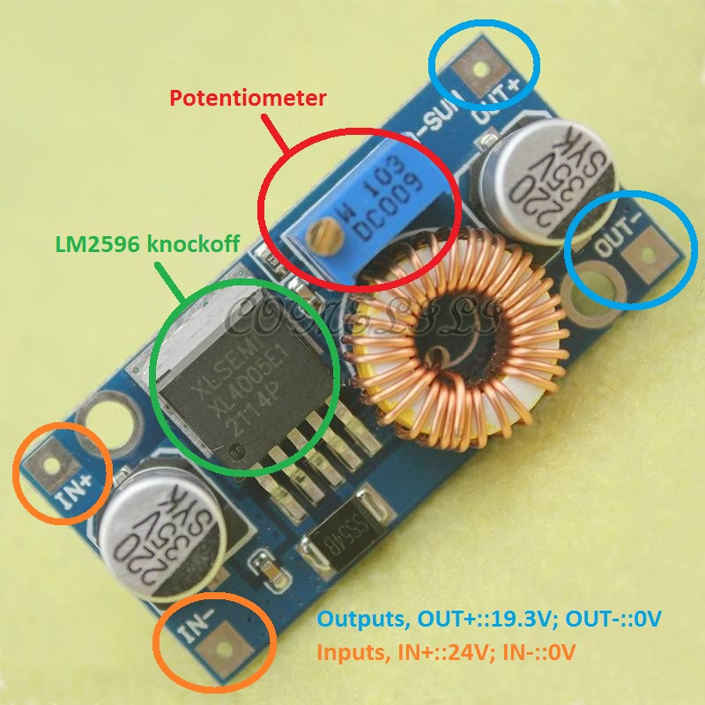

As shown above, the board acts as a 4 terminal device, with two terminals dedicated to input and two to output. The input will necessarily have 24V across it while the output should have the voltage required to power the barrel jack on the laptop. This voltage, from the writer’s memory is approximately 19.3V, but it should be checked by taking the laptop power supply and measuring the voltage between the inside and outside parts of its barrel jack (the bit that sticks into the laptop) or by inspecting the “brick” of the laptop’s power supply for specific voltages.

Once the desired voltage has been obtained from the laptop (e.g. 19.3V), this voltage needs to be set on the board. Take the board and connect the inputs to a power supply, making sure to set both IN+ and IN- to 24V and 0V (GND) respectively. Note that some power supplies have V+, V-, and GND (symbolized as an upside down T): the GND on some models refers simply to an AC ground and may not indicate 0V, in which case the power supply should be reading the difference between V+ and V-, and V- should be treated as 0V. If in doubt, verify your voltages with a multimeter before connecting the board.

When the board is connected, the output’s voltage may be set by way of the potentiometer (a variable resistor), which is labelled in the picture above. Using a screwdriver, one may adjust the screw on the potentiometer which should have a direct effect on the output voltage. Measure the output voltage with a multimeter as you adjust the potentiometer and achieve the desired laptop voltage as found on the barrel jack of the power supply. When this voltage has been achieved, the board is “ready” and it should be tested by soldering a barrel jack connector to the output and plugging the jack into the laptop while the board is powered.

It should be noted that the normal laptop power supply is rated for 7A, and this board is only rated for 5A. While this isn’t anticipated to be an issue, a capacitor bank may be needed in parallel with the board’s output to accommodate peak loads. Furthermore, the amount of current drawn by the board may be significant, and its efficiency is low, so a heatsink may need to be attached to the LM2596 chip itself.