**Project Title:** Tetris-Online

**Project Team Information:**

Final Project Group: 2

Student 1: Duke Ly

CS7319: Off Campus

Student 2: Yao Wang

CS7319: On Campus

**Who will submit the Project Proposal and Final Project Deliverables:**

Yao Wang

**Project Overview:**

1. The software system will be a two-player, time-based Tetris battle game with the ability to connect two players over a shared network.
2. Players shall be able to set a name/nickname. Players shall be able to create a game lobby/join an existing game lobby. Players shall be able to view both their Tetris screen as well as their opponent. Players shall be able to see both their current score as well as their opponent. The Tetris gameplay shall follow the guidelines set forth by The Tetris Company. If one player is eliminated before the timer ends, then the opposing player shall win. If both players are not eliminated when the timer ends, then the player with the most points shall be the winner.
3. Prototyping Interfaces:

Main Page:

Player Connect Page:

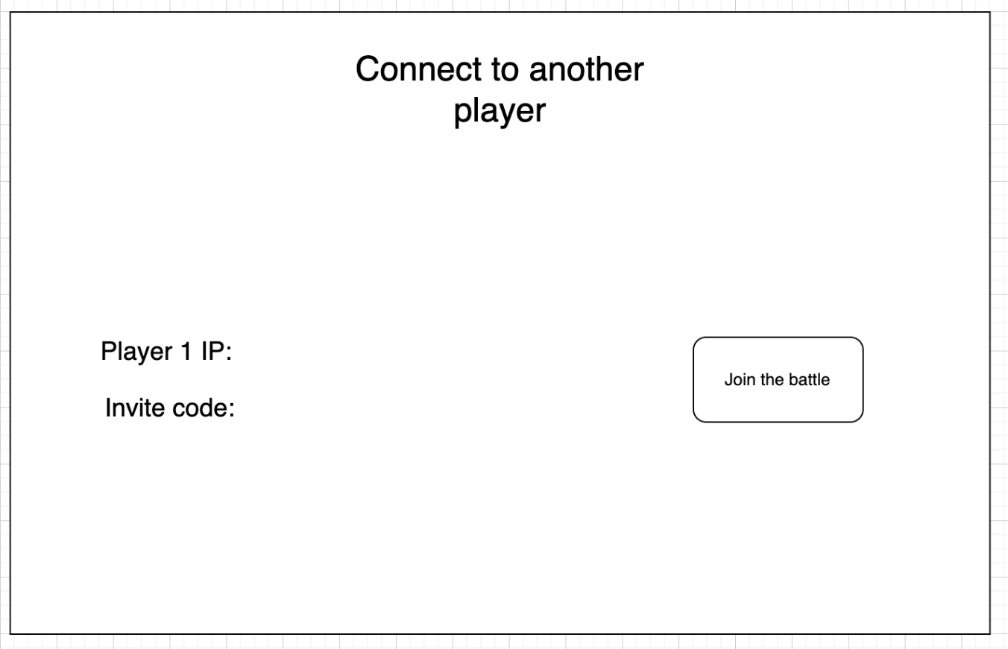

Battle Page: 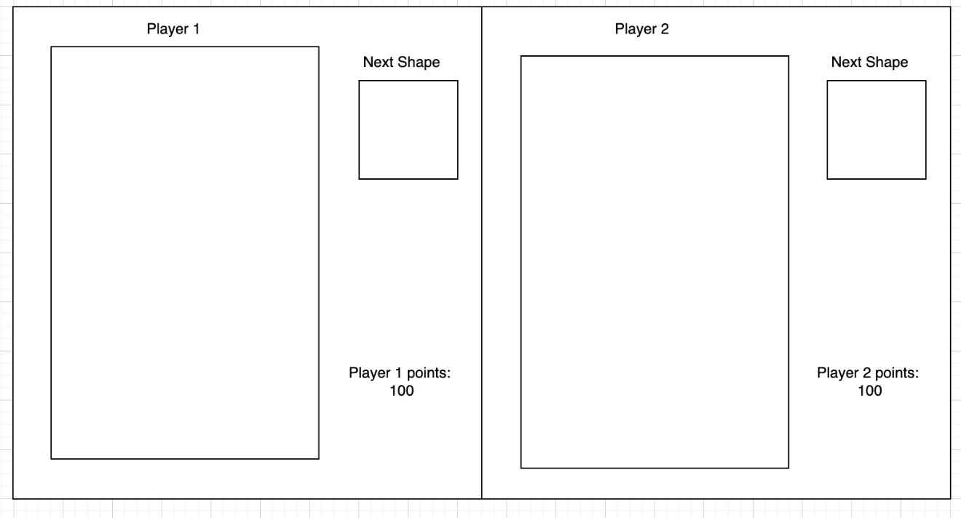

**Project Design:**

1. C2 Architecture and Event-Based Architecture are selected to be the candidate architecture styles for this project. C2(Command and Control) architecture is a framework designed to enable efficient command and control operations. It facilitates the flow of information, decision making and execution of commands across different subsystems. Event-Based architecture focuses on handling events and handles how the system/subsystems react to event stimulus. Overall, event-based architecture offers a flexible and scalable approach to building distributed systems that can effectively handle asynchronous events.
2. Architecture Diagrams:

Figure 1 Event-Based Architecture

Figure 2 C2 Architecture

1. We believe that the Asynchronous design is more suitable for Tetris because each player has a different speed and each step of the game is not synchronized, so using Asynchronous will be more suitable for this game. In addition, the real-time update of event based is also a reason for our choice. We hope that the status of two players can be seen at the same time in the battle interface, such as scores, game progress, etc. so we chose the event-based architecture.

**Project Implementation Plan:**

For the C2 Architecture we will be using Python and VS code. Because our team comes from different backgrounds, we cannot find a language that both of us are fluent in. So, we decided to use an easy to learn language to build this game. Also, we think Python has great support on the ecosystem and libraries, Like Pygame and Flask-SocketIO to provide support for the development. We will be using VS code as our main editor, because it both supports Windows machine and Mac. We will also use GitHub as our code repositories.

We will have the Tetris game running locally first, then we will be implementing the online battle part.

For the event-based architecture we will be using the same coding language and code editor. But the implementation will be slightly different. We will be implementing the game logic first, then we will create the network connection part and client-side part. Between each part of the development, we will perform some testing to ensure the progress of the entire project.

**Project Members’ Roles and Responsibilities:**

Duke Ly (Team Manager): Event Router, Network, Testing

Yao Wang (Team Lead): Submitting the project, Game logic, GUI, Testing