**CUSTOMER NEEDS AND FINAL CONCEPTS**

Our team has selected the three most relevant stakeholders whose input is being used to guide the development of the web application. These stakeholders represent groups and individuals that are the most directly impacted by our product, and these stakeholders include volunteers, organizations, and the team’s faculty advisor. Included below are the roles of these stakeholders, as pertaining to our project.

* **Volunteers**

Volunteers are individuals who participate in community-related events, such as canvassing or other events that are paid or unpaid. Volunteers are the primary end users of the Crowd Canvass web application, so it is important that the usability of the application meets their standards.

* **Organizations**

Organizations are companies and volunteer groups that are the facilitators of events that can be run through Crowd Canvass. These are the groups that would potentially be purchasing our product for their events, so it is imperative that the application meets their needs.

* **Faculty Advisor, Nadiyah Johnson**

Professor Johnson serves as the faculty advisor for this project. She is very involved in the Milwaukee tech community, has several years of relevant industry experience, and was previously involved in working with Crowd Canvass.

**DATA COLLECTION**

**Survey**

A selection of individuals known to be involved in their communities as volunteers were given access to a google forms survey. As the ultimate end users of our application, it is important to hear from this group. The goal of this survey was to learn about the survey participants’ views regarding our proposed application for Crowd Canvass and gauge their level of interest. Participants were encouraged to share their opinion on whether they would use the app, what features they would find useful, and other relevant topics. The survey can be found in the appendix.

**Volunteer Data**

End-users of the application, volunteers, will be required to enter personal details to register for events. This information will be stored in a central database, and the data will be used to track the involvement of each registered user of the application. There is also potential for volunteer location tracking. This data could be used by event organizers to better facilitate events and plan for future events.

**Organization Data**

Organizations will be required to enter personal/organization details to create events. Event information will also be stored which includes details such as event type, address, and whether it is paid or not. This information will all be stored in a central database. Organizations will have the ability to view registration details for their events in order to understand the number of individuals registered for their events.

**CUSTOMER STATEMENTS AND INTERPRETED NEEDS**

Table 1: Interpretation of Customer Needs

|  |  |  |
| --- | --- | --- |
|  | **Customer Response** | **Interpreted Need** |
|  | **Q: Based on the description of Crowd Canvass, does this project interest you? Why or why not?** |  |
| 1) | “This project does interest me. As someone who has been involved in community volunteering events, this app would have made the facilitation of the events much more efficient.” | There is demand for this type of product. |
| 2) | “Not really because I don't vote/have interests in that area.” | The product needs to cover more communities in addition to the Milwaukee area. |
|  | **Q: Aside from canvassing, what other community-related events do you think this app could be used for?** |  |
| 3) | “Volunteering or door to door sales” | The product needs to serve additional types of events. |
| 4) | “This could be great for testing out new ideas for anything in the communities. Groups could use this information to see how the general public feels about things. Furthermore, people could convene together to make changes in the world.” | The product needs to be used as a form of public service. |
|  | **Q: The proposed app will allow users to search and sign up for canvassing events in their community. This app will also track the involvement of each volunteer. What additional features would you like to see in this product?** |  |
| 5) | “Some type of chat feature to communicate with the other volunteers if they are on the same project together” | The product needs to incorporate a way for volunteers to communicate with each other in order to increase event efficiency. |
| 6) | “One feature could consider the percentage of the community that goes to certain events or looking at what percent of all volunteers go to which events.” | The product needs to incorporate some form of data analytics in order to better plan and interpret event turnouts. |
|  | **Q: Would you allow this app to track your location during the events you signed up for?** |  |
| 7) | 66.7% responded yes, 16.7% responded no, and 16.7% responded maybe. | The product needs to turn off location tracking for volunteers who opt out of this feature. |
|  | **Q: How much would you pay to use a service like this for your community event?** |  |
| 8) | “As a volunteer I wouldn’t pay but if I was an organizer, I would pay like $50 per event.” | Organizations should be charged a small fee to host events through the application. |
| 9) | “If I’m volunteering, I don’t expect to pay anything unless it was a non-profitable service that plans to give some of its funds to charities.” | Volunteers should not be charged to use the application. |

**BENCHMARKING**

Table 2: Competition Analysis

|  |  |  |  |
| --- | --- | --- | --- |
| ***Features*** | ***Product canvass*** | ***Product Organizer*** | ***Your product*** |
| **Connects volunteers to campaigns.** | Does not connect volunteers to campaigns. | Does not connect volunteers to campaigns. | It focuses on crowd sourcing so there is the layer of connecting volunteers to campaigns. |
| **GPS based canvassing** | Yes though it is focused on dividing areas for sales teams | Yes it uses GPS to assist canvassers in the field | Yes, It uses GPS as a way to bring volunteers together as well as help in assisting in the field. |
| **Survey analytics and data collection** | Yes extensive real time analytics geared towards a sales team. | Yes as an alternative to clipboards and paper. | Yes has survey collection and summaries of data collected. |

In terms of similarity of product, Organizer and our product Crowd Canvass are the most similar. Canvass is similar to a lot of other products in that its scope is limited to sales teams that are canvassing an area and it being a tool for managers of those teams to use. Though they do share the GPS and data analytic features that are found in the other two. In terms of our target audience canvass is not a valid option. Organizer on the other hand is very similar to crowd canvass but with a more limited scope. They are focused as being a tool for established canvass campaigns and are pitched as a good replacement for the old clipboard paper model. This is where the uniqueness of crowd canvass comes in especially when it comes to connecting local volunteers to canvassing campaigns in the area. It is the crowd sourcing aspect of connecting these two groups while having the features of other similar products that makes it unique.

Table 3: Benchmarks and Descriptions

|  |  |  |  |
| --- | --- | --- | --- |
| Test | Description | Passing Requirements | Pass/Fail |
| Software function | Documentation of features to make sure we can account for what is working as well as known bugs | All functions of the product work as well as minimal bugs and detailed documentation of known problems. | TBD |
| Price | Finding the price use and setting up of campaigns found through continued surveys and testing. | The price must find a balance of cost and amount needed to charge from campaigns. | TBD |
| Ease of Use | Having people test and use the product and fill out a survey about how intuitive and easy it is to use. | A ranking system of 1-5. 1 being the lowest level and 5 the highest. Passing is a 3. | TBD |
| Accuracy of data Collection | Determining if the data collected is accurate through testing and documenting the results. | Passing is when all the data collected is stored, analyzed correctly, and viewable to the user consistently. | TBD |
| Security of Data | Determine if the data given from the user is safe and only going to the required people. Through extensive testing and using web security tools. | Passing is having all data given be only distributed to those with authority to view it. No data leaks of potentially sensitive information. | TBD |

**Benchmarks and Test**

*Software Function*

Cannot be verified at the moment, but upon development a pass/fail test shall be administered.

*Price*

Based on initial surveys volunteering will be free as will use of the product but to start a campaign it will either be free our somewhere less than $50. More surveys and testing needed.

*Ease of Use*

The goal is to make the product intuitive and easy to use without much instruction but until an initial product is developed, we cannot verify how well this is being accomplished.

*Accuracy of Data Collection*

This will come down to the way we develop our database and algorithms for the data analysis. Though once we do this and enter dummy data and then real test data it will be very easy to see if it is functioning correctly.

*Security of Data*

Cannot be verified until the product is made, and test data is being used. Ideally the data given will be secure and not be seen by those who should not have access to it.

**NEEDS HIERARCHY**

Table 4: Interpretation of customer responses weighted in importance from least (1) to most (5)

|  |  |  |  |  |  |  |  |
| --- | --- | --- | --- | --- | --- | --- | --- |
|  |  | **Need** |  |  | **Importance** |  |  |
|  |  |  |  |  |  |
|  |  |  |  |  |  |  |  |
|  |  |  |  |  |  |  |  |
| 1 |  | Aesthetics | | 3 | |  |  |
|  |  |  | |  | |  |  |
| 2 |  | Reliability | | 4 | |  |  |
|  |  |  | |  | |  |  |
| 3 |  | Communication in app | | 1 | |  |  |
|  |  |  | |  | |  |  |
| 4 |  | Price | | 2 | |  |  |
|  |  |  | |  | |  |  |
| 5 |  | Security of data | | 5 | |  |  |
|  |  |  | |  | |  |  |
| 6 |  | Accuracy of data and GPS | | 5 | |  |  |
|  |  |  | |  | |  |  |
| 7 |  | Intuitive Interface | | 4 | |  |  |
|  |  |  | |  | |  |  |

**METRICS**

The following section presents customer needs and their metrics. The metrics are presented with marginal (minimum) and ideal (preferred) values in Table 4.

Table 5: Metrics Descriptions

|  |  |  |  |  |  |
| --- | --- | --- | --- | --- | --- |
| **Need number**  **(Table 4)** | **Metric** | **Importance** | **Units** | **Marginal Value** | **Ideal Value** |
| 2,6 | Accuracy of data and GPS | 5 | % Difference | 3-5% | 0-3% |
| 7,1,3 | Ease of Use | 4 | Technical Skill | Beginner | Beginner |
| 5 | Security of Data | 5 | Binary | Safe | Safe |
| 4 | Price | 2 | Dollars | 50 | 0 |

**CONCEPTS**

**Initial Concepts**

The initial generated concept for the web-based application was to develop an application that can create and find canvassing events along with other volunteer events. The event organizer would also be able to create surveys, track their volunteers using GPS location, and have an option to pay volunteers.

**Final Concepts**

The final concept we came up with is very similar to the initial concept. We will create a web-based application that allows people to organize and find canvassing events along with other volunteer events. The organizer can create surveys and view data analytics based off those surveys.  The data analytics will allow the organizer to view a summary of the data and a more in-depth analysis of the overall results. Organizers can also track their volunteers using GPS location, and have an option to pay volunteers. Volunteers will have an option to opt-in or opt-out of the GPS location tracking.  We are thinking about using a 3rd party service, such as PayPal, to handle the payments, but that is still an ongoing development.  Both volunteers and organizers will have a map where they can find or create events. For canvassing events, when someone is doing a route for door-to-door, they will give someone their volunteer reference number, that way we can see who recommended which house on their survey.

*Application*

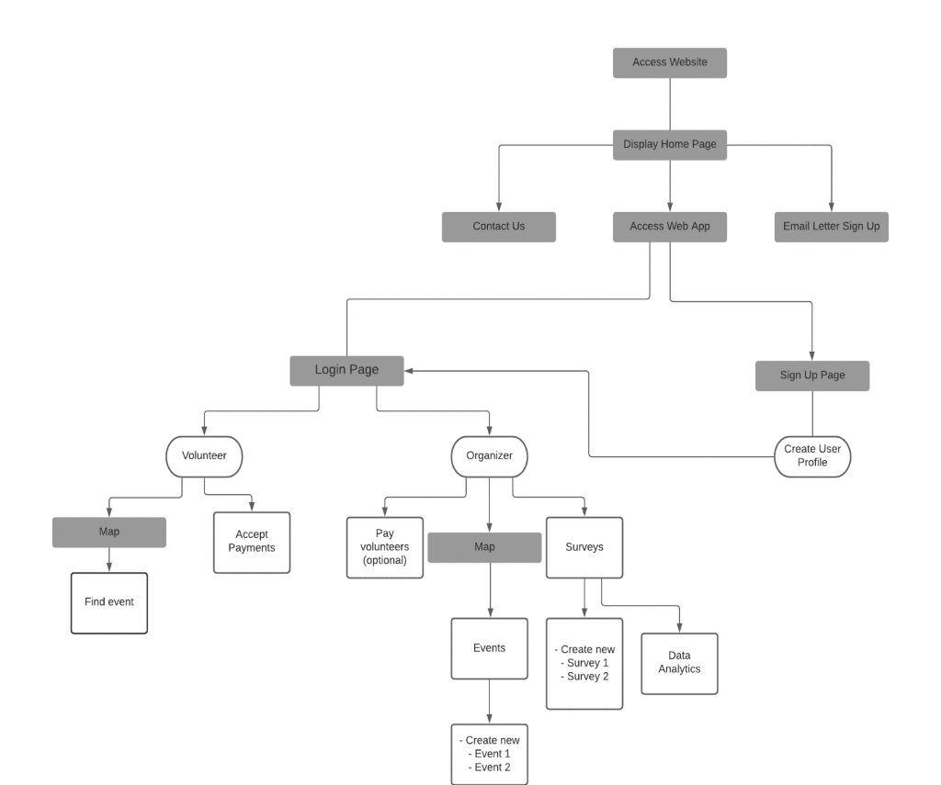

Figure 1: Flowchart of Web-App Functionality

The user will first access the crowdcanvass.io website to reach the web app. After accessing the main website, the home page will be displayed. That home page has the Contact Us section, an email letter signup section, and a portal to access the web application. After accessing the web app, the user will be presented with an option to login or signup. If they go to sign up, they will be prompted to create a user profile. Users who go to login will be either a volunteer or organizer. Volunteers and Organizers have access to a map which will allow volunteers to find events, and it will allow organizers to create events. Volunteers can also accept payments while organizers can optionally pay volunteers. Organizers can also create surveys for their events and view data analytics.

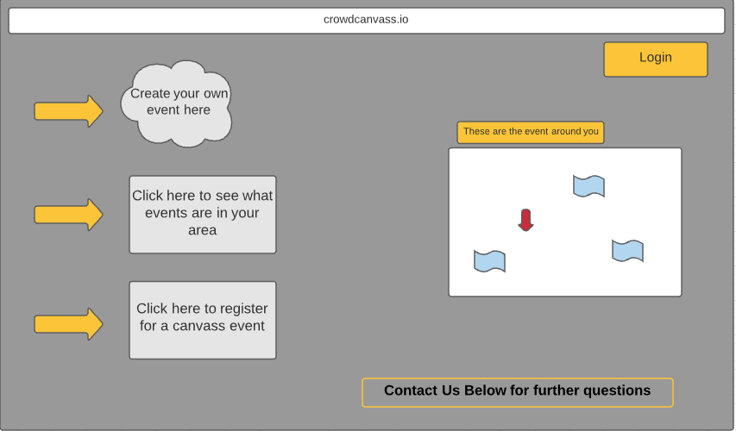

Figure 2: Conceptual Main Screen (Desktop)

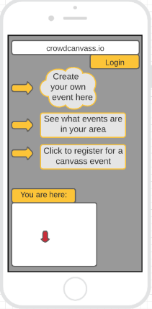

Figure 3: Conceptual Main Screen (Mobile)

Both figures 2 & 3 will be the first images people will see when they open the web app, from both a desktop and a mobile device. Once the web app is opened, it will immediately ask to use the client's location so then it can show the location of the client and the events within the local area. For both platforms, the “Contact Us” information will be lower, and can be viewed up scrolling lower.

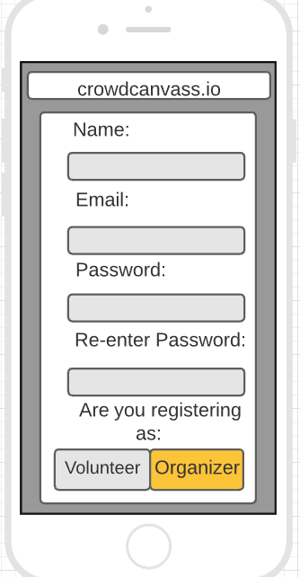

Figure 4: Conceptual Sign Up Screen (Mobile)

From Figure 4, we see, on a mobile device, that someone is trying to set up an account, and they have 'Organizer' selected, this is indicated by the orange highlight. When someone is creating an account, they need to enter their name, email, and account password they desire to enter, as well as indicting the purpose of the account. The 'Organizer' account can make events as well as do everything a ‘Volunteer’ can when it comes to signing up for events. The reason for the distinction is that the 'Organizer' needs to pay a fee for events, especially the events that pay the volunteers.

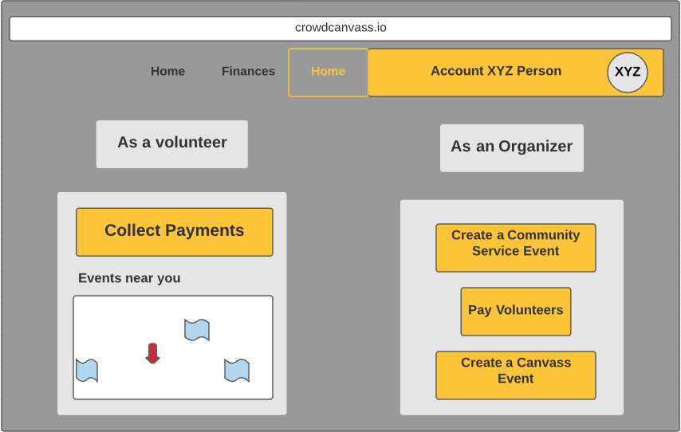

Figure 5: Conceptual Home Screen (Desktop)

Once an account is made, the account user can then select to either create an event or volunteer for one. Figure 5 shows what a desktop view is once a person signs into their account. If the person has a volunteer account, and they try to do anything under "As an Organizer", they would be redirected to their account settings to upgrade their account. On this page, the location permission will be used or asked again. The red arrow is the location of the person, and the blue flags are where the events are located. When a volunteer registers for an event, they will all receive a volunteer reference number that they can use for canvassing events. All this information is viewable under the 'Home' tab, which is seen being selected on the top of the page.

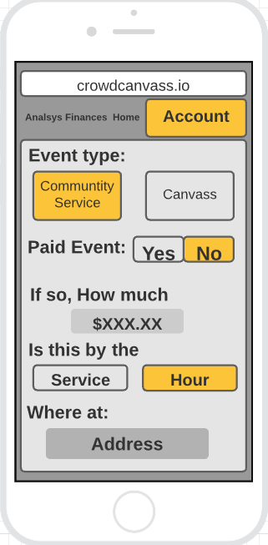

Figure 6:  Conceptual Event Creation Page (Mobile)

As seen in Figure 6, we are creating an event through an 'Organizer' setting through a mobile platform. The Organizer needs to decide if the event will be community service based, or a canvass based. The home screen helps the Organizer by preselecting options, but the Organizer could change the type if they selected the wrong one type. Then the Organizer will need to say the price, and how the quantity will be distributed. The location of the event will be provided next. What would be below all this, not on the screen, will be the event description and more information relating to the event. Figure 6 is accessible whenever an ‘Organizer’ selects any of the create events.

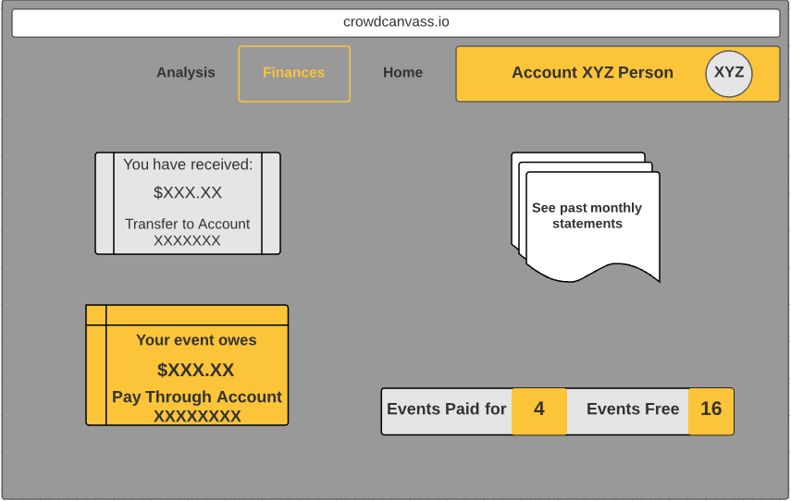

Figure 7: Conceptual Finances Page (Desktop)

The 'Organizer' can see their monthly profit, or how much they are in debt to their event (Figure 7). They can see how much they will pay out for their event and which account it is being paid through. We can also see how much money they have received, and they can transfer it to their bank account as well. We can also see how many events were put on by the organization, as well as if they were paid or free. The data shown is set for the term length. This information is all viewable from the 'Finances' tab, and we see it selected near the top of the page. Their account can be linked to a Third-Party as well, such as PayPal. This display (Figure 7) is viewable after selecting any payment options from the volunteer or organizer sections.

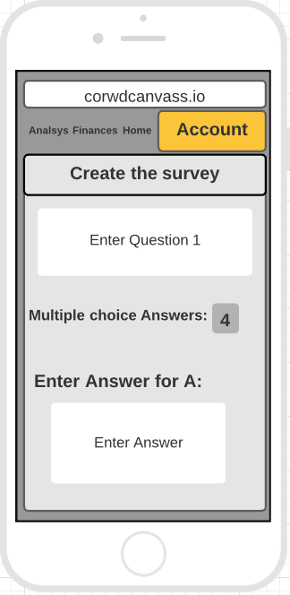

Figure 8: Conceptual Survey Creation Page (Mobile)

The survey creation page (Figure 8) is showing the steps taken when creating a survey for any length for a canvassing event. We can see the formatting and how the 'Organizer' intends to have the questions answered. This will help us analyze the data tables in the ‘Analysis’ page section (Figure 9).

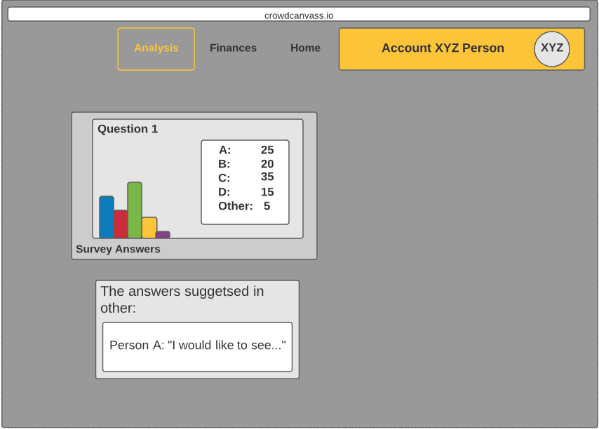

Figure 9: Conceptual Setting Screen

The ‘Analysis’ page (Figure 9) displays the information about the surveys. It breaks down the questions to the percentage of the people that voted for which answer. When someone selects other, and decides to type their own answer, the 'Organizer' can view the answer as well as who said it. For the graph, as well as the 'Other' box, the organizer can use the scroll feature, from track pads as well as mouses, to scroll and see different data information and other responses. Also, within this figure, we see that analysis is selected near the top.

**APPENDIX**

*Administered Survey Data*

