# One Page Sample (For Marketing/Management/Sales/Licensors):

## Title of Game: Waifu Winner!

## Studio Name: IDK Something….

## Platforms: Mobile/Console/PC(Steam/Steam Deck Verified)

## Target Demographic: Teen/Adult Males

## ESRB Rating: M

# Game Summary: Save the cute animals and defeat the forces of evil in style with your favorite waifu in this bullet heaven rogue-lite inspired by Vampire Survivors! Level up, gain new powers, and be prepared to kill hundreds of monsters!

# About This Game Outline:

Waifu Winner is a time survival auto-shooter with rogue-lite elements. Players can play solo or with up to 4 friends. The goal is to save creatures caged in the world, gather experience killing monsters to level up, and eventually kill a giant boss of that area.

Game supports mouse, keyboard, controller, and touch screen support and can be played with one hand.

# Unique Selling Points:

* Play as sexy waifus
* 20 Different starting abilities with 4 combinations leading to over 4000 unique combinations! (<https://www.statskingdom.com/combinations-calculator.html>)
* Support for 4 player online and local co-op
* 9 unique locations with 9 unique difficult bosses
* Endless mode with online leaderboards

# Starting tips:

* Experiment with different builds
* Get two offensive items
* Re-roll when you don’t get an item that works

# Ten Page Design Document Sample:

## Game Design Document Template:

## Cover Page:

## Story/Game Summary:

## Characters and Controls (Re-mappable):

* Gamepad
  + Left analog stick: movement
  + LT zoom in
  + LB dash
  + Right analog stick: aiming mode
  + A to select option

## Gameplay Overview:

## Gameplay Experience (Feel of the game):

* Game goes from same isometric perspective and feel of Hades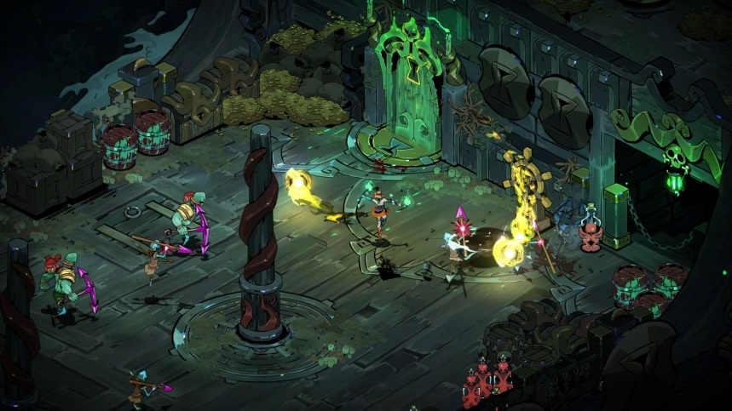 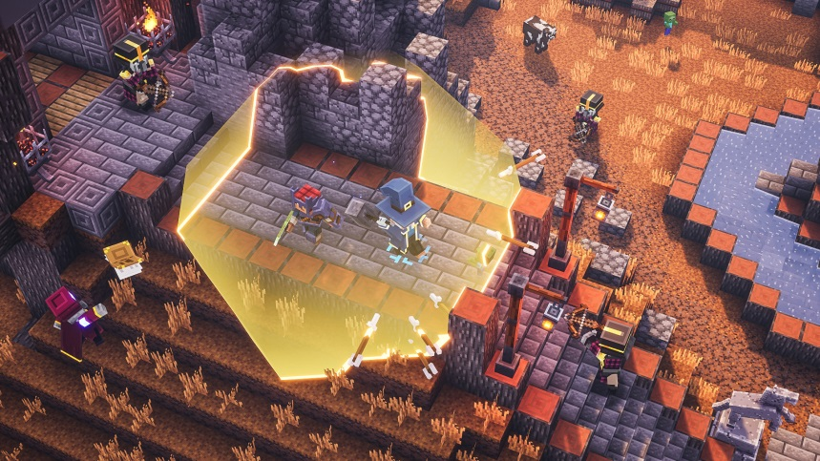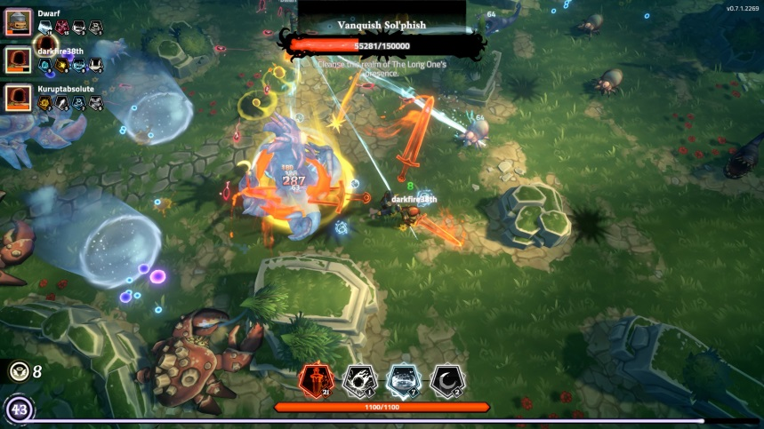

## Mechanics and Modes:

## Enemies and Bosses:

* Tentacle monster:
  + [https://candlelightstudio.itch.io/octopus-sprite-idle-animation](https://candlelightstudio.itch.io/octopus-sprite-idle-animation#)

## DLC

* Bundle package with OST (If we get a composer!)
* Collaboration DLC (Street Fighter Chun-li and arena)

## Monetization

* Paid downloadable game, $10 USD
* In-game purchase(s): Yes
  + Cosmetics only, no pay2win

# Research:

Visual Effects:  
  
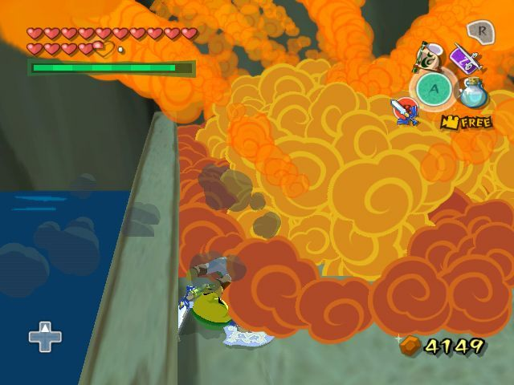

# Wants:

I want it to be in the style of Kill la Kill, but pixel art style!

Resources:

* Vampire Survivors Made With Godot (Possibly Same As UAlbany Game Jam tbh)
  + <https://www.youtube.com/watch?v=abA7TF7z6W8&list=PLtosjGHWDab682nfZ1f6JSQ1cjap7Ieeb>
* Free graph paper for level design (Great for blocking out ideas for levels
  + <https://virtual-graph-paper.com/>

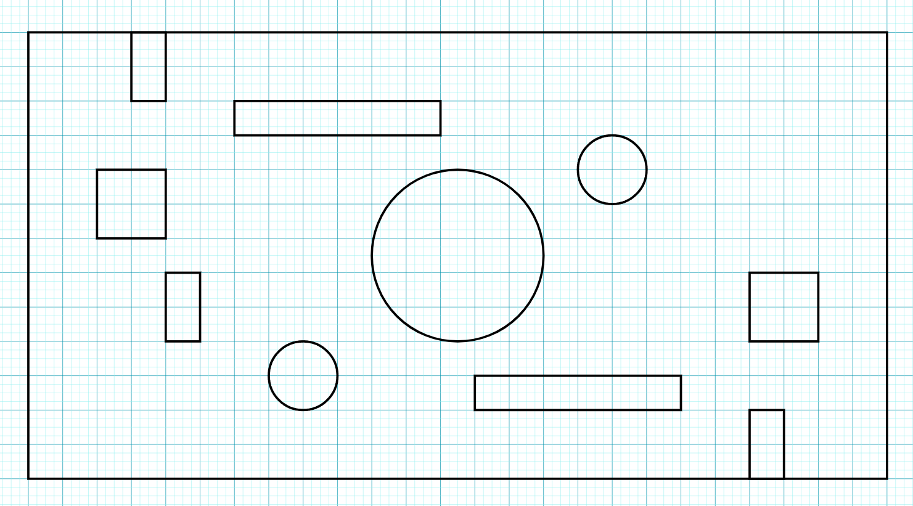

First attempt, it’s not pretty but it gets the point across

* Free sound effects:
  + <https://www.zapsplat.com/>
* Making a basic top down 2D auto shooter <https://www.youtube.com/watch?v=LqrAbEaDQzc>