## ERD Design Approval Form

Student Name

Wyatt Coff

Student ID

001192251

File Name for the Submitted ERD

assesment_1_WyattCoff.mwb

Provide a screenshot of the ERD

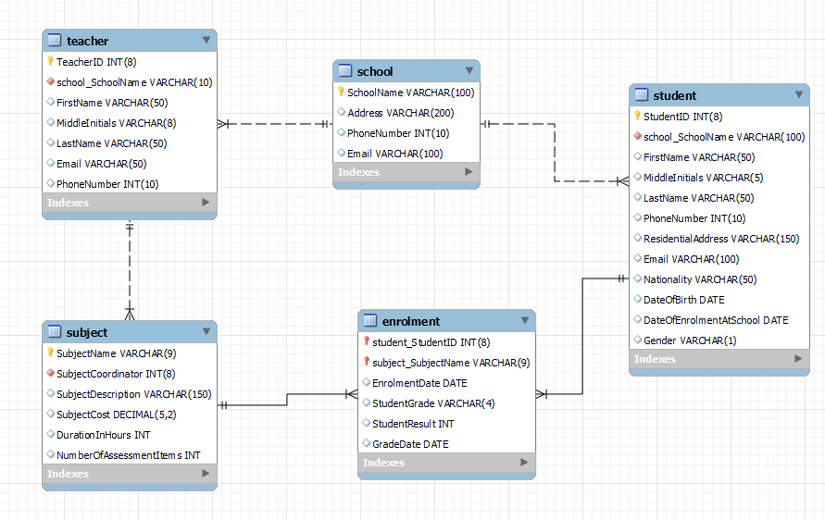

Provide the following information

Tables and relationships

|  |  |  |  |
| --- | --- | --- | --- |
| Table Name | Primary Key | Foreign key(s) & Table | Relationships statement to other tables |
| student | StudenID | SchoolName – Foreign key referencing SchoolName in the school table | A ‘school’ has many ‘students’ |
| subject | SubjectName | SubjectCoordinator - Foreign Key referencing TeacherID in the teacher table | A ‘teacher’ coordinates many ‘subjects’ |
| school | SchoolName | None | None |
| teacher | TeacherID | SchoolName – Foreign key referencing SchoolName in the school table | A ‘school’ has many ‘teachers’ |
| subject_enrolment | EnrolmentID | StudentID - Foreign Key referencing StudentID in the student table  SubjectName - Foreign Key referencing SubjectName in the subject table | A ‘student’ is enrolled in many ‘subjects’.  A ‘subject’ has many ‘students’ enrolled in it |

Tables and data

Provide information on all tables

|  |  |  |  |
| --- | --- | --- | --- |
| Table Name | student | | |
| Column Name | **Datatype** | **Data Character Capacity** | **Reason for the chosen Datatype and Data Capacity** |
| StudentID | VARCHAR (8) | Max 8 | Student ID have a set length – 8 characters will be sufficient |
| FirstName | VARCHAR (50) | Max 50 | First Names vary in length – 50 characters will be sufficient |
| MiddleInitials | VARCHAR (5) | Max 5 | A person middle name initials tend to be the first letters of a person’s name but can be up to 5 characters long – 5 characters will suffice |
| LastName | VARCHAR (50) | Max 50 | Last Names vary in length – 50 characters will be sufficient |
| PhoneNumber | INT (10) | Max 10 | Phone numbers are generally no bigger than 10 digits – 10 characters |
| ResidentialAddress | VARCHAR (150) | Max 150 | Residential Addresses can vary largely in length and may require many characters – 150 characters will suffice |
| Email | VARCHAR (100) | Max 100 | A persons Email can vary in length – 100 characters will be sufficient |
| Nationality | VARCHAR (50) | Max 50 | A persons Nationality can vary in length – 50 characters will be sufficient |
| DateOfBirth | DATE | 10 | The DATE data type was chosen because it was specifically designed to store date values in a standardized format (YYYY-MM-DD) |
| DateOfEnrolmentAtSchool | DATE | 10 | The DATE data type was chosen because it was specifically designed to store date values in a standardized format (YYYY-MM-DD) |
| Gender | VARCHAR (1) | 1 | A person gender can be expressed buy either putting M for Male or F for Female – 1 character should be sufficient |
| SchoolName (FK) | VARCHAR (100) | Max 100 | Foreign key imported from school table - retains the same data type |

|  |  |  |  |
| --- | --- | --- | --- |
| Table Name | subject | | |
| Column Name | **Datatype** | **Data Character Capacity** | **Reason for the chosen Datatype and Data Capacity** |
| SubjectName (PK) | VARCHAR (20) | Max 20 | A Subjects Name can vary in length – 20 characters will be sufficient |
| SubjectDescription | VARCHAR (150) | Max 150 | A Subject Description can be large and vary in length – 150 characters will be sufficient |
| SubjectCost | DECIMAL (5, 2) | 5 digits before the decimal point  2 digits after the decimal point | This datatype, in this instance, allows for a maximum of 5 digits before the decimal point and 2 after the decimal point, this is perfect to store the cost of a subject |
| DurationInHours | INT |  | This stores the number of hours a class takes to complete, since this varies from subject to subject there is no limit specified |
| NumberOfAssessmentItems | INT |  | This stores the number of assessments a subject has, since this varies from subject to subject there is no limit specified |
| SubjectCoordinator (FK) | VARCHAR (8) | Max 8 | Foreign key imported from teacher table, referencing TeacherID - retains the same data type |

|  |  |  |  |
| --- | --- | --- | --- |
| Table Name | School | | |
| Column Name | **Datatype** | **Data Character Capacity** | **Reason for the chosen Datatype and Data Capacity** |
| SchoolName (PK) | VARCHAR (100) | Max 100 | The school’s name can vary – 100 characters will be sufficient |
| Address | VARCHAR (200) | Max 200 | A school’s address can be large and vary, it will also contain both numbers and letters – varchar and 200 characters will be sufficiant |
| PhoneNumber | INT (10) | Max 10 | Phone numbers are generally no bigger than 10 digits – 10 characters |
| Email | VARCHAR (100) | Max 100 | Emails can vary in length – 100 characters will be sufficient |

|  |  |  |  |
| --- | --- | --- | --- |
| Table Name | Teacher | | |
| Column Name | **Datatype** | **Data Character Capacity** | **Reason for the chosen Datatype and Data Capacity** |
| TeacherID (PK) | VARCHAR (8) | Max 8 | Teacher ID have a set length – 8 characters will be sufficient |
| FirstName | VARCHAR (50) | Max 50 | First Names vary in length – 50 characters will be sufficient |
| MiddleInitials | VARCHAR (8) | Max 8 | A person middle name initials tend to be the first letters of a person’s name e.g. James would be ‘J’ – 1 character will be sufficient |
| LastName | VARCHAR (50) | Max 50 | Last Names vary in length – 50 characters will be sufficient |
| Email | VARCHAR (100) | Max 100 | Emails can vary in length – 100 characters will be sufficient |
| PhoneNumber | INT (10) | Max 10 | Phone numbers are generally no bigger than 10 digits – 10 characters |
| SchoolName (FK) | VARCHAR (100) | Max 100 | Foreign key imported from school table, referencing SchoolName - retains the same data type |

|  |  |  |  |
| --- | --- | --- | --- |
| Table Name | enrolment | | |
| Column Name | **Datatype** | **Data Character Capacity** | **Reason for the chosen Datatype and Data Capacity** |
| StudnetID (FK) | VARCHAR (8) | Max 8 | Foreign key imported from student table, referencing StudentID - retains the same data type |
| SubjectName (FK) | VARCHAR (20) | Max 8 | Foreign key imported from Subject table, referencing SubjectlName - retains the same data type |
| EnrolmentDate | DATE | 10 | The DATE data type was chosen because it was specifically designed to store date values in a standardized format (YYYY-MM-DD) |
| StudentGrade | VARCHAR (4) | Max 4 | This holds a student grade in the format of 4 Characters being Pass, Cred, Dist, Fail – 4 characters will be sufficient |
| StudentResult | INT (100) | Max 100 | The student grade range is from 1 – 100, depending on the result received a student will receive a corresponding Grade |
| GradeDate | DATE | 10 | The DATE data type was chosen because it was specifically designed to store date values in a standardized format (YYYY-MM-DD) |

Upload to LEARN for approval of ERD Design when complete

Include the MySQL WorkBench ERD file (.mwb)