**Populate data:**

Insert Into student statement from the SQL Script

Provide a screenshot of the SQL code

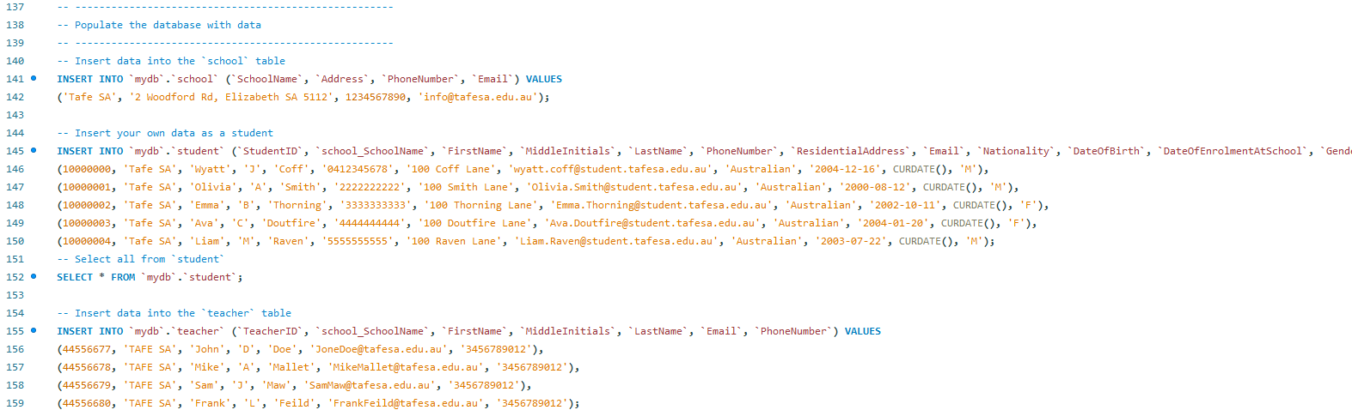

Provide a screenshot of the output created by the “Name & Phone” query

Query to count all students in the database - expect 5:

Query to count students enrolled in each subject - expect 2 in each subject total 10:

Query to show the highest result for all students in a subject - expect WEB451SQL 75, IT_PracTL 60, ICT302IWC 90 and 5SDA 90:

Query to show the lowest result for all students in a subject - expect 5SDA 60, ICT302IWC 60, IT_PracTL 55, WEB451SQL 70:

Provide the query for your own record in the database - take a screenshot of the output

Change the query to show the records for another student – take a screenshot of the output

Provide a screenshot of the SQL code for the query – include the comment in the screenshot

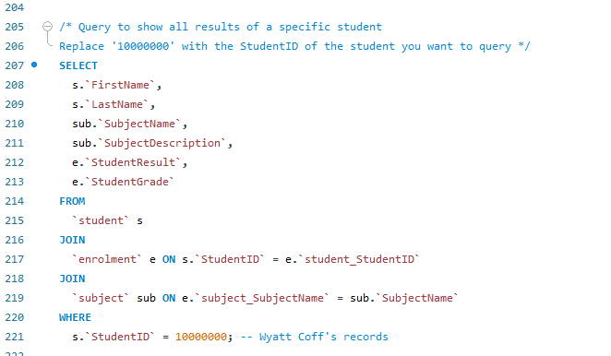

Provide 2 screenshots of the output for 2 subjects you are enrolled in

Provide a screenshot(s) of the SQL code you created for “Alter Table and Update”

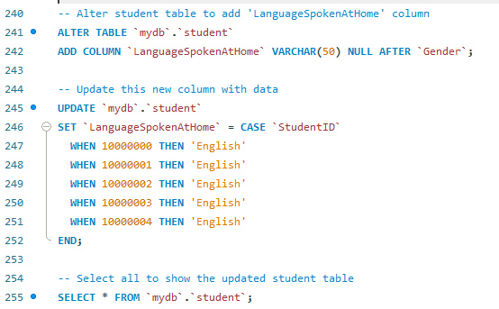

Provide screenshots of the output from SELECT * FROM student; after the “Alter Table and Update” queries have been run :

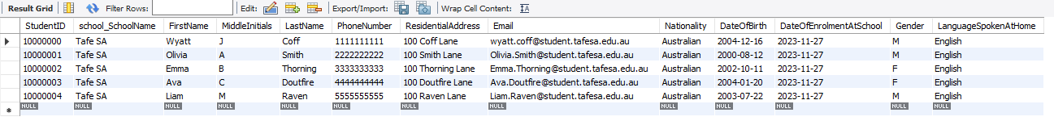

Provide screenshots of the SQL code and comments used to “Change A Subject Coordinator”

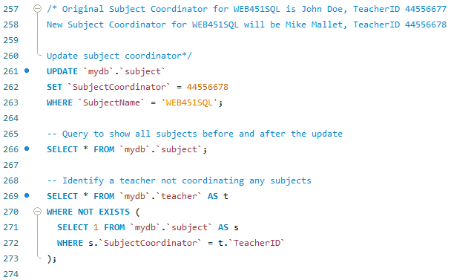

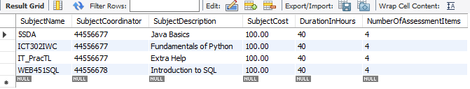

Provide screenshots of the SQL code and comments used to “Delete a teacher”:



