UNCLASSIFIED // PUBLIC DATA // PORTFOLIO SAMPLE, NOT AN OFFICIAL SFPD PRODUCT
Reported Vehicle Break-Ins Fall 35%; Half of Remaining Incidents Concentrate in 11% of the City
Crime Analysis Bulletin No. 2026-01 | September 25, 2026 | Prepared by: Travis [Last Name]
Data current through August 2026 (pulled September 25, 2026) | Source: SFPD Incident Reports via DataSF
BOTTOM LINE UP FRONT
Reported vehicle break-ins in San Francisco fell 35% over the past year, to about 330 a month, the lowest level since the dataset began in 2018. The decline began abruptly in fall 2023 and has continued since. The problem is now more concentrated: half of all mapped break-ins in the past 12 months occurred in statistically significant hot spots covering 11% of the city, centered on the Western Addition, Tenderloin, South of Market, and the Mission. That core has persisted for two years, while new clusters are forming to the south in the Mission, Potrero Hill, and near Bayview.
KEY JUDGMENTS
- Reported vehicle break-ins have almost certainly declined since 2019 (high confidence). The last 12 months (3,966 reports) ran 35% below the prior 12 (6,140), and the seasonally adjusted downward trend is statistically significant.
- The core hot spot will very likely remain the city's main concentration over the next six months (high confidence). 85% of this year's hot spot cells were also hot the year before.
- Activity is likely shifting south and east (moderate confidence). New hot spot cells appeared in the Mission, Potrero Hill, and near Bayview while cells on the northern waterfront dropped out. Bayview was the only police district with more reports than last year (+6%).
- Monthly volume will likely stay near current levels, roughly 250 to 450 reports, through early 2027 (moderate confidence).
1. TREND: A SHARP BREAK IN FALL 2023
Monthly reports peaked at 2,628 in October 2019. After a pandemic dip in 2020 and a rebound through mid-2023, reports fell sharply starting in September 2023, from about 2,100 a month to under 1,000 by year's end, and have declined steadily since. Annual reports fell from 25,422 in 2019 to 5,239 in 2025. A Mann-Kendall test on the seasonally adjusted series confirms a significant downward trend (τ = −0.58, p < 0.001), with a median decline of 22 reports per month (95% CI: 19 to 24).
The fall 2023 break coincided with the city's announced enforcement campaign against auto burglary, which included bait cars, plainclothes operations, and prosecution of organized crews. This analysis establishes timing, not cause.
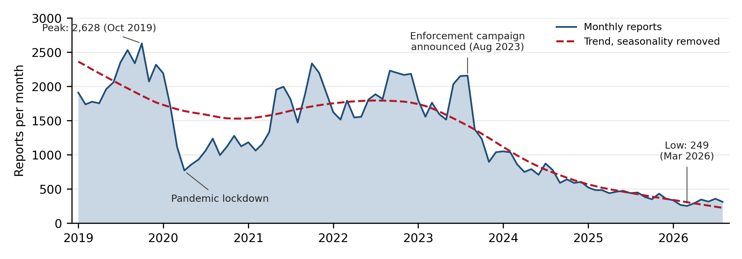
Figure 1. Monthly reported vehicle break-ins, January 2019 to August 2026. Dashed line: STL trend component with seasonality removed.
2. WHEN
Reports cluster in the evening: 44% of the past year's incidents were logged between 5 p.m. and midnight, highest on Friday and Saturday nights. About 9% carry a time of exactly midnight, twice the hourly average. That is likely a default entry for break-ins discovered later, so hour-level detail should be treated with caution.

3. WHERE: PERSISTENT CORE, EMERGING SOUTHERN CLUSTERS
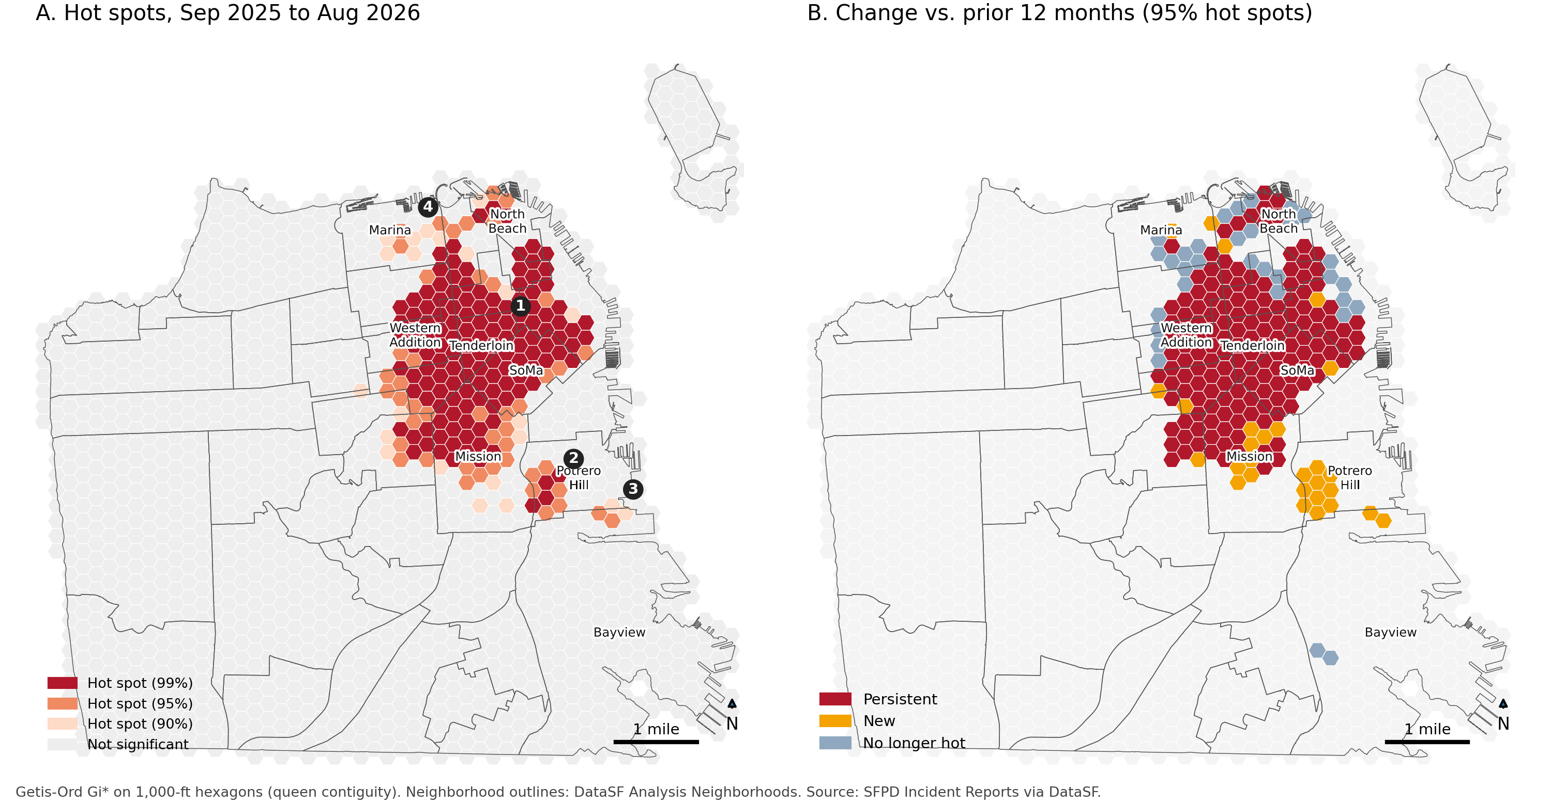
Figure 2. (A) Getis-Ord Gi* hot spots, last 12 months; numbers mark contiguous hot spot zones. (B) 95% hot spot cells compared with the prior 12 months.
A Getis-Ord Gi* analysis of 1,673 hexagonal cells (1,000 ft) identified 182 hot spot cells at 95% confidence, 136 of them at 99%. They cover 10.9% of the city's land area but contain 49% of mapped incidents. Zone 1 runs from the Western Addition through the Tenderloin and South of Market into the Mission; its most intense cells are in the Western Addition. Of the 182 cells, 154 were also hot in the prior year. New cells appeared in the Mission and Potrero Hill (Zone 2) and near Bayview (Zone 3), while cells in the Marina, Russian Hill, North Beach, and the Financial District dropped out.
One location stands out. Jackson St and Kearny St recorded 55 reports in the past year, nearly three times the next-highest intersection. Its annual count rose from 24 in 2019 to 71 in 2023 while citywide reports were falling.
4. OUTLOOK
Volume will likely hold between roughly 250 and 450 reports a month through early 2027. Break-ins historically peaked in late summer and fall, but that seasonal swing has faded with falling volume: fall 2025 averaged 386 reports a month, below the preceding summer's 451. The trend slope describes the past decline and should not be projected forward.
ANALYTIC CONSIDERATIONS
These are reported incidents, not all break-ins. Underreporting is common, and changes in reporting habits, including online reporting, can shift counts independent of crime. SFPD masks locations to the nearest intersection, which stacks reports at corners; counting in 1,000-ft hexagons reduces this effect. 10.5% of reports lacked valid coordinates and are excluded from the map only; many are likely online reports, which do not validate addresses. At 1,500-ft cells, 91% of the hot spot area was unchanged; at 500 ft the pattern fragments (57% overlap), as expected with sparse counts. The trend test assumes independent months, so its p-value is somewhat optimistic, though the conclusion holds.
RECOMMENDATIONS AND INTELLIGENCE GAPS
- Focus evening patrol and prevention messaging on Zone 1's persistent 99% cells, Friday and Saturday, 5 p.m. to midnight.
- Review the Mission, Potrero Hill, and Bayview cells monthly to test whether activity is displacing south.
- Gaps: the cause of the Jackson and Kearny concentration; parking and visitor volume by area, to separate risk from exposure; arrest and case data, to test whether enforcement drove the decline.
Sources and Methods. SFPD Incident Reports, 2018 to Present (DataSF), subcategory “Larceny - From Vehicle,” January 2019 to August 2026. Supplemental reports removed and records deduplicated to 118,396 unique incidents; September 2026 excluded as incomplete. Trend: STL decomposition, Mann-Kendall test, and Sen’s slope (Python). Hot spots: Getis-Ord Gi* on 1,000-ft hexagons clipped to DataSF Analysis Neighborhoods, queen contiguity, 3,631 mapped incidents (Sep 2025 to Aug 2026); 125 of 182 hot cells also pass a false discovery rate correction. Code: [GitHub link].

