**SQL EXERCISE**

Retrieve the required information using SQL language.

Use the functions in the below URL for reference:

<http://dev.mysql.com/doc/refman/5.5/en/functions.html>

1. How many copies of the book titled The Lost Tribe are owned by the library branch whose name is "Sharpstown"?

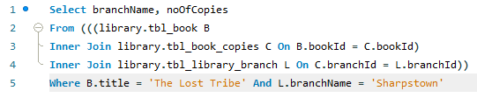

There are none.

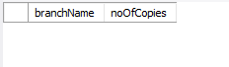

1. How many copies of the book titled The Lost Tribe are owned by each library branch?

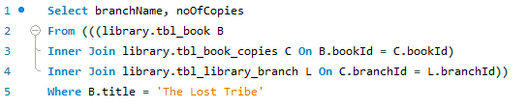

The Arkansas branch has 100 copies.



1. Retrieve the names of all borrowers who do not have any books checked out .



There are many:

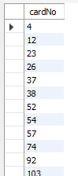

1. For each book that is loaned out from the "Sharpstown" branch and whose DueDate is today, retrieve the book title, the borrower's name, and the borrower's address.

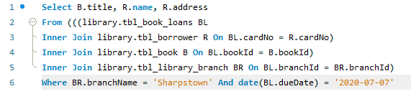

No results for todays date (2021-07-07).

Testing for a sample date in the database:

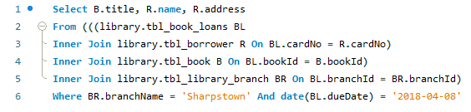



1. For each library branch, retrieve the branch name and the total number of books loaned out from that branch.

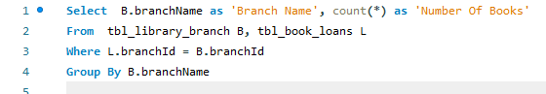

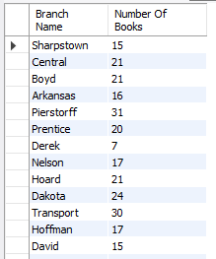

1. Retrieve the names, addresses, and number of books checked out for all borrowers who have more than five books checked out.

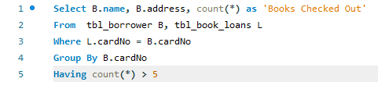

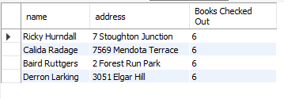

1. For each book authored (or co-authored) by "Stephen King", retrieve the title and the number of copies owned by the library branch whose name is "Central"

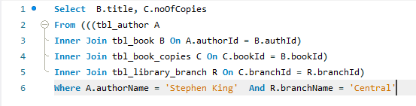

There are no Stephan King books owned by Central Library. Here are the Stephen King books.

