Wiki: https://github.com/WyattMorgan20/GDP-Group-1-Balance---AI-Assisted-Bookkeeping/wiki/Use-Cases-(Iteration-2)
1. Account Creation
- Goal: Creating an Account
- Success Scenario Steps:
  - On system startup, login prompt appears
  - User clicks create account button on prompt
  - User enters desired username and password
  - User sets up Multi-Factor Authentication
  - User confirms entered credentials and clicks create account button
  - System creates the account
- Diagram:
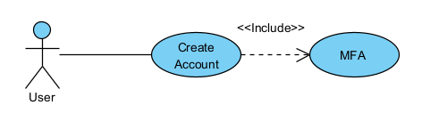
2. User Login
- Goal: Log In
- Success Scenario Steps:
  - On system startup, login prompt appears
  - After account creation, user is sent back to login prompt
  - User enters login information and clicks login button
  - User enter Multi-Factor Authentication credentials
  - System confirms credentials and logs user in
- Exceptions:
  - System confirms credentials and sends error: No matching user account
  - System confirms credentials and sends error: Incorrect credentials
- Diagrams:
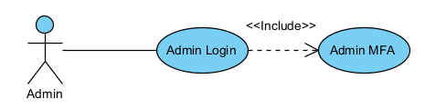 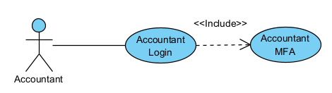 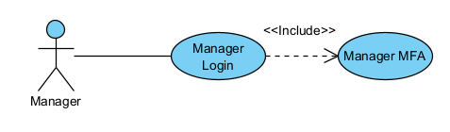 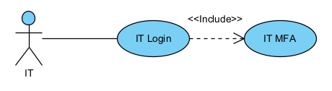
3. Manager Permissions
- Goal: Give Manager accounts proper Managerial permissions
- Success Scenario Steps:
  - After logging in, Manager is sent to Managerial dashboard
  - At the dashboard, Manager will:
    - See alerts for record deletion requests and final month-end close confirmation request for all current assigned bookkeeping projects
    - Get weekly report about updates to all current assigned bookkeeping projects
    - Receive ability to create, delete, and update all current assigned bookkeeping projects
    - See updates for accountants that have not updated books in two-day periods from assignments
    - Get notifications to review and approve reconciliations prepared by accountants
- Diagram:
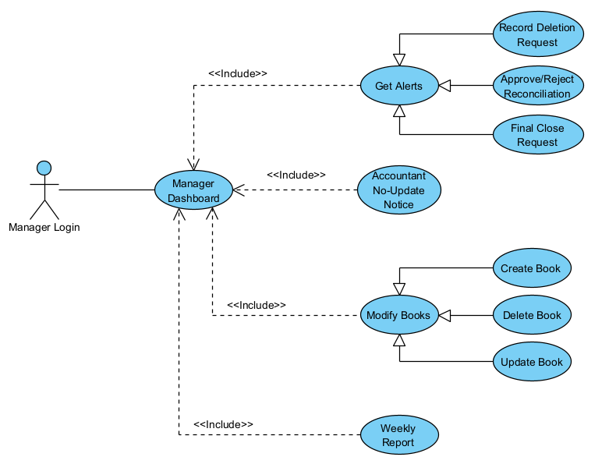
4. Accountant Permissions
- Goal: Give Accountant accounts proper Account permissions
- Success Scenario Steps:
  - After logging in, Accountant is sent to Accountants dashboard
  - At the dashboard, Accountant will:
    - Be able to add and update records in assigned bookkeeping projects
    - Have the ability to add supporting documents to assigned bookkeeping projects
    - Be able to view given task lists for assigned bookkeeping projects
    - Get the ability to prepare reconciliations
    - Receive notifications for review approval or rejection status from managers
    - Get read-only access to prior-period records for reference
- Diagram:
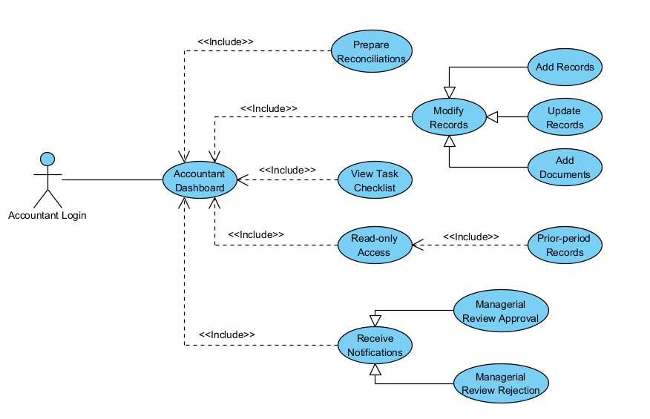
5. IT Permissions
- Goal: Give IT accounts proper IT permissions
- Success Scenario Steps:
  - After logging in, IT is sent to IT dashboard
  - At the dashboard, IT will:
    - Have the ability to create, modify and deactivate accounts that don't have the admin role
    - Be able to assign or revoke role-based access classes
    - Have the ability to manage authentication methods for users
    - Get the ability to see read-only copies of logs and audit trails
    - Have permissions to monitor system well-being(troubleshooting, errors, integrated software/systems)
- Diagram:
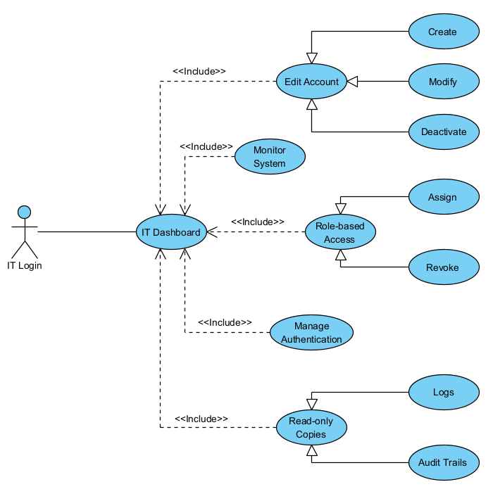
6. Audit Trail
- Goal: Allow respective users to see the audit trail for all transactions
- Success Scenario Steps:
  - After logging in, the user is sent to their respective dashboard
  - At the dashboard, the user will:
    - View timestamps for when a transaction is added to the books
    - View generated timestamps for when a transaction in the books is modified
    - Be able to open transactions to view their context
    - Click links to connected entries in opened transactions
    - View all timestamps for the transaction as a list inside the opened entry
- Diagram:
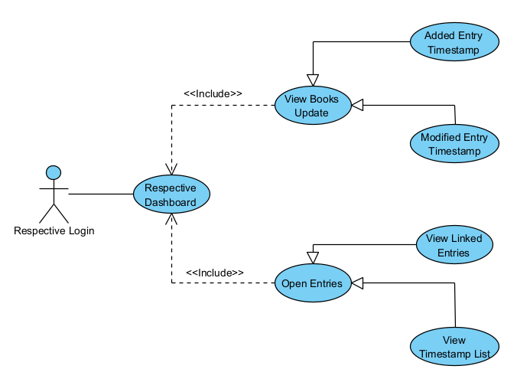
7. AI Integration
- Goal: Add AI to the system
- Success Scenario Steps:
  - After logging in, the user is sent to their respective dashboard
  - At dashboard, the user will be able to:
    - Use a chatbot AI assistant that works like an on-screen assistant for month-end close operations
    - View automatically-audited transaction links done by the built-in system AI
- Diagram:
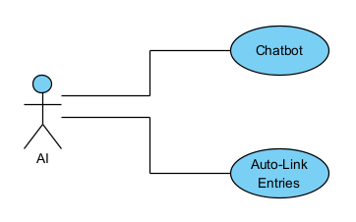
8. Data Management
- Goal: Manage data as efficiently and logical as possible.
- Success Steps:
  - After logging in, the user will be sent to their respective dashboard
  - To manage data, the user will have the following options:
    - Store information within a database (cloud-based)
    - Larger enterprises may need to use local storage for faster data access
    - Receipt scanning could be done using mobile features
- Diagram:
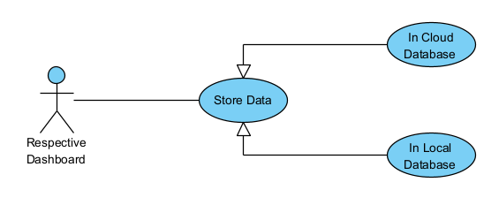
9. Bookkeeping Features
- Goal: Successfully prepare and generate records for bookkeeping and audit trails.
- Success Steps:
  - After logging in, the user will be sent to their respective dashboard
  - The user will generate data for audits based on the following options:
    - Auto-prepare bank reconciliation as the final product
    - Generate journal entries along with documents to support the entries
    - Show and highlight variances and anomalies to show any conflicting information
    - Generate Prepared By Client workflows for client interaction
    - Excel integration for exports and reporting
    - Supported input formats include .csv, .txt, and more common file types
    - Bank statements are included in audit trails
- Diagram:
