**Practice Exam – 02**

**5 points**

For this Practice_Exam 02 you will be creating an app called **Fitness Tracker App** to help users calculate the total calories burned during physical activities. Users can input essential fitness details, such as activity type (Running, Cycling, Swimming, etc.), duration in minutes, and calories burned per minute, and receive an instant calculation of their total calories burned.

Note: Please go through the demo video of the app provided in the zip file.

**Instructions to create the project.**

1. Create a project in Xcode with the name **LastName_Exam02**.
2. Ensure the project meets minimum deployment and formatting requirements as specified below.

## **Instructions to Create the Fitness Tracker App**

1. Design and implement the Fitness Tracker App. Relevant images for goal types are provided in the zip file. You may use custom names for view controllers and segues.
2. Your app should consist of the following UI components, and you may use your own colors of choice.
3. **Components for View – 1 (Figure 1)**
   * 1. A title at the top displaying the app name **Fitness Tracker App**. You can create the title same as shown in the below figure:

* + 1. Three Labels for:
       1. **Activity Type**
       2. **Duration (Minutes)**
       3. **Calories Burned per minute**
    2. Three TextFields for user input next to the corresponding labels.
    3. Two buttons:
       1. **Calculate Calories**
       2. **Reset**

1. Once all values are entered, when clicked **Calculate Calories** button, the app should calculate the total calories burned and display it in the second view, along with the user-entered details and a relevant image.

### ****Hint to Calculate Total Calories Burned:****

* 1. Define a global variable: totalCaloriesBurned, initializing them with **0.00**.
  2. First, Calculate the total calories burned using:

**totalCaloriesBurned = duration * caloriesPerMinute**

### ****Write a**** ****prepare**** ****function for segue to pass data to the Second View****

1. **Components for View – 2 (Figure 2)**

* Labels displaying:
  + 1. **Activity Type**
    2. **Entered Duration**
    3. **Entered Calories**
    4. **Calculated Total Calories Burned**
* An ImageView displaying an image relevant to the selected activity type, with an animation effect. You can use the below function code for animation in the code or can use any animation effect.

**ImageViewOutlet.alpha = 0.0**

**UIView.animate(withDuration: 1.5) {**

**self.ImageViewOutlet.alpha = 1.0**

* When the user navigates back to View 1, all input fields should reset to default.
* Once user tries to navigate back to View 1, all the input text fields should not display any data previously entered**.** You can use the function below or the function of your own choice in your code to not display any data in the text fields when you click on the back button:

**override func viewWillAppear(_ animated: Bool) {**

**super.viewWillAppear(animated)**

**// Reset all input fields**

**ActivityOutlet.text = ""**

**DurationOutlet.text = ""**

**CaloriesPerMinuteOutlet.text = ""**

**}**

**Test Cases:**

|  |  |  |
| --- | --- | --- |
| **Test Case** | **Input Values** | **Expected Output** |
| Test Case 1 | Activity type: running  Duration: 30  Calories Burned per Minute: 10 | Activity Type: running  Entered Duration: 30  Entered Calories Burned per Minute: 10  Total Calories Burned: 300  Image: Running Image |
| Test Case 2 | Activity type: cycling  Duration: 45  Calories Burned per Minute: 8 | Activity type: cycling  Duration: 45  Entered Calories Burned per Minute: 8  Total Calories Burned: 360  Image: Cycling Image |
| Test Case 3 | Activity type: swimming  Duration: 60  Calories Burned per Minute: 12 | Activity Type: swimming  Entered Duration: 60  Entered Calories Burned per Minute: 12  Total Calories Burned: 720  Image: Swimming Image |

**Refer to the below images for sample outputs:**

**INITIAL VIEW OF FIRST SCREEN When all the values are entered in text fields**

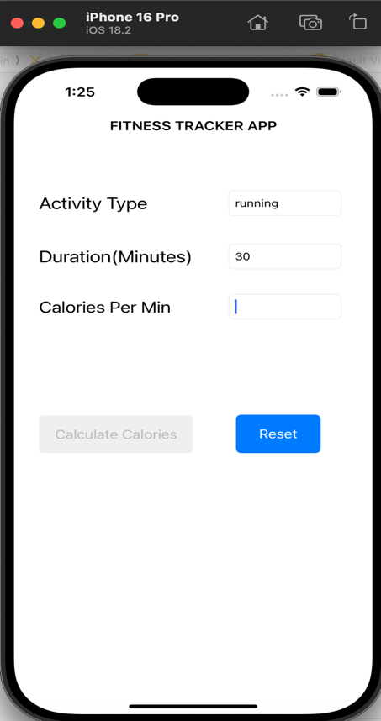

**When all the values are not entered When calculate calories button is clicked**

**When Back navigator on top/reset is clicked When activity type that is not listed**

**is given as input**

1. **Submission Instructions:**
2. Save your XCode project.
3. Make sure the name of the project folder is **LastName_PracticeExam02**. Compress the folder and submit it.